|  |  |
| --- | --- |
| Comprehensive Energy Efficiency Retrofits to Existing Victorian Houses |  |
| April 2019 |  |

|  |  |
| --- | --- |
| Authorised and published by  Sustainability Victoria Level 28, Urban Workshop 50 Lonsdale Street Melbourne  Victoria 3000 Australia  Comprehensive Energy Efficiency Retrofits  to Existing Victorian Houses  © Sustainability Victoria 2020  April 2019  **Accessibility**  This document is available in PDF and Word format on the internet at sustainability.vic.gov. au  While reasonable efforts have been made to ensure that the contents of this publication  are factually correct, Sustainability Victoria  gives no warranty regarding its accuracy, completeness, currency or suitability for any particular purpose and to the extent permitted  by law, does not accept any liability for loss  or damages incurred as a result of reliance  placed upon the content of this publication.  This publication is provided on the basis  that all persons accessing it undertake  responsibility for assessing the relevance and accuracy of its content.  This report should be attributed to  Sustainability Victoria.  This report is licensed under a Creative  Commons Attribution 4.0 Australia licence.  In essence, you are free to copy, distribute and adapt the work, as long as you attribute the  work and abide by the other licence terms.  Go to http://creativecommons.org/licenses/by/4.0/  to view a copy of this licence. |  |

## Foreword

In February 2019, the COAG Energy Council, comprising energy Ministers from all Australian jurisdictions, approved the *Trajectory for Low Energy Buildings*. This establishes a trajectory towards zero energy (and carbon) new residential and commercial buildings, starting with the updates to the National Construction Code in 2022. Recognising that existing (pre-2005) houses account for most of the housing stock and offer the greatest potential for energy and greenhouse savings, the Energy Council also endorsed the development of a *Trajectory for Low Energy Existing Homes* in 2019. The intention of this strategy is to increase the energy performance of existing residential dwellings to save energy and reduce energy bills, improve the thermal comfort, and potentially health, of the occupants, improve resilience to extreme weather events and black-outs (by reducing electricity peak demand), and reduce greenhouse gas emissions from residential energy use.

In this report, we present the results of Sustainability Victoria’s *Comprehensive Retrofit Trial*, undertaken in fourteen existing houses located in Melbourne. Fairly comprehensive building shell and heating system upgrades were undertaken at the houses, with the aim of improving their thermal comfort during the winter months and significantly reducing heating energy consumption, the largest area of energy consumption in Victorian houses. Where funds permitted, water heating, refrigeration and/or lighting upgrades were also undertaken at the houses, targeting the other main areas of residential energy consumption. Metering equipment and householder surveys were used to assess the quantitative and qualitative impact of the comprehensive upgrades, and to estimate the energy, energy bill and greenhouse gas emission savings achieved by the retrofits.

The *Comprehensive Retrofit Trial* builds on Sustainability Victoria’s body of work on the energy efficiency upgrade potential of Victoria’s existing (pre-2005) housing stock, that commenced with the *On-Ground Assessment* study. The initial study was based on *modelling* a wide range of building shell, appliance and lighting upgrades in existing houses, based on 60 houses chosen to be reasonably representative of Victoria’s existing housing stock. It showed that significant energy and greenhouse savings could be achieved if houses were subjected to comprehensive retrofits. This was followed by a series of retrofit trials where key individual energy efficiency retrofits were undertaken at houses, to assess the actual costs and energy saving impacts.

In this new study, we *implemented* comprehensive retrofits at existing houses, providing insights into the actual costs involved, and the comfort improvement and energy savings that can be achieved in practice. It has confirmed that significant improvements to the thermal comfort of existing houses can be achieved through comprehensive retrofits that aim to reduce heating energy consumption *as well as* significant energy bill savings, and that useful savings can be achieved where inefficient water heaters, refrigerators and lighting are replaced. There was little evidence of an economic rebound effect, whereby households increase their consumption of an energy service (such as heating) because the cost of this service is lower, reducing the energy savings achieved.

While the building shell and heating system retrofits generated large energy savings, they were the most expensive retrofit type and had the longest payback period, based only on the energy bill savings. We did not collect the data necessary to assess any health benefits resulting from these retrofits. However, we have used data from good quality overseas studies to investigate the potential health cost savings. Combined with other potentially large savings, such as reduced electricity costs from reduced summer and winter peak electricity demand, the overall society-wide savings from comprehensive energy efficiency retrofits to existing houses could be much larger than the energy bill savings, reducing the payback period from around 20 years to well under 10 years, making this a much more attractive economic proposition.

Through the C*omprehensive Retrofit Trial,* we also collected detailed data on how Victorian households actually use their heating, a little studied area. Analysis of this data shows that the operating profile of the heating is different to what is commonly assumed, and that temperatures in the heated areas of houses are often lower than expected. It has also highlighted the quite high electricity consumption of gas ducted heaters with the new, more efficient, gas ducted heaters used as replacements often having a higher electricity consumption than the ones they replaced.

## Acknowledgements

This report is based on the analysis of data collected from the fourteen households that participated in Sustainability Victoria’s *Comprehensive Retrofit Trial*. We would like to especially thank these households for their participation in the study by providing access to their houses for: data collection relating to the design and construction of their houses, as well as details of their lighting and major appliances; the conduct of blower door (air pressurisation) tests to measure the air leakage rate of the houses; the installation and removal of monitoring equipment; and, the implementation of the energy efficiency upgrades. The households also provided historical gas and electricity billing data, undertook surveys relating to their use of heating and cooling and other appliances, and partly funded the energy efficiency retrofits.

Sustainability Victoria contracted several companies to assist with the implementation of the retrofit trial, through recruiting the households and liaising with them throughout the trial, collecting data to identify the most appropriate retrofits and negotiating the retrofit package with the households, engaging and managing the companies that undertook the retrofits, installing and removing metering equipment, and conducting the householder surveys. Moreland Energy Foundation Limited (MEFL) was contracted to manage the implementation of the first batch of five houses, and EnviroGroup was contracted to manage the implementation of the second (5 houses) and third (4 houses) batches. Energy Efficient Strategies was contracted to manage the installation and removal of the metering equipment for the third batch of houses.

## Abbreviations and Acronyms

ABS Australian Bureau of Statistics

Av. Average

ACH Air changes per hour

BRE Building Research Establishment

oC degree Celsius

CFL Compact Fluorescent Lamp

COAG Council of Australian Governments

CO2-e  Carbon dioxide equivalent

Elec. Electricity

EU European Union

HER House Energy Rating

IEA International Energy Agency

Inc. Including

Insul. Insulation

kg kilogram

kW kilowatt

kWh kilowatt-hour

LED Light emitting diode

MEFL Moreland Energy Foundation Limited

MJ Mega joules

MW Megawatt

NatHERS Nationwide House Energy Rating Scheme

No. Number

NZ New Zealand

OGA On Ground Assessment

PV Photovoltaic

RAC Reverse-cycle air conditioner

STC Small scale Technology Certificate

SV Sustainability Victoria

TV Television

UK United Kingdom

VEU Victorian Energy Upgrades

WHO World Health Organisation

Yr Year

## Glossary

Building shell The key external elements of a house, including walls, roof/ceiling, floor and windows.

Conversion efficiency The ratio of the useful energy output of a heating or cooling system divided by the input energy.

Energy efficiency retrofit This is an energy efficiency improvement (or upgrade) to the building shell of a house, such as the installation of insulation or draught proofing, that does not involve changing the floor area or layout of the house. This contrasts with a “renovation”, which involves adding floor area to an existing house and/or major structural changes. It also includes the replacement of an existing appliance or lighting with a new, more efficient, model.

FirstRate5 One of the rating tools accredited under the Nationwide House Energy Rating Scheme (NatHERS). It is a thermal modelling program which can be used in Victoria to assess compliance with the energy efficiency requirements for new houses. The program calculates the annual heating and cooling energy required (expressed in MJ/m2 per year) to maintain specified comfort conditions inside a house in a particular climatic location. It also assigns a House Energy Rating so that the energy efficiency of different houses can be compared.

Heating and cooling load The annual energy output of heating/cooling devices required to maintain certain thermal comfort conditions inside a home. Usually expressed in megajoules.

House Energy Rating Star rating from 0 to 10 obtained from a thermal modelling program such as FirstRate5, which indicates the thermal efficiency of the building shell of a house. The higher the rating, to more efficient the house is.

Load profile This is a graph that shows how the energy consumption of a house, or individual appliance, varies throughout the day. It is most commonly used for electrical appliances, where it shows the average electrical power consumption for a certain time interval, in either Watts or kilowatts. For gas appliances, the average gas power consumption is shown in MJ per hour.

Reverse-cycle air conditioner An air conditioner which uses a refrigeration (or heat pump) cycle to provide both heating and cooling.

R-value Thermal resistance. This is a measure of the extent to which a certain material resists the transfer of heat through it in response to a temperature difference across the material. The higher the R-value, the greater the insulating effect of the material. R-values can be applied to both individual insulation products (e.g. an insulation batt) and to composite building sections (e.g. wall, floor, roof/ceiling) that may or may not have insulation added.

Thermal comfort This refers to a situation when the internal conditions inside a house – air temperature, humidity, air movement, and the temperature or internal surfaces – mean that a person feels comfortable. Houses that are too cold and draughty are not thermally comfortable, and cold internal surfaces can make this worse.

Thermal mass Materials which have the ability to absorb and store a significant amount of heat when ambient air temperatures are higher, and release this heat when ambient air temperatures are lower. In the context of house construction this includes materials such as bricks and masonry, and a concrete slab on ground. The presence of thermal mass inside a house tends to stabilise internal temperatures throughout the day.

Contents

1 Introduction 10

1.1 Background 10

1.2 How the study was undertaken 13

1.3 Overview of the report 16

2 Energy efficiency upgrade opportunities in existing houses 17

2.1 Energy use in Victorian houses 17

2.2 Reducing heat losses and gains through the building shell 18

2.3 Other key energy saving opportunities 26

2.4 Interaction of energy efficiency upgrades 32

3 Results of the Comprehensive Retrofit Trial 33

3.1 The housing sample 33

3.2 Retrofits undertaken at the houses 35

3.3 Analysis methodology 37

3.4 Impact of the retrofits on energy consumption 44

3.5 Potential health benefits from energy efficiency upgrades 53

3.6 Householder perceptions of the retrofits 56

3.7 Was there a ‘rebound effect’ from the retrofits? 60

3.8 Practical issues 62

4 Use of heating in Victorian houses 65

4.1 Introduction 65

4.2 Operation of heating systems 66

4.3 Characteristics of gas ducted heating systems 70

5 Summary and conclusions 74

5.1 Summary 74

5.2 Conclusions 82

6 References 85

7 Appendix 1 - House CR1 87

7.1 The original set-up 87

7.2 The energy efficiency retrofits 88

7.3 Impact of the retrofits 89

7.4 Householder experience of the retrofits 92

7.5 Economics of the retrofits 93

8 Appendix 2 – House CR2 95

8.1 The original set-up 95

8.2 The energy efficiency retrofits 96

8.3 Impact of the retrofits 97

8.4 Householder experience of the retrofits 100

8.5 Economics of the retrofits 101

9 Appendix 3 – House CR3 103

9.1 The original set-up 103

9.2 The energy efficiency retrofits 104

9.3 Impact of the retrofits 105

9.4 Householder experience of the retrofits 109

9.5 Economics of the retrofits 109

10 Appendix 4 – House CR4 111

10.1 The original set-up 111

10.2 The energy efficiency retrofits 112

10.3 Impact of the retrofits 112

10.4 Householder experience of the retrofits 116

10.5 Economics of the retrofits 117

11 Appendix 5 – House CR5 119

11.1 The original set-up 119

11.2 The energy efficiency retrofits 120

11.3 Impact of the retrofits 120

11.4 Householder experience of the retrofits 124

11.5 Economics of the retrofits 125

12 Appendix 6 – House CR6 127

12.1 The original set-up 127

12.2 The energy efficiency retrofits 128

12.3 Impact of the retrofits 130

12.4 Householder experience of the retrofits 133

12.5 Economics of the retrofits 134

13 Appendix 7 – House CR7 136

13.1 The original set-up 136

13.2 The energy efficiency retrofits 137

13.3 Impact of the retrofits 138

13.4 Householder experience of the retrofits 143

13.5 Economics of the retrofits 144

14 Appendix 8 – House CR8 146

14.1 The original set-up 146

14.2 The energy efficiency retrofits 147

14.3 Impact of the retrofits 148

14.4 Householder experience of the retrofits 153

14.5 Economics of the retrofits 154

15 Appendix 9 – House CR9 156

15.1 The original set-up 156

15.2 The energy efficiency retrofits 157

15.3 Impact of the retrofits 158

15.4 Householder experience of the retrofits 164

15.5 Economics of the retrofits 164

16 Appendix 10 – House CR10 167

16.1 The original set-up 167

16.2 The energy efficiency retrofits 168

16.3 Impact of the retrofits 169

16.4 Householder experience of the retrofits 174

16.5 Economics of the retrofits 175

17 Appendix 11 – House CR11 177

17.1 The original set-up 177

17.2 The energy efficiency retrofits 178

17.3 Impact of the retrofits 180

17.4 Householder experience of the retrofits 185

17.5 Economics of the retrofits 186

18 Appendix 12 – House CR12 188

18.1 The original set-up 188

18.2 The energy efficiency retrofits 189

18.3 Impact of the retrofits 191

18.4 Householder experience of the retrofits 195

18.5 Economics of the retrofits 196

19 Appendix 13 - House CR13 198

19.1 The original set-up 198

19.2 The energy efficiency retrofits 199

19.3 Impact of the retrofits 201

19.4 Householder experience of the retrofits 207

19.5 Economics of the retrofits 208

20 Appendix 14 – House CR14 210

20.1 The original set-up 210

20.2 The energy efficiency retrofits 211

20.3 Impact of the retrofits 213

20.4 Householder experience of the retrofits 217

20.5 Economics of the retrofits 218

21 Appendix 15 – Comparison of Analysis Methodologies 220

22 Appendix 16 – Heater Operating and Internal Temperature Profiles 228

22.1 Operation of the heating systems 228

22.2 Internal temperature profiles 234

1. Introduction
   1. Background

It is recognised that the existing housing stock represents the largest potential for energy savings and greenhouse gas abatement in the Australian residential sector [CoAGEC2018]. Sustainability Victoria’s *On-Ground Assessment (OGA)* study of existing (pre-2005) Victorian houses showed that, with an average House Energy Rating of only 1.8 Stars, these houses had very inefficient building shells, and contained major appliances that were considerably less efficient than the average new appliances being sold today [SV2015][[1]](#footnote-2).

Modelling was undertaken to assess the cost (excluding any government incentives), and energy and greenhouse saving impact, of a range of building shell, lighting and appliance upgrades that could be practically applied to the *OGA* study houses, and the payback period was calculated to compare the cost effectiveness of the different upgrade measures, based on the energy bill savings. The results of this analysis are summarised in Table 1, which shows the costs and savings for the different upgrade measures modelled, averaged across the “stock” of 60 houses that participated in the study. In this table, the original results from the study [SV2015] have been adjusted to reflect changes in energy prices and greenhouse gas coefficients that have occurred since then, the reduction in the cost of LED lighting, and the results of several retrofit trials that have been conducted since this study was completed[[2]](#footnote-3).

SV’s *OGA* study identified a significant energy saving and greenhouse gas abatement potential in Victoria’s existing housing stock from energy efficiency upgrades: average gas savings of 29,229 MJ per year, or 58% of average household gas use; average electricity savings of 5,563 MJ per year (1,544 kWh per year), or 33% of average household mains electricity use; and, average greenhouse gas abatement of 3.4 tonnes CO2-e per year, 41% of average household greenhouse gas emissions from energy end-use[[3]](#footnote-4).

Table 1: Average impact of all upgrade measures modelled, across the stock of 60 *OGA* Study houses (updated)

|  |  |  |  |  |  |  |  |
| --- | --- | --- | --- | --- | --- | --- | --- |
| Upgrade measure | % Houses upgraded | Av. Energy Saving (MJ/yr) | | Av. GHG saving (kg/yr) | Av. Bill Saving ($/yr) | Av. Cost ($) | Av. Payback (yrs) |
| Gas | Elec |
| Low flow shower rose | 56.7% | 1,333 | 69 | 96 | $65.3 | $48.8 | 0.7 |
| Swimming pool pump | 6.2% | 0 | 231 | 75 | $16.6 | $33.9 | 2.0 |
| Ceiling insulation (easy) | 11.7% | 958 | 32 | 63 | $24.9 | $79 | 3.2 |
| Lighting | 93.3% | 0 | 1,202 | 391 | $110.6 | $363 | 3.3 |
| Ceiling insulation (difficult) | 33.3% | 1,630 | 68 | 112 | $43.6 | $278 | 6.4 |
| Heating | 80.0% | 6,239 | 215 | 414 | $162.7 | $1,111 | 6.8 |
| Draught sealing | 98.3% | 5,779 | 164 | 372 | $147.4 | $1,020 | 6.9 |
| Clothes washer | 55.0% | 135 | 16 | 13 | $26.0 | $191 | 7.4 |
| Water heater – to HE Gas | 58.3% | 460 | 1,004 | 352 | $62.2 | $477 | 7.7 |
| Refrigerator &/or freezer | 86.7% | 0 | 1,202 | 391 | $110.6 | $1,104 | 10.0 |
| Reduce sub-floor ventilation | 21.7% | 589 | 12 | 36 | $14.6 | $167 | 11.4 |
| Seal wall cavity | 50.0% | 903 | 24 | 58 | $22.9 | $270 | 11.8 |
| Gas heating ductwork | 12.6% | 1,126 | 9 | 65 | $26.6 | $350 | 13.1 |
| TV | 95.0% | 0 | 696 | 226 | $64.0 | $964 | 15.1 |
| Ceiling insulation (top up) | 43.3% | 853 | 22 | 54 | $21.5 | $335 | 15.6 |
| Underfloor insulation | 40.0% | 1,803 | 10 | 103 | $42.2 | $785 | 18.6 |
| Dishwasher | 43.3% | 0 | 112 | 36 | $12.0 | $258 | 21.6 |
| Cavity wall insulation | 95.0% | 5,283 | 130 | 334 | $132.9 | $3,959 | 29.8 |
| Cooling | 40.0% | 0 | 160 | 52 | $14.7 | $465 | 31.5 |
| Drapes and/or pelmets | 100.0% | 2,209 | 54 | 140 | $55.6 | $2,036 | 36.6 |
| Clothes dryer – heat pump | 60.0% | 0 | 124 | 40 | $11.4 | $728 | 64 |
| Double glazing | 100.0% | 2,278 | 66 | 147 | $58.2 | $12,145 | 209 |
| External shading | 31.7% | 0 | 9 | 3 | $0.8 | $464 | 587 |
| **Total – inc. drapes** |  | **29,299** | **5,563** | **3,426** | **$1,189** | **$15,485** | **13.0** |
| Total – inc. double glazing |  | 29,369 | 5,575 | 3,434 | $1,192 | $25,594 | 21.5 |

The data collection for the *OGA* study was undertaken from 2009 to 2012, and so some of the energy saving and greenhouse gas abatement potential identified in the participating houses will have already been taken up, due to government policies and programs that aim to drive improvements in household energy efficiency[[4]](#footnote-5), and technology change and market forces that result in new appliances and equipment often being more efficient than the ones they replace.

Since the *OGA* study, Sustainability Victoria has undertaken a series of trials where individual energy efficiency retrofits were implemented in houses to: assess the actual costs and energy saving impacts; assess householder acceptance of the upgrades and perceptions of their impact (e.g. improvements in thermal comfort, changes in lighting quality); and, to identify practical issues that need to be taken into consideration when considering the retrofits. Nine of these trials have been analysed and documented in reports, covering halogen downlight retrofits [SV2016a], comprehensive draught sealing [SV2016b], pump-in cavity wall insulation [SV2016c], gas heating ductwork replacement [SV2016d], swimming pool pump replacement [SV2016e], gas water heater replacement [SV2016f], heat pump clothes dryers [SV2016g], refrigerator replacements [SV2017a], and window film secondary glazing [SV2017b].

The aim of the study covered by this report was to investigate the impact of a comprehensive package of building shell, lighting and appliance upgrades, to a total value of around $12,000 to $13,000, rather than the impact of individual retrofits. The focus of the upgrade package was on significantly improving the thermal comfort of the houses and saving energy during the winter months through insulation and draught sealing, and upgrading the energy efficiency of the heating systems. The balance of the retrofit package was targeted towards other major energy end uses, such as water heating, refrigeration and lighting.

Heating is the largest area of energy consumption in Victorian houses. It is estimated that heating currently accounts for around 57.4% of total Victorian residential energy consumption, and around 28.6% of Victorian greenhouse gas emissions from residential energy use[[5]](#footnote-6), so targeting heating energy savings has the potential to significantly reduce household energy consumption, energy bills and greenhouse gas emissions. In addition to this, improved thermal comfort during winter months is expected to provide health benefits for house occupants, especially for vulnerable and low income households, leading to further savings for the households and society[[6]](#footnote-7).

The potential for energy efficiency upgrades of existing houses to improve health outcomes was recognised recently as one justification for COAG Energy Council’s *Trajectory for Low Energy Buildings* [CoAGEC2018]:

*Energy efficient buildings can be more comfortable and, with appropriate ventilation, can create conditions that support improved occupant health and well-being, particularly among vulnerable groups such as children, the elderly and those with pre-existing illnesses. Benefits can include improved physical health such as reduced symptoms of respiratory and cardiovascular conditions, rheumatism, arthritis and allergies, and improved mental health (reduced chronic stress and depression). This is especially the case where inefficient existing homes have their building shell upgraded through features such as insulation, draught sealing and window protection.*

The *Low Energy Housing Trajectory* work [CoAGEC2018, DEE2019] notes that an even wider range of benefits can result from upgrading the energy efficiency of existing houses, including improved energy affordability, houses that are more resilient to changing and extreme weather conditions, and mitigation of electricity peak demand, a key driver of increasing electricity prices[[7]](#footnote-8). Energy efficiency’s role in helping to mitigate peak electricity demand is likely to become increasingly important in Victoria over the coming decade or so, as Victoria’s large stock of gas heating appliances is increasingly replaced by reverse-cycle air conditioning.

Improving the energy efficiency of a country’s building stock, including houses, is seen as a key element of achieving the International Energy Agency’s (IEA) *Efficient World Strategy* [IEA2018] which, in turn, is seen as a key element of reducing global greenhouse gas emissions. In its 2018 energy efficiency report, the IEA recommended that governments put in place “comprehensive efficiency policies, targeting both new and existing building stock and appliances”, including measures to “adopt high efficiency appliances and undertake deep energy efficiency retrofits”.

* 1. How the study was undertaken

The *Comprehensive Retrofit Trial* was undertaken in three stages, with five houses retrofitted in 2013 (CR1 to CR5), five in 2014 (CR6 to CR10), and four in 2015 (CR11 to CR14). Moreland Energy Foundation Limited (MEFL) was engaged by Sustainability Victoria to manage the retrofits in the first batch of houses, and EnviroGroup was engaged to manage the retrofits in the second and third batch of houses. MEFL and EnviroGroup were responsible for a range of activities during the implementation of the trial:

* recruiting households to participate in the trial, based on recruitment criteria established by Sustainability Victoria, and liaising with them throughout the trial. Social media and e-mail newsletters were used to encourage households to register their interest in the trial via an on-line portal, and this list was assessed to identify and short-list those households that were most closely aligned with the trial’s eligibility criteria;
* undertaking site inspections to confirm the eligibility of the households to participate in the trial, collecting data and information on the construction and insulation status of the houses’ building shell, and collecting data on the type, age and efficiency status of the heating system and other key appliances;
* using the data on the energy efficiency status of the participating houses to identify and prioritise the retrofits[[8]](#footnote-9), and negotiating the final retrofit package with the households, in conjunction Sustainability Victoria. The agreed package had to fit within the total budget allowed for the project, with a contribution of up to $10,000 provided by Sustainability Victoria, and a contribution of around $2,000 to $3,000 provided by the participating households;
* obtaining written consent from the participating households for the retrofit package, the collection of historical energy billing data, as well as for the installation of metering equipment and the conduct of householder surveys;
* engaging and managing a sub-contractor to measure the air leakage rate of the houses before and after the retrofits were undertaken;
* engaging an electrician to install electrical metering equipment in the houses’ electrical switchboards and undertake safety checks prior to the installation of any insulation, and engaging a gas fitter to install gas metering equipment on the gas heater (where present);
* installing plug-in metering equipment to monitor the electricity consumption of the gas heating and other major appliances (e.g. refrigerator, washing machine, clothes dryer, dishwasher), installing temperature sensors to monitor outside temperatures and temperatures in heated areas of the home, and installing light sensors to monitor the operating time of any incandescent or halogen lighting that was identified for retrofit[[9]](#footnote-10);
* identifying, engaging and managing sub-contractors to undertake the retrofit work;
* undertaking householder surveys before and after the retrofits to obtain data on how the households used their heating and other major appliances, the householders’ perceptions of the impact of the retrofits, and any issues that were caused by the retrofits;
* collecting historical energy billing data from the households for up to three years prior to the retrofits; and,
* collecting all metering equipment at the end of the trial and providing to Sustainability Victoria, along with historical energy billing data, pre- and post-retrofit householder surveys, and photographs of the building shell and key appliances before and after the retrofits.

To be eligible to participate in the trial, the houses had to be constructed prior to 2005 and not have been recently renovated (e.g. within the last ten years), and ideally represent a range of ages and construction styles. Houses constructed prior to 1990, with at least three occupants likely to have continuous occupancy during the trial period (either no or few planned vacations), above average energy consumption, and with the potential for a comprehensive upgrade were preferred. Where gas was used, an average daily gas consumption above 300 MJ per day during the winter months was preferred. Ideally, the current occupants had been living in the house for at least three years, and could provide three years of historical energy billing data.

Where possible, the metering equipment was installed in the houses around the middle of May, the retrofits undertaken around the end of June over a one- or two-week period, and the metering equipment removed around the middle of September. This meant that the houses were monitored over the main winter heating period. The aim was to obtain around five to six weeks of metering data prior to the retrofits, and around eight to ten weeks of metering data after the retrofits were undertaken. The pre-retrofit metering data was used to benchmark the household’s energy and lighting use, and comfort levels, and this was compared with the post-retrofit metering data to identify the impact of the retrofits on household energy consumption, use of the heating system, thermal comfort levels, and lighting use. This differential analysis approach was used mainly to meet the requirements of the project funding[[10]](#footnote-11), although there are some advantages compared to a longer-term study: less time commitment was required from the participating households; and, household occupancy levels and behaviour was less likely to change during the four-month period during which the trial was conducted.

Sustainability Victoria’s *OmegaWatt* metering equipment was used to monitor energy use, temperatures and lighting use in the households before and after the retrofits were undertaken. Metering equipment was installed in the electrical switchboard to monitor the electricity consumption on all switchboard circuits, using a 10-minute logging interval. This was used to identify the household’s total electricity consumption during the monitoring period, as well as the electricity consumption of specific end-uses such as lighting, electric water heating (if present), and reverse-cycle air conditioners (if present).

A gas sub-meter was installed on the gas line to the gas heater, and a pulse-count meter (10-minute logging interval) used to record the gas consumption. Plug-in electrical meters were installed on the electricity supply to the gas heater, and on major appliances such as refrigerators, washing machines, clothes dryers and dishwashers. These were set to either a 1-minute (first batch of houses) or 2-minute (all other houses) logging interval. In addition to recording the electricity consumption, these meters provided detailed data on the times at which the heating was operating.

Temperature loggers, set to a 10-minute logging interval, were installed to monitor outside and inside temperatures. Two temperature loggers were used to monitor outside temperatures, as previous experience had shown that this data can sometimes be corrupted by exhaust emissions from gas heaters and water heaters, and from sunlight. Three to four temperature sensors were installed in the main heated areas of the houses, and the data from these meters was averaged to obtain the average temperature in the heated areas of the houses. This data was used to assess the thermal comfort of the houses before and after the retrofits, to determine the temperature difference between inside and outside the houses (a key driver of heating energy consumption), and to help identify any changes in how the occupants changed their usage of the heating after the retrofits were undertaken.

All the metering equipment used on-board memory cards to store the data, and this data was downloaded and analysed by Sustainability Victoria at the end of the trial. Further information on the analysis methodology used is provided in Section 3.3 below.

Most of the houses that participated in the trial had gas ducted heating as the main form of heating. This was partly because this is currently the main form of heating used in Victorian houses, and partly because the use of this type of heating meant that the households had an average gas consumption greater than 300 MJ per day during winter months. The use of gas heating made it relatively straight forward to estimate the amount of gas used for heating during the year, as gas is used for only a limited number of end uses – heating, water heating, cooking – and increases significantly during the main heating season, typically May to October.

Where the existing gas ducted heating system was upgraded, it was replaced with a new high efficiency model, and in most cases the ductwork was also replaced with new high efficiency ductwork. Existing gas water heaters were either upgraded to a new high efficiency model, or in some cases to a gas-boosted solar water heater. Where an electric water heater was upgraded, this was replaced with a high efficiency gas water heater if natural gas was already connected to the property.

This project did not explore the option of replacing existing gas heating and/or water heating with a high efficiency electrical option, such as high efficiency reverse-cycle air conditioning or high efficiency heat pump water heating. This was partly due to the higher cost of these high efficiency electrical options compared to upgrading the efficiency of the existing gas appliance, and partly due to the preferences of the householders.

As rooftop photovoltaic (PV) systems become cheaper, making it feasible to install larger systems[[11]](#footnote-12), it is likely that increasing numbers of households will replace gas appliances with high efficiency electrical appliances as part of a retrofit or renovation project, or at the end of gas appliance’s life. During the sunnier months, PV systems generate excess electricity during the middle of the day, when residential electricity consumption tends to be lowest. Operating electrical cooling/heating and water heating during this period to “soak up” this excess PV output, is one way of making better use of the surplus electricity generated. For example, a heat pump water heating system could be controlled by a timer so that it heats water during the middle hours of the day, and a reverse-cycle air conditioner could be controlled so that it operated during the middle of the day to either pre-heat (cooler months) or pre-cool (warmer months) the house, reducing the amount of heating (or cooling) required later in the day.

Moving from a mixed gas-electric house to an all-electric house means that it is no longer necessary to pay the fixed annual gas supply charge, currently around $350 per year, and the use of high efficiency reverse-cycle air conditioners for heating and a high efficiency solar-electric or heat pump water may generate additional running cost savings.

* 1. Overview of the report

In Chapter 2 of the report we provide an overview of the energy efficiency upgrade opportunities in existing Victorian houses. This provides some background context for the *Comprehensive* *Retrofit Trial*, as well as a guide to the key energy efficiency upgrades to focus on to maximise the energy and energy bill savings achieved.

In Chapter 3, we summarise the results of the *Comprehensive Retrofit Trial*. This includes details of the houses that participated in the *Trial,* the retrofits undertaken at the houses and their cost, the analysis methodology used, and the energy, energy bill and greenhouse gas saving impacts of the retrofits. This chapter also discusses the householders’ perceptions of the retrofits, practical issues encountered with the retrofits, and whether or not there was a “rebound effect” associated with the retrofits.

As part of the *Retrofit Trial*, we undertook detailed monitoring of the heating systems in the 14 houses, including the times at which the heating was operated, and the temperatures to which the houses were heated. We also collected data on the operating characteristics of the existing gas ducted heating systems found at the houses, as well as the new replacement heaters. In Chapter 4, we summarise the key findings of our analysis of how the heating systems were used in the *Retrofit Trial* houses. Detailed data on the operation of the heating systems in each of the houses is provided in Appendix 16.

In Chapter 5 we present the summary and conclusions of the *Comprehensive Retrofit Trial*.

In Appendices 1 to 14, we provide individual case studies for each of the houses that participated in the *Retrofit Trial*.

In Appendix 15, we compare the two methodologies that were used to estimate the energy savings achieved at the *Retrofit Trial* houses from the building shell and heating system upgrades.

1. Energy efficiency upgrade opportunities in existing houses
   1. Energy use in Victorian houses

The estimated breakdown of residential energy use in Victoria in 2018 is shown in Figure 1 [DoIS2015b]. Energy use is dominated by heating, which accounts for around 57.4% of all energy consumption. At 19.0% of all energy consumption, water heating also makes a significant contribution to overall residential energy use. The dominance of heating and water heating mean that these are key targets for energy efficiency retrofits which aim to reduce household energy consumption in existing houses, and therefore reduce energy bills and greenhouse gas emissions.

Figure 1: Breakdown of Victorian residential energy use - 2018

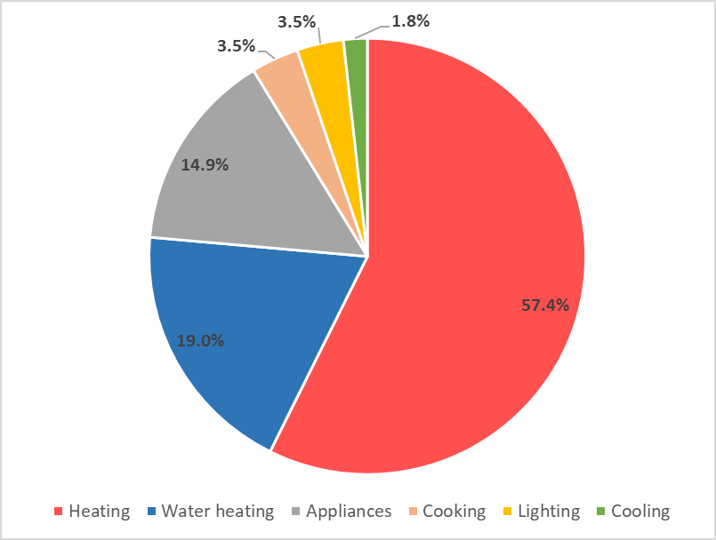

In Victoria, energy use for both heating and water heating is currently dominated by gas (mainly natural gas), as is shown in Figure 2 [DoIS2015b]. Gas is estimated to account for 85.4% of all residential heating energy consumption, and 83.3% of all water heating energy consumption. Electricity currently accounts for only a small share (5.0%) of heating energy consumption, with wood accounting for the next largest share (9.6%). For water heating, electricity is estimated to account for 16.7% of energy consumption, with most of this being in the larger off-peak electric storage water heaters.

Figure 2: Breakdown of Victorian heating and water heating energy use, by fuel - 2018

|  |  |
| --- | --- |
| Heating | Water heating |

Figure 3 provides a breakdown of Victorian residential electricity and gas use into different key end-use areas. Gas use is dominated by heating (73.4%) and water heating (23.8%), with these two end-uses accounting for the clear majority (97.2%) of consumption. Refrigeration (18.4%), is the largest single area of electricity end-use, followed by lighting (12.4%), water heating (11.5%) and heating (10.3%) – collectively, these end-uses account for a little over a half (52.6%) of all electricity use. These areas of gas and electricity end-use are the key targets for energy efficiency upgrades, if the energy bill and greenhouse savings are to be maximised.

While “Other Appliances” and “IT and HE equipment[[12]](#footnote-13)” are also major areas of electricity end use, these categories aggregate electricity consumption by a range of individual appliances.

Figure 3: Breakdown of Victorian residential gas and electricity use - 2018

|  |  |
| --- | --- |
| Electricity | Gas |

* 1. Reducing heat losses and gains through the building shell

Improving the thermal efficiency of a house’s building shell reduces heat losses from the home during the heating season, and reduces heat entry into the home on warm summer days. It is a key way to reduce heating energy consumption, and will reduce cooling energy consumption if the house uses an air conditioner or evaporative cooler to stay comfortable on hot days. It can also significantly improve occupant comfort in both summer and winter, as well as reduce or eliminate the incidence of condensation and mould – improvements in both these areas can provide health benefits for the occupants.

The extent to which building shell improvements can increase comfort and reduce energy consumption depends on the efficiency status of the building shell. Houses that have no insulation are uncomfortable in both winter and summer and, especially during the winter months, can have high energy consumption and high heating bills. In this case, the installation of ceiling insulation is the highest priority upgrade measure. However, most Victorian houses already have at least some level of insulation installed on the ceiling, and they may also have sarking (reflective foil laminate) installed in the walls, meaning that different strategies need to be used to improve comfort and maximise the energy savings.

We have used a simple heat load calculator[[13]](#footnote-14) to explore the impact that the existing status of the house can have on winter heat losses, as well as on the potential impact of key building shell upgrades. The analysis is based on a house with a floor area of 130 m2 of either brick-veneer or weatherboard construction[[14]](#footnote-15) and a suspended timber floor, typical of many Victorian houses constructed prior to 1990. It is assumed that the house has a natural air leakage rate of 2 air changes per hour (ACH)[[15]](#footnote-16), consistent with the findings of the *On-Ground Assessment* study [SV2015]. For the modelling, the internal temperature profile of the house when heating is based on the average observed in the houses in this *Trial* (see Section 4.2.2), and the heating operating times were also based on the average operating heating operating profile for these houses (See Section 4.2.1)[[16]](#footnote-17).

Figure 4: Impact of building shell thermal efficiency on winter heat losses

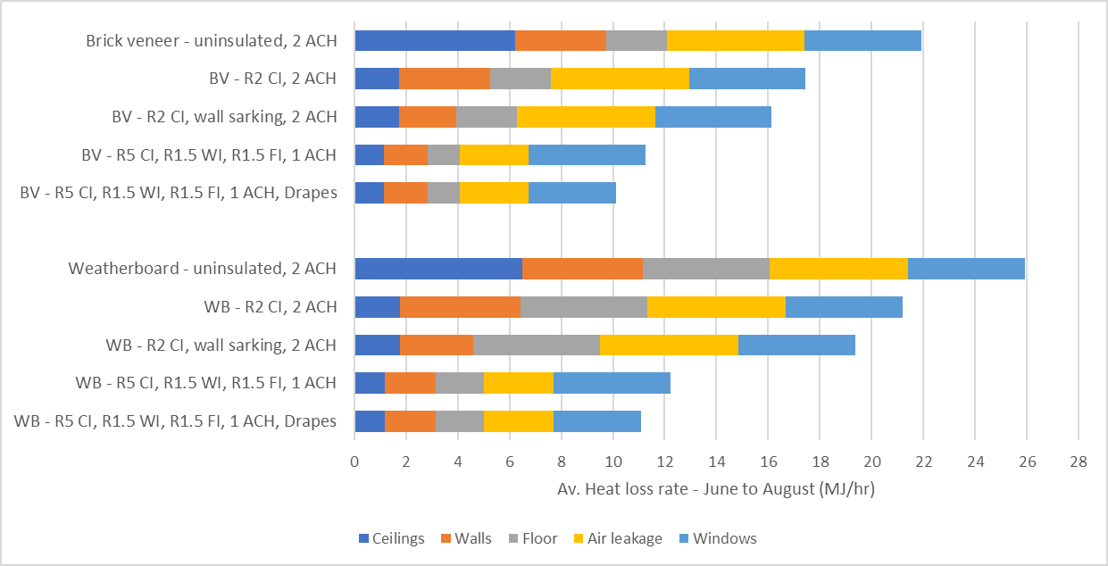

Note: BV = Brick-veneer and WB = weatherboard. For the upgrades: CI = ceiling insulation; WI = wall insulation; FI – floor insulation; ACH = air changes per hour; Drapes = thick drapes in a box pelmet.

Figure 4 shows how the average winter heat loss rate from the houses when the heating is operating – broken down into the different building elements - changes as they are progressively upgraded from a fully uninsulated state. As expected, the weatherboard house has a higher winter heat loss rate than the brick-veneer house, as it has a less efficient building shell. Both improve significantly as the various building shell elements are upgraded, either by adding thermal insulation[[17]](#footnote-18) or by reducing air leakage. The outputs of the modelling are also presented in Table 2, although here we look at the proportion of the total heat losses attributable to each building element.

* + 1. Ceiling insulation

Both Figure 4 and Table 2 show that if the house is totally uninsulated, most of the heat loss occurs through the ceiling, and this is therefore the key area to focus on to reduce heat losses. It is also one of the most cost effective energy efficiency upgrades, with an estimated average payback period of only 3.2 years if it is an easy installation, and 6.4 years if it is a difficult installation[[18]](#footnote-19) (See Table 1). Most Victorian houses already have some level of ceiling insulation; around R1.5 to R2.0 would be typical for older houses. The *OGA* study found that, of the sample of 60 pre-2005 houses, 45% had some uninsulated ceiling, 11.7% that could be easily insulated and 33.3% that were difficult to insulate. However, very few of these houses were *totally* uninsulated. Most had a certain proportion of their ceiling covered by insulation – often the older parts of the house were uninsulated, while a newer extension was insulated. The installation of even quite a low level of ceiling insulation (e.g. R2.0) significantly reduces the proportion of total heat losses which occur through the ceiling.

Table 2: Proportion of total winter heat loss through different building shell elements

|  |  |  |  |  |  |
| --- | --- | --- | --- | --- | --- |
| House / building shell scenario | Ceiling | Walls | Floor | Air leakage | Windows |
| **Weatherboard house – unenclosed sub-floor** |  |  |  |  |  |
| Uninsulated, 2 ACH | 25.1% | 18.0% | 18.9% | 20.6% | 17.4% |
| R2 ceiling insulation, 2 ACH | 8.4% | 22.0% | 23.1% | 25.2% | 21.3% |
| R2 ceiling insulation, wall sarking, 2 ACH | 9.1% | 14.7% | 25.3% | 27.6% | 23.3% |
| R5 ceiling insulation, R1.5 wall insulation & sarking, R1.5 floor insulation, 1 ACH | 9.5% | 16.3% | 15.3% | 21.9% | 37.0% |
| R5 ceiling insulation, R1.5 wall insulation & sarking, R1.5 floor insulation, 1 ACH, thick drapes & pelmet | 10.5% | 18.0% | 16.9% | 24.1% | 30.5% |
| **Brick-veneer house – enclosed sub-floor** |  |  |  |  |  |
| Uninsulated, 2 ACH | 28.4% | 16.0% | 10.7% | 24.4% | 20.6% |
| R2 ceiling insulation, 2 ACH | 10.0% | 20.1% | 13.4% | 30.6% | 25.9% |
| R2 ceiling insulation, wall sarking, 2 ACH | 10.8% | 13.6% | 14.5% | 33.1% | 28.0% |
| R5 ceiling insulation, R1.5 wall insulation & sarking, R1.5 floor insulation, 1 ACH | 10.1% | 15.0% | 11.0% | 23.7% | 40.1% |
| R5 ceiling insulation, R1.5 wall insulation & sarking, R1.5 floor insulation, 1 ACH, thick drapes and pelmets | 11.2% | 16.7% | 12.3% | 26.4% | 33.3% |

Where there is already a low level of ceiling insulation present, this could be “topped up” by adding further insulation, e.g. adding R3.0 to R3.5 insulation batts on top of the existing R2.0 batts. The impact of this is much smaller than when an uninsulated ceiling is insulated – in the example modelled for Figure 4 and Table 2, adding R3.0 insulation to an uninsulated ceiling in the weatherboard house reduces winter heat losses through the ceiling by 5.0 MJ/hr, while topping up R2.0 ceiling insulation to R5.0 reduces winter heat losses by only 0.6 MJ/hr, or 12% of the saving compared to the totally uninsulated case. This means that ceiling insulation top-ups are much less cost effective than insulating an uninsulated ceiling. SV’s *OGA* study found an average payback period of 15.6 years for ceiling insulation top-ups (see Table 1).

Some insulation installers recommend removing any existing insulation before adding new insulation, but this may not be necessary and will add considerably to the cost, making ceiling insulation top-ups even less cost effective. If the existing insulation is in reasonable condition, then simply adding insulation on top of this should be fine. Existing insulation should be removed if is wet or damp in areas, or has been damaged by rodents, possums or birds[[19]](#footnote-20).

Some houses may also have some insulation in the external wall cavity, in the form of “sarking”, often reflective foil laminate (RFL). This reduces heat losses through the wall to some extent, making air leakage, floor insulation and windows the best areas to focus on to reduce winter heat losses.

* + 1. Draught sealing

Reducing air leakage (or draughts) is one of the more cost effective building shell efficiency improvements, and has been studied in both the *On-Ground Assessment* study [SV2015] and the *Draught Sealing Retrofit Trial* [SV2016b]. The *Retrofit Trial* found that a comprehensive approach to draught sealing could reduce the air leakage of existing houses by around a half (54%) for an average commercial cost of $1,038, resulting in an average payback period of around 7.5 years. On average, the heating energy consumption was reduced by 10.5% in the houses. Costs and paybacks would be substantially lower if the draught sealing was undertaken as a DIY project [SV2016b].

There are many sources of air leakage in houses, and therefore many areas to address to significantly reduce air leakage[[20]](#footnote-21). In the *Draught Sealing* *Retrofit Trial*, the main areas to focus on were found to be general caulking of cracks and gaps, sealing ducted evaporative cooler outlet covers in winter, self-closing dampers for exhaust fans and vents, and sealing wall vents. Collectively, these were found to account for 80% of the reduction in air leakage that was achieved across the sixteen houses in the trial [SV2016b].

Caution needs to be used when applying comprehensive draught sealing to houses. While draughts can be uncomfortable and increase heating and cooling costs, a minimum level of ventilation is required in houses to maintain a healthy indoor environment. The natural air leakage that occurs in houses helps to remove water vapour and other internal air contaminants from the room air[[21]](#footnote-22). High levels of internal water vapour can lead to condensation problems in winter – which, in turn, can cause mould and mildew growth - and the build-up of gasses, toxins and pollutants can trigger respiratory heath issues. Ventilation is also important for summer cooling, replacing hot air inside the house with cooler outside air, especially at night or after a cool change.

In all houses, it is important to have *controlled ventilation* – operable windows, doors, vents, exhaust fans or hoods – which allow adequate ventilation to be provided *when* and *where* it is required. Adequate controlled ventilation should be provided for all cooking, bathroom and laundry areas, and any other areas with high moisture loads, to expel warm, moist air at its source when these areas are being used. The provision of openable windows that provide good cross-ventilation during summer months is also important for occupant comfort.

Special care needs to be taken in houses which have internal gas appliances, especially houses which have unflued gas heaters[[22]](#footnote-23), a gas heater installed in a chimney, or an open flued gas heater. All unflued gas appliances require a certain amount of *fixed* ventilation to expel the products of combustion from the home and to operate safely. Open flue gas heaters – which draw combustion air from the room in which they are located – also require an adequate supply of fresh room air to operate safely. The fixed ventilation openings required for unflued and open flue gas heaters must never be blocked. Draught sealing should not be undertaken in houses that have these types of heating, or other indoor gas appliances (e.g. internal open flued gas water heater or internal gas ducted heater), unless a licensed gas fitter checks that it is possible to operate the gas appliances safely. If there are exhaust fans present in the house, this check should also consider how the operation of the fans impacts on the operation of the gas appliances. It is recommended that gas appliances are serviced at least every 2 years by a licensed gas fitter, and that carbon monoxide checks are undertaken at this time. Further information on these issues, and on the safe operation of gas appliances, is provided by Energy Safe Victoria[[23]](#footnote-24).

In recent years, a specific safety issue associated with open flue gas heaters operated in conjunction with exhaust fans has been identified. Inadequate ventilation and the use of exhaust fans can create a negative pressure that draws carbon monoxide (and other exhaust gases) back into the house under certain circumstances. Similar issues can arise when an open flue gas heater is installed in a chimney, if holes in the mortar or brickwork stop the chimney drawing properly. Carbon monoxide is an odourless and poisonous gas that can cause serious health issues and death.

Energy Safe Victoria advise that open flue gas heaters are not compatible with houses that have been sealed to a high level of air tightness, either existing houses or new ones[[24]](#footnote-25). In this case, room sealed gas heaters – which have a combustion circuit which is completely sealed from the living area of the house, and which draw their combustion air from outside – or an efficient form of electric heating such as a reverse-cycle air conditioner could be used as an alternative.

* + 1. Underfloor insulation

Uninsulated suspended floors can be a significant source of winter heat loss, especially in houses that have an unenclosed sub-floor space[[25]](#footnote-26) - this means that the ambient air temperature under the floor is the same as the outside air temperature, and that the sub-floor space is exposed to the prevailing winds, increasing both the heat losses and air leakage. This is usually the case for weatherboard houses, and can also be the case for brick-veneer houses.

Uninsulated suspended floors are also a source of heat gain on hot summer days when the outside air temperature is higher than the internal temperature and, as in winter, this is made worse if the sub-floor space is unenclosed. However, an uninsulated floor also helps to cool the house in summer when the outside air temperature is lower than inside the house. This means that to maintain summer comfort, it is important that floor insulation is used as part of a comprehensive upgrade package that includes (at least), well-insulated ceiling and well shaded east, north and west facing windows, and provision for good cross-ventilation when outside air temperatures are lower. Well-insulated external walls will also help.

The installation of under-floor insulation is one of the less cost-effective building shell upgrade measures, although it is more cost effective for houses that have central heating, especially if they have an unenclosed sub-floor space. The *OGA* study estimated that the average cost of installing under-floor insulation was around $1,963, and the average payback on the energy savings was 18.6 years (see Table 1); the payback was 18.3 years for houses with central heating and 19.9 years for houses with room heating[[26]](#footnote-27). The winter heat loss rate through the floor when the sub-floor space is unenclosed is a about twice as high as when the sub-floor space is enclosed, and the reduction in heat losses when insulation is installed is about 2.8 times higher[[27]](#footnote-28).

Space restrictions will affect the type of insulation that can be installed, as well as the cost of installing it. Where access is easy and there is sufficient clearance under the floor, a range of insulation products can be installed, including insulation batts, boards or blankets, spray-on foam, reflective foil laminate, concertina reflective foil batts, or a combination of these products. Where there is insufficient space for a person to gain access to the sub-floor space it may be possible to have an expanding foam insulation product sprayed under the floor-boards[[28]](#footnote-29), although costs are likely to be higher.

* + 1. Wall insulation

Most Victorian houses constructed prior to 1990 have either no insulation in their external wall cavity, or only wall sarking (usually reflective foil laminate), making the external walls a significant source of winter heater losses, as well as a significant source of heat gains on hot summer days[[29]](#footnote-30). SV’s *On Ground Assessment* study found that 95% of the 60 houses involved in the study would benefit from the installation of wall insulation [SV2015].

There are several ways of adding insulation to the external wall cavity of an existing house, the most common in Victoria being pump-in cavity wall insulation, usually either hydrophobic (water repellent) granulated rockwool or expandable foam. The level of insulation (or R-value) that can be installed depends on the width of the wall cavity and the thermal properties of the insulation material, the way in which the insulation is installed[[30]](#footnote-31), and the extent of coverage that can be achieved. The insulation is pumped into the wall cavity, with access being gained either through the roof by lifting the tiles or roofing iron (less common) above the wall cavity, drilling small holes through the external wall cladding, or drilling small holes through the internal wall lining. In houses with brick-veneer or cavity brick walls, individual bricks can be removed to provide access to the wall cavity, and replaced afterwards. A combination of both methods may also be used, as holes need to be drilled through walls to install insulation under windows. Where holes are drilled in external or internal walls, they need to be patched up afterwards, and this can have some visual impact on the house. Care needs to be taken to match the mortar or paint to the existing house.

The cost and impact of installing granulated rockwool insulation was investigated in SV’s *Cavity Wall Insulation Retrofit Trial* [SV2016c][[31]](#footnote-32). In this study, the average cost of installing the insulation in the 15 participating houses was $4,286, making this quite an expensive upgrade measure. From monitoring the houses, it was estimated that the insulation reduced heating energy consumption by around 15.5%, giving a 29.4-year payback on the investment, based only on the heating energy saving[[32]](#footnote-33). As is the case for other building shell upgrades, the overall energy saving will be larger, and the payback period shorter, where a house has central heating rather than room heating[[33]](#footnote-34).

The installation of granulated rockwool requires a wall cavity that is wide enough to lower the installation hose to the bottom of the cavity, and for the hose to deliver the insulation effectively. A minimum cavity width of around 40 mm is required. This is usually not a problem with brick-veneer and weatherboard walls, but can be an issue for cavity brick (also known as double-brick) walls. The wall cavity must also be free of obstructions, such as mortar scraps in a cavity brick wall, or pieces of timber or extra wide noggins in a framed timber wall [SV2016c].

The insulation needs to be installed properly, and good coverage needs to be achieved, for the pump-in cavity wall insulation to realise its full energy saving potential. Insulation needs to be installed both under and above windows, and in brick-veneer walls insulation batts need to be installed against the internal wall lining above the top of the brickwork to supplement the insulation pumped into the cavity[[34]](#footnote-35). There are a range of issues that can make sections of walls difficult, or impossible, to insulate: water tanks located against walls; pipes and cables in the walls; wasp nests obstructing the wall cavity; roof access issues caused by solar water heater panels or photovoltaic (PV) panels; and housing characteristics, such as an intersecting eave from an adjoining wall [SV2016c].

It can be difficult to verify that pump-in cavity wall insulation has been installed correctly. Thermal imaging cameras can be used to give an indication of the level of coverage achieved, although the conditions under which the imaging is undertaken are important[[35]](#footnote-36), the operator needs to be experienced, and a good quality camera needs to be used [SV2016c].

Other approaches to insulating existing external walls are possible:

* Weatherboard walls can be insulated by removing some of the external boards, to allow insulation batts to be installed between the wall studs, and replacing them afterwards;
* All types of walls can be insulated by fixing foam insulation boards to the outside of the wall, and rendering them;
* All types of walls can be insulated by fixing foam insulation boards to the internal lining of the external walls (e.g. inside the house), and covering them with plasterboard. This will reduce the house’s internal floor area to some extent. Some companies manufacture plasterboard sheets that are pre-bonded to foam board insulation[[36]](#footnote-37).

The alternative approaches described above are likely to have similar costs to the pump-in cavity wall insulation. Where insulation is added to the outside or inside of the external wall, or where the external wall cladding is removed to install insulation, it should be possible to ensure good insulation coverage.

Opportunities can also arise during a major renovation of an existing brick-veneer or weatherboard house. In this case, the internal wall linings of some external walls may be removed as part of the renovation. For example, upstairs additions may require structural support to be added to the existing ground floor walls, requiring the removal of the wall linings from some sections of the external wall. This provides an easy and lower cost opportunity to insulate any uninsulated wall sections, prior to the internal wall cladding being replaced.

In all cases where insulation is to be installed into an external wall cavity that contains electrical wiring, it is important that the wiring is inspected by a licensed electrician, to ensure that it is suitable to be covered with insulation[[37]](#footnote-38). This may mean that the current carrying capacity of the wiring that will be covered needs to be de-rated, and this may require some modifications at the switchboard such as reducing the rating of the circuit breakers.

* + 1. Window treatments

Windows can be a major source of winter heat losses in existing houses, especially where there are no window coverings or where only venetian blinds, vertical blinds, Holland blinds, or lightweight curtains with no boxed pelmet[[38]](#footnote-39) are used. This is especially the case where houses already have some ceiling insulation and/or are more airtight than typical existing houses.

There are a range of approaches to improving the thermal performance of existing windows to reduce winter heat losses, including[[39]](#footnote-40) [SV2017b]:

* Installing thick, close-fitting drapes housed in a boxed pelmet. The drape, in conjunction with the boxed pelmet, creates a still air gap between the window, and this can provide an insulating effect similar to double-glazing when the curtains are closed. The effectiveness of this approach depends on how well the curtains are installed, and how they are utilised by the house occupants;
* Shutters can be installed on the inside or outside (e.g. roller shutters) of the windows. For maximum impact on reducing heat losses, they need to fit tightly against the window frame with no gaps between any louvres, so that they create a still airgap between the shutter and the existing windows. The construction of the shutters would also have to ensure that there was little thermal bridging across the shutter material;
* Low emissivity (low-e) window films can be applied to the inside of single-glazed windows. This film has a special coating that reflects radiant heat back into the room, reducing heat losses. The improvement achieved depends on the particular film which is used, but typically would be around 10% to 20% compared to a single-glazed window;
* Secondary glazing - an additional pane of glass or clear acrylic can be fitted to an existing single glazed-window to form a double-glazed window within the existing window frame. The effectiveness of this approach will depend on the spacing between the panes of glass (13 to 16 mm is optimal) and how air tight it is, as well as on the thermal properties of the window frame. In the best cases, this will have an insulating effect as good as new double-glazing of the same frame type. A relatively cheap approach to secondary glazing is to apply heat shrink window film to the existing window frame to form the still air gap. In this case, the performance is unlikely to be as good as dedicated secondary glazing[[40]](#footnote-41), and it is unlikely to be as durable. The film can be installed professionally, and is also available in DIY kits;
* Replacing existing windows with new double-glazed windows. The choice of good double-glazed windows with wood, PVC or thermally improved aluminium window frames will result in the greatest improvement in the thermal performance of the windows, however this is likely to be very expensive[[41]](#footnote-42). Where existing windows are to be replaced anyway, because they have deteriorated or will be updated as part of a major renovation project, this can be a much more cost-effective approach, as the additional cost is only the cost difference between the double-glazed windows and the single-glazed windows which would have been used as a replacement.

Most approaches to improving the thermal performance of existing windows are quite expensive, and have a reasonably long payback period. SV’s *OGA* study estimated an average payback period of 209 years for replacing existing windows with new double-glazed windows, and 37 years for installing thick drapes and pelmets (based on typical commercial costs). The installation of secondary glazing is much cheaper than double-glazing - around 50% to 60% of the cost - suggesting an average payback period of 105 to 125 years for this upgrade. Installation of the heat shrink window film is much cheaper again, especially if this is undertaken as a DIY project[[42]](#footnote-43). [SV2015] SV’s trial of heat shrink window film found an average payback period of 14.6 years based on commercial installation rates, and only 2.4 years if the film was installed as a DIY project. However, the average heating energy saving found in this trial was only 3.7%, lower than the 5% to 7% saving expected from double- or secondary-glazing. [SV2017b]

Good external shading on east, north and west facing windows is also important for summer comfort, and for reducing cooling energy costs where a house has air conditioning.

* 1. Other key energy saving opportunities

In addition to the various building shell upgrades – which improve comfort *and* save energy – there are a number of appliance and equipment upgrades that can have a significant impact on energy consumption and energy bills: heating; water heating; refrigeration; and, lighting.

* + 1. Heating

Heating is the single largest area of energy consumption in Victorian houses. It is estimated to account for 57.4% of all residential energy consumption, 73.4% of residential gas consumption, and 10.3% of residential electricity consumption [DoIS2015b]. This means that in addition to improving the efficiency of a house’s building shell to reduce the winter “heating load”, upgrading to a more efficient heating system can also provide significant energy savings.

Data on the main type of heating system installed in Victorian houses is shown in Figure 5. These figures are SV estimates, based on the *ABS4602 Environmental Issues* series of reports[[43]](#footnote-44). Gas central heating systems (mainly ducted systems) are the dominant type of heating, and currently have a 42.5% share of the heating installed. Gas room heating is currently the other main type of heating installed (21.5% in 2018), but has a rapidly declining share, largely due to the increasing share of room reverse-cycle air conditioners used as the main form of heating (13.0% in 2018). The share of wood (9.1% in 2018) and room electric resistance heating[[44]](#footnote-45) (8.8% in 2018) are about the same, and both are declining slowly. Ducted reverse-cycle air conditioning accounts for a low share of the installed heating (3.0% in 2018), although this share is slowly growing – this is likely to be due mainly to the new house and apartment market. There is also a small amount of central electric heating installed (1.9% in 2018) – mainly in slab electric heating – but this share is also declining.

Figure 5: Main type of heating used in Victorian houses

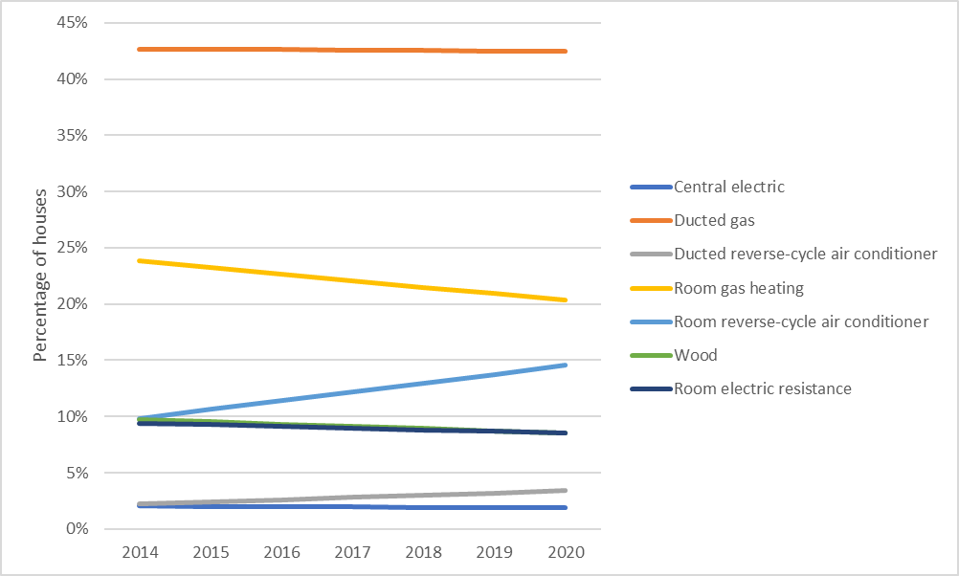

SV’s *OGA* study explored the impact of replacing heating systems in existing houses with new high efficiency heating systems[[45]](#footnote-46). Overall, heating system upgrades were found to be a cost-effective efficiency upgrade, with an average payback period of 6.8 years (see Table 1). The largest energy and energy bill savings were achieved for the gas ducted heating system upgrades; these had an estimated average payback of 5.4 years based on current energy tariffs. Gas room and room reverse-cycle air conditioners had lower energy savings and a longer average payback period, 12.2 years and 55.8 years[[46]](#footnote-47) respectively. Upgrading electric panel heaters to reverse-cycle air conditioners was the most cost-effective upgrade option, with an average payback period of only 3.7 years. This is due to their relatively high electricity consumption (for a room heater), and the higher cost of electricity.

The *Victorian Energy Upgrades[[47]](#footnote-48)* scheme provides a range of incentives that reduce the cost of upgrading from an inefficient, greenhouse-intensive, heating system to a new high efficiency option, reducing running costs and greenhouse gas emissions. This includes replacing in-slab electric heating, ducted gas and reverse-cycle air conditioners, gas room heaters, room reverse-cycle air conditioners, and electric resistance heating. The incentive reduces the cost of the upgrade, and therefore the payback period.

Ducted heating systems, of both the gas ducted and reverse-cycle ducted type, have further potential for energy savings if old heating ductwork is upgraded to new well-insulated ductwork. SV’s *Gas Heating Ductwork Retrofit Trial* [SV2016d] investigated the costs and savings when replacing old ductwork with new high efficiency ductwork in a sample of 8 houses. It found that older ductwork was often poorly insulated, and could have holes and tears in the outer sleeve of the ductwork, resulting in significant heat losses through the ductwork. Based on monitoring undertaken during the trial, it was estimated that this upgrade gave average heating energy savings of around 14%, resulting in an average payback of 13.1 years (see Table 1). Replacing existing ductwork with new efficient ductwork can be quite expensive – the average cost in the trial was $2,774 – although this upgrade is eligible for an incentive through the *Victorian Energy Upgrades* scheme.

A clear trend of room reverse-cycle air conditioners (RACs) replacing gas room heaters is already evident, and seems likely to continue. The most efficient room RACs can have heating costs that are lower than the most efficient gas room heaters[[48]](#footnote-49), although currently their greenhouse gas emissions are a bit higher if standard mains electricity is used. This situation will change over the coming decade, as the contribution of renewable sources to the electricity supply progressively increases. Also, where houses install photovoltaic (PV) systems to generate electricity, it may be possible to pre-cool the house in summer and pre-heat the house in winter using the PV output during the middle of the day, and thereby reduce overall cooling/heating costs. The installation of a battery in conjunction with the PV system, increases the chance of using the PV generated electricity to power the air conditioner.

* + 1. Water heating

Water heating is the second largest area of energy consumption in Victorian houses, making it another key focus area for energy savings. It is estimated to account for 19.0% of all residential energy consumption, 23.8% of residential gas consumption, and 11.5% of residential electricity consumption [DoIS2015b].

One simple way to reduce water heating energy consumption is to reduce the amount of hot water used, either via behavioural changes – taking shorter showers, using the cold-wash cycle on the washing machine – or via equipment upgrades, such as installing a low-flow shower rose, an energy efficient washing machine or an energy efficient dishwasher. Where the existing shower rose is not of a low-flow type, replacing it with a low flow shower rose with a flow rate of less than 9 litres per minute is a very cost effective measure, as it reduces both energy and water costs. The *OGA* study estimated an average payback period of only 0.7 years for this upgrade, the lowest for all measures considered in this study [SV2015].

Data on the main type of water heating system installed in Victorian houses is shown in Figure 6. These figures are SV estimates, based on the *ABS4602 Environmental Issues* series of reports[[49]](#footnote-50). Gas water heating systems are the dominant type, and are estimated to currently account for around 64.1% of all residential water heating systems, with this share slowly declining. Most of these (around 51%) are gas instantaneous water heaters, with gas storage water heaters estimated to account for 49% - this share has declined significantly over the last decade, and is expected to continue to do so [DEE2018]. Gas instantaneous water heaters tend to be somewhat more efficient than gas storage water heaters at average household hot water use levels, and especially so for smaller households (2 people or less). This is due to the fixed “standing losses” (heat losses through the walls of the storage cylinder) of gas storage water heaters, which mean that their efficiency reduces significantly as daily hot water use decreases [SV2016f][[50]](#footnote-51).

Figure 6: Main type of water heating installed in Victorian houses

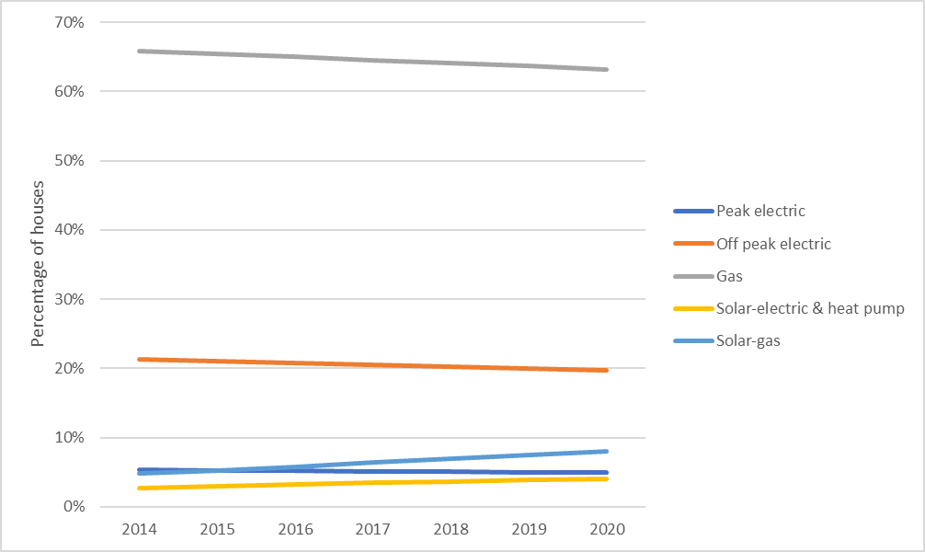

Electric storage water heaters are the next main type, accounting for around 25.4% of water heaters – 20.3% being the larger electric off-peak storage water heaters, usually located outside, and 5.1% being the smaller peak electric water heaters, usually located inside in a cupboard. These tend to be more prevalent in regional Victoria in areas without reticulated natural gas. Both types of electric water heaters can have high annual running costs and greenhouse gas emissions, although the smaller peak electric water heaters tend to have the highest annual running cost because they are run on the more expensive peak electricity tariff[[51]](#footnote-52). As with gas storage water heaters, electric storage water heaters have standing losses, meaning that their efficiency decreases as the level of hot water use declines. Significant energy and energy bill savings are possible when the electric water heaters are replaced by a lower running cost, lower greenhouse, option such as heat pump, solar or high efficiency gas. However, it can be difficult to replace the small peak electric water heaters located inside, especially in flats and apartments, making off-peak electric water heaters the key upgrade target.

Water heaters that use renewable energy in some way account for the remaining share of the installed water heaters: - gas-boosted solar (6.9%), and electric-boosted solar and heat pump (3.7%)[[52]](#footnote-53). The share of these types of water heaters has been increasing, especially gas-boosted solar water heaters, due to Victorian requirements for new homes that have been in place since the mid-2000s. This largely explains the declining share of the “conventional” gas and electric water heater types.

SV’s *OGA* study explored the impact of replacing existing gas or electric water heaters with a lower running cost option [SV2015]. These households mainly had gas water heaters, and only a few had off-peak electric storage water heaters. All houses with an electric water heater also had reticulated gas. The most cost-effective option for upgrading the gas and electric water heaters was found to be high efficiency gas – it was assumed that storage water heaters were replaced with a high efficiency gas storage water heater, and gas instantaneous systems with a high efficiency gas instantaneous unit. The average payback period for the upgrade was 7.7 years, based on current energy tariffs (see Table 1). As expected, upgrading the electric off-peak storage water heater was the most cost effective option (average payback of 5.0 years), followed by the gas storage water heater (9.2 years) and the gas instantaneous water heater (10.9 years).

The *Gas Water Heater Retrofit Trial* [SV 2016f] investigated the costs and energy savings when existing gas storage water heaters were replaced with new high efficiency water heaters at 6 houses – in 5 of the houses the replacement was a 5 Star gas storage water heater, and at one house a 6 Star gas instantaneous water heater was used as the replacement. The average cost of the upgrade was $2,061, and the average payback was 26.3 years, *if based on the full upgrade cost*. In practice, most upgrades are undertaken at the end of life of the existing water heater – in this case the additional cost of the high efficiency water heater would be only $806, and the average payback 10.3 years. In this trial, the new gas instantaneous water heater performed better than the 5 Star gas storage water heaters, as it maintained a high level of efficiency over most of its operating range.

The *OGA* study also considered the alternative of replacing the gas and electric water heaters with a gas boosted solar water heater. Based on current energy tariffs, this study found an average payback period of 18.9 years for this upgrade: - 9.5 years where an electric storage water heater was replaced, 19.1 years where a gas storage water heater was replaced, and 31.1 years where a gas instantaneous water heater was replaced [SV2015].

Significant financial incentives are available to replace existing water heaters with a new high efficiency, low greenhouse option, through both the Small-scale Technology Certificate (STC) scheme[[53]](#footnote-54) and the *Victorian Energy Upgrades* *(VEU)* scheme[[54]](#footnote-55). STCs provide incentives for installing a solar or heat pump water heater in either an existing or a new house. The *VEU* scheme provides an additional incentive where an existing electric storage water heater is replaced with either a high efficiency gas, heat pump, solar-electric or solar-gas water heater, and where an existing gas water heater is replaced by a high efficiency solar-gas water heater. Both schemes are based on certificates, with the higher efficiency (STCs) or lower greenhouse (*VEU*) upgrades generating the most certificates. The value of the financial incentive depends on the market value of these certificates, and where both the STC and VEU scheme apply, the value of the incentive can be quite high. This significantly reduces both the cost to the householder and the payback period. In Victoria, this makes the replacement of an electric storage water heater with either a high efficiency heat pump or high efficiency gas water heater a very cost-effective upgrade option.

* + 1. Refrigeration

Refrigeration (fridges and freezers) is the single largest electrical end-use in Victorian houses. While it accounts for only 5.1% of overall residential energy consumption, it accounts for 18.4% of residential electricity consumption [DoIS2015b].

Significant energy savings are possible when old family-sized refrigerators are replaced with a new high efficiency refrigerator. SV’s *Refrigerator Retrofit Trial* [SV2017a] looked at the costs and savings when existing refrigerators were replaced with new high efficiency models at 7 houses. The average energy consumption of the existing refrigerators was 913 kWh per year (the highest was 1,292 kWh per year), and this was reduced to 298 kWh per year after they were replaced by high efficiency models, an energy saving of 615 kWh per year (67.4%). The average cost of the new refrigerators was $2,123, giving a payback period of 12.5 years if based on the full replacement cost. As with heaters and water heaters, this replacement is most likely to take place at or near the end of life of the existing refrigerator; in this case the cost of upgrading to a high efficiency model is only $637, reducing the payback period to 3.8 years.

* + 1. Lighting

Lighting is another significant area of electrical end-use in Victorian houses. It accounts for around 3.5% of total residential energy consumption, and 12.4% of residential electricity consumption [DoIS2015b].

Replacing any inefficient incandescent or halogen light globes with efficient LED or compact fluorescent lamps (CFL) can reduce the energy consumption of the light globes by around 80%. In recent times, very efficient LED lamps have become available, and these can generate energy savings when they replace CFL lamps.

Mains voltage, or extra low voltage (12 volt) halogen downlight lamps, also provide a good energy saving opportunity when they are replaced with efficient LED lamps. These are often used in the living areas of houses – where the daily usage of lighting is higher – and are installed at a higher density than incandescent light globes. SV’s *Halogen Downlight Retrofit Trial* [SV2016a] looked at the costs and savings when replacing 12-volt halogen downlights in the living areas of 16 houses. In the 12 houses where an LED lamp was used as a replacement energy savings of 80% were achieved, even though the light levels increased. This trial was undertaken in 2011 and 2012, and the cost of LED lamps has decreased significantly since then.

Some care needs to be taken when upgrading halogen downlight lamps to an LED lamps, as the size and shape of the replacement lamp may not be compatible with the existing downlight fitting and, in the case of the 12-volt downlight lamps, the LED lamp may not be electronically compatible with the existing transformer (or electronic converter). The replacement lamp needs to be chosen carefully, and it is advisable to trial a few lamps first to check their compatibility, before implementing a full-scale upgrade. Detailed information on the compatibility issues that can arise when halogen downlights are replaced is provided in the *Retrofit Trial* report [SV2016a].

In Victoria, residential lighting has undergone a very significant transformation since 2009, due to the *Victorian Energy Upgrades* scheme. This led initially to a large-scale replacement of incandescent light globes with CFLs (and some LEDs), and more recently to a large-scale replacement of halogen downlights with LEDs, most undertaken at no or little cost to the households. In December 2018, a new measure was introduced into the scheme which will provide an incentive to replace CFL light globes with very high efficiency LED lamps.

* 1. Interaction of energy efficiency upgrades

To achieve significant comfort improvements in existing houses, and therefore significant energy savings, a comprehensive approach to energy efficiency upgrades is required, including air sealing, insulation of uninsulated or poorly insulated building elements, as well as a heating system upgrade. However, it needs to be kept in mind that the various upgrades can interact, so that the total energy saving achieved is somewhat less than might be assumed from the impact of the individual upgrades used.

One important area of interaction is between the building shell upgrades and the heating system upgrades. For example, a fairly comprehensive package of building shell upgrades to a weatherboard house might result in a 40% reduction in the house’s heating load, and upgrading a ducted heater in this house might result in a further 20% energy saving. However, if this was implemented as a retrofit package, the overall energy saving would be expected to be 52%[[55]](#footnote-56), and not 60%.

In practice, the theoretical energy saving is unlikely to be achieved, due to installation issues. For example, complete coverage might not be achieved when the insulation is installed. Also, if part of the ceiling or external walls are already insulated, the energy savings achieved from insulating the uninsulated parts will not be as large as if the house was fully uninsulated prior to the retrofits.

Other examples of interactions between energy efficiency upgrades occur where water efficiency measures, which reduce hot water use (e.g. low flow shower rose), are implemented at the same time as water heater upgrades.

A detailed discussion of the interaction between energy efficiency upgrades is provided in the *OGA* study report [SV2015][[56]](#footnote-57).

1. Results of the Comprehensive Retrofit Trial
   1. The housing sample

A total of 14 houses participated in the *Comprehensive Retrofit Trial*. A summary of the key energy consumption characteristics of these houses is provided in Table 3, and a summary of the building shell characteristics of the houses prior to the retrofits is shown in Table 4. More detailed information on the houses, and the households that participated in the trial, is provided in the individual case study write-ups in Appendices 1 to 14.

The houses ranged in size from a floor area of 70 m2 to 235 m2, with the average floor area being 132 m2; the number of occupants ranged from 2 to 7 people, with the average being 3.9 people. All houses used both electricity and natural gas, and all except one of the houses had gas ducted heating as the main form of heating; the other house used a room reverse-cycle air conditioner. Similarly, most houses had a gas storage water heater, and only two used an electric storage water heater. Six of the houses had a rooftop photovoltaic (PV) system installed to generate electricity – this is higher than the current Victorian average.

The average annual gas consumption of the houses was 70,196 MJ per year, and the estimated annual average gas use for heating was 50,712 MJ per year (72%)[[57]](#footnote-58). The fairly high annual gas consumption and annual gas use for heating reflects the high incidence of gas ducted heating found in these houses and the inefficient nature of the houses’ building shells, as well as the use of gas storage water heating. The estimated annual electricity consumption of the houses was 4,655 kWh per year. The gas consumption of the houses was well above the Victorian average for a four-person household, although the electricity consumption was lower than the average[[58]](#footnote-59).

For the houses that had gas ducted heating, the average annual gas consumption was 74,566 MJ per year, with an average of 54,613 MJ per year (73.2%) used for heating.

Table 3: Key energy consumption characteristics of the *Comprehensive Retrofit Trial* houses

|  |  |  |  |  |  |  |  |  |  |
| --- | --- | --- | --- | --- | --- | --- | --- | --- | --- |
| House | Floor area (m2) | No. of people | Main heating type | Main water heating type | Gas consumption | | | Elec. Consumption (kWh/yr) | PV system installed? |
| Total (MJ/yr) | Heating (MJ/yr) | % Heating |
| CR1 | 176 | 7 | Gas ducted | Gas storage | 150,038 | 111,012 | 74% | 6,647 |  |
| CR2 | 216 | 4 | Gas ducted | Gas storage | 85,686 | 56,566 | 66% | 6,880 | Yes |
| CR3 | 235 | 4 | Gas ducted | Gas storage | 63,591 | 46,538 | 73% | 3,389 | Yes |
| CR4 | 98 | 2 | Gas ducted | Gas storage | 69,781 | 40,916 | 59% | 3,686 |  |
| CR5 | 80 | 3 | Room split system | Gas storage | 13,375 | - | - | 5,756 |  |
| CR6 | 122 | 4 | Gas ducted | Gas storage | 111,384 | 78,259 | 70% | 3,107 |  |
| CR7 | 126 | 3 | Gas ducted | Gas storage | 62,201 | 42,494 | 68% | 3,390 | Yes |
| CR8 | 130 | 5 | Gas ducted | Gas storage | 67,698 | 51,120 | 76% | 3,560 |  |
| CR9 | 122 | 4 | Gas ducted | Electric storage | 55,756 | 55,643 | 100% | 9,180 |  |
| CR10 | 174 | 5 | Gas ducted | Gas storage | 84,968 | 50,110 | 59% | 5,180 | Yes |
| CR11[[59]](#footnote-60) | 70 | 2 | Gas ducted | Electric storage | 30,269 | 32,707 | - | 5,443 |  |
| CR12 | 80 | 4 | Gas ducted | Gas storage | 62,840 | 47,458 | 76% | 1,100 | Yes |
| CR13 | 114 | 4 | Gas ducted | Gas storage | 70,600 | 59,396 | 84% | 5,740 |  |
| CR14 | 101 | 3 | Gas ducted | Gas storage | 54,552 | 37,752 | 69% | 2,110 | Yes |
| Average | 132 | 3.9 |  |  | 70,196 | 50,712 | 72% | 4,655 |  |

Most of the houses had brick-veneer walls (10); only three had weatherboard walls, and one had cavity-brick (or double-brick) walls. In general, the external walls were uninsulated, although three of the houses with brick-veneer construction had RFL (reflective foil laminate) in the walls. Most of the houses had tiled roofs (10), with the others being covered in corrugated iron or metal sheeting of some type. Only one of the houses had an uninsulated ceiling; all the rest had some insulation on the ceiling, although for most houses the insulation level was quite low (only R1.5 to R2.0), and there may have been gaps and poor coverage in some areas. Most houses (11) had suspended timber floors, and most of these were uninsulated; two of the houses had insulation installed under the floor, mainly in the living areas. The three concrete slab-on-ground floors were uninsulated. The average natural air leakage rate of the houses was 1.45 air changes per hour (ACH), lower than the average air leakage rate of the houses in SV’s *OGA* study.

Table 4: Building shell characteristics of the *Comprehensive Retrofit Trial* houses

|  |  |  |  |  |  |  |  |  |  |
| --- | --- | --- | --- | --- | --- | --- | --- | --- | --- |
| House | Floor area (m2) | Decade house built | Ceiling / roof | | External walls | | Floor | | Air leakage rate (ACH) |
| Type | Insulation | Type | Insulation | Type | Insulation |
| CR1 | 176 | 2000 | Metal | R2.0 | Brick veneer | RFL | Slab on ground | None | 0.99 |
| CR2 | 216 | 1990 | Tiled | R1.5 | Brick veneer | None | Suspended timber | None | 0.83 |
| CR3 | 235 | 1990 | Tiled | R2.5 | Brick veneer | RFL | Slab on ground | None | 0.87 |
| CR4 | 98 | 1970 | Tiled | R2.0 | Brick veneer | None | Suspended timber | None | 0.86 |
| CR5 | 80 | 1980 | Metal | None | Cavity brick | None | Slab on ground | None | 1.57 |
| CR6 | 122 | 1920 | Metal | R1.0, poor coverage | Weather-board | None | Suspended timber | None | 1.88 |
| CR7 | 126 | 1910 | Metal | R3.2 | Weather-board | None | Suspended timber | None | 1.20 |
| CR8 | 130 | 1940 | Tiled | R2.0 | Brick veneer | None | Suspended timber | None | 1.89 |
| CR9 | 122 | 1950 | Tiled | R1.5 to R2.0 | Weather-board | None | Suspended timber | Living areas | 2.09 |
| CR10 | 174 | 1980 | Tiled | R3.0 | Brick veneer | RFL | Suspended timber | None | 1.02 |
| CR11 | 70 | 1970 | Tiled | R2.0, gaps | Brick veneer | None | Suspended timber | 10m2 insulated | 2.10 |
| CR12 | 80 | 1950 | Tiled | R2.5 | Brick veneer | None | Suspended timber | None | 2.30 |
| CR13 | 114 | 1960 | Tiled | R2.0 | Brick veneer | None | Suspended timber | None | 1.70 |
| CR14 | 101 | 1960 | Tiled | R4.0 in some areas | Brick veneer | None | Suspended timber | None | 0.98 |
| Average | 132 |  |  |  |  |  |  |  | 1.45 |

* 1. Retrofits undertaken at the houses

Information collected from site surveys of the houses was used to identify a package of comprehensive retrofit measures, with the key aims being to improve the thermal comfort of the houses during winter months and to reduce their heating energy consumption – this meant that the highest priority retrofits were building shell and heating system upgrades. The target cost of the retrofit package was around $12,000 to $13,000, and the final package was negotiated and agreed with the householders and Sustainability Victoria before implementation. Where there were sufficient funds available after the building shell and heating system upgrades were accounted for, consideration was given to lighting, water heating and refrigeration upgrades.

Table 5: Retrofits undertaken and retrofit costs for the *Comprehensive Retrofit Trial* houses

|  |  |  |  |  |  |  |  |  |  |  |  |
| --- | --- | --- | --- | --- | --- | --- | --- | --- | --- | --- | --- |
| House | Draught Sealing | Ceiling Insul. Top Up | Ceiling Insul. | Wall Insul. | Floor Insul. | Ducted Heater | Duct | Water heater | Lights | Fridge | Total |
| CR1 | $1,114 | $2,657 | - | $4,056 | - | $2,321 | $2,246 | - | - | - | **$12,394** |
| CR2 | $1,328 | $1,822 | - | $5,210 | - | $3,120 | - | - | $695 | $2,149 | **$14,324** |
| CR3 | $1,290 | $1,386 | - | - | - | $2,285 | $2,285 | $1,420 | - | $1,395 | **$10,061** |
| CR4 | $674 | - | - | $3,183 | $1,711 | $2,070 | $1,565 | $1,399 | - | - | **$10,602** |
| CR5 | $896 | - | $1,786 | $3,420 | - | - | - | $5,980 | - | $1,977 | **$14,059** |
| CR6 | $660 | $2,461 | - | $6,604 | - | $3,345 | - | - | - | - | **$13,070** |
| CR7 | $420 | - | - | $5,630 | $1,408 | - | $2,640 | - | $800 | $2,028 | **$12,926** |
| CR8 | $560 | $1,688 | - | $5,827 | $2,459 | $3,290 | $3,277 | $3,874 | $135 | - | **$21,110** |
| CR9 | $620 | $1,273 | - | - | $653 | $3,224 | $2,917 | $4,368 | - | - | **$13,055** |
| CR10 | $670 | - | - | - | $2,746 | $3,455 | $3,128 | - | $325 | $2,820 | **$13,144** |
| CR11 | $233 | $939 | - | - | $1,409 | $3,281 | $1,996 | $2,582 | - | $2,245 | **$12,685** |
| CR12 | $335 | $1,869 | - | $3,388 | $576 | $3,281 | $1,697 | - | $230 | - | **$11,376** |
| CR13 | $308 | $2,750 | - | - | - | $3,281 | $2,043 | - | $115 | $2,245 | **$10,742** |
| CR14 | $243 | - | - | $3,469 | $1,684 | $3,280 | $1,756 | $1,845 | $690 | - | **$12,967** |
| **Av.** | **$668** | **$1,872** | **$1,786** | **$4,532** | **$1,581** | **$3,019** | **$2,323** | **$3,067** | **$427** | **$2,123** | **$13,037** |
| *OGA* | $1,037 | $774 | $673 | $4,167 | $1,962 | $3,063 | NA | $2,330[[60]](#footnote-61) | $574 | $1,745 | NA |

The retrofits undertaken at each of the houses, and the cost of the retrofits are shown in Table 5[[61]](#footnote-62). The average cost of the various retrofit types is shown at the bottom of the table, and is compared with the average cost estimated in the *On-Ground Assessment* study; the average size of the *OGA* study houses was 131 m2, so quite similar. The average cost of the wall insulation and ducted heating upgrades were similar (within 10%). In other areas, the average costs were either lower or higher compared to the *OGA* study:

* The average cost of the draught sealing in the *Comprehensive* *Retrofit Trial* was lower than for the *OGA* study or for the *Comprehensive Retrofit Trial*, as the scope of the draught sealing undertaken, and its impact, was lower;
* The average cost of the ceiling insulation top-ups was higher. This was because in many of the houses the existing ceiling insulation was removed before new insulation with a higher R-value was installed, increasing the cost. Removal of the existing insulation may not have been necessary at some of these houses;
* The average cost of insulating an uninsulated ceiling was higher, due to the area being insulated. In the *OGA* study, most houses did not have a fully uninsulated ceiling;
* The average cost of installing under-floor insulation was lower. This was mainly due to a few of the houses already having some floor insulation, reducing the area that needed to be insulated;
* The average cost of upgrading water heaters was somewhat higher. This was largely due to existing gas storage water heaters being upgraded to 7 Star gas instantaneous units at two of the houses (CR8 and CR9). Where relevant, the *OGA* study was based on upgrading to only a 6 Star gas instantaneous water heater, which are cheaper than 7 Star models;
* The lighting upgrade costs were lower, largely because there were fewer lighting upgrade opportunities in the *Comprehensive Retrofit Trial* houses;
* The average cost of the fridge upgrades was higher, due to the average size of the *Comprehensive Retrofit Trial* fridges (469 litres) being larger than the average size of the 2-door fridges in the *OGA* study (417 litres).

General increases in prices due to inflation would also have had some impact on the average costs found in the *Comprehensive Retrofit Trial*, and those estimated for the *OGA* study.

The average total cost of the retrofit packages implemented at the houses was $13,037, with some variation either side of this due to the scope of the retrofit work undertaken. The total cost of the retrofit package at house CR8 was $21,110, well above the average cost. The occupants of this house decided to fund some additional retrofit measures on top of those covered by Sustainability Victoria.

The retrofits were generally undertaken during the last week of June and the first week of July, although in some cases retrofits were undertaken outside of this period, due to logistical issues. This was mainly the case with the first batch of five houses. The aim was to allow for some monitoring of the houses during the winter heating season prior to the retrofits, as well as some monitoring after the retrofits had been undertaken.

* 1. Analysis methodology

Metering equipment was installed at the houses to monitor energy consumption, and inside and outside temperatures, prior to and after the retrofits. This data was then analysed to estimate the impact of the retrofits on household energy consumption and internal temperatures. The metering equipment was installed around the middle of May, and remained in place until mid- to late-September, so that data was collected for much of the heating season.

Householder surveys were also undertaken before and after the retrofits, to obtain information on their perceptions of thermal comfort, their level of satisfaction with any appliances or equipment that were to be replaced, and their level of satisfaction with the retrofits.

* + 1. Building shell and heating system upgrades

As most of the retrofits aimed to increase the energy efficiency of the building shell and heating system at the houses, heating was expected to be the largest area of energy savings. The data collected on the energy consumption of the heating system[[62]](#footnote-63) was combined with the temperature data to characterise the overall performance of the building shell and heating system before and after the retrofits, and to identify the impact of the retrofits on heating energy consumption.

Estimating the heating energy savings based on the data collected during a single heating season presents some challenges, as the outside temperatures prior to the retrofits (mid-May to end June) were generally higher than afterwards (July to mid-September). The average daily outside temperature profile[[63]](#footnote-64) of the 14 houses on those days when the heating was operating, before and after the retrofits, is shown in Figure 7(a). While the outside temperatures were quite similar from around 8:00 am in the morning to noon, after the retrofits the outside temperatures were lower from noon until 8:00 am the next morning, and especially so from the late afternoon to the early morning hours. The temperatures inside the houses when the heating was operating were very similar after the retrofits compared to before, and this meant that the temperature difference between the inside of the houses and the outside was generally higher after the retrofits, from noon until 8:00 am the next morning (see Figure 7(b)[[64]](#footnote-65)). It is this temperature difference that drives the heat losses from the building, meaning that the heating systems had to work harder after the retrofits to maintain the same inside temperatures. This issue needed to be taken into account to accurately estimate any heating energy savings resulting from the building shell and heating system retrofits.

Figure 7: Average daily temperature profiles, before and after the retrofits

|  |  |
| --- | --- |
| (a) Outside temperature | (b) Temperature difference |

Two methods were used to estimate the heating energy savings achieved by the retrofits:

* **Method 1 – rate of energy loss from the building shell and heating system**

This method was developed for Sustainability Victoria by Energy Efficient Strategies, and aims to calculate the rate of energy loss from the building shell and heating system when the heating system is operating in a steady state mode. The heater energy consumption, and data on the inside temperature and temperature difference across the building shell, is used to identify those periods when the heater is operating in steady state mode[[65]](#footnote-66). The average energy consumption rate of the heater (MJ per hour) and average temperature difference (oC) is calculated for each packet of suitable data, and the points plotted on a scatter diagram. A line of best fit, passing through the origin, is then applied to the data points to characterise the energy loss rate[[66]](#footnote-67) of the building shell and heating system over a range of temperature differences. This is done for both the pre- and post-retrofit periods, and the slopes of the lines[[67]](#footnote-68) compared to estimate the heating energy saving as a percentage. The annual heating energy consumption of the houses prior to the retrofits is estimated from historical energy bills[[68]](#footnote-69), and the percentage heating energy saving estimated from the scatter diagrams is applied to this to estimate the annual heating energy savings.

* **Method 2 – temperature dependence of the heating energy consumption**

This method is based on the analysis techniques developed by the US-based organisation OpenEE[[69]](#footnote-70). It uses the outside temperature data collected at each house to calculate the daily average temperature, and correlates this with the daily energy consumption of the heating system to characterise the temperature dependence of the heating energy consumption. Data for the days on which the heating is operating is plotted on a scatter diagram, and a line of best fit applied to the data to obtain the function that characterises the temperature dependence of heating energy use of the house, before and after the retrofits. These functions are then applied to annual average daily temperature data for a typical year for the house location[[70]](#footnote-71) and, combined with assumptions regarding the start and end date for the heating season and the percentage of time the house is unoccupied (and therefore unheated), this is used to estimate annual heating energy use before and after the retrofits. This is then used to estimate the annual heating energy savings.

For both methods, where the heating is provided by a gas ducted heating system, the energy consumption of any ‘pilot light’ is also taken into consideration[[71]](#footnote-72). Many older gas ducted heaters have a gas pilot light, and these have a fixed daily energy consumption that can be quite high[[72]](#footnote-73). Significant additional energy savings can often be achieved when these older heaters are replaced by a new gas ducted heater with an electronic ignition and no pilot light.

A comparison of the scatter diagrams produced by the two analysis methods for house CR8 is provided in Figure 8. In both cases, it is evident that the building shell and heating system upgrades undertaken at the house have had a significant impact on the house’s heating energy consumption. The analysis based on Method 1 estimated a 58.8% saving of the annual heating energy consumption of 45,351 MJ per year, or a saving of 26,677 MJ per year, once pilot light savings were accounted for. The analysis based on Method 2 estimated a 54.5% saving of annual heating energy consumption of 51,120 MJ per year, or a saving of 27,841 MJ per year.

Figure 8: Comparison of scatter diagrams for house CR8

|  |  |
| --- | --- |
| Method 1 – energy loss vs temperature difference | Method 2 – energy consumption vs av. temperature |

For this study, the heating energy use prior to the retrofits, and the heating energy savings, were estimated using both methods. A comparison of the two approaches for each of the houses is provided in Appendix 15. However, for the final analysis, we used the estimates derived using Method 2. This was for a number of reasons:

* Method 1 estimates a “technical” energy saving, based on the reduction of energy losses through the building shell and heating system when the heating is operating in steady state mode. This saving is independent of user behaviour, and does not account for any impact from increasing (or reducing[[73]](#footnote-74)) the thermostat setting after the retrofits, or from any changes to the operating period. Also, building shell upgrades can mean that it is no longer necessary to operate the heating on certain days, or at certain times – this is especially the case at the start and end of the heating season when the days are warmer and there is more sunshine. This can result in further energy savings that are not accounted for by the “technical” energy saving;
* Method 2 accounts for the “technical” energy savings, the impact of user behaviour after the retrofits – which might increase or decrease energy use - and any impacts that mean the house no longer requires heating on certain days or at certain times. In addition to this it provides a simpler and quicker analysis methodology and, in most cases, provides more useful data points for the analysis. We believe it gives a more accurate estimate of the heating energy consumption prior to and after the retrofits, and therefore of the energy savings. To obtain the most accurate estimate, it is necessary to have information on the length of the heating season (e.g. in which months does this normally start and finish), the percentage of time the house is normally unoccupied during the heating season, and whether or not any gas pilot light is switched off during the summer months.

Where the houses have gas ducted heating, the building shell upgrades and any heating system upgrade change the electricity consumption associated with the gas ducted heater[[74]](#footnote-75), and this also needs to be taken into account. In this study, both the electricity and gas consumption of the gas ducted heaters was metered, and this data was used to identify the relationship between the heaters’ electricity and gas consumption. In general, there is a strong linear relationship between the two. As an example, Figure 9 shows the daily electricity consumption of the original and new gas ducted heaters at house CR8 compared to their daily gas consumption. The electricity consumption of the heaters was calculated as a percentage of the gas consumption (using MJ as the energy unit), and this was applied to the annual heating energy consumption before and after the retrofits, to estimate the impact on heater electricity consumption. For house CR8, the gas ducted heater’s electricity consumption was 2.17% of the gas consumption prior to the retrofits (annual electricity consumption of 308 kWh per year), and 3.87% of the gas consumption after the retrofits (annual electricity consumption of 259 kWh per year)[[75]](#footnote-76). This meant that the building shell and heating system upgrade resulted in a 58 kWh per year electricity saving.

Figure 9: Relationship between electricity and gas consumption of heaters at house CR8

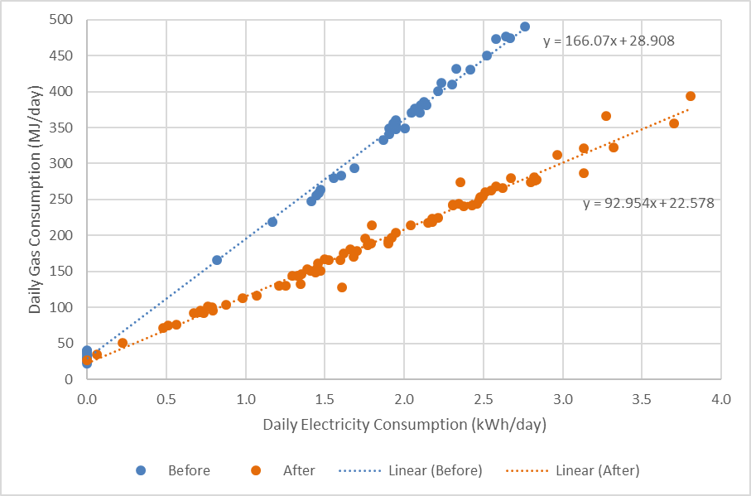

Some of the houses included in the *Comprehensive Retrofit Trial* used “secondary heating” to supplement their main heating system. For example, they may have used a plug-in oil-filled column heater to heat bedrooms at night, or may have used a gas room heater to supplement the gas ducted heating in areas of the house where the gas ducted heating was not adequate. The energy use of this secondary heating is also impacted by the retrofits. In some of the houses, any electric secondary heating was identified during the initial house surveys, and separately metered, allowing the energy savings associated with the secondary heating to be estimated. However, if the secondary heating was provided by a room gas heater or a wood heater this was not possible.

Secondary heating is a little studied area of residential energy use in Australia, and the impact of secondary heating on overall heating energy consumption and energy costs is not well understood. Where houses have only space (or room) heating as the main form of heating – e.g. a gas room heater or room reverse-cycle air conditioner – the energy consumption associated with any secondary heating could be quite high. If it is provided by plug-in electric heaters, the energy costs could also be very high. Any building shell retrofits will generally also reduce the energy consumption of the secondary heating, further improving the cost-effectiveness of such upgrades.

* + 1. Lighting upgrades

Data collected from metering equipment installed in the houses’ electrical switchboards was used to estimate energy savings resulting from any lighting upgrades. Lighting circuits were metered separately using a 10-minute logging interval, allowing the daily electricity use of the lighting before and after any lighting retrofits were undertaken to be calculated. As an example, Figure 10 shows the daily electricity consumption of the lighting circuit at house CR8 before (blue columns) and after (orange columns) the lighting retrofits[[76]](#footnote-77). In this house, the average daily electricity use of the lighting decreased from 1.48 kWh per day before the retrofits to 0.66 kWh per day afterwards, a saving of 0.81 kWh per day. This suggests an annual electricity saving of 296 kWh per year. However, lighting use changes throughout the year as the daylight hours change, being lower during the summer months than during the winter months. To account for this, we applied an adjustment factor to the pre- and post-retrofit lighting energy consumption data, to convert the daily averages for the monitoring period into estimated annual daily averages[[77]](#footnote-78). The conversion factor used took account of the time of year that the data was collected. For house CR8, this resulted in an estimated annual saving of 163 kWh per year.

Figure 10: Daily electricity consumption of the lighting at house CR8

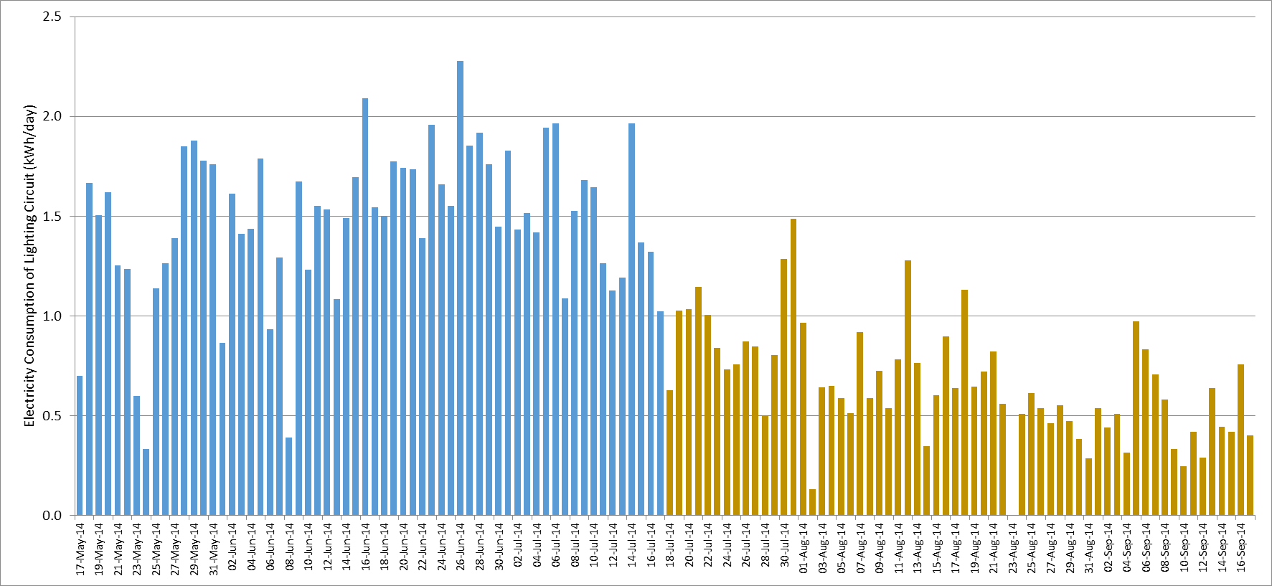

* + 1. Refrigerator upgrades

Refrigerator electricity consumption was monitored using a plug-in meter with a 1- or 2- minute logging interval, and the ambient temperature in the room in which the refrigerator was located was monitored using a small temperature sensor. An example of the electricity consumption data collected during the trial for house CR7 is shown in Figure 11 – it is clear that replacing the old refrigerator with a new high efficiency one has resulted in a very significant electricity saving[[78]](#footnote-79). Refrigerator energy consumption is highly dependent on the ambient temperature of the room in which it is located, and shows significant seasonal variation. The daily electricity consumption of refrigerators tends to be lower during the winter months than during the summer months, so daily energy consumption data collected during the winter months (as in this trial) does not provide a reliable estimate of the annual consumption.

Seven of the houses that participated in the *Comprehensive Retrofit Trial* had existing refrigerators replaced with new high efficiency ones. The electricity consumption and internal temperature data for these refrigerators was analysed by Lloyd Harrington of Energy Efficient Strategies as part of SV’s *Refrigerator Retrofit Trial* [SV2017a]. Harrington employed a sophisticated analysis methodology that segmented refrigerator electricity consumption into its component parts, and used this to develop a model for each refrigerator to estimate its annual electricity consumption over a typical year[[79]](#footnote-80). For house CR7 it was estimated that the original refrigerator had an annual electricity consumption of 893 kWh per year, and that the high efficiency replacement refrigerator had an annual electricity consumption of 238 kWh per year, giving an annual saving of 655 kWh per year (73.3%). For this study, we used the energy saving estimates from the *Refrigerator Retrofit Trial*.

Figure 11: Daily electricity consumption of the refrigerator at house CR7

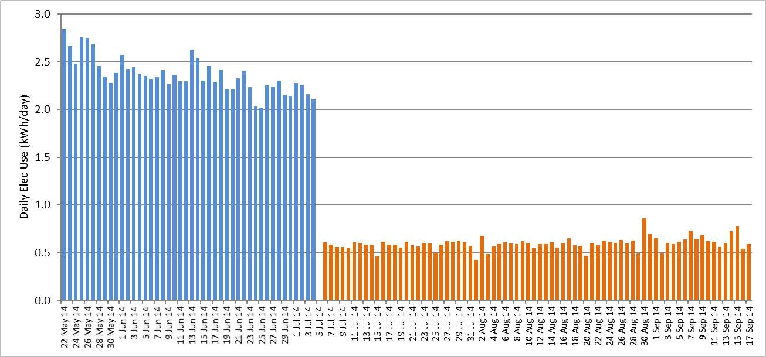

* + 1. Water heater upgrades

Water heater replacements were undertaken at seven of the *Comprehensive Retrofit Trial* houses. In two of the houses, electric storage water heaters were replaced with high efficiency gas water heaters. At the other houses, an existing gas storage water heater was replaced with a high efficiency gas water heater; the exception was house CR5, where a gas-boosted solar water heater was used as the replacement.

Where the houses had electric water heaters, these were connected to a separate electrical circuit, and so their electricity consumption was monitored using the switchboard metering. An example of this, for house CR9, is shown in Figure 12, where the daily water heating electricity consumption is compared to the house’s total electricity consumption. However, the budget for the *Comprehensive Retrofit Trial* did not allow for separate gas metering to be installed on the gas water heaters. A water heating tool developed by Sustainability Victoria was used to estimate the water heating energy use of the gas water heaters prior to the retrofits, and afterwards. The tool first estimates the average daily hot water consumption based on the number of occupants, the type of shower rose, and the type of washing machine, and combines this with efficiency performance data on different types of water heaters. Where relevant, the efficiency level of the water heater is also taken into account. Where metered data was available from the existing electrical water heaters, this was used to confirm the hot water use estimate, before the energy use of the replacement gas water heater was calculated.

Figure 12: Water heater and total electricity consumption for house CR9

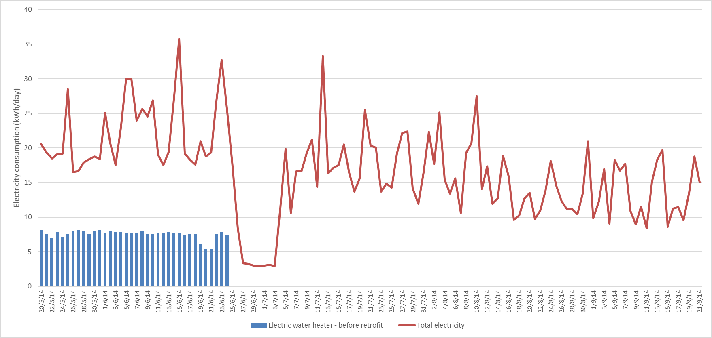

* 1. Impact of the retrofits on energy consumption
     1. Overall impact of the package of retrofits

The impacts of the retrofit packages on the fourteen houses that participated in the *Comprehensive Retrofit Trial* are summarised in Table 6. This shows the initial annual electricity and gas consumption of the houses, the total cost of the retrofit packages, the estimated total annual gas and electricity savings achieved – both in absolute terms and as a percentage of the initial consumption – the estimated annual greenhouse gas and energy bill savings, and the payback period on the investment in the energy efficiency upgrades. Data is provided for each house, as well as for the average across all houses.

The average cost of the retrofit packages was $13,037 – this is based on the full cost of the upgrades, and does not include any government incentives or rebates that are available. On average, the retrofit packages are estimated to have resulted in total annual gas savings of 20,016 MJ per year (28.5% of initial average gas use) and annual electricity savings of 794 kWh per year (17.1% of initial average electricity use). The average reduction in energy-related greenhouse gas emissions was 2.05 tonnes per year, and the average energy bill saving was $663 per year (based on current energy prices); this gave an average payback period of 19.7 years on the cost of the retrofit packages. Note that the energy bill savings do not include any savings from reduced summer cooling use that is likely to have resulted from the building shell retrofits where the households used some form of air conditioning during the summer months. There may have also been some additional energy savings associated with the use of secondary heating that was not measured.

Table 6: Overall impact of the energy efficiency retrofit packages

|  |  |  |  |  |  |  |  |  |  |  |
| --- | --- | --- | --- | --- | --- | --- | --- | --- | --- | --- |
| House No. | Initial Gas Use (MJ/yr) | Initial Elec. Use (kWh/yr) | Retrofit Package Cost ($) | Annual energy saving | | Saving as percentage of initial energy use | | Greenhouse gas saving (kg/yr) | Energy bill saving ($/yr) | Payback period (Years) |
| Gas (MJ/yr) | Elec. (kWh/yr) | Gas | Elec. |
| CR1 | 150,038 | 6,647 | $12,394 | 54,058 | 233 | 36.0% | 3.5% | 3,266 | $1,145 | 10.8 |
| CR2 | 85,686 | 6,880 | $14,324 | 17,878 | 965 | 20.9% | 14.0% | 2,128 | $691 | 20.7 |
| CR3 | 63,591 | 3,389 | $10,061 | 22,772 | 352 | 35.8% | 10.4% | 1,675 | $617 | 16.3 |
| CR4 | 69,781 | 3,686 | $10,602 | 21,589 | 68 | 30.9% | 1.8% | 1,274 | $509 | 20.8 |
| CR5 | 13,375 | 5,756 | $14,059 | 10,550 | 344 | 78.9% | 6.0% | 990 | $410 | 34.3 |
| CR6 | 111,384 | 3,107 | $13,070 | 37,624 | 459 | 33.8% | 14.8% | 2,623 | $899 | 14.5 |
| CR7 | 62,201 | 3,390 | $12,927 | 14,530 | 1,171 | 23.4% | 34.5% | 2,186 | $698 | 18.5 |
| CR8 | 67,698 | 3,560 | $21,110 | 32,013 | 224 | 47.3% | 6.3% | 2,036 | $784 | 26.9 |
| CR9 | 55,756 | 9,180 | $13,054 | 334 | 2,530 | 0.6% | 27.6% | 3,004 | $499 | 26.1 |
| CR10 | 84,968 | 5,180 | $13,144 | 15,050 | 1,019 | 17.7% | 19.7% | 2,035 | $652 | 20.2 |
| CR11 | 30,269 | 5,443 | $12,683 | 1,581 | 2,703 | 5.2% | 49.7% | 3,277 | $873 | 14.5 |
| CR12 | 62,840 | 1,100 | $11,375 | 27,654 | 23 | 44.0% | 2.1% | 1,557 | $613 | 18.6 |
| CR13 | 70,600 | 5,740 | $10,741 | 5,283 | 828 | 7.5% | 14.4% | 1,270 | $380 | 28.3 |
| CR14 | 54,552 | 2,110 | $12,967 | 19,311 | 200 | 35.4% | 9.5% | 1,304 | $516 | 25.2 |
| Av. | 70,196 | 4,655 | $13,037 | 20,016 | 794 | 28.5% | 17.1% | 2,045 | $663 | 19.7 |

The impact of the retrofit packages varied widely from house-to-house. It depended on the initial efficiency status of the house and its physical size, the number of occupants, and occupant behaviour[[80]](#footnote-81) – which all affect the house’s initial electricity and gas consumption – and on the retrofit measures applied at each house. As the retrofit packages mainly targeted building shell and heating system upgrades, and as most houses were heated with gas, the gas savings are considerably larger than the electricity savings.

In general, the energy savings were largest at the houses that had the highest initial gas use, as these had high gas heating use and therefore the largest potential to save energy. At houses CR9 and CR11, the annual gas savings were less than might be expected. This was because at these houses an existing electric water heater was replaced with a high efficiency gas water heater – this results in a significant electricity saving and a significant increase in gas consumption, which off-sets the gas savings from the building shell and heating system upgrades to some extent.

The houses with the largest electricity savings were those that had either an electric water heater replaced with a gas water heater (CR9 and CR11), or an existing refrigerator replaced with a high efficiency new one (CR2, CR3, CR5, CR7, CR10, CR11 and CR13), or both. In some cases, lighting retrofits generated additional electricity savings.

Table 7 provides information on the average impact of the different types of retrofits across the ‘stock’ of 14 houses that participated in the *Retrofit* *Trial*. Due to the timing of the retrofits, it was not possible to separately assess the impact of the individual building shell and heating system upgrades applied at the houses, so these were treated as one group[[81]](#footnote-82). Building shell and heating system upgrades were undertaken at all houses. The average cost of this upgrade type was $10,228 (78.5% of the total retrofit package costs), and the average energy bill saving was $441 per year (65.7% of the total energy bill savings), giving an average payback period of 23.2 years, based on the energy bill saving. As expected, the building shell and heating system upgrades dominated the gas savings (97.5% of the total), but accounted for only a small proportion of the electricity savings (6.8%)[[82]](#footnote-83). They accounted for 56.3% of the total greenhouse gas savings. This is lower than their contribution to the energy savings, as natural gas currently has a much lower greenhouse gas coefficient than mains electricity.

Table 7: Average impact of the different types of retrofits – across all 14 houses

|  |  |  |  |  |  |  |
| --- | --- | --- | --- | --- | --- | --- |
| Retrofit type | Average cost  ($) | Average annual energy saving | | Average greenhouse gas saving (kg/yr) | Average energy bill saving  ($/yr) | Average payback period (Years) |
| Gas  (MJ/yr) | Electricity (kWh/yr) |
| Building shell & heating | $10,228 | 19,844 | 54 | 1,162 | $441 | 23.2 |
| Water heater | $1,533 | 172 | 361 | 435 | $102 | 15.1 |
| Refrigerator | $1,061 | - | 308 | 363 | $98 | 10.8 |
| Lighting | $214 | - | 71 | 84 | $22 | 9.5 |
| All | $13,037 | 20,016 | 794 | 2,045 | $663 | 19.7 |

The refrigerator, water heating and lighting upgrades were all applied in seven (50%) of the fourteen houses. The average payback period of these appliance and equipment upgrades was considerably lower than for the building shell and heating system upgrade package, consistent with the results of SV’s *OGA* study [SV2015][[83]](#footnote-84). Of these, the average cost of the water heater upgrades was highest ($1,533), and it generated the largest electricity (361 kWh per year), greenhouse gas (435 kg per year), and energy bill ($102 per year) saving. This was mainly due to the two houses where an electric storage water heater was replaced with a high efficiency gas water heater. The average cost of the refrigerator retrofits was $1,061, and these also generated significant electricity, greenhouse gas and energy bill savings. The lighting retrofits had the lowest average cost, and lowest savings, although they were the most cost-effective of the upgrades (9.5-year average payback). In most of the houses, only limited lighting retrofits were undertaken. This is likely to have been partly due to the impact that the *Victorian Energy Upgrades* scheme has had on transforming residential lighting in Victoria[[84]](#footnote-85).

The costs cited in Tables 6 and 7 are based on the full cost of implementing the upgrades. In some cases, discounts or rebates are available that reduce these costs[[85]](#footnote-86). In addition to this, upgrades of the heating system, water heater and refrigerator are usually undertaken when the existing appliance has either reached its end of life, or is close to it, and will need to be replaced anyway. In this case, the cost of upgrading to an energy efficient option is much less than the full replacement cost.

Table 8 provides information on the average impact of the different types of retrofits, *when implemented*. This highlights the fact that significant and fairly cost effective energy savings are available in those houses where old refrigerators can be replaced by efficient new ones, and old inefficient water heaters – especially electric storage water heaters – can be replaced with a new efficient one.

Further information on the impact of each of the different types of retrofits in the houses is provided in the individual case study write-ups (see Appendices 1 to 14).

Table 8: Average impact of the different types of retrofits – when implemented

|  |  |  |  |  |  |  |
| --- | --- | --- | --- | --- | --- | --- |
| Retrofit type | Average cost  ($) | Average annual energy saving | | Average greenhouse gas saving (kg/yr) | Average energy bill saving  ($/yr) | Average payback period (Years) |
| Gas  (MJ/yr) | Electricity (kWh/yr) |
| Building shell & heating | $10,228 | 19,844 | 54 | 1,162 | $441 | 23.2 |
| Water heater | $3,067 | 344 | 722 | 871 | $203 | 15.1 |
| Refrigerator | $2,123 | - | 616 | 727 | $196 | 10.8 |
| Lighting | $427 | - | 143 | 168 | $45 | 9.5 |

The payback periods shown in Tables 6 to 8 are based only on the energy bill savings. The building shell upgrades, and possibly also the heating upgrades, improved the thermal comfort of the houses during winter (see Section 3.6 below), and this could improve occupant heath and result in significant additional medical cost savings for the households and society more generally. This issue is discussed in Section 3.5 below.

* + 1. Building shell and heating retrofits

The impacts of the building shell and heating system retrofit packages on the heating energy consumption at the fourteen houses that participated in the *Comprehensive Retrofit Trial* are summarised in Table 9. This shows the estimated average annual energy consumption for the main heating fuel prior to the retrofits[[86]](#footnote-87), and the estimated average annual heating energy saving achieved, both in absolute terms and as a percentage of the initial heating energy consumption. The heating energy savings achieved at the houses ranged from a low of only 8.9% (CR13) up to 58.3% (CR12). The average heating energy saving across all houses was 38.9%. Heating energy savings of 30% or greater were achieved at 11 (78.6%) of the 14 houses, and heating energy savings of 40% or greater were achieved at 7 (50.0%) of the 14 houses.

Table 9: Impact of the building shell and heating system upgrades on heating energy use

|  |  |  |  |
| --- | --- | --- | --- |
| House number | Annual heating energy use - main fuel (MJ/yr) | Annual heating energy saving – main fuel (MJ/yr) | Heating energy saving – main fuel (%) |
| CR1 | 111,012 | 54,058 | 48.7% |
| CR2 | 56,566 | 17,878 | 31.6% |
| CR3 | 46,538 | 20,636 | 44.3% |
| CR4 | 40,916 | 17,602 | 43.0% |
| CR5 | 4,391 | 396 | 9.0% |
| CR6 | 78,259 | 37,624 | 48.1% |
| CR7 | 42,494 | 14,530 | 34.2% |
| CR8 | 51,120 | 27,841 | 54.5% |
| CR9 | 55,643 | 11,764 | 21.1% |
| CR10 | 50,110 | 15,050 | 30.0% |
| CR11 | 32,707 | 14,365 | 43.9% |
| CR12 | 47,458 | 27,654 | 58.3% |
| CR13 | 59,396 | 5,283 | 8.9% |
| CR14 | 37,752 | 13,535 | 35.9% |
| Average | 51,026 | 19,873 | 38.9% |

The lowest heating energy savings were achieved at houses CR13 (8.9%), CR5 (9.0%) and CR9 (21.1%). At house CR13, the retrofits undertaken were draught sealing, ceiling insulation top-up, and the replacement of the existing gas ducted heater and its associated ductwork. The impact of the draught sealing was quite low – the natural air leakage rate was reduced from 1.7 ACH to only 1.6 ACH – and the impact of the ceiling insulation top-up was also likely to have been low, as the ceiling was already insulated with loose-fill cellulose fibre prior to the retrofits. At this house an electric oil-filled column heater was used to heat one of the bedrooms overnight, as the original gas ducted heater was too noisy. After the retrofits, the occupants decided to operate the new gas ducted heater overnight on cold nights instead of the column heater, as it was much quieter than the old system. While this led to an electricity saving for the column heater, it meant that the gas and electricity consumption of the new gas ducted heater was higher than it would have otherwise been. The “technical” energy saving for this house estimated using Method 1 was 33.0%. In practice, the gas energy saving was substantially lower than this due to the increased use of the gas ducted heating after the retrofits. This example highlights the unexpected interactions that can occur when retrofits are undertaken.

House CR5 was double storey, with a room split-system air conditioner used to condition the downstairs living area. While both the walls and ceiling of this house were insulated[[87]](#footnote-88), the installation of the ceiling insulation is likely to have had only a limited impact on the heat losses from the downstairs living area where the heating was located. In addition to this, the internal temperatures when the heating was operating were somewhat higher after the retrofits, reducing the heating energy savings achieved.

At house CR9, the heating was operated for much longer hours for a few weeks immediately after the completion of the retrofits, and then returned to normal. This reduced the estimated saving achieved from the retrofits. Also, the nature of the retrofit work undertaken is likely to have contributed to the below average savings: the ceiling was already insulated with loose-fill cellulose fibre, and some sections of the floor were already insulated, reducing the impact of these upgrade measures; the existing gas ducted heater had an electronic ignition, reducing the gas saving achieved from replacing this with a new efficient heater - many old gas ducted heaters have a gas pilot light, and this can use 4,000 to 8,000 MJ per year; and, the gas heating ductwork was replaced, although the original ductwork was in reasonable condition, so the savings from this upgrade may have also been quite low.

The houses with the highest heating energy savings, CR12 (58.3%) and CR8 (54.4%), were both small brick-veneer houses with fairly high air leakage rates. They both had some insulation on the ceilings (around R1.5 to R2.0), and walls and floors that were uninsulated, and both had very old gas ducted heating systems and ductwork. House CR6 was a small weatherboard house with poorly insulated ceilings and uninsulated walls and floor (which was unenclosed). The gas ducted heater and ductwork were both quite old. While a 48.1% energy saving was achieved at this house, space restrictions meant that underfloor insulation was not installed, and the ductwork was not replaced. If these retrofits had been undertaken, then the energy saving would have been larger.

Table 10 shows the impact that the building shell and heating system upgrades had on the houses’ overall energy consumption, the greenhouse gas and energy bill savings, and payback period, based on the energy bill savings. The energy savings are dominated by gas, because this was the main heating fuel used, and the gas-heated houses all had ducted (or central) heating systems. The average gas saving of 19,844 MJ per year was 28.3% of the houses’ original average gas consumption.

The average electricity saving achieved was quite small, only 54 kWh per year (194 MJ per year), although varied considerably from house-to-house. It accounted for only 1.2% of the houses’ original average electricity consumption. The highest electricity savings were achieved in houses CR6, CR1, CR7 and CR5. In houses CR6 and CR1, much of the electricity saving was associated with plug-in electric heating used as supplementary heating, and was 433 kWh per year and 301 kWh per year respectively. In house CR7 the gas ducted heater was not replaced, so this saving was due to the heating operating for less time to heat the house. House CR5 had a room reverse-cycle air conditioner as the main form of heating. In some houses, the electricity consumption of the gas ducted heating increased after the retrofits (shown as a negative saving). This was due to the new high efficiency gas ducted heaters often having a higher power consumption when the heating was operating, due mainly to a more powerful air circulation fan.

Table 10: Impact of the building shell and heating system retrofits on the houses’ energy use

|  |  |  |  |  |  |  |  |  |  |  |
| --- | --- | --- | --- | --- | --- | --- | --- | --- | --- | --- |
| House No. | Initial Gas Use (MJ/yr) | Initial Elec. Use (kWh/yr) | Retrofit Package Cost ($) | Annual energy saving | | Saving as percentage of initial energy use | | Greenhouse gas saving (kg/yr) | Energy bill saving ($/yr) | Payback period (Years) |
| Gas (MJ/yr) | Elec. (kWh/yr) | Gas | Elec. |
| CR1 | 150,038 | 6,647 | $12,394 | 54,058 | 233 | 36.0% | 3.5% | 3,266 | $1,145 | 10.8 |
| CR2 | 85,686 | 6,880 | $11,480 | 17,878 | 49 | 20.9% | 0.7% | 1,047 | $398 | 28.8 |
| CR3 | 63,591 | 3,389 | $7,246 | 20,636 | -90 | 32.5% | -2.7% | 1,036 | $425 | 17.0 |
| CR4 | 69,781 | 3,686 | $9,203 | 17,602 | 68 | 25.2% | 1.8% | 1,054 | $414 | 22.2 |
| CR5 | 13,375 | 5,756 | $6,102 | - | 110 | - | 1.9% | 130 | $35 | 174.1 |
| CR6 | 111,384 | 3,107 | $13,070 | 37,624 | 459 | 33.8% | 14.8% | 2,623 | $899 | 14.5 |
| CR7 | 62,201 | 3,390 | $10,099 | 14,530 | 111 | 23.4% | 3.3% | 935 | $360 | 28.1 |
| CR8 | 67,698 | 3,560 | $17,101 | 27,841 | 58 | 41.1% | 1.6% | 1,609 | $631 | 27.1 |
| CR9 | 55,756 | 9,180 | $8,686 | 11,764 | -35 | 21.1% | -0.4% | 609 | $255 | 34.1 |
| CR10 | 84,968 | 5,180 | $9,998 | 15,050 | 4 | 17.7% | 0.1% | 837 | $328 | 30.5 |
| CR11 | 30,269 | 5,443 | $7,857 | 14,365 | -52 | 47.5% | -1.0% | 734 | $299 | 26.2 |
| CR12 | 62,840 | 1,100 | $11,145 | 27,654 | -17 | 44.0% | -1.5% | 1,511 | $600 | 18.6 |
| CR13 | 70,600 | 5,740 | $8,381 | 5,283 | -121 | 7.5% | -2.1% | 150 | $77 | 108.6 |
| CR14 | 54,552 | 2,110 | $10,432 | 13,535 | -21 | 24.8% | -1.0% | 724 | $305 | 34.2 |
| Av. | 70,196 | 4,655 | $10,228 | 19,844 | 54 | 28.3% | 1.2% | 1,162 | $441 | 23.2 |

The houses with the highest percentage heating energy savings (see Table 9) did not necessarily have the highest absolute heating energy savings or highest energy bill savings. Generally, the houses with the highest initial heating energy use had the highest absolute savings. Where the retrofits reduced the energy consumption of supplementary plug-in electric heating, this significantly increased the energy bill saving, due to the high cost of mains electricity.

* + 1. Water heating retrofits

The impacts of the water heating retrofits are shown in Table 11. This includes the initial gas and electricity consumption of the houses, and the estimated annual energy, greenhouse gas, and energy bill savings resulting from the water heater replacements. As it was not possible to install equipment to meter the hot water use of the households and the energy consumption of the gas water heaters, these savings have been estimated using a tool developed by Sustainability Victoria that accounts for the number of house occupants and how they use hot water[[88]](#footnote-89).

The average energy savings from the water heater retrofits are dominated by the electricity savings – 722 kWh per year, or 2,599 MJ per year[[89]](#footnote-90). These savings occurred at the two houses that had electric storage water heaters replaced with a high efficiency gas water heater (CR9 and CR11). At these houses, the average electricity saving was 2,551 kWh per year (9,184 MJ per year) – this resulted in a high greenhouse gas saving (average of 2.34 tonnes per year) and a high energy bill saving (average of $374 per year), giving this retrofit relatively low payback period (average of 11.5 years). At these houses the gas consumption also increased significantly, due to the installation of the gas water heater, and this off-set some of the energy savings achieved by the building shell and heater upgrades.

The payback period for house CR9 was much longer than the payback period for house CR11. At CR9, the existing gravity feed electric storage water heater was replaced with a 7 Star equivalent[[90]](#footnote-91) gas instantaneous water heater – these are quite expensive, and gas pipework also needed to be installed, resulting in quite a high installation cost. Also, we believe that the hot water use at this house increased significantly after the retrofits, by as much as 50%[[91]](#footnote-92). This meant that the gas consumption of the instantaneous water heater was higher than would be expected. Both the high installation cost and the increased hot water consumption (reducing the energy saving) led to the high payback period. At house CR11 the electric water heater was replaced with a 5 Star gas storage water heater, a much lower cost option. Also, the original electric storage water heater was run on the general electricity tariff, rather than the cheaper off-peak electricity tariff, leading to a large energy bill saving.

Table 11: Impact of the water heating retrofits

|  |  |  |  |  |  |  |  |  |  |  |
| --- | --- | --- | --- | --- | --- | --- | --- | --- | --- | --- |
| House No. | Initial Gas Use (MJ/yr) | Initial Elec. Use (kWh/yr) | Retrofit Package Cost ($) | Annual energy saving | | Saving as percentage of initial energy use | | Greenhouse gas saving (kg/yr) | Energy bill saving ($/yr) | Payback period (Years) |
| Gas (MJ/yr) | Elec. (kWh/yr) | Gas | Elec. |
| CR3 | 63,591 | 3,389 | $1,420 | 2,136 | - | 3.4% | - | 118 | $51 | 28.1 |
| CR4 | 69,781 | 3,686 | $1,399 | 3,987 | - | 5.7% | - | 221 | $95 | 14.7 |
| CR5 | 13,375 | 5,756 | $5,980 | 10,550 | -48 | 78.9% | -0.8% | 527 | $285 | 21.0 |
| CR8 | 67,698 | 3,560 | $3,874 | 4,172 | - | 6.2% | - | 231 | $100 | 38.9 |
| CR9 | 55,756 | 9,180 | $4,368 | -11,430 | 2,565 | -20.5% | 27.9% | 2,394 | $245 | 17.9 |
| CR11 | 30,269 | 5,443 | $2,582 | -12,784 | 2,537 | -42.2% | 46.6% | 2,286 | $504 | 5.1 |
| CR14 | 54,552 | 2,110 | $1,845 | 5,776 | - | 10.6% | - | 320 | $144 | 12.8 |
| **Av.** | **50,718** | **4,732** | **$3,067** | **344** | **722** | **0.7%** | **15.3%** | **871** | **$203** | **15.1** |
| Av. gas | 53,800 | 3,700 | $2,904 | 5,324 | -10 | 9.9% | -0.3% | 283 | $135 | 23.1 |
| Av. elec. | 43,013 | 7,312 | $3,475 | -12,107 | 2,551 | -28.1% | 34.9% | 2,340 | $374 | 11.5 |

The average gas saving from the water heater retrofits was only 344 MJ per year. This is lower than expected as the savings at the houses where a gas water heater was replaced with another gas-fuelled water heater were off-set by the increased gas use at those houses where an electric water heater was replaced with a gas water heater. For those houses where an existing gas water heater was replaced, the average gas saving was 5,324 MJ per year, resulting in average energy bill savings of $135 per year, and an average payback period of 23.1 years. The gas savings were highest at house CR5, as here a gas storage water heater was replaced with a gas-boosted solar water heater. However, the high cost of the gas boosted solar water heater meant that even though this had the largest energy and energy bill saving, it still had an above average payback period.

For the houses where a gas water heater was replaced with another gas water heater, the longest paybacks occurred at houses CR8 and CR3. At house CR8, a 5 Star gas storage water heater (already quite efficient) was replaced with a 7 Star equivalent gas instantaneous water heater, at quite a high cost. The relatively low energy saving achieved, combined with the high installation cost, led to the high payback period. At house CR3, an existing 4 Star gas storage water heater was replaced with a 5 Star gas storage water heater, resulting in a relatively small energy saving.

* + 1. Refrigerator retrofits

The impacts of the refrigerator replacements are shown in Table 12, and these are discussed in much more detail in the *Refrigerator Retrofit Trial* report [SV2017a]. The average annual electricity savings from the refrigerator retrofits was 616 kWh per year, or 12.0% of the houses’ average initial electricity consumption. The replacements achieved an average saving of 67.4% of the original refrigerators’ electricity consumption [SV2917a]. The highest electricity savings were achieved at CR13, CR2 and CR10. At these houses, the original refrigerators were inefficient and had a high annual electricity consumption ranging from 1,224 kWh per year (CR13) to 1,386 kWh per year (CR2). At house CR13, two refrigerators (a separate fridge and freezer) were replaced with one high efficiency fridge-freezer. The lowest electricity savings occurred at houses CR11 and CR5. The original refrigerators at these houses were reasonably efficient, and had a relatively low annual electricity consumption: 442 kWh per year at CR11, where the original refrigerator was only 4 years old; and, 576 kWh per year at CR5.

Table 12: Impact of the refrigerator retrofits

|  |  |  |  |  |  |  |  |  |  |  |
| --- | --- | --- | --- | --- | --- | --- | --- | --- | --- | --- |
| House Number | Initial Gas Use (MJ/yr) | Initial Electricity Use (kWh/yr) | Retrofit Package Cost ($) | Annual energy saving | | Saving as percentage of initial energy use | | Greenhouse gas saving (kg/yr) | Energy bill saving ($/yr) | Payback period (Years) |
| Gas (MJ/yr) | Electricity (kWh/yr) | Gas | Electricity |
| CR2 | 85,686 | 6,880 | $2,149 | - | 898 | - | 13.1% | 1,060 | $287 | 7.5 |
| CR3 | 63,591 | 3,389 | $1,395 | - | 442 | - | 13.0% | 522 | $141 | 9.9 |
| CR5 | 13,375 | 5,756 | $1,977 | - | 282 | - | 4.9% | 333 | $90 | 22.0 |
| CR7 | 62,201 | 3,390 | $2,028 | - | 655 | - | 19.3% | 773 | $209 | 9.7 |
| CR10 | 84,968 | 5,180 | $2,820 | - | 887 | - | 17.1% | 1,047 | $283 | 10.0 |
| CR11 | 30,269 | 5,443 | $2,245 | - | 218 | - | 4.0% | 257 | $70 | 32.3 |
| CR13 | 70,600 | 5,740 | $2,245 | - | 928 | - | 16.2% | 1,095 | $296 | 7.6 |
| Average | 58,670 | 5,111 | $2,123 | - | 616 | - | 12.0% | 727 | $196 | 10.8 |

* + 1. Lighting retrofits

The impacts of the lighting retrofits are shown in Table 13. The average electricity saving across the seven houses where lighting retrofits occurred was 143 kWh per year (515 MJ per year), or 3.6% of the houses’ average initial electricity consumption. The energy and energy bills savings were highest, and the payback period lowest, at those houses where a significant number of halogen downlight lamps were replaced with LED lamps – CR7 (16 replaced), CR14 (14 replaced) and CR10 (21 replaced). The electricity savings at house CR8 were also relatively high; at this house 4 halogen spotlights were replaced with LED lamps in the kitchen, a fairly high usage area for lighting. The energy savings were much lower in the other houses, either because only a few inefficient lamps were replaced or because the lamps that were replaced were in low usage areas[[92]](#footnote-93).

Table 13: Impact of the lighting retrofits

|  |  |  |  |  |  |  |  |  |  |  |
| --- | --- | --- | --- | --- | --- | --- | --- | --- | --- | --- |
| House Number | Initial Gas Use (MJ/yr) | Initial Electricity Use (kWh/yr) | Retrofit Package Cost ($) | Annual energy saving | | Saving as percentage of initial energy use | | Greenhouse gas saving (kg/yr) | Energy bill saving ($/yr) | Payback period (Years) |
| Gas (MJ/yr) | Electricity (kWh/yr) | Gas | Electricity |
| CR2 | 85,686 | 6,880 | $695 | - | 18 | - | 0.3% | 22 | $5.9 | 118.4 |
| CR7 | 62,201 | 3,390 | $800 | - | 405 | - | 11.9% | 478 | $129.2 | 6.2 |
| CR8 | 67,698 | 3,560 | $135 | - | 166 | - | 4.7% | 196 | $53.0 | 2.5 |
| CR10 | 84,968 | 5,180 | $325 | - | 128 | - | 2.5% | 151 | $40.8 | 8.0 |
| CR12 | 62,840 | 1,100 | $230 | - | 40 | - | 3.6% | 47 | $12.6 | 18.2 |
| CR13 | 70,600 | 5,740 | $115 | - | 21 | - | 0.4% | 25 | $6.7 | 17.2 |
| CR14 | 54,552 | 2,110 | $690 | - | 221 | - | 10.5% | 260 | $66.2 | 10.4 |
| Average | 69,792 | 3,994 | $427 | - | 143 | - | 3.6% | 168 | $44.9 | 9.5 |

* 1. Potential health benefits from energy efficiency upgrades

The health issues associated with inefficient housing in Australia, and the potential health and economic benefits from improving the energy efficiency of housing, especially existing housing, are not widely appreciated. A multi-country study reported in *The* *Lancet* [Lancet2015] found that 6.96% of deaths from all causes in Australia could be attributed to non-optimum (moderate to extreme hot and cold) ambient temperatures, 6.5% due to cold temperatures and 0.45% to hot temperatures. Applied to Victoria, these figures suggest that around 2,769 deaths per year might be attributable to non-optimum ambient temperatures, around 10 times higher than the annual deaths from all transport accidents[[93]](#footnote-94).

While the study reported in *The* *Lancet* was based on external ambient temperatures, people who live in inefficient houses are likely to be exposed to lower inside ambient temperatures during the winter months and higher inside ambient temperatures during summer months, and/or may find it difficult and expensive to adequately heat/cool their houses, making them more susceptible to the health issues associated with non-optimum ambient temperatures. In addition to deaths, the non-optimum temperatures could cause or exacerbate a range of medical conditions[[94]](#footnote-95). A recent World Health Organisation report [WHO2018] stated that “Housing that is difficult and expensive to heat can contribute to poor respiratory and cardiovascular outcomes, while high indoor temperatures can increase cardiovascular mortality”. The report noted that in high-income countries around 70% of people’s time is spent inside their homes, and that this percentage is higher for children, the elderly and those with a disability or chronic illness. Ageing populations mean that the percentage of time people spend indoors is likely to increase.

A study by the UK Building Research Establishment (BRE) found that there would be very significant health cost savings from reducing the hazards associated with poor housing in England and the UK [BRE2015], including excess cold in winter and excess heat in summer. It estimated that reducing the worst (Category 1) hazards in English houses would cost 10.1 billion British Pounds and would generate annual savings for the National Health Service of 1.4 billion British Pounds, giving a payback on the health savings of 7.13 years. Of this, 60.2% of the costs (6.1 billion British Pounds) and 60.0% of the savings (0.85 billion British Pounds) were attributed to repairs that mitigated the impact of excess cold/heat, giving a payback on the health savings of 7.14 years. This is substantially lower than the average payback of 23.2 years found for the building shell and heating system upgrades in the *Comprehensive Retrofit Trial*, based *only on* the energy bill savings (see Table 10).

For the UK as a whole, the BRE study found that the total reduction in NHS costs from eliminating all significant hazards associated with poor housing would be 1.4 to 2.5 billion British Pounds. They noted that this was comparable in magnitude to the cost burden of other significant public health issues, such as physical inactivity, smoking and alcohol intake [BRE2015][[95]](#footnote-96).

BRE also studied the cost of poor housing in the European Union [BRE2018]. They found quite variable results across the 28 EU member states. The incidence of households reporting problems with heating were found to be lowest in Austria, Denmark, Finland, Germany, Luxembourg, Netherlands, Slovenia and Sweden. Denmark had one of the lowest incidences of problems of all types, and the report authors noted that it “has promoted the building and continued improvement of a high quality housing stock over many years and thus prevents many of the costs from occurring in the first place”. The total cost of repairing all hazards associated with poor housing in the EU was estimated to be 295 billion Euros, and the total annual societal medical savings were estimated to be 194 billion Euros, comprised of 9 billion Euros of direct medical savings and 185 billion Euros of indirect medical savings. This gave a payback on the total medical savings of 1.52 years. The payback in the countries with the most efficient houses and less problems with heating was 2 years or greater, while the payback for the countries that reported the greatest problems with heating was generally under 1 year.

For the *Comprehensive Retrofit Trial*, we have not collected the data that would allow an assessment of the health benefits to be made, and we are not able to directly estimate the health benefits associated with the building shell and heating system upgrades as there is currently no robust Victorian (or Australian) evidence base for this. Sustainability Victoria’s *Healthy Homes* project[[96]](#footnote-97) is seeking to obtain this evidence for low income households with chronic health issues. However, the data from BRE’s UK study provides some insights for Victoria, as there are similarities in the death rates from non-optimum temperatures, as well as with the difficulty of heating houses.

In the UK, it is estimated that 8.78% of all deaths result from non-optimum ambient temperatures, 8.48% from cold and 0.3% from heat [Lancet2015]. This is a bit higher than the comparable figure for Australia; this is to be expected, due to the colder climate in the UK. The BRE study of the EU [BRE2018] found that 36% of UK houses reported problems heating their homes. A 2007 Victorian study by the Department of Human Services [DHS2008] found that 35% of Victorian households reported difficulties heating their homes, 34% of concession households and 36% of non-concession households. The greatest difficulties were experienced with private (52%) and public (55%) rental properties.

The UK and Australian situation is in stark contrast to Sweden, a country that has much colder winters than either country, but higher quality housing. In Sweden, it is estimated that 3.87% of all deaths result from non-optimum temperatures [Lancet2015] – 3.69% from cold and 0.18% from heat – and that no houses reported problems with heating [BRE2018]. The WHO report noted that winter deaths are “greater in countries with milder climates than in those with more severe winter conditions, in part because countries with mild winters often have homes characterized by poor domestic thermal efficiency that are harder to heat than well insulated houses in more extreme climates” [WHO2018].

*If* it is assumed that the payback on the reduced health costs due to building shell and heating system upgrades in Victoria are the same as in the UK (7.14 years), the data from the *Comprehensive Retrofit Trial* (see Table 10 above), suggests this would result in an average annual health saving of $1,432 per year[[97]](#footnote-98) – 3.2 times larger than the energy bill saving - increasing the overall saving to $1,873 per year, and reducing the average payback from 23.2 years to 5.5 years if viewed from a wider societal perspective. Even if the health benefit only applied to half of the households, this would still give an average annual total saving (energy bill and health) of $1,157 per year, reducing the average payback to 8.8 years. While these calculations are speculative, and further work needs to be undertaken in Victoria to obtain robust evidence of the health benefits and savings, it suggests that taking a wider perspective of the benefits associated with building shell and heating system upgrades transforms the economic proposition.

A number of New Zealand studies reported in [CECLCL2018][[98]](#footnote-99) provide some support for these estimates:

* A cost-benefit analysis of a home insulation program [Chapman2009] found a net present value of NZ$1,574 (5% discount rate, 30-year analysis period) per household for the installation of insulation and basic draught proofing measures in uninsulated houses, with 66.1% of the benefit being due to reduced hospital admissions;
* A more recent analysis [MEF2011] of the energy and health benefits of the *Warm Up New Zealand: Health Smart Programme,* based on two years of actual implementation and two years of planned implementation[[99]](#footnote-100), found the net benefit to be NZ$951 million (4% discount rate, 30-year analysis period, 74% additionality assumed). The total cost of the program was estimated to be $NZ332, and the total benefit estimated to be NZ$1,283 million, comprising NZ$17 million of energy benefits and NZ$1,266 million of health benefits[[100]](#footnote-101) – these included benefits associated with hospitalisation, hospitalisation costs, pharmaceutical costs, *reductions in mortality (deaths)*, GP visits, *and sick days or days off school*. The benefit-cost ratio was 3.9, and the identified health benefits accounted for 98.7% of the total benefit. The vast majority of the benefit (99.8%) was expected to come from the insulation upgrade.

The energy bill and health savings represent only part of the economic benefit that would result from comprehensive energy efficiency upgrades to existing Victorian houses. Warmer houses are likely to have less problems with damp and mould, and therefore less health issues associated with this. And, as noted in the *Good Housing Better Health* report [TAPP2016], “Even relatively minor health outcomes can result in days off work with consequential impacts on productivity, household budgets and the local and national economy. Such outcomes can also affect school attendance, contributing to educational under-achievement, and potential future economic performance”.

In addition to this, the greenhouse gas abatement that results from building shell and heating system (and other efficiency) upgrades has an economic value, and building shell upgrades to existing houses have the potential to significantly reduce the thermal loads on houses during both summer and winter, therefore reducing peak demands on the electricity system where houses use electric heating and/or cooling. A 2004 modelling study for VENCORP [EES2004] found that increasing the building shell efficiency of all Victorian houses to a 5 Star rating would result in an average reduction in the peak demand of Victoria’s electricity system of at least 533 MW[[101]](#footnote-102), based on the 40 highest demand days from 1999 to 2003, with the highest demand reduction being at least 900 MW (11%).

Investment in generation and supply infrastructure to meet electricity peak demand is one of the key drivers of electricity prices, and the economic benefit of reduced electricity prices flows to all households and businesses. This issue is likely to become more important in coming years, due to a gradual transition from gas heating to reverse-cycle air conditioning as a key form of heating in Victorian houses (see Figure 5 above), which has the potential to increase electricity peak demands on both summer afternoons, and winter mornings and evenings.

If the multiple benefits of comprehensive energy efficiency upgrades to existing houses are taken into account – energy bill, health, improved work and school attendance and productivity, greenhouse gas abatement, and electricity peak demand reduction – the savings for the households and wider society are likely to be much greater than the energy bill savings alone would suggest, and therefore the payback period will be much lower.

* 1. Householder perceptions of the retrofits

Householder surveys were conducted before and after the retrofits, to obtain the occupants’ perceptions of the level of winter comfort of their houses and the degree of difficulty heating them, and satisfaction with the heating, water heating, lighting and refrigerators, if these were to be upgraded. Both quantitative and qualitative data was collected[[102]](#footnote-103). The quantitative part of the survey aimed to provide results that could be aggregated across the fourteen houses. However, the survey instrument was not consistently or well applied for the first batch of five houses, meaning that the results could only be aggregated for houses CR6 to CR14.

A summary of the survey results for each house, including householder comments, is provided in the individual case study write-ups (see Appendices 1 to 14). Figure 13 shows the change in the average householder rating for the different attributes assessed in the householder surveys for houses CR6 to CR14. The attributes were rated on a scale of 1 to 5, before and after the retrofits[[103]](#footnote-104). All attributes showed an improvement after the retrofits, with the satisfaction in the performance of the refrigerator showing the largest increase, and satisfaction with the performance of the lighting showing the smallest increase.

Figure 13: Average householder ratings for different attributes, houses CR6 to CR14

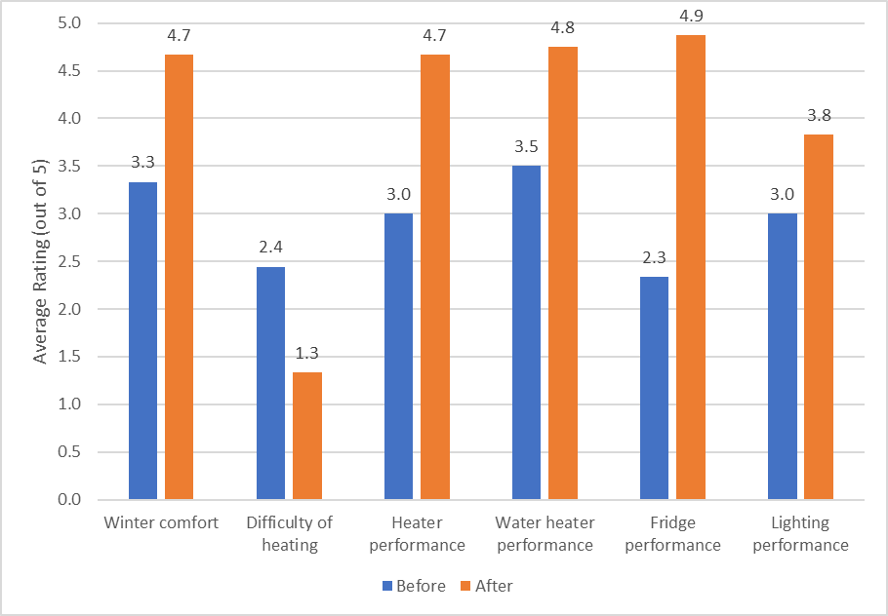

In most cases, prior to the retrofits the occupants found their houses to be reasonably comfortable during the winter months when the heating was operating, although they were often slow to heat up, and cooled down quickly once the heating was turned off. The internal temperatures were often uneven throughout the houses, and some areas or rooms were noticeably colder. Draughts were noticeable in some of the houses. The average rating for “winter comfort” was 3.3 prior to the retrofits, and this increased considerably, to an average of 4.7, afterwards; the average rating for “difficulty of heating” decreased from 2.4 to 1.3. The fact that the average “winter comfort” rating of the houses was higher than 3 (comfortable) and the average “difficulty of heating” rating was just above 2 prior to the retrofits, suggests that even though the houses had poor building shell efficiency, the gas ducted heating used in most houses could provide sufficient heat to keep the houses warm when it was operating, although in some houses plug-in electric heating or gas room heating was used to supplement the ducted heating.

The significant increase in winter comfort observed was achieved at the same time that there was a very significant reduction in heating energy use (38.9% on average). The reduction in heating energy consumption resulted in energy and energy bill savings, and the improvement in winter comfort can have mental and physical health benefits[[104]](#footnote-105) which can provide additional cost savings for the house occupants and society more generally[[105]](#footnote-106). These additional benefits were not measured as part of this study.

A selection of householder comments from the post-retrofit surveys is shown in Figure 14, and more detailed comments for the individual households are provided in the case studies in Appendices 1 to 14. Several themes are evident in these comments. The houses were found to be warmer, less draughty and more comfortable, heated up more quickly and held the heat for longer once the heating was turned off, and internal temperatures were more consistent throughout the houses. Householders often reported that they now ran the heating less frequently and, in some cases, could turn the thermostat setting on the heating down – adding insulation to ceilings, walls and floors increases the temperature of internal building surfaces, meaning that people can feel comfortable at lower air temperatures[[106]](#footnote-107). One household noted that the addition of the under-floor insulation meant that their bare floorboards were no longer as cold to walk on.

Figure 14: Selected comments from householders

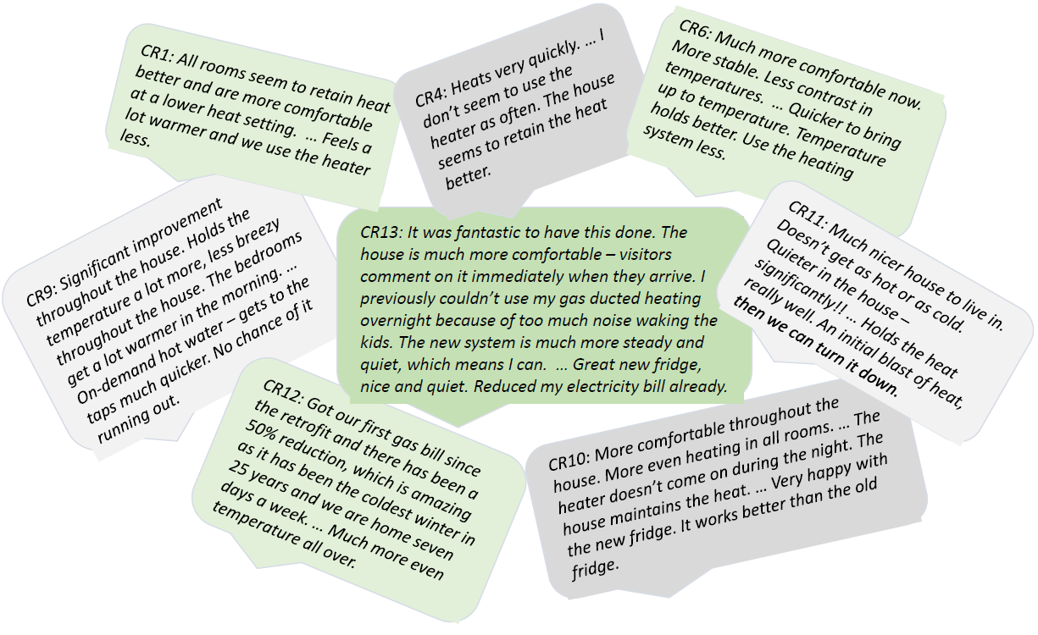

A range of other benefits were noticed by some occupants. The addition of the insulation combined with draught sealing, reduced the outside noise coming into some houses, and in some cases the draught sealing led to better internal air quality (“less dusty”). The occupants of one house noted that the increased winter comfort meant that they were now able to get up earlier in winter, and were more likely to stay at home and work, rather than going out.

As the *Comprehensive Retrofit Trial* was undertaken during the heating season, survey data was not collected on the householder’s perceptions of summer comfort. It is likely that the insulation undertaken at the houses would have significantly improved their summer comfort, especially the houses with poorly insulated ceilings and where cavity wall insulation was installed. This improved summer comfort should have led to additional energy bill savings in those houses that used air conditioning to provide comfort on hot days. Climate change is leading to more hot days during the summer months, meaning that the comfort and energy saving benefits from the building shell upgrades will become increasingly important.

Many of the gas ducted heaters at the houses were quite old and inefficient, and some had poor quality ductwork. Some were starting to break down more frequently, and in some cases the pilot lights would occasionally go out. The old heaters were often found to be noisy; in some cases, this meant that the heating was not operated at night, or when children were in bed. The new gas ducted heaters were found to work better than the ones they replaced, although it was difficult for the householders to differentiate between the improved heating performance resulting from the building shell upgrades and from the improved performance of the new heater. In general, the new systems were found to be quieter (one household found it to be noisier). Occupants also liked the modern control systems used on the new heaters (“more user friendly, easier to program”).

Some of the older existing water heating systems were becoming unreliable and breaking down more frequently, or had pilot lights that occasionally went out. The key issues affecting householder satisfaction with their water heater performance were: whether or not they ran out of hot water; the amount of time it took for hot water to reach outlets in the bathroom and kitchen after the taps were turned on; and, the “quality” of the shower, which can be affected by the pressure of the hot water[[107]](#footnote-108).

In general, householder satisfaction with their water heater increased after the retrofits. Where satisfaction increased, this was due to the water being heated more quickly, a higher water pressure or flow rate at the shower – and therefore a better-quality showering experience – and less delay before the hot water reached the outlets. This was especially the case at house CR9, where an old gravity feed electric storage water heater was replaced with a high efficiency gas instantaneous water heater. The occupants noted that the hot water flow rate had increased - meaning that the hot water reached the taps more quickly, the bath filled more quickly, and shower quality was better – and, “the threat of it going cold was gone”. At house CR14 – where an old 2-Star gas storage system was replaced with a new 5-Star storage system - satisfaction with the water heater decreased from a rating of 5 before the replacement to a rating of 4 afterwards. This was because the occupants found the new system heated the water more slowly, and resulted in a lower flow rate. At house CR8 – where a 5-Star gas storage system was replaced with a 7-Star gas instantaneous system – the occupants were satisfied with the retrofit, but found that, due to the placement of the new system, it now took a bit longer for the hot water to reach the kitchen and bathroom outlets.

The refrigerator replacements showed the largest increase in householder satisfaction. In general, the older fridges were found to be noisier than the new fridges, and some of the old fridges were starting to show signs of “wear and tear” – the fridge at house CR13 had leaking door seals, and sometimes froze items placed at the back of the refrigerator. The increased satisfaction with the new fridges was due to them being quieter (except at one house), having better compartment design, and having better controls – such as digital temperature displays on both the inside and outside of the fridge. Where a refrigerator with a top-mounted freezer was replaced with one with a bottom-mounted freezer, the occupants found that this provided easier access and was “ergonomically better”.

Householder satisfaction with the lighting depended mainly on the light levels provided by the lighting, the time it took for lights to switch on and come up to full brightness, and the appearance of the lighting. In general, the lighting retrofits tended to have little impact on the perceived light levels or the time taken for the lights to switch on, and this probably explains the relatively small increase in satisfaction after the retrofits. In some households, the increased satisfaction was based on the anticipated energy savings which would be achieved by replacing “power hungry” halogen downlights. In some cases, it was because light levels or the quality of the lighting (less glare) improved. At one house, where CFL lamps replaced incandescent light globes, the occupants noted that it took longer for the new lamps to come on. At CR8, where halogen reflector lamps were replaced with LED’s, the occupants were satisfied with the new lighting, but noted that the new lamps were physically longer and poked out of the fitting.

* 1. Was there a ‘rebound effect’ from the retrofits?

As part of the study we investigated whether the retrofits had an impact on the way in which the households used energy. In particular, we investigated whether or not there was a *rebound effect* (sometimes called the *take-back effect*) associated with the comprehensive retrofits. Some economists argue that energy efficiency upgrades result in lower energy savings than expected (anywhere between 10 to 50% less), because consumers choose to take some of the energy savings as a higher level of energy service. For example, the Productivity Commission’s report on its inquiry into energy efficiency [PC2005] states that “energy efficiency makes energy appear cheaper relative to other items as less money is required to purchase the same energy services. Consequently, the household will tend to use more energy”. The main energy service impacted by the comprehensive energy efficiency upgrades was heating, although retrofits at half of the houses also impacted on the energy services of water heating, refrigeration and lighting.

Figure 15: Impact of the building shell and heater upgrades on heating energy use

|  |  |
| --- | --- |
| (a) Average daily operating profile of the heating | (b) Average daily internal temperature profile |

In the context of the building shell and heating system retrofits – which impact on the heating energy service - the presence of rebound would mean that householders chose to operate their heating for longer hours, and/or operated their heating at a higher thermostat setting, after the retrofits. Figure 15 (a) shows the average daily operating profile of the heating[[108]](#footnote-109) in the fourteen *Retrofit Trial* houses before and after the retrofits, and Figure 15 (b) shows the average daily internal temperature profile[[109]](#footnote-110) of the houses. The operating profile of the heating in the houses was very similar after the retrofits compared to before. If anything, the heating was operated less. This is likely to be partly due to the building shell retrofits meaning that less heating was required – due to better retention of heat output by the heater or solar gain[[110]](#footnote-111) during the day – and partly due to the warmer weather in the latter part of the post-retrofit monitoring period (early September). There is no evidence of greater heating use after the retrofits. Similarly, the pre- and post-retrofit internal temperature profiles are almost identical[[111]](#footnote-112), meaning that, on average, the thermostat settings used and the level of comfort required by the households have not increased because the cost of the heating energy service is now cheaper. There is no evidence of comfort “take-back” here. This is consistent with the results seen in other building shell retrofit trials undertaken by Sustainability Victoria [SV2016b, SV2016c, SV2016d].

The fact that rebound was not observed for the building shell and heating system upgrades is not surprising. The house occupants are not necessarily “rational economic actors” and, in any event, it is highly unlikely they would be able to assess the costs of operating their heating before and after the retrofits. Operation of the heating tends to be based on household occupancy patterns during the day, which remain relatively fixed. Heating was rarely run overnight, or was operated on a “night setback” (lower thermostat setting) if it was. It is not known exactly why this is, but it is likely to be due to householder perceptions of the need for overnight heating (related to comfort and/or health issues), prevailing social norms, and possibly also a desire to reduce the cost of heating their homes. Heating thermostat settings are based on householder perceptions of thermal comfort, and vary quite widely, both during the day and across households (see Chapter 4). In general, householders reported using the same thermostat settings after the retrofits – although the actual settings might have been different due to a new thermostat being used with the new heaters – and, in some cases, they reported that they reduced the thermostat settings.

While, on average, there is no evidence of any rebound across the fourteen households that participated in the *Trial*, the response to the building shell and heating retrofits did vary from house-to-house (See Appendices 1 to 14 for individual case studies). In half of the houses[[112]](#footnote-113), the internal temperatures when the heating was operating were slightly lower after the retrofits compared to before; internal temperatures were higher after the retrofits when the heating was operating in only three of the houses[[113]](#footnote-114). In the rest of the houses, the internal temperatures were very similar. In many cases, the night-time temperatures from around midnight to 6:00 am were higher after the retrofits than before, as well as during the middle parts of the day. This was at times when the heating was generally not operating, and is likely to have been due to the much better heat retention of the better insulated houses.

The largest increase in internal temperatures after the retrofits occurred at house CR5. At this house the heating energy saving achieved (9.0%) was somewhat less than expected, and this was due partly to the increase in temperature. Internal temperatures were also higher at house CR13 after the retrofits. Here, prior to the retrofits, an oil-filled column heater was used in a bedroom overnight, because the original gas ducted heater was too noisy. The new gas ducted heater was much quieter, so it was run on cold nights after the retrofits instead of the column heater. While this reduced the saving achieved for the gas heating (only 8.9%), this was off-set to some extent by electricity saving from using the column heater less. This change in behaviour is not really associated with the efficiency of the new heater; the installation of any new heater which was quieter than the old one is likely to have led to the same result. This is an example of *technical* rebound rather than an *economic* rebound.

The data collected for the water heating upgrades does not allow a detailed assessment of whether or not there was a rebound effect associated with the upgrades. This would have required the installation of equipment to monitor the gas consumption of any gas-fuelled water heaters, the amount of hot water being used, and both the cold water and hot water temperatures[[114]](#footnote-115). This data is necessary to determine if there is a change in the *water heating task*[[115]](#footnote-116) after the retrofits compared to before. SV’s small *Gas Water Heater Retrofit Trial* [SV2016f] found little evidence of an economic rebound associated with the water heater retrofits. The water heating task increased in two of the households that participated in this trial; in one house this was because a faulty internal gas storage water heater was replaced with a new gas instantaneous water heater, an example of “technical” rebound; in the other the occupants reported that they spent more time in the shower after the retrofits due to the weather being colder.

In the *Comprehensive Retrofit Trial*, house CR9 reported that their shower flow rate had increased after the retrofits and that they were now taking longer showers as there was no longer a threat of running out of hot water. We estimate that this could have increased their hot water use by as much as 50%. At this house, an old gravity fed hot water system was replaced with a new gas instantaneous system. This is an example of technical rebound, and is very likely to have occurred if any mains pressure or instantaneous water heater was used to replace the old system, regardless of how efficient it was.

Refrigerators are an appliance that is used 24/7, so it is not possible to use them more. Economic rebound might be considered to have occurred if the occupants purchased a more efficient and larger refrigerator than they otherwise would have, because the more efficient model would have a lower energy consumption. For the refrigerator replacements in the *Comprehensive Retrofit Trial*, this issue was investigated in SV’s *Refrigerator Retrofit Trial* report [SV2017a]. The average size of the new high efficiency refrigerators (469 litres) after the retrofits was less than the average size of the refrigerators (516 litres) before the retrofits. As is usually the case, the averages mask the variation that occurred across the seven houses that had refrigerator replacements. The new fridge was smaller in four of the houses (CR2, CR3, CR7 and CR10), and was larger in three of the houses (CR5, CR11, CR13). Often there are physical constraints on the size of the new refrigerator that can be installed, as it must fit within the available space in the kitchen. The “life stage” of the household can also affect the size of the replacement refrigerator – growing households might require a larger refrigerator, while shrinking ones might be happy with a smaller one.

Lighting upgrades were undertaken at seven of the houses, although in most cases these were quite minor and did not involve replacing many lamps. The data collected for the lighting upgrades does not allow us to determine if there was a rebound effect. This issue was studied in detail for SV’s *Halogen Downlight Retrofit Trial* [SV2016a], undertaken in sixteen houses, four of which had the halogen downlight lamps replaced with compact fluorescent lamps (CFLs) and twelve of which used LED lamps as the replacement. This study found no evidence of an economic rebound. Lighting use did increase after the retrofits in the four houses that had CFLs installed, but this was due to the technical characteristics of the lamps (slower to switch on and come up to full brightness), rather than their efficiency. In the houses where the LED lamps were used – which were more efficient than the CFLs – there was, on average, no change in the usage of the lighting after the retrofits. Besides being much more efficient, the LED lamps had technical characteristics (light output, switch on time) that were very similar to the halogen lamps they replaced, and were used by the householders in the same way.

* 1. Practical issues

Undertaking comprehensive housing energy efficiency retrofits presents significant challenges. The houses need to be assessed to identify the upgrades that are practical to undertake and will provide the greatest benefits, and the cost and cost-effectiveness of the upgrades needs to be considered. Here there may be some tension between the building shell and equipment upgrades. The equipment upgrades tend to be more cost effective than the building shell upgrades, based on the payback on the energy bill savings but, in addition to reducing energy bills, the building shell upgrades improve the thermal comfort of the houses in winter and, in most cases, also in summer. The cost-effectiveness of the upgrades will vary from house-to-house, and depend very much on the initial efficiency status of the house and its equipment, and how a particular household uses energy. Generally, the households that have the largest energy use also have the greatest potential for saving energy, and the upgrades are more cost effective than in houses with low energy use.

Once the upgrades to be undertaken have been identified, the installers need to visit the houses to assess the practicality of the upgrades and to provide a quote for installing the products and equipment. An electrical inspection, and some preliminary electrical work, may be required where insulation is to be installed. A comprehensive retrofit will usually involve a range of different businesses/trades. It is only at the end of this process that the practicality of the retrofit package and the costs of the retrofits will be known with certainty.

The retrofit work is then undertaken. Where open flue gas appliances are present in the house, and draught sealing work has been undertaken, a licensed gas fitter should then be engaged to assess the safety of the gas installation when any exhaust fans are operating.

There are a range of practical issues that can arise when undertaking comprehensive retrofits. Feedback from the organisations that managed the *Retrofit Trial*, and the householder surveys, have provided some insights into these. Also, a range of issues for specific retrofit types were identified in SV’s previous retrofit trials[[116]](#footnote-117).

The issues identified in the *Comprehensive Retrofit Trial* are noted below. Most of these related to the quality of the work undertaken by the installers, and/or a failure to clean up properly afterwards. Better quality control processes, and checking of the completed work would have avoided many of the issues. The engagement of the installers with the householders was also raised as an issue. Householders preferred installers who came well prepared, explained clearly what would happen and why, gave attention to detail, and cleaned up properly afterwards.

***Ceiling insulation***

Most of the houses already had some ceiling insulation, and required only ceiling insulation top-ups to bring the insulation up to an acceptable level. However, in many of the houses the original ceiling insulation was removed, and new insulation installed with the required R-value. Removal of the insulation, and installing new insulation with a high R-value, increases cost, and this is already one of the less cost-effective upgrade measures. Where the existing insulation is in reasonable condition it can remain in place, and new insulation simply placed on top. Clear guidelines may be necessary for installers and householders, to help ensure that existing insulation is only removed when this is necessary.

In at least one of the houses, the wrong batt width was specified by the person who came to quote for the work. It is important that the existing ceiling insulation is inspected, and measurements taken, so that the correct batt or blanket width is specified, where this type of insulation is to be used. The inspections should also identify any potential issues or hazards that might arise when installing the insulation.

***Wall insulation***

Installing cavity wall insulation is one of the more complex energy efficiency upgrades, and is the one where most issues occurred in the *Retrofit Trial*. The initial assessments and quotation did not always take all relevant site issues into account, meaning that quoted costs did not correspond to the final costs. In some cases, sections of wall that were already insulated were not identified, sections of wall that could not be insulated were not taken into account, and the need for auxiliary equipment (such as cherry pickers) was not identified. There were also examples of poor installation practices: the bottom of the cavity walls was not blocked off, resulting in loose-fill insulation falling into the sub-floor space; bricks were not replaced after the insulation had been pumped into the cavity; poor quality mortar was used to fill drill holes, and this had started to crumble; and, at one house there was increased incidence of mould in the bathroom after the wall insulation retrofit, because the loose-fill insulation was blocking the outlet to a wall-mounted exhaust fan. In a number of cases, householders were unhappy because the work had not been cleaned up adequately afterwards.

***Draught sealing***

The draught sealing work was not always of suitable quality. In some houses the weather stripping came loose from the door frames, and in one house the installation of the weather stripping meant that the doors couldn’t close. Retention of cooking odours after the draught sealing was an issue in one house. This could be easily overcome if there was a ventilation hood or ceiling/wall exhaust fan in the kitchen area, and may mean that better information needs to be provided to householders so that they understand how to operate their house once it has been made more airtight.

***Replacement of old ductwork***

In a number of the houses the new ductwork was not installed properly, and sections of the ductwork became detached, allowing heater air to escape into the sub-floor space. Installers need to be careful that the ductwork is fixed securely to the plenums, branch take-offs and footers, and there should be a physical inspection of the ductwork afterwards, with the gas ducted heater operating, to confirm that the ductwork has been fixed securely. Adequate strapping should be used to ensure that the ductwork does not touch the ground.

***Replacement of lighting***

At some houses where compact fluorescent lamps were used as a replacement for incandescent or halogen lighting globes, the householders were frustrated by the long warm-up time of the new lamps. LED light globes are now becoming more common and much cheaper, and as long as they have a suitable beam shape[[117]](#footnote-118) and colour appearance, would make a better replacement. In some cases, the light levels from installing the replacement lamps were found to be lower than achieved with the old, inefficient lighting. It is important that replacement lamps are selected carefully, so that they have a comparable light output to the lamps that they replace.

A range of issues can occur when halogen downlight lamps are replaced with a high efficiency lamp, generally and LED. These are discussed in detail in SV’s *Halogen Downlight Retrofit Trial* report [SV2016a]. There can be issues with the size and shape of the replacement lamp and its physical compatibility with the downlight fitting, and there can be electrical compatibility issues with the existing transformers (or electronic convertors), which reduce the 240 volt mains electricity supply down to 12 volts. At one of the *Comprehensive Retrofit Trial* houses the LED lamps suffered from flickering when first installed, an electrical compatibility issue. This was easily rectified by engaging an electrician to replace the transformers with a suitable LED driver.

1. Use of heating in Victorian houses
   1. Introduction

While the main aim of this study was to investigate the impact of undertaking comprehensive energy efficiency upgrades, it has allowed us to obtain better insights into the operation of heating systems in Victorian houses. There have been few studies looking at how Victorian households use their heating[[118]](#footnote-119), including the times of day that the heating is operated, the total amount of time each day that the heating is operated for, and the temperature that the houses are heated to. Assumptions concerning these operating parameters are incorporated into the tools that are used to model heating energy use in new and existing houses to assess the energy efficiency of their building shells, in Victoria and other states.

The Nationwide House Energy Rating Scheme (NatHERS) tools such as *AccuRate* and *FirstRate5* calculate the energy output required from the heating system[[119]](#footnote-120) to maintain specified thermal comfort conditions in living and bedroom zones[[120]](#footnote-121). It is known that these settings do not reflect how people actually heat their homes, and are likely to overestimate the heating energy output required for most households. However, the NatHERS tools are also used in modelling studies or in tools to estimate more realistic heating loads for houses, as the basis for estimating actual heating energy consumption. This requires the standard assumptions used in the NatHERS rating tools to be varied. The assumptions made in these modelling studies and tools have not been verified by empirical data[[121]](#footnote-122).

During the retrofit trial, detailed data was collected on the main heating systems in the houses, including both the electricity consumption (1- to 2-minute logging intervals) and gas consumption (10-minute logging interval) of the gas ducted heating systems, and the internal temperatures in the heated areas of the houses (10-minute logging interval). For the house that had a reverse-cycle air conditioner, the energy consumption was monitored using metering equipment installed in the electrical switchboard (10-minute logging interval). Temperature sensors were placed in three to four heated areas of the houses, usually in a combination of living and bedroom zones, and this data was used to estimate the average internal temperature when heating.

The data was analysed to identify the percentage of time that the heating was operating during the day[[122]](#footnote-123), and the average internal temperatures achieved when the heating was operating, based on 10-minute intervals throughout the day. While metering was generally installed in mid-May and removed in mid-September, the best datasets are for the winter months of June to August. For analysis, the data was split into the three winter months, and further segmented into weekdays and weekends, as houses generally have a higher level of occupancy on weekends.

Data was also collected on the operation of the gas ducted heaters in 13 of the 14 houses, and in most cases an old existing gas ducted heater was replaced with a new high efficiency unit. This has provided some valuable insights into the energy performance of gas ducted heaters, and the differences between the older heaters and the new ones.

* 1. Operation of heating systems
     1. Heater operating profile

Figures 16 (b) to (d) show the average daily operating profile[[123]](#footnote-124) of the heaters in the fourteen *Comprehensive Retrofit Trial* houses over the winter months, with the data segmented into all days, weekdays and weekends. Figure 16 (a) provides a direct comparison of the three winter months, based on all days in each month. It also shows the percentage of the day that SV’s heating tool assumes that the heater *could* be operating[[124]](#footnote-125), based on a simple weighting of the “all day” and “away day” heating profiles[[125]](#footnote-126) for an unzoned house. All houses with gas ducted heating in this study operated their heating in a largely unzoned manner, meaning that most areas of the house were heated, and to similar temperatures.

Figure 16 (a) shows that the heating profiles are very similar across the three winter months although, apart from the early morning period (6:30 am to 9:00 am), the heating was operated less often during August. This probably reflects the higher daytime temperatures that can occur during the latter part of August. The heating was rarely operated from midnight to 6:30 am (operated between 5% and 20% of the time), but usage ramped up from 6:30 am, peaked between 7:30 am to 8:00 am (60% to 65%), and dropped to a lower level between 9:00 am and 10:00 am. There was generally some heating use during the middle part of the day (35% to 45%) from 10:00 am to 4:00 pm, and a fairly broad evening peak (70% to 80%) from 6:00 pm to 10:00 pm, after which usage dropped off quite rapidly leading up to midnight. The heating was operated less during the morning peak heating period than during the broad evening peak heating period. It is not known why this is, as generally morning temperatures are lower than in the evening, but it suggests that the house occupants are more tolerant of lower temperatures in the morning.

Figure 16: Average daily operating profile of heating in all *Retrofit Trial* houses

|  |  |
| --- | --- |
| (a) June to July, all days | (b) June |
| (c) July | (d) August |

A comparison with the weighted profile from SV’s Tool (Figure 16 (a)) shows that it ignores the small amount of heating that occurs from 11:00 pm to 6:30 am. The impact of this on the heating energy estimate may not be large, as where heating is operated overnight it is often run on a lower thermostat setting[[126]](#footnote-127), and overnight heating tends to reduce the output required from the heating when it is turned back up to the full thermostat setting first thing in the morning. The data obtained from the *Trial* houses suggests that, on average: the morning heating peak period goes from around 6:30 am to 9:00 am, so it starts a bit later and goes for longer than assumed in SV’s Tool; and, that the evening peak heating period goes from around 5:00 pm to 11:00 pm (and is a reasonable match to what is assumed in SV’s tool). In practice, the operation of the heating is higher during the middle of the day (9:00 am to 5:00 pm) than is assumed in SV’s Tool, although operation during the morning peak and evening peak heating periods is significantly less than is assumed in SV’s Tool. One reason for this is that the tool assumes that the house is occupied on all days, while the data from the *Trial* includes those days when the heating was not operated, usually due to the houses being unoccupied.

The data collected during the *Comprehensive Retrofit Trial* suggests that the following assumptions for SV’s Tool for an unzoned house would provide a better fit with the observed data: All day heating profile – 7:00 am to 11:30 pm; Work day heating profile – 6:00 am to 9:00 am, and 5:00 pm to 11:00 pm; heating not operated for 17% of the time; average profile based on 50% “all day” and 50% “away day” profile. Figure 17 provides a comparison of the average heating profile obtained using these assumptions with the data from the *Retrofit Trial*. While the usage of the heating during the early morning peak is still over-estimated, this should compensate for the assumption that the heating is not operated from 11:30 pm to 6:00 am.

Figure 17: Comparison of modified heating profile assumptions with *Retrofit Trial* data

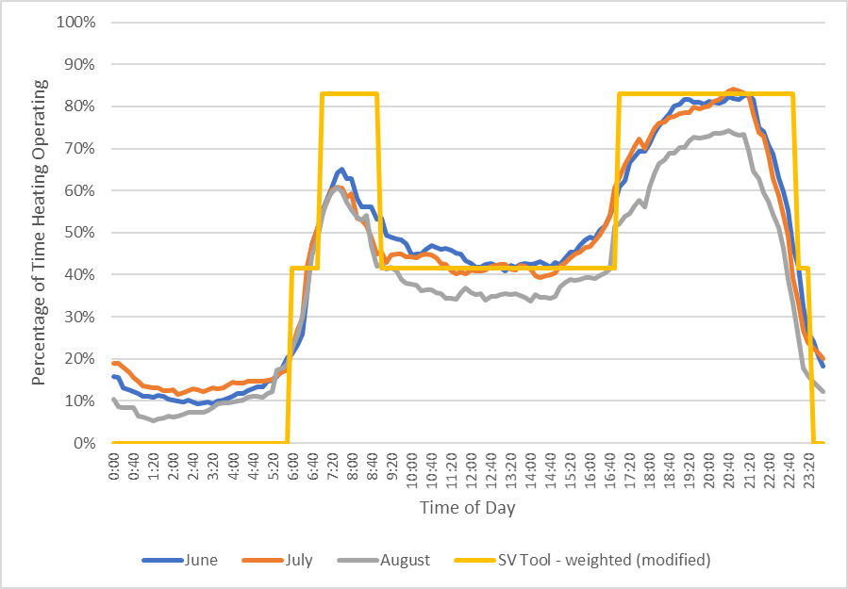

Figures 16 (b) to (d) show that the weekday and weekend heating profiles are quite similar, although on weekends the heating is first switched on later in the morning and is operated more during the middle period of the day – this is expected as people are likely to rise later on the weekends, and houses tend to have a higher level of occupancy throughout the day on weekends[[127]](#footnote-128). There is a much more pronounced morning peak heating period on weekdays, compared to weekends, when the morning peak is much broader and extends to around noon. The operating profile of the heating in the late afternoon and evenings is similar on weekdays and weekends, although the data for June and August suggest heating is used less during the evening on weekends in these months. Heating during the middle period of the day on weekends is higher in July (around 55%) compared to either June (around 50%) and August (around 35%). This most probably reflects the differences in daytime temperatures during these months.

The heating operating profile data has also been used to estimate the average daily operating time of the heaters from June to August, on weekdays, weekends and on all days. The results of this analysis are shown in Table 14. The daily averages are similar in June (10.6 hours/day) and July (10.5 hours/day). The average daily usage is higher in July on the weekends compared to June, and is higher on weekdays in June compared to July. The average daily operating times in August (8.9 hours/day) are the lowest. As expected, the average daily operating time on weekends is higher than on weekdays in June and July, although is lower in August. Across all houses, the average total operating time of the heating over the winter months June to August was 920 hours. If we assume a heating season that runs from April to November, and that heating operating time is proportional to heating degree days (HDD)[[128]](#footnote-129), this suggests an average total annual operating time for the heating of up to 1,669 hours[[129]](#footnote-130).

Table 14: Average daily operating time of heating in Retrofit Trial houses

|  |  |  |  |
| --- | --- | --- | --- |
| **Period** | **June** | **July** | **August** |
| Weekdays (hrs/day) | 10.5 | 10.2 | 9.0 |
| Weekends (hrs/day) | 10.9 | 11.3 | 8.8 |
| All days (hrs/day) | 10.6 | 10.5 | 8.9 |
| Month (hours) | 318 | 326 | 276 |

* + 1. Heating temperature profile

The operating time data collected from the fourteen houses was correlated with the internal temperature data, and used to calculate the average internal temperature when the heating was operating[[130]](#footnote-131). As there was little use of the heaters from midnight to 6:00 am, the averages obtained from this approach are less reliable for this night-time period. The results for the 6:00 am to midnight period are much more reliable.

Figures 18 (b) to (d) show the average daily internal temperature profile of the fourteen *Comprehensive Retrofit Trial* houses over the winter months, with the data segmented into all days, weekdays and weekends. Figure 18 (a) provides a direct comparison of the three winter months, based on all days in each month. The profiles were very similar across the three winter months. The average temperatures in the heated areas of the houses were much lower when the heating was first switched on in the morning around 6:00 am, around 16.0 to 16.5oC, and rose gradually during the day so that from mid-afternoon to early evening (2:00 pm to 6:00 pm) they were in the 18.5oC to 19.0oC range. During the main evening peak heating period, the temperatures were generally in the 19.0oC to 19.5oC range. Average internal temperatures in the heated areas were much lower from midnight to 6:00 am. Where houses operated their heating at night, they usually employed a thermostat setting in the range of 14oC to 15oC.

Figures 18 (b) to (d) show that the heating temperature profiles were similar on the weekdays and weekend from around 11:00 am to midnight, but that the internal temperatures were generally lower on the weekend. This was because the heating was switched on later in the morning on weekends, when the internal temperatures were lower.

Figure 18: Average internal temperatures in all houses when heating operating

|  |  |
| --- | --- |
| (a) June to July, all days | (b) June |
| (c) July | (d) August |

The NatHERS rating tools assume that the living areas of the houses are heated to 20oC from 7:00 am to midnight, and SV’s Tool also assumes that the living areas are heated to 20oC. Both tools assume that bedrooms are heated to 18oC – if the temperatures in the living and bedroom areas are weighted 65%:35%, this suggests an average temperature of 19.3oC. The data from the *Comprehensive Retrofit Trial* houses suggests that, on average, houses are heated to lower temperatures, especially during the morning and early afternoon, meaning that these tools may be over-estimating the heating loads.

* 1. Characteristics of gas ducted heating systems

Thirteen of the houses that participated in the *Comprehensive Retrofit Trial* used gas ducted heating as their main form of heating, and the existing heater was replaced with a new high efficiency gas ducted heater at twelve of the houses[[131]](#footnote-132). Metering equipment was used to monitor the gas and electricity consumption of the heaters, providing insights into the operation of older and new gas ducted heaters in houses.

The key energy performance parameters of the gas ducted heaters measured during the *Trial* are provided in Table 15. This includes: the Star Rating of the original and replacement heaters[[132]](#footnote-133), an indication of their relative energy efficiency; the gas pilot rate of the existing heaters (MJ per hour) and the annual gas consumption of the gas pilot (MJ per year), assuming that it is not switched off during the summer months[[133]](#footnote-134); the average maximum electrical power consumption of the heaters when operating (Watts) and the estimated daily (kWh per day) and annual (kWh per year) electrical power consumption of the heaters[[134]](#footnote-135); and, the electrical consumption of the heaters as a percentage of their gas consumption[[135]](#footnote-136).

Table 15: Characteristics of gas ducted heaters installed in the *Comprehensive Retrofit Trial* houses

|  |  |  |  |  |  |  |  |  |  |  |  |  |
| --- | --- | --- | --- | --- | --- | --- | --- | --- | --- | --- | --- | --- |
| House No. | Original gas ducted heater | | | | | | | Replacement heater | | | | |
| Star Rating | Gas Pilot (MJ/day) | Gas Pilot (MJ/yr) | Av. Elec Power (Watts) | Av. Elec. Use (kWh/day) | Elec Use (kWh/yr) | Elec as % gas | Star Rating | Av. Elec Power (Watts) | Av. Elec. Use (kWh/day) | Elec Use (kWh/yr) | Elec as % gas |
| CR1 | 1.6 | 21.9 | 7,992 | 320 | 3.36 | 487 | 1.58% | 6.0 | 690 | 3.66 | 555 | 3.51% |
| CR2 | 2.1 | 19.3 | 7,045 | 410 | 3.54 | 451 | 2.87% | 6.0 | 534 | 3.33 | 402 | 3.74% |
| CR3 | 2.5 | 23.7 | 8,651 | 382 | 1.66 | 229 | 1.77% | 5.8 | 642 | 2.21 | 319 | 4.43% |
| CR4 | 2.1 | 19.3 | 7,045 | 406 | 1.74 | 282 | 2.48% | 6.0 | 487 | 1.20 | 214 | 3.31% |
| CR6 | 2.0 | 16.8 | 6,132 | 459 | 2.05 | 443 | 2.04% | 5.8 | 543 | 2.33 | 418 | 3.40% |
| CR7 | 3.5 | - | - | 324 | 1.66 | 280 | 2.27% | - | - | - | - | **-** |
| CR8 | 2.0 | 19.3 | 7,045 | 422 | 1.96 | 308 | 2.17% | 5.8 | 473 | 1.93 | 250 | 3.87% |
| CR9 | 2.7 | - | - | 511 | 2.90 | 416 | 2.69% | 5.8 | 423 | 3.68 | 451 | 3.70% |
| CR10 | 3.1 | 19.2 | 7,008 | 593 | 1.92 | 349 | 2.51% | 5.8 | 489 | 2.24 | 346 | 3.55% |
| CR11 | 2.8 | - | - | 313 | 1.23 | 121 | 1.33% | 6.0 | 441 | 1.65 | 173 | 3.39% |
| CR12 | 2.1 | 11.6 | 4,234 | 252 | 1.69 | 223 | 1.69% | 6.0 | 494 | 2.02 | 239 | 4.35% |
| CR13 | 3.1 | 13.6 | 4,964 | 364 | 2.02 | 282 | 1.71% | 6.0 | 659 | 5.08 | 639 | 4.25% |
| CR14 | 4.0 | - | - | 476 | 1.86 | 241 | 2.27% | 6.0 | 566 | 1.97 | 262 | 3.80% |
| Av. | 2.6 | 18.3 | 6,679 | 402 | 2.12 | 316 | 2.11% | 5.9 | 537 | 2.61 | 356 | 3.78% |

The original gas ducted heaters at the houses were very inefficient. The Gas Energy Ratings of most heaters were in the range of 1.6 to 3.1 Stars, although a few of the houses had higher efficiency models, 3.5 Stars (CR7) and 4.0 Stars (CR14). The average rating of the heaters was 2.6 Stars. The low star-rated heaters have a low conversion efficiency[[136]](#footnote-137), and most have a gas pilot light that can be responsible for a considerable amount of gas consumption. Four of the houses had heaters with an electronic ignition and no pilot light (CR7, CR9, CR11, CR14). At the other houses the consumption of the gas pilot light ranged from 11.6 to 23.7 MJ per day, with the average being 18.3 MJ per day. This corresponds to an annual gas consumption of 4,234 to 8,651 MJ per year (average of 6,679 MJ per year), if the pilot light is not switched off during the warmer months. The gas pilot consumption is fixed, and is independent of how much the heater is used. This means that simply replacing old gas ducted heaters with new heaters with an electronic ignition can provide a significant energy saving. The new heaters are also likely to have a higher conversion efficiency, generating further savings.

The data collected during the *Trial* has also highlighted the significant electricity consumption of gas ducted heaters. This is largely due to the main air circulation fan, but the combustion air fan and control electronics of the heaters also consume electricity. The average maximum power consumption of the original heaters when operating ranged from 252 Watts to 593 Watts (average of 402 Watts), and in the pre-retrofit period their average daily electricity consumption ranged from 1.23 to 3.54 kWh per day (average of 2.12 kWh per day). The estimated annual electricity consumption of the heaters ranged from 121 to 487 kWh per year (average of 316 kWh per year). At the high end, this electricity consumption is comparable to the annual electricity consumption of a family sized refrigerator[[137]](#footnote-138).

The replacement gas ducted heaters had an energy rating of either 5.8 or 6.0 Stars, and had an electronic ignition, so were much more efficient than the heaters they replaced. Interestingly, the new heaters tended to have a higher electrical power consumption than the heaters they replaced. The average maximum power consumption of the heaters ranged from 423 Watts to 690 Watts, with the average being 537 Watts. In some cases, even though the building shell upgrades meant that the heating had to work less after the retrofits, the electricity consumption of the new gas ducted heaters was higher than the ones they replaced. The average daily electricity consumption of the heaters in the post-retrofit period ranged from 1.20 to 5.08 kWh per day (average of 2.61 kWh per day), and the estimated annual electricity consumption varied from 173 to 639 kWh per year (average of 356 kWh per year). This meant that at some houses, the gas savings were offset to some extent by an increase in the electricity consumption.

The electricity consumption of the gas ducted heaters is due mainly to their air circulation fan, so the increase in the electricity consumption of the heaters means that they had more powerful fans. It is not known why this is. It may be due to the rated capacity of the replacement heaters being larger than the rated capacity of the original heaters, and it may be due to manufacturers installing more powerful air circulation fans to accommodate the increasing size of new houses, or installation of the system in a roof-space.

The metered daily gas and electricity consumption of the gas ducted heaters was used to identify the relationship between their gas and electricity consumption. The results of this analysis are shown in Table 15, and in Figure 19 (below) we show the percentage electricity use plotted against the heaters’ energy rating. In all cases, the electricity consumption of the heaters (when expressed in MJ) was only a small percentage of their gas consumption. For the original heaters, this ranged from 1.58% to 2.87% (average of 2.11%), and for the new heaters this ranged from 3.31% to 4.43% (average of 3.78%). The percentage electricity use was higher for the new, more efficient, gas ducted heaters. This was partly due to them having a higher conversion efficiency, and therefore lower gas use, and partly due to them having more powerful air circulation fans.

Figure 19: Relationship between the Gas Energy Rating and the percentage electricity use

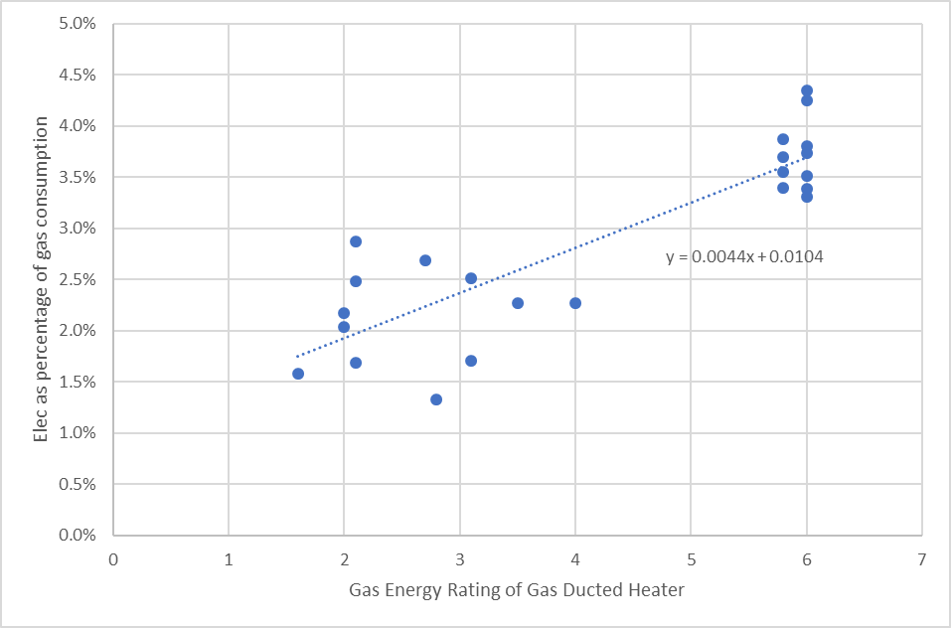

The general trend of an increasing percentage of electricity consumption with increased energy rating is evident in Figure 19. There is some variation for a given Gas Energy Rating, even for the same model of heater. This is because the power consumption of the air circulation fans depends on the pressure that the fans operate against, and this depends on: the diameter and length of the ductwork, and its layout; whether or not the ductwork runs under the floor or through the roof-space; the type of outlets used to inject the heated air into the house and the status of the vents on these outlets; the layout of the house and any internal obstructions to air flow; and, the state of the filter on the return air grille.

The energy ratings used on the Gas Energy Rating labels, and the annual energy consumption figure[[138]](#footnote-139), account for both the gas and electricity consumption of the heaters. Because the electricity consumption of the heaters is only a small percentage of the gas consumption, the efficiency of the air circulation fans used in the heaters has only a small impact on the energy ratings and the energy consumption figure. However, as noted above, the annual electricity consumption of the heaters can be quite high[[139]](#footnote-140) – as high as a new family sized refrigerator - and the cost and greenhouse impact of the electricity consumption, per unit of energy use, is higher than for natural gas. The Gas Energy Rating labels would be much more informative for consumers if they provided information on both the annual gas and electricity consumption of the heaters, as well as an energy rating for their electricity use. This would allow consumers to better understand the cost of both the gas and electricity used by the gas ducted heaters, and would provide an incentive for heater manufacturers to use higher efficiency air circulation fans to reduce this electricity consumption.

1. Summary and conclusions
   1. Summary
      1. Background to the study

Older existing (pre-2005) houses in Victoria are quite inefficient, resulting in much higher energy use than is necessary. SV’s *On-Ground Assessment* (*OGA*) study found that, with an average House Energy Rating of only 1.8 Stars, existing houses had inefficient building shells, due to being poorly insulated and having a high level of air leakage. They were also found to contain major appliances and lighting that were considerably less efficient than the average new appliances sold today. The *OGA* study found that significant energy and greenhouse gas savings were possible if a very comprehensive package of energy efficiency upgrades was applied to the houses – 58% of average household gas use and 33% of average household mains electricity use.

Following the *OGA* study, SV undertook a series of retrofit trials in houses, to investigate the actual costs and impacts of a range of common energy efficiency upgrades. These trials focussed on single energy efficiency upgrades.

The study described in this report investigated the impact of a comprehensive package of energy efficiency upgrades (or retrofits) applied to existing houses. The key focus of the study was on building shell (draught sealing and insulation) and heating system upgrades that could significantly reduce heating energy consumption, while also improving the winter comfort of the houses. As well as reducing energy bills, improved thermal comfort during winter months is believed to provide health benefits for the occupants, especially for vulnerable and low income households, leading to further financial savings for the households and society.

Heating is the main area of energy use in Victorian houses. It currently accounts for around 57.4% of total Victorian residential energy consumption (73.4% of gas use and 10.3% of electricity use), and 28.6% of Victorian greenhouse gas emissions from residential energy use. Water heating, which accounts for 19.0% of all residential energy consumption (23.8% of gas and 11.5% of electricity), is the next highest area of energy use. Other key end-uses are refrigeration (18.4% of electricity) and lighting (12.4% of electricity). Together with heating and water heating, these are the major residential energy end-uses – they account for 97.2% of gas use and 52.6% of electricity use. This makes them the key end-uses to focus on to achieve large energy, energy bill and greenhouse savings in existing houses.

Heating energy consumption can be reduced by increasing the energy efficiency of a house’s building shell, and by upgrading the efficiency of the heating system. Building shell upgrades increase thermal comfort in both winter and summer, and can reduce summer energy consumption if air conditioning is used for cooling. Building shell upgrades also reduce peak energy demand for heating in the morning and evening on cold winter days, and in the late afternoon on hot summer afternoons.

The International Energy Agency recommends that countries implement policies and programs to improve the energy efficiency of their building stock, including existing houses, by increasing the uptake of high efficiency appliances and undertaking deep energy efficiency retrofits. This is seen as a key element of country strategies to reduce greenhouse gas emissions to address climate change. Australian Governments are responding to this challenge by developing a *Trajectory for Low Energy Existing Homes*, seeking to unlock the wide range of benefits that can result from comprehensive energy efficiency upgrades.

* + 1. How the study was undertaken

The *Comprehensive Retrofit Trial* was undertaken at fourteen existing houses located in Melbourne. SV engaged MEFL (first five houses) and EnviroGroup (all other houses) to: recruit the households, based on eligibility criteria established by SV; undertake site inspections to confirm household eligibility for the trial and collect data; conduct householder surveys; collect historical energy billing data; install and remove metering equipment; identify and negotiate the final retrofit package for each house; and, manage the retrofit process. The site data, energy billing data, householder surveys and metering data was provided to SV for analysis.

The participating houses had an average floor area of 132 m2 and an average of 3.9 occupants. Most had brick-veneer walls and suspended timber floors, and most had at least some level of ceiling insulation (typically R1.5 to R2.0); the walls and floor were generally not insulated. The average air leakage rate of the houses was 1.45 air changes per hour. Thirteen of the 14 houses used gas ducted heaters as their main form of heating; the heaters were generally quite old and inefficient (2 to 3 Stars), most had a gas pilot light, and the associated ductwork was often old and in poor condition. The average total gas consumption of the households was 70,196 MJ per year, with 50,712 MJ per year (72%) used for heating. Average electricity consumption was 4,655 kWh per year. The gas consumption of the houses was above the Victorian average for a four-person household, although the electricity consumption was lower than the average[[140]](#footnote-141).

A comprehensive package of energy efficiency upgrades, to a total value of $12,000 to $13,000, was applied to each of the houses. The focus of the package was on significantly improving the thermal comfort of the houses and saving energy during the winter months though insulation and draught sealing, and upgrading the energy efficiency of the heating systems. The balance of the retrofit package was targeted towards the other major energy end-uses such as water heating, refrigeration and lighting.

All houses had some level of comprehensive draught sealing undertaken, and some insulation improvements: 9 houses had ceiling insulation top-ups; one house had ceiling insulation added to an uninsulated ceiling; 9 houses had cavity wall insulation installed; and, 8 houses had under-floor insulation installed. Old gas ducted heaters were replaced at 12 houses, and gas heating ductwork was replaced at 11 houses. Water heater, refrigerator and lighting upgrades were all undertaken at 7 of the houses. The cost of the retrofit packages varied from $10,061 to $21,110, with the average cost being $13,037.

Most of the houses used gas ducted heating as the main form of heating (one had a room reverse-cycle air conditioner), and gas water heating (two houses had electric water heaters, but also had gas reticulated). Where the existing gas ducted heating system was upgraded, it was replaced by a new high efficiency model, and in most cases the ductwork was also replaced with new high efficiency ductwork. Existing gas water heaters were either upgraded to a new high efficiency model or, in some cases, to a gas-boosted solar water heater. The electric water heaters were replaced with a high efficiency gas water heater.

Where possible, metering equipment was installed in the houses in the middle of May, the retrofits undertaken around the end of June over a one- to two-week period, and the metering equipment removed around the end of September. This meant that the houses were monitored over the main winter heating period. The pre-retrofit data was used to benchmark the household’s energy use and comfort levels, and this was compared with the post-retrofit data to identify the impact of the retrofits on household energy consumption, use of the heating system, thermal comfort levels, and lighting use.

This project did not explore the option of replacing existing gas heating and/or water heating with a high efficiency electrical option, such as high efficiency reverse-cycle air conditioning or high efficiency heat pump water heater. This was partly due to the higher cost of these electrical options compared to upgrading to a high efficiency gas option, and partly due to the preferences of households. As rooftop PV systems become cheaper, making it feasible to install larger systems, it is likely that increasing numbers of households will replace gas appliances with high efficiency electrical appliances as part of a retrofit or renovation project, or at the end of the gas appliance’s life.

* + 1. Overall impact of the energy efficiency upgrade packages

On average, the retrofit packages implemented at the fourteen houses resulted in estimated annual gas savings of 20,016 MJ per year (28.5% of initial gas use), and annual electricity savings of 794 kWh per year (17.1% of initial electricity use). As the retrofit packages focussed on building shell and heating system upgrades, and as most of the houses were heated with gas, the gas savings were considerably larger than the electricity savings. The average reduction in energy-related greenhouse gas emissions was 2.05 tonnes per year, and the average energy bill saving was $663 per year (based on current energy prices), although this did not include any savings associated with summer cooling and, in some houses, did not include any savings associated with secondary heating. This gave an average payback of period of 19.7 years on the investment in the energy efficiency upgrades, based on the energy bill savings.

The impact of the retrofit packages varied widely from house to house. It depended on the initial efficiency status of the house and its physical size, the number of occupants, and occupant behaviours, and on the retrofit measures applied at each house.

In general, the energy savings were largest at the houses with the highest initial gas use, as these had high gas heating use and therefore the largest potential to save energy from building shell and heating system upgrades. At two of the houses (CR9 and CR11), the annual gas savings were less than might be expected. This was because at these houses an existing electric water heater was replaced with a high efficiency gas water heater, resulting in a significant electricity saving and a significant increase in gas consumption, off-setting the savings from the building shell and heating system upgrades to some extent.

The houses with the largest electricity savings were those that had either an electric water heater replaced with a gas water heater, an existing refrigerator replaced with a high efficiency refrigerator, or both. At houses where a reasonable number of halogen downlights were replaced with LEDs, this also generated significant additional electricity savings.

Building shell and heating system upgrades were undertaken at all houses. The average cost of this upgrade type was $10,228 (78.5% of the total retrofit package cost), and the average energy bill saving was $441 per year (65.7% of the total energy bill savings), giving an average payback of 23.2 years. As expected, the building shell and heating system upgrades dominated the gas savings (97.5% of the total), but accounted for only a small proportion of the electricity savings (6.8%). The average greenhouse gas saving achieved was 1.16 tonnes per year, 56.3% of the total.

Table 16: Average impact of the different types of retrofits – across all 14 houses

|  |  |  |  |  |  |  |
| --- | --- | --- | --- | --- | --- | --- |
| Retrofit type | Average cost  ($) | Average annual energy saving | | Average greenhouse gas saving (kg/yr) | Average energy bill saving  ($/yr) | Average payback period (Years) |
| Gas (MJ/yr) | Electricity (kWh/yr) |
| Building shell & heating | $10,228 | 19,844 | 54 | 1,162 | $441 | 23.2 |
| Water heater | $1,533 | 172 | 361 | 435 | $102 | 15.1 |
| Refrigerator | $1,061 | - | 308 | 363 | $98 | 10.8 |
| Lighting | $214 | - | 71 | 84 | $22 | 9.5 |
| All | $13,037 | 20,016 | 794 | 2,045 | $663 | 19.7 |

Table 17: Average impact of the different types of retrofits – when implemented

|  |  |  |  |  |  |  |
| --- | --- | --- | --- | --- | --- | --- |
| Retrofit type | Average cost  ($) | Average annual energy saving | | Average greenhouse gas saving (kg/yr) | Average energy bill saving  ($/yr) | Average payback period (Years) |
| Gas  (MJ/yr) | Electricity (kWh/yr) |
| Building shell & heating | $10,228 | 19,844 | 54 | 1,162 | $441 | 23.2 |
| Water heater | $3,067 | 344 | 722 | 871 | $203 | 15.1 |
| Refrigerator | $2,123 | - | 616 | 727 | $196 | 10.8 |
| Lighting | $427 | - | 143 | 168 | $45 | 9.5 |

The refrigerator, water heating and lighting upgrades were all applied at seven (50%) of the fourteen houses. The average payback period of these upgrades was considerably lower than for the building shell and heating system upgrade package, consistent with the results of the *OGA* study. Of these, the water heater upgrades had the highest average cost ($1,533 across the fourteen houses), and generated the largest electricity (361 kWh per year), and energy bill ($102 per year) saving. Most of the savings came from the houses where the electric water heaters were replaced with a high efficiency gas water heater. The average cost of the refrigerator upgrade was $1,061, and these also generated significant electricity (308 kWh per year) and energy bill ($98 per year) savings. The lighting retrofits had the lowest average cost, and lowest savings, although they were the most cost-effective of the upgrades (9.5-year payback). In most houses, only limited lighting retrofits were undertaken. This is likely to have been partly due to the impact that the *Victorian Energy Upgrades (VEU)* scheme has had on transforming residential lighting in Victoria over the last decade.

The upgrade costs and payback periods used in Tables 16 and 17 are based on the *full cost* of implementing the upgrades. In some cases, discounts or rebates are available that reduce theses costs[[141]](#footnote-142). The heater, water heater, refrigerator, lighting, ductwork and draught sealing upgrades are all currently eligible for a financial incentive. In addition to this, upgrades of the heating system, water heating and refrigerator are usually undertaken when the existing appliance has either reached its end of life or is close to it, and will need to be replaced anyway. In this case, the cost of upgrading to an energy efficient option is much less than the full replacement cost. If these factors are taken into account, the effective costs of the upgrade packages to the households, and therefore the payback period, is somewhat lower.

* + 1. Impact of the building shell and heating system upgrades

The average energy consumption of the main heating system used at the houses prior to the retrofits was 51,026 MJ per year. The building shell and heating system upgrades are estimated to have reduced this by an average of 19,873 MJ per year, or 38.9%. The heating energy savings ranged from a low of only 8.9% up to 58.3%: savings of 30% or greater were achieved at 11 (78.6%) of the houses; and, heating energy savings of 40% or greater were achieved at 7 (50%) of the houses. Some houses used smaller room electric or gas heaters to supplement the main heating system in some areas of the houses. The upgrades resulted in some energy savings for these heaters, but they were not always metered, so the full extent of these savings are unknown.

The houses with the largest heating energy savings, CR12 (58.3%) and CR8 (54.4%), were both small brick-veneer houses with fairly high air leakage rates. They both had some insulation on the ceilings (around R1.5 to R2.0), and walls and floors that were uninsulated, and both had very old gas ducted heating systems and ductwork.

The houses with the lowest heating energy savings either had limited building shell and heating upgrades (CR5 and CR13), and/or modified their heating use after the retrofits in some way: the occupants of CR13 (8.9% saving) operated the new gas ducted heater overnight on cold nights instead of an electric column heater used in one bedroom; the occupants of CR5 (9.0% saving) increased internal temperatures after the retrofits; house CR9 (21.1% saving) already had some ceiling and underfloor insulation, and a gas ducted heater with an electronic ignition (no gas pilot), and the occupants significantly increased the use of their heater for a few weeks immediately after the retrofits.

The average electricity saving achieved was quite small - only 54 kWh per year (1.2% of the houses’ original electricity use) - although this varied considerably from house-to-house. Most houses had gas ducted heating, and the electricity consumption of the gas ducted heaters often increased after the retrofits, because the electrical power consumption of the new heaters was generally higher than for the old heaters they replaced. The highest electricity savings were achieved at those houses that had supplementary electrical heating (CR1, CR6), where the existing gas ducted heater was not replaced (CR7), or where the main heating was electric (CR5, which had a room reverse-cycle air conditioner).

The houses with the highest *percentage* heating energy savings (see Table 9) did not necessarily have the highest *absolute* heating energy savings, or the highest energy bill savings. Generally, the houses with the highest initial heating energy consumption had the highest absolute savings. Where the retrofits reduced the energy consumption of any supplementary electric heating, this significantly increased the energy bill savings, due to the relatively high cost of mains electricity.

The savings and paybacks presented in Tables 16 and 17 are based *only* on the energy bill savings, resulting in a fairly long payback period (23.2 years) for the building shell and heating system upgrades. These upgrades can significantly improve thermal comfort during the winter months, and the building shell upgrades will also improve summer comfort. There is now a significant body of evidence from overseas studies that houses that are too cold during winter and too hot during summer create or exacerbate a range of health issues, and that improving thermal comfort can have significant health benefits, reducing medical costs. Currently there is no a robust Victorian (or Australian) evidence base for these health benefits, but high quality studies from the UK, EU and New Zealand suggest that the health savings could be around three times larger than the energy bill savings and, if taken into account, would significantly increase the overall savings achieved and dramatically lower the payback period.

Even then, the energy bill and health benefits resulting from comprehensive building shell and heating system upgrades at existing houses are likely to represent only part of the overall benefit. The reduction of work and school absences associated with health issues caused by houses that are too cold/hot, and the reduction of electricity peak demand in both summer and winter, could provide significant additional benefits. The greenhouse gas savings resulting from the energy savings also has an economic value.

* + 1. Impact of the appliance and lighting upgrades

The lighting and appliance upgrades were all undertaken at half of the houses, and the average impact *at the houses where these retrofits were undertaken* is shown in Table 17.

The average energy savings from the water heater retrofits are dominated by the electricity savings, which averaged 722 kWh per year. These savings occurred at the two houses (CR9 and CR11) that had electric water heaters replaced. At these houses, the average electricity saving was 2,551 kWh per year, resulting in average greenhouse gas savings of 2.34 tonnes per year, and average energy bill savings of $374 per year, giving an average payback of 11.5 years (see Table 11). The gas consumption also increased significantly, due to the installation of the new high efficiency gas water heaters, and this off-set some of the energy savings from the building shell and heater upgrades. The energy savings at house CR9 – where an existing gravity fed water heater was replaced with a high efficiency gas instantaneous water heater – were less than expected, due to increased hot water use by the household after the retrofit.

The average gas savings from the water heater retrofits was only 344 MJ per year. This is lower than expected, as the savings at the houses where a gas water heater was replaced with another gas water heater were off-set by the increased gas use at those houses where an electric water heater was replaced with gas. For those houses where there was a gas-for-gas replacement, the average gas saving as 5,324 MJ per year, resulting in average energy bill savings of $135 per year, and an average payback of 23.1 years. The gas savings were highest at house CR5, where a gas storage water heater was replaced with a gas-boosted solar water heater. However, the high cost of the gas-boosted solar water heater meant that even though this had the largest gas saving (10,550 MJ per year), it still had an above average payback period.

For the houses that had refrigerator retrofits, the average annual electricity saving was 616 kWh per year, 12.0% of the houses’ average electricity use. On average, the replacements reduced the refrigerators’ energy consumption by 67.4%. The highest energy savings were achieved at the houses that had old, inefficient, refrigerators, and at one house (CR13) where separate refrigerator and freezer were replaced with one new refrigerator-freezer.

The average electricity saving across the seven houses that had lighting upgrades was 143 kWh per year, 3.6% of their average electricity use. The energy and energy bill savings were highest, and the payback lowest, at those houses where a significant number of halogen downlight lamps were replaced with LEDs. The energy savings were much lower in most of the other houses, either because only a few inefficient lamps were replaced, or because the lamps that were replaced were in low usage areas.

* + 1. Householder perceptions of the retrofit impacts

Householder surveys were conducted before and after the retrofits were undertaken, to obtain the occupants’ perceptions of the level of winter comfort of their houses and the degree of difficulty heating them, and their level of satisfaction with the heating, water heating, lighting and refrigerators, if these were to be upgraded.

In most cases, prior to the retrofits the occupants found their houses to be reasonably comfortable during the winter months when the heating was operating, although they were often slow to heat up, and cooled down quickly once the heating was turned off. The inside temperatures were often uneven throughout the houses, and some areas or rooms were noticeably cooler. Draughts were noticeable in some of the houses. The average rating for “winter comfort” was 3.3 on a scale of 1 to 5 prior to the retrofits, and this increased to an average of 4.7 afterwards; the average rating for “difficulty of heating” decreased from 2.4 to 1.3 (with a rating of 1 indicating no difficulty). The fact that the average “winter comfort” rating of the houses was higher than 3 (comfortable) and the average “difficulty of heating” rating was just above 2 prior to the retrofits, suggests that even though the houses had poor building shells and inefficient heating, the heating systems were sized so that they could provide sufficient heat to keep the house warm when operating. However, some houses used plug-in electric or gas room heaters to supplement the main heating system.

After the retrofits, the occupants reported that the houses were warmer, less draughty and more comfortable, heated up more quickly and held the heat for longer once the heating was turned off, and had more even and consistent inside temperatures. Householders often reported that they now ran the heating less frequently and, in some cases, could turn the thermostat setting on the heating down and still feel comfortable.

The significant increase in winter comfort was achieved *at the same time* thatthere was a very significant reduction in the heating energy use (38.9% on average), and therefore energy bills. The improved comfort noted by the occupants may also have health benefits for the householders in the longer term, providing further cost savings, for both the households and society.

It is likely that the building shell upgrades would have improved the summer comfort of the houses, and reduced summer cooling bills where they used air conditioning, however this data was not collected as part of the study.

Many of the gas ducted heaters at the houses were quite old and inefficient, and some had poor quality ductwork. Some were starting to break down more frequently, and in some cases the pilot lights would occasionally go out. The old heaters were found to be noisy; in some cases, this meant that the heating was not operated at night or when the children were in bed. The new heaters were found to work better, with the average satisfaction rating increasing from 3.0 to 4.7. They were generally found to be quieter, and the modern control systems used were also seen as an advantage.

As with the gas ducted heaters, some of the older water heating systems at the houses were becoming unreliable and breaking down more frequently, or had pilot lights that occasionally went out. In general, householder satisfaction with their water heater increased after the retrofits, from an average rating of 3.5 to 4.8. This was due to the water being heated more quickly, a higher water pressure or flow rate at the shower, and less delay before the hot water reached the outlets. This was especially the case at house CR9, where an old gravity-fed electric storage water heater was replaced with a high efficiency gas instantaneous water heater. At the one house where the satisfaction with the water heater decreased (CR14), this was because the new 5 Star gas storage system was found to heat the water more slowly, and resulted in a lower flow rate.

The refrigerator retrofits showed the largest increase in householder satisfaction, from an average rating of 2.3 to 4.8. In general, the older fridges were found to be noisier than the new ones, and some of the old fridges were starting to show signs of “wear and tear”, such as leaking door seals that led to excessive condensation inside the refrigerator. The increased satisfaction with the new fridges was due to them being quieter, and having better controls. Where a refrigerator with a top-mounted freezer was replaced with one with a bottom mounted freezer, the occupants found that this provided easier access and was “ergonomically better”.

Householder satisfaction with the lighting increased slightly after the retrofits, from an average rating of 3.0 to 3.8. The level of satisfaction depended mainly on the light levels provided by the lighting, the time it took for the lights to switch on and come up to full brightness, and the physical appearance of the lighting. In general, the lighting retrofits tended to have little impact on the perceived light levels or the time taken for the lights to switch on, especially where LEDs were used as the replacement. In some houses, the increased satisfaction with the new lighting was due to the anticipated energy savings from replacing “power hungry” lighting such as halogen downlights.

* + 1. Practical issues

There were a number of issues associated with the retrofits undertaken at the houses. Most related to the quality of the work undertaken by the installers, and/or a failure to clean up properly afterwards. Better quality control processes, and checking of the completed work, would have avoided many of these issues. Householders preferred installers who came well prepared, explained clearly what would happen and why, gave attention to detail, and cleaned up properly afterwards.

One issue was that for many of the ceiling insulation top-ups, the existing insulation was fully removed and then replaced by new insulation with a high R-value. This adds considerably to the cost, and may not have been necessary. Clear guidelines may be necessary for installers and householders, to help ensure that existing insulation is only removed when necessary.

A number of issues were experienced with the cavity wall insulation, the most complex of the upgrades undertaken: the initial assessment and quotation did not always take relevant site issues into consideration, meaning that the final job was more expensive than anticipated and/or that in practice some sections of wall could not be insulated; there were also examples of poor installation, such as the bottom of wall cavities not properly blocked off (allowing insulation to fall into the sub-floor space), bricks not being replaced after insulation was installed, poor quality mortar used to patch drill holes, and insulation blocking up exhaust vents because adequate screening had not been provided.

Draught sealing was another area where the installation work was not always of high quality – in some houses the weather stripping came away from the door frames and, in one case, the installation of the weather stripping meant that the doors wouldn’t close properly.

Installation issues also occurred with the replacement of the gas heating ductwork. It was not always installed properly, and in some cases sections of the new ductwork became detached, reducing the heating energy savings until it was identified and rectified.

Some size compatibility and electronic compatibility issues occurred with the lighting retrofits, although these were easily identified and rectified. In a few cases the light levels after the retrofits were lower than before. This issue can be easily avoided by selecting a replacement lamp with a similar light output and similar beam shape to the lamp it is replacing.

* + 1. Use of heating in Victorian houses

The data collected through the *Comprehensive* *Retrofit Trial* provides insights into how Victorian households use their heating during the main winter months, both in terms of the times of day that heating is normally operated, and the temperatures that the houses are heated to. The aggregated data from the households suggests that, on average: there is little use of heating during the early morning hours from midnight to 6:00 am – typically the heating is only operated for between 10% to 15% of the time during this period; there is a fairly pronounced morning peak heating period from around 6:30 am to 9:00 am, and a broader evening peak heating period from around 5:00 to 11:00 pm; heating use during the morning peak period (used for around 60% of the time) is markedly lower than during the evening peak (used for around 80% to 85% of the time); and, heating is typically used for around 40% of the time during the middle of the day. The data also shows that the morning heating peak is much more pronounced on weekdays. On weekends, the heating tends to come on later in the morning, and there is higher usage of the heating during the middle of the day.

In the *Retrofit Trial* houses, the heating was used for an average of 10.6 hours per day in June, 10.5 hours per day in July, and 8.9 hours per day in August, or for an average of 920 hours during the winter months. This suggests average annual usage of up to 1,669 hours per year.

The heating temperatures achieved in the houses seem to be lower than is often assumed – generally it is assumed that households heat to around 20oC in the living areas, and around 18oC in bedroom areas. In the *Retrofit Trial* houses, the average temperature in the heated areas of the houses was in the range of 16oC to 17oC when heating is first switched on in the morning (around 6:00 am), increased slowly to reach around 18oC at midday and around 19oC at 4:00 pm, and was in the range of 19.0oC to 19.5oC from 4 pm to midnight. As noted above, there was little use of heating during the early morning hours. Where it was used, it was often run on a “night set-back”, with the thermostat set in the range of 14oC to 15oC.

* + 1. Energy performance of gas ducted heaters

Many of the existing gas ducted heating systems at the *Comprehensive* *Retrofit Trial* houses were very inefficient. The average Gas Energy Rating of the heaters was only 2.6 Stars. Nine of the 13 heaters had a continuously burning gas pilot light, with a fixed daily gas consumption in the range of 11.6 to 23.7 MJ per day (18.3 MJ per day average). If the gas pilot was not switched off during the summer months, this would result in an annual gas consumption of 4,234 to 8,651 MJ per year. Simply replacing an existing heater with a pilot light with a new heater with an electronic ignition, and no gas pilot light, would therefore result in a significant energy and energy bill ($100 to $200 per year) savings.

Gas ducted heaters have quite a high annual electricity consumption in locations such as Melbourne that have colder winter weather. The electricity consumption is largely due to the main air circulation fan, but control circuits and any combustion fan (if present) also consume electricity. The existing gas ducted heaters at the houses had a maximum power consumption when operating in the range of 252 Watts to 593 Watts (average 402 Watts), and an estimated annual electricity consumption of 121 to 487 kWh per year (average 316 kWh per year). While the annual electricity consumption was much less than the gas consumption – it ranged from 1.33% to 2.87% of gas consumption (average of 2.11%) – at the higher end of the range, the annual electricity consumption was comparable to a family sized refrigerator. These are subjected to both minimum energy performance standards (MEPS) and energy labelling requirements.

The new high efficiency (average 5.9 Star rating) gas ducted heaters used as a replacement had a much lower gas consumption, due to a higher conversion efficiency and having an electronic ignition. However, their electrical power consumption was higher than the existing heaters – 423 to 690 Watts (average of 537 Watts) – as was their annual electricity consumption – 173 to 555 kWh (average of 356 kWh). The electricity consumption of the new heaters was 3.31% to 4.43% (3.78% average) of the heaters’ gas consumption. This was partly because the more efficient heaters used less gas, and partly due to their higher electrical power consumption.

Consumers are likely to be unaware of the high electricity consumption of the gas ducted heaters. While gas ducted heaters carry Gas Energy Rating Labels when sold, these do not provide any information on the likely annual electricity consumption of the heaters. A separate electrical Energy Rating Label on the gas ducted heaters would provide consumers with useful information on how efficiently the heaters used electricity and on their likely annual electricity consumption.

* 1. Conclusions

This study has shown that comprehensive energy efficiency upgrades to existing Victorian houses generate significant energy, energy bill, and greenhouse gas savings. For an average upgrade cost of $13,037, total gas consumption of the participating households was reduced by an average of 28.5%, total electricity consumption by an average of 17.1%, and greenhouse gas emissions by an average of 2.05 tonnes CO2-e per year. The average annual energy bill saving was $663 per year, based on current energy prices. In reality, the actual upgrade costs faced by households are likely to be lower, due to the availability of financial incentives for some upgrade measures and the fact that most major appliances would be upgraded when they are at, or close to, their end of life and would have to be replaced anyway.

These large energy and energy bill savings coincided with a significant improvement in the thermal comfort of the houses during the winter months, as well as increased householder satisfaction with their water heating, lighting and refrigeration. Across the houses, there was little evidence of a *rebound effect*, whereby householder behaviour reduces the energy savings, although this did vary from house to house. In some cases, household behaviour change led to further reductions in energy consumption, and in other cases it led to increases in energy consumption. In most cases where energy consumption increased after the retrofits, this was due to the original appliance being faulty or not performing well, and the increase in consumption would have occurred regardless of whether it was replaced with a high efficiency appliance or not. This is *technical* rebound and not *economic* rebound.

The fourteen houses that participated in this study were quite inefficient, and had a gas consumption that was well above the Victorian average; this is especially the case given the relatively small size of the houses. The magnitude of the energy savings achieved at the houses depended on the initial efficiency status of their building shell, major appliances and lighting, and how the households used their heating, water heating and lighting. Houses that were the most inefficient and had the highest use of energy, especially for heating, tended to have the largest overall savings and the lowest payback on the investment in the upgrade measures. Customised assessments by experienced assessors are required to identify those efficiency upgrades that will generate the largest and most cost-effective savings for a particular household.

As expected from SV’s previous *On-Ground Assessment* study, the building shell and heating system upgrades had the highest cost and, while they generated large energy and energy bill savings, had a long payback based *only* on their energy bill savings (average of 23.2 years). However, evidence from high quality overseas studies suggest that these upgrades - which improve the thermal comfort of the houses in winter and summer – could have significant health benefits, and that the reduction in health costs due to the upgrades could be around three times higher than the energy bill savings. Other benefits are likely to result from the upgrades, providing further cost savings for the households and society more generally: they are likely to reduce the incidence of damp and mould, leading to further health benefits; improved health is likely to reduce absence from school and work, improving workplace productivity and educational attainment; the building shell upgrades will reduce peak electricity demand in both summer and winter in houses that use electric cooling and heating, putting downward pressure on electricity prices; and, the greenhouse gas abatement has an economic value.

If considered as a whole, the multiple benefits of upgrading the building shell and heating systems in existing Victoria houses is likely to be much larger than the energy bill saving, making this a much more cost-effective proposition from a household and societal perspective.

Energy and energy bill savings from upgrading the energy efficiency of water heating, refrigerators and lighting can also be significant, and these upgrades are generally more cost effective than the building shell and heating system upgrades if only the energy bill savings are considered. The largest savings occur where an electric storage water heater is replaced with a more efficient option, an old inefficient refrigerator is replaced, or where inefficient halogen downlights in the main living areas of houses are replaced.

As with Sustainability Victoria’s previous retrofit trials, a number of practical issues were experienced during the retrofits, due to poor quality work undertaken by the installers. There is a need for better installation standards and guidelines, training, and better quality control procedures in the energy efficiency retrofit “industry”, to ensure better quality outcomes and greater consumer satisfaction.

The *Trial* provided the opportunity to obtain detailed data on how households use heating in Melbourne, including the frequency of use, time of use during the day, and the inside temperatures achieved when the heating is operating. The results suggest that heating is used a bit differently than is commonly assumed, and that internal temperatures are often lower than is assumed, especially in the morning and early afternoon.

Data obtained from the existing a new gas ducted heaters used at most of the houses showed that these had quite a high annual electricity consumption, and that at the higher end this was comparable to a family sized refrigerator. Often the electrical power consumption of the new, high efficiency, heaters was higher than the heaters they replaced, and the annual electricity consumption was often also higher, even though the gas consumption was much lower. Currently, the Gas Energy Rating Labels used on new gas ducted heaters don’t provide information on the heaters’ annual electricity consumption or their efficiency of electricity use (mostly due to the main air distribution fan). A separate electrical Energy Rating Label for these heaters could make this information available to consumers, and encourage manufacturers to improve the efficiency of their air distribution fans.

1. References

BRE2015 Nicol S. et al, *BRE Briefing Paper – The Cost of Poor Housing in the NHS*, Building Research Establishment, UK, 2015

BRE2018 Nicol S. et al, *The Cost of Poor Housing in the European Union*, Building Research Establishment, UK, 2018

CCC2019 *UK housing: Fit for the Future?,* Committee on Climate Change, February, 2019

Chapman2009 Chapman R, Howden-Chapman H, Viggers H, O’Dea D, Kennedy M, “Retrofitting houses with insulation: a cost-benefit analysis of a randomised community trial”, 2009, *Journal of Epidemiology and Community Health*, 63(4)

CRCLCL2018 Daly D, Halldorsson J, Kempton L, Cooper P, 2018, *Targeted review of evidence of direct and co-benefits of energy efficiency upgrades in low income dwellings in Australia*, CRC for Low Carbon Living

CoAGEC2018 *Report for Achieving Low Energy Homes*, CoAG Energy Council, December 2018

DEE2018 *Policy Framework for Hot Water Systems in Australia & New Zealand*, Energy Efficiency & Conservation Authority (NZ), Department of Environment and Energy, 2018

DEE2019 *Trajectory for Low Energy Existing Homes – Discussion Paper*, Department of Environment and Energy, 28 March, 2019

DHS2008 *Victorian Utility Consumption Household Survey 2007 – Final Report*, 10 April, 2008. Roy Morgan Research for Department of Human Services

DoIS2015a *Residential Baseline Study for Australia 2000 – 2030*, EnergyConsult for Dept. of Industry & Science (on behalf of the E3 Program), August 2015

DoIS2015b *OutputTables - Final V1.0 – AU* published in conjunction with the report *Residential Baseline Study for Australia 2000 – 2030*, EnergyConsult for Dept. of Industry & Science (on behalf of the E3 Program), August 2015

IEA2018 *Energy Efficiency 2018 – Analysis and outlooks to 2040*, International Energy Agency, 2018

Lancet2015 Gasparrini A, Guo Y, Hashizume M, Lavinge E, Zanobetti A, Schwartz J, Tobias A, Tong S, Rocklov J, Forsberg B, Leone M, De Sario M, Bell M, Guo Y-L, Wu C, Kan H, Yi S, Coelho M, Saldiva P, Hinda Y, Kim H, Armstrong B, “Mortality risk attributable to high and low ambient temperature: a multicounty observational study”, *The Lancet*, Vol 386, July 25, 2015

MED2011 Grimes A, Denne T, Howden-Chapman P, Arnold R, Telfar-Barnard L, Preval N, Young C, *Cost Benefit Analysis of the Warm UP New Zealand: Heat Smart Program*, October 2011 (Revised June 2012), prepared for the Ministry of Economic Development

PC2005 *The Private Cost Effectiveness of Improving Energy Efficiency*, Productivity Commission Inquiry, No. 36, 31 August, 2005

SV2015 *Energy Efficiency Upgrade Potential of Existing Victorian Houses*, Sustainability Victoria, December 2015

SV2016a *Halogen Downlight Retrofit Trial*, Sustainability Victoria, January 2016

SV2016b *Draught Sealing Retrofit Trial*, Sustainability Victoria, January 2016

SV2016c *Cavity Wall Insulation Retrofit Trial*, Sustainability Victoria, January 2016

SV2016d *Gas Heating Ductwork Retrofit Trial*, Sustainability Victoria, January 2016

SV2016e *Swimming Pool Pump Retrofit Trial*, Sustainability Victoria, April 2016

SV2016f *Gas Water Heater Retrofit Trial*, Sustainability Victoria, June 2016

SV2016g *Clothes Dryer Retrofit Trial*, Sustainability Victoria, August 2016

SV2017a *Refrigerator Retrofit Trial*, Sustainability Victoria, January 2017

SV2017b *Window Film Secondary Glazing Retrofit Trial*, Sustainability Victoria January 2017

TAPP2016 *Good Housing Better Health*, The Academic – Practitioner Partnership, Housing and Communities Research Group, School of Social Policy, University of Birmingham, July 2016.

WHO2018 *WHO Housing and Health Guidelines*, World Health Organisation, 2018.

1. Appendix 1 - House CR1

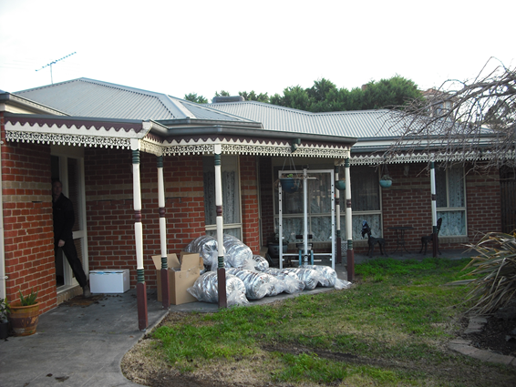

*All rooms seem to retain heat better and are more comfortable at a lower heat setting.*

*Feels a lot warmer and we use the heater less.*

* 1. The original set-up

The house is a 176 m2 brick-veneer with a concrete slab-on-ground floor and a corrugated iron roof, constructed in the early 2000s. It shows that even quite modern houses can achieve significant energy savings from energy efficiency upgrades. Prior to the retrofits, it had only R2.0 insulation batts installed on the ceiling and reflective foil laminate (RFL) in the external walls. It had a measured natural air leakage rate of 0.99 air changes per hour, which means that in winter the warm air inside the house was replaced by cold outside air, which had to be re-heated, about once every hour. The main air leakage sites were the ceiling outlets of the ducted evaporative cooling system, four external doors without adequate weather stripping, architraves that were not sealed to plaster walls, and a pet door and ceiling access hatch that did not have weather stripping.

The house is occupied by a family of seven. Prior to the retrofits, the annual gas consumption of the household was around 150,038 MJ per year, with an estimated 111,012 MJ (74%) of this used for home heating. This is significantly higher than the average of 61,190 MJ per year for central heating found in Sustainability Victoria’s previous study of the existing housing stock [SV2015], due to the fairly large size of the house, and the long operating hours and quite high thermostat settings used for heating. Historically, the annual electricity consumption of the household was around 6,650 kWh per year, or an average daily electricity consumption of 18.2 kWh per day[[142]](#footnote-143). Immediately prior to the retrofits the daily electricity consumption was much higher than this – an average of 38.5 kWh per day over the period 28 May to 23 June, 2013 – and this seems to have been largely due to the use of a number of electric fan heaters to supplement the gas ducted heating.

The house is heated mainly with a gas ducted heating system. This was used for around 18.4 hours per day during the winter months. It was controlled manually, and was typically run from around 7:00 to 11:30 am in the morning, and from around 4:30 pm to 1:30 am in the evening and early morning, with some further use during the daytime and early morning hours. The heating thermostat was normally set to around 23oC, although at times it was raised to 25 to 26oC. This relatively high thermostat setting, coupled with the long hours of operation, relatively large size of the house, and low insulation level explains the high annual gas consumption for heating. The house occupants found the house to be reasonably comfortable during the winter months, although only if the heater thermostat was on a high setting. Heat distribution throughout the house was described as uneven, and some rooms were very slow to heat up.

The existing gas ducted heater and its associated ductwork were around 14 years old. The gas ducted heating furnace was very inefficient, with only a 1.6 Star rating. Both the gas furnace and ductwork were located in the roof space, with the ductwork run to ceiling outlets. The gas ducted heating was supplemented by the use of a small electric heater (420 Watts power consumption) in the lounge room, and possibly in some of the other rooms.

* 1. The energy efficiency retrofits

The comprehensive retrofits undertaken at the house focussed on increasing winter comfort and reducing winter heating energy use, by increasing the energy efficiency of the house’s building shell through insulation and draught sealing, and increasing the energy efficiency of the ducted heating system by upgrading both the gas furnace and the ductwork. The retrofits which were undertaken are shown in Figure 20. The draught sealing reduced the air leakage rate to 0.36 air changes per hour, and included weather stripping four external doors, sealing architraves and installing dampers on ceiling exhaust fans. The total cost of all retrofit work was $12,394.

Figure 20: Energy efficiency retrofits undertaken

|  |  |  |
| --- | --- | --- |
| Air leakage rate of 0.99 Air Changes per Hour |  | Draught sealing to reduce air leakage rate to 0.36 Air Changes per Hour |

|  |  |  |
| --- | --- | --- |
| R2.0 ceiling insulation |  | Ceiling insulation topped up to R3.5 |

|  |  |  |
| --- | --- | --- |
| RFL insulation in the external wall cavity |  | Hydrophobic granulated rockwool insulation pumped into the external wall cavity |

|  |  |  |
| --- | --- | --- |
| 14-year old, 1.6 Star gas ducted heater |  | New 6-Star gas ducted heater |

|  |  |  |
| --- | --- | --- |
| 14-year old heating ductwork |  | New R1.4 heating ductwork |

* 1. Impact of the retrofits

The house was monitored before and after the retrofits were undertaken to help assess the impact of the retrofits on energy consumption and occupant comfort, and surveys were also conducted with the occupants to obtain their feedback on the impact of the retrofits. The gas and electricity consumption of the gas ducted heating, the electricity consumption of the electric heater in the lounge[[143]](#footnote-144), and the internal and outside temperatures were monitored over the period 28 May to 23 August 2013. The retrofit work commenced on 25 June with the draught sealing, and was completed on 19 July when both the gas ducted heater and ductwork were replaced.

* + 1. Building shell and heating retrofits

Figure 21 shows the daily gas consumption of the gas ducted heater plotted against the average daily outside temperature[[144]](#footnote-145) (red line) over the entire monitoring period. The blue columns show the gas consumption of the heater prior to the retrofits, and the green and orange columns show the gas consumption after the retrofits – the green columns cover the period prior to the upgrade of the ducted heating system, and the orange columns cover the period after the upgrade of the gas ducted heating system, when all retrofit work had been completed. It is evident from this graph that that the daily gas consumption of the heating is highly dependent on the average daily outside temperature; gas consumption tends to be lower on the warmer days and higher on the colder days. It is also evident that daily gas use after the retrofits was substantially lower than before, especially after the upgrade of the ducted heating system.

Figure 21: Gas consumption of ducted heating vs average daily outside temperature

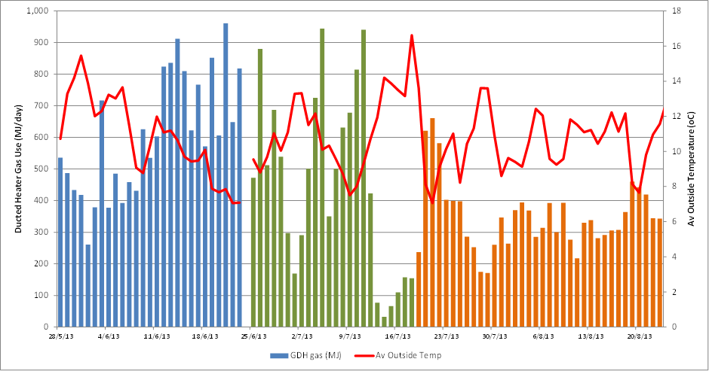

Further evidence of the reduction in heating energy consumption is provided in Figure 22. Figure 22 (a) shows the average daily gas consumption profile of the gas ducted heater on the days on which the heating was used prior to the retrofits, and in the period after all building shell and heating retrofits had been completed (after 19 July). The gas consumption has dropped from an average of 606 MJ per day prior to the retrofits to an average of 353 MJ per day after the retrofits, or a reduction of around 42%. Figure 22 (b) shows the average daily electricity consumption profile of the electric heater in the lounge, before and after the retrofits. In this case the average daily electricity use dropped from 4.9 kWh per day before the retrofits to 2.6 kWh per day after the retrofits, a reduction of around 48%.

Figure 22: Average daily energy consumption profile of the heating

|  |  |
| --- | --- |
| (a) Gas ducted heating system | (b) Electric heater in lounge |

In practice, the energy savings achieved by the building shell and ducted heating system retrofits are likely to have been a bit different to this, and the further information provided in Figure 23 helps to understand why. These graphs show the average daily outside and inside temperature profiles of the house[[145]](#footnote-146) before and after the retrofits were undertaken. From Figure 23 (a) it is evident that, in general, the outside air temperatures were lower during the post-retrofit period than during the pre-retrofit period, especially during the afternoon and night time hours. The average daily outside temperature was 10.8oC prior to the retrofits and 10.4oC afterwards.

Figure 23 (b) shows that, after the retrofits, the inside temperatures were generally higher during the early morning hours when the heating was less likely to be operating, even though the night-time outside temperatures were lower. This reflects the ability of the better insulated house (walls and increased ceiling insulation) to retain heat inside the home. It is also evident that when the heating was first switched on in the morning after the retrofits (7:00 to 10:00 am), the better insulated house, combined with the more efficient ducted heating system, led to the house heating up more quickly. Inside temperatures were lower during the day and in the evening after the retrofits. Over the whole day, the average inside temperature in the heated areas decreased from 20.4oC to 20.2oC. The occupants noted that they were now able to set the thermostat at a lower temperature and still maintain comfort conditions. Insulating the ceiling and external walls means that the temperature of internal buildings surfaces increases, and occupants can still feel comfortable at lower air temperatures.

Figure 23 (c) shows that the average temperature difference between inside and outside the house was larger after the retrofits during the early morning hours (midnight to 9:00 am) and in the late afternoon and evening (after 4:00 pm). The temperature difference was a bit lower during the daylight hours after the retrofits. During the times that the heater was operating, the average temperature difference between inside and outside the house was 9.5oC before the retrofits and 9.7oC[[146]](#footnote-147) afterwards. This temperature difference is proportional to the rate of heat loss from the house, and therefore the “heating load” faced by the heater. The higher average temperature difference after the retrofits means that the heater had to work a bit harder to maintain comfort conditions inside the house.

Figure 23: Average daily outside and inside temperature profiles

|  |  |
| --- | --- |
| (a) Average daily outside temperature profile | (b) Average daily inside temperature profile |
|  | (c) Average daily temperature difference profile |

To obtain an alternative estimate of the heating energy savings achieved by the building shell and heating system retrofits, we used the data on the average daily gas consumption of the heater and average daily outside temperatures to characterise the energy performance of the heating system before and after the retrofits, and to estimate the annual heating energy consumption in a typical year[[147]](#footnote-148). The results of this analysis are provided in Figure 24. We estimate that the annual energy saving achieved was 54,058 MJ per year, or a 48.7% saving.

In addition to reducing gas use for heating, the upgrades resulted in a reduction in energy consumption by the electric heater in the lounge room, as well as a change in the electricity consumption of the gas ducted heater. Based on an analysis of the weather data before and after the retrofits[[148]](#footnote-149), we estimate that electricity savings of around 301 kWh per year were achieved for the electric heater in the lounge room.

Gas ducted heaters can be quite high consumers of electricity, due to their large air circulation fans – the ducted heater used an average of 3.4 kWh per day of electricity prior to the retrofits and 3.7 kWh per day afterwards. The initial draught sealing and insulation retrofits resulted in the gas ducted heater having a reduced electricity consumption. However, the replacement of the existing gas ducted heater with a high efficiency model increased the electricity consumption. This was because the new gas ducted heater had a significantly higher electrical power consumption when the fan was operating, around 690 Watts compared to 320 Watts for the original heater. The more powerful fan in the new gas ducted heater reflects the fact that the heating outlets were located in the ceiling and so greater fan power is required to push the air down into the house to effectively distribute the heat. The much lower fan power of the existing ducted heater suggests that it may have not been powerful enough to distribute the heated air very effectively. Based on the measured electricity and gas consumption data for both the original and new gas ducted heaters[[149]](#footnote-150) we estimate the net annual increase in electricity consumption of the gas ducted heater was around 68 kWh per year.

Figure 24: Energy performance characteristics of the main heating system

**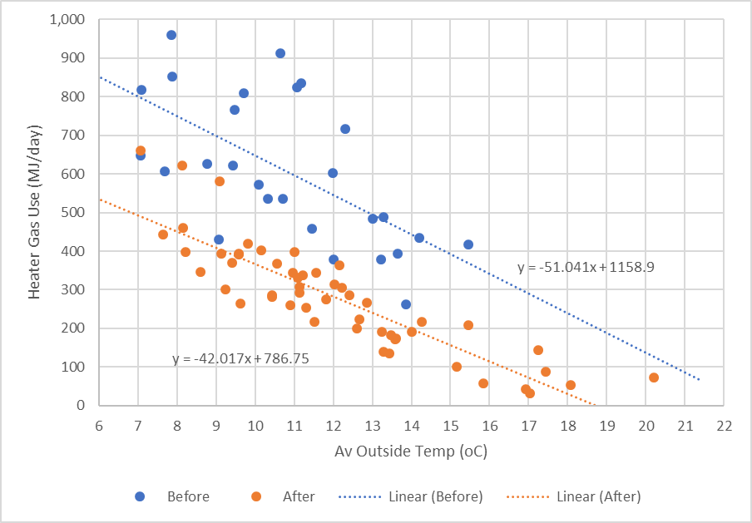**

* 1. Householder experience of the retrofits

Overall the house occupants were happy with the retrofits. The building shell and heating system upgrades were perceived to have increased the winter comfort of the home - from a rating of 3 to a rating of 4 on a scale of 1 to 5[[150]](#footnote-151). They commented that the house was now “Much more comfortable”. It was noted that the house warmed up more quickly, felt a lot warmer and retained the heat, that they could set the thermostat at a lower temperature and still feel comfortable, and that they were now able to turn the heater off a lot more. The bedrooms were found to be noticeably warmer in the morning. Some unexpected benefits were that the house was less draughty, that there was better air quality, and that it was less dusty.

Due to the timing of the retrofit trials the occupants were not able to provide feedback on any improvements in summer comfort resulting from the retrofits. It is likely that the insulation and air sealing would have also lead to improvements in occupant comfort during the summer months. They may have also resulted in some additional summer energy savings. However, as this house is cooled with a ducted evaporative cooling system, which has relatively low electricity consumption, any summer cooling savings are expected to be quite modest.

* 1. Economics of the retrofits

The cost of the different energy efficiency retrofits (parts and labour), and the estimated annual energy, energy bill and greenhouse gas savings which resulted from them are shown in Table 18. The costs presented in the table do not include any government incentives, and the energy savings are based on typical current energy tariffs[[151]](#footnote-152). The energy bill savings are only for the heating season. The savings relate to both the gas ducted heater and the electric heater used in the lounge room. Due to the bunched way in which the building shell and heating retrofits were undertaken it was not possible to identify the impact of each individual retrofit, so we have grouped the measures together.

Table 18: Summary of cost and annual savings for the energy efficiency retrofits

|  |  |  |  |  |  |  |
| --- | --- | --- | --- | --- | --- | --- |
| Retrofit | Cost  ($) | Annual savings | | | | Payback period  (Yrs) |
| Gas  (MJ/yr) | Electricity  (kWh/yr) | Greenhouse gas  (kg/yr) | Energy Bill  ($/yr) |
| Draught sealing | $1,114 |  |  |  |  |  |
| Ceiling insulation top-up | $2,657 |  |  |  |  |  |
| Wall insulation | $4,056 |  |  |  |  |  |
| Gas ducted heater | $2,321 |  |  |  |  |  |
| Gas heating ductwork | $2,246 |  |  |  |  |  |
| ***Sub-total - building shell and heating system*** | ***$12,394*** | ***54,058*** | ***-68*** | ***2,911*** | ***$1,049*** | ***11.8*** |
| Reduction in electric heater use | - | - | 301 | 355 | $96 | NA |
| Total | $12,394 | 54,058 | 233 | 3,266 | $1,145 | 10.8 |

We estimate that the house used an average of 111,012 MJ per year of gas for heating prior to the retrofits. Our analysis of the heating data collected during the retrofit trial suggests that a heating energy saving of 54,058 MJ per year (48.7%) was achieved for the gas consumption, but that the electricity consumption of the gas ducted heater increased by 68 kWh per year, due to the new heater having a higher fan power. This increase in electricity use was offset by a 301 kWh per year reduction in energy consumption of the electric heater used for supplementary heating, giving a net electricity saving of 233 kWh per year.

The cost of the overall retrofit package was $12,394. We estimate that it reduced the total annual gas consumption of the household by around 54,058 MJ per year (36.0%) and annual electricity consumption by around 233 kWh per year (3.5%), resulting in annual energy bill savings of around $1,145 per year for a payback of around 10.8 years. Annual greenhouse gas savings are estimated to be 3.27 tonnes per year.

In practice, the gas ducted heater, gas heating ductwork and draught sealing upgrades would be eligible for a financial incentive through the *Victorian Energy Upgrades* scheme, and this would further reduce the investment required from the householder[[152]](#footnote-153). It is also likely that in most cases the gas ducted heater upgrade would only be undertaken when the existing unit fails or is close to its end of life. This means that the additional cost of installing the high efficiency heater is only the differential cost between a standard appliance and a high efficiency model, or around $900. If these factors are taken into account, the overall cost of the upgrades would be effectively lower, and therefore the payback somewhat shorter.

Over the next decade or so we expect that energy prices will continue to rise, especially for gas, increasing the size of the annual energy bill saving and increasing the rate of return on the initial investment.

1. Appendix 2 – House CR2

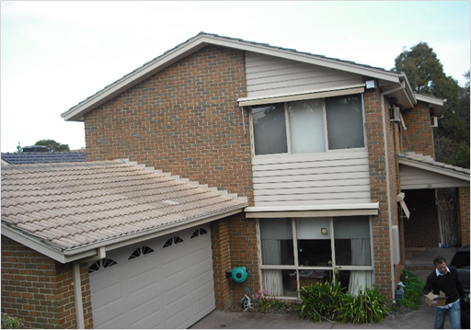

*The general comfort is higher.*

*There are less cold breezes and the heat retention is good. The draught sealing and ceiling insulation worked well.*

* 1. The original set-up

The house is a 216 m2 double storey brick-veneer, with a suspended timber floor and a tiled roof, constructed in the 1990s. Prior to the retrofits, it had cellulose fibre insulation with an R-value of around R1.5 installed on the ceiling, and no insulation installed in the external walls or under the floor. The house was reasonably airtight for an existing house. It had a measured natural air leakage rate of 0.83 air changes per hour, which means that in winter the warm air inside the house was replaced by cold outside air, which had to be re-heated, about once every 1.2 hours. The main air leakage sites were four external doors without adequate weather stripping, three ceiling exhaust fans without self-closing dampers, fixed vents above windows in the bathroom, and architraves not sealed to plaster walls.

The house is occupied by a family of four. Prior to the retrofits its annual gas consumption was around 85,686 MJ per year, with an estimated 56,566 MJ (66%) of this used for home heating. This is lower than the average of 61,190 MJ per year for central heating found in Sustainability Victoria’s previous study of the existing housing stock [SV2015]. This may have been partly due to the house being double storey – making it more efficient than a single storey house with the same floor area – and partly due to the relatively low thermostat settings used for heating. The annual mains electricity consumption was around 6,880 kWh per year, or an average daily electricity consumption of 18.6 kWh per day[[153]](#footnote-154). The house also had photovoltaic (or solar) panels installed on the roof to generate electricity – some of this is used in the house, and some is exported to the electricity grid.

The house is heated mainly with a gas ducted heating system, used for around 13.5 hours per day during the winter months. The heating is manually controlled, and was typically run on weekdays from around 6:30 to 8:00 am in the morning and from the mid-afternoon to 11:00 pm at night, with further use during the morning and early afternoon on some days. On weekends, the heating was normally operated for a longer time. The heating thermostat was set in the range of 18oC to 20oC, usually at the lower end of this range, and was often adjusted several times during the day. The occupants found the house to be comfortable during the winter months.

The existing gas ducted heating furnace was inefficient, with only a 2.1 Star rating. The age of the heater and ductwork was not recorded, but they are likely to be at least 15-years old. The ductwork was in reasonable condition.

* 1. The energy efficiency retrofits

The comprehensive retrofits undertaken at the house focussed on increasing winter comfort and reducing winter heating energy use by increasing the energy efficiency of the house’s building shell, through insulation and draught sealing, and increasing the energy efficiency of the ducted heating system by upgrading the gas furnace. An old refrigerator and freezer were also replaced with a single new high efficiency two-door refrigerator, and halogen lighting in a rumpus room area was replaced with LED lighting. The retrofits which were undertaken are shown in Figure 25. The draught sealing reduced the natural air leakage rate to 0.53 air changes per hour, and included weather stripping four external doors and some windows, sealing architraves and installing dampers on three ceiling exhaust fans. The total cost of all retrofit work was $14,324.

Figure 25: Energy efficiency retrofits undertaken

|  |  |  |
| --- | --- | --- |
| Air leakage rate of 0.83 Air Changes per Hour |  | Draught sealing to reduce air leakage rate to 0.53 Air Changes per Hour |

|  |  |  |
| --- | --- | --- |
| R1.5 cellulose fibre ceiling insulation |  | Ceiling insulation topped up with R3.5 batts |

|  |  |  |
| --- | --- | --- |
| No insulation in the external wall cavity |  | Hydrophobic granulated rockwool insulation pumped into the external wall cavity of the upper storey |

|  |  |  |
| --- | --- | --- |
| >15-year old, 2.1 Star gas ducted heater |  | New 6-Star gas ducted heater |

|  |  |  |
| --- | --- | --- |
| 16-year old, 502-litre refrigerator, and 25-year old, 290-litre separate upgright freezer |  | New 3.5 Star, 505-litre 2-door refrigerator/freezer |

|  |  |  |
| --- | --- | --- |
| 6 x 50 Watt halogen downlights |  | 6 x 12 Watt LED downlights |

The building shell and heating retrofits started on 1 July with the draught sealing, and were completed on 25 July when the gas ducted heater was replaced. The halogen downlights were replaced with LEDs on 23 July, and the existing refrigerator and freezer were replaced on 31 July.

* 1. Impact of the retrofits

The house was monitored before and after the retrofits were undertaken to assess the impact of the retrofits on energy consumption and occupant comfort, and surveys were conducted with the occupants to get feedback on their experience of the retrofits. The gas and electricity consumption of the gas ducted heating furnace, and the inside and outside temperatures were monitored over the period 28 May to 11 September, 2013. The electricity consumption of the refrigerator, and the operation of the lighting in the Rumpus Room were also monitored over this period.

* + 1. Building shell and heating retrofits

Figure 26 shows the daily gas consumption of the gas ducted heater plotted against the average daily outside temperature[[154]](#footnote-155) (red line) over the entire monitoring period. The blue columns show the gas consumption of the heater prior to the start of the retrofits, and the green and orange columns show the gas consumption after the retrofits – the green columns cover the period prior to the upgrade of the gas ducted heating system and the orange columns cover the period after this, when all retrofit work had been completed. It is evident from this graph that that the daily gas consumption of the heating is highly dependent on the average daily outside temperature; gas consumption tends to be lower on the warmer days and higher on the colder days. It is also evident that daily gas consumption after the retrofits was lower than before, especially after the upgrade of the ducted heating system.

Figure 26: Gas consumption of ducted heating vs average daily outside temperature

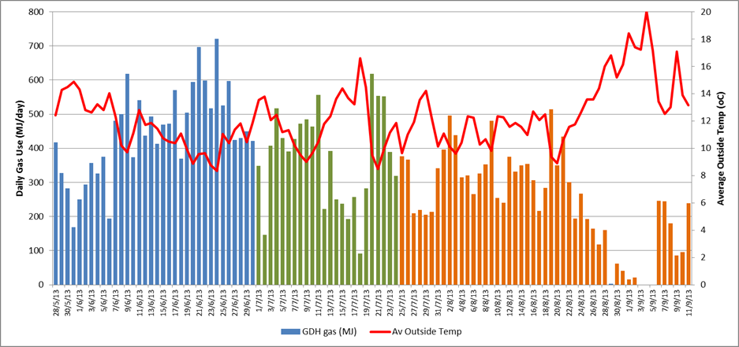

Further evidence of the reduction in heating energy consumption is provided in Figure 27. This shows the average daily gas consumption profile of the gas ducted heater on days on which the heating was used prior to the retrofits and in the period after all building shell and heating retrofits had been completed (after 25 July) – the data for after the retrofits was up to 26 August, as after this date the outside temperatures increased significantly. The average daily gas consumption dropped from 447 MJ per day prior to the retrofits to an average of 315 MJ per day after the retrofits, or a reduction of around 30%.

Figure 27: Average daily gas consumption profile of the heating

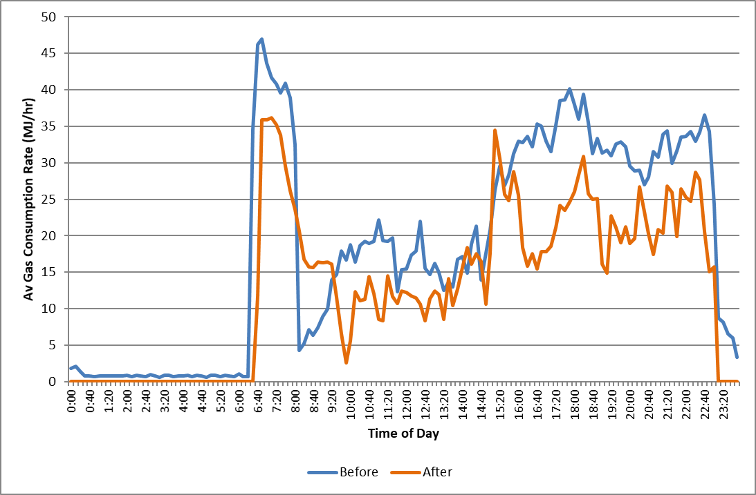

In practice, the energy savings achieved by the building shell and ducted heating system retrofits are likely to have been a bit different to this ‘raw estimate’, and the further information provided in Figure 28 helps to understand why. The graphs show the average daily outside and inside temperature profiles of the house[[155]](#footnote-156) before and after the retrofits were undertaken.

Figure 28: Average daily outside and inside temperature profiles

|  |  |
| --- | --- |
| (a) Average daily outside temperature profile | (b) Average daily inside temperature profile |
|  | (c) Average daily temperature difference profile |

Figure 28 (a) shows that it was generally slightly cooler outside in the morning before the retrofits compared to afterwards, although was a bit warmer during the afternoon and early evening. The average daily outside temperature was 11.5oC before the retrofits and 11.5oC afterwards. Figure 28 (b) shows that the inside temperatures were generally a bit higher when the heating was operating before the retrofits compared to afterwards – the average inside temperature was 17.7oC before the retrofits and 17.5oC afterwards. This may have been due differences in the settings on the thermostat control used for the existing and new ducted heater, or may have been because the building shell upgrades meant that the occupants felt comfortable at a lower room temperature afterwards.

Figure 28 (c) shows that the average temperature difference between inside and outside the house was quite similar before and after the retrofits, although was slightly greater in the late evening and early morning hours before the retrofits (10:00 pm to 3:30 pm) and in the early afternoon (midday to 2:30 pm). The average temperature difference between inside and outside the house decreased from 6.1oC prior to the retrofits to 6.0oC[[156]](#footnote-157) afterwards. This temperature difference is proportional to the rate of heat loss from the house, and therefore the “heating load” faced by the heater. The slightly lower average temperature difference after the retrofits means that the heater did not have to work as hard to maintain comfort conditions inside the house.

To obtain an alternative estimate of the heating energy savings achieved by the building shell and heating system retrofits, we used the data on the average daily gas consumption of the heater and average daily outside temperatures to characterise the energy performance of the heating system before and after the retrofits, and to estimate the annual heating energy consumption in a typical year[[157]](#footnote-158). The results of this analysis are provided in Figure 29. We estimate that the annual energy saving achieved was 17,878 MJ per year, or a 31.6% saving.

Figure 29: Energy performance characteristics of the main heating system

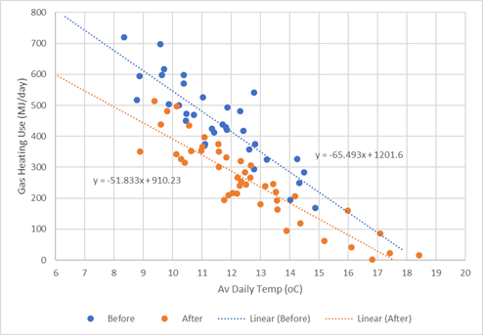

In addition to the gas saving, we estimate that there was a small reduction in the electricity use associated with the gas ducted heater replacement. Gas ducted heaters use electricity to power the main air circulation and combustion fans, as well as the electronic controls. The average electricity consumption before the heater upgrade was 3.54 kWh per day compared to 3.33 kWh per day afterwards, or a saving of 0.21 kWh per day. Over a full year, we estimate that the electricity consumption would have decreased by 49 kWh[[158]](#footnote-159).

* + 1. Refrigerator retrofits

The house initially had both an old a two-door refrigerator (502 litres, 16 years old) and an old upright freezer (290 litres, 25 years old). These were replaced with a single new 505-litre, 3.5 Star 2-door refrigerator. This resulted in a significant electricity saving, partly because the two existing units with a total volume of 792 litres were replaced with one new smaller unit, and partly due to the higher efficiency of the replacement refrigerator. The daily electricity consumption of the refrigeration appliances before and after the replacement are shown in Figure 30. The blue columns are for the existing 2-door refrigerator and the red columns for the existing upright freezer, while the orange columns are for the new high efficiency refrigerator. The average energy saving during the monitoring period was 2.3 kWh per day. The annual electricity saving was estimated to be 898 kWh per year (or 64.8%)[[159]](#footnote-160).

Figure 30: Daily electricity consumption of the refrigerator/freezer

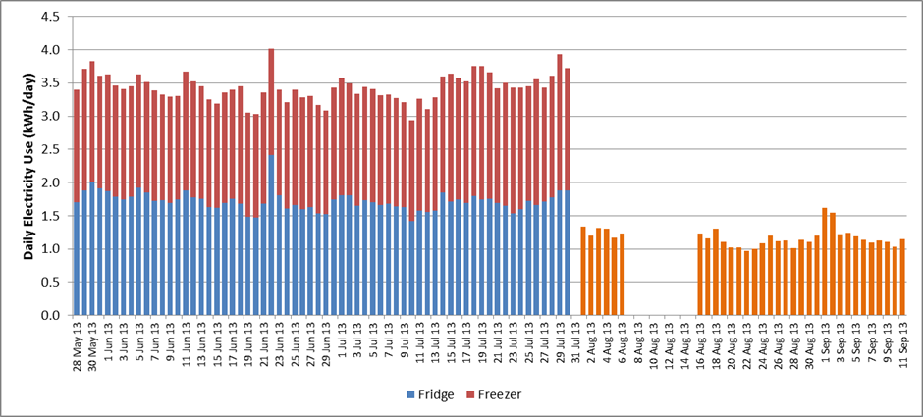

* + 1. Lighting retrofits

Six halogen downlights located above a pool table in the Rumpus Room were replaced with LED downlights. Each halogen downlight fitting had a power consumption of around 62 Watts, 50 Watts for the lamp and 12 Watts for the transformer. The six existing lamps were replaced with 12 Watt LED lamps, giving a total power saving of 300 Watts. The lighting in the Rumpus Room seems to have had only light usage. Over the full monitoring period it was used for only 18.4 hours, which translates to around 44.7 hours over a full year. The estimated annual energy saving from this retrofit was only 18.4 kWh per year.

* 1. Householder experience of the retrofits

Overall the house occupants were happy with the retrofits. They felt that the house was more comfortable after the retrofits, with both the lounge and bedroom areas being noticeably warmer, and that the house was quicker to heat up. They noted that there were initially some issues with the new gas ducted heater as the fan speed was set too high and was noisy; reducing the fan speed fixed this issue. They also found the new thermostat controller was different than the one it replaced, with the variation between the 20oC and 21oC settings found to be quite large.

Due to the timing of the retrofit trials the occupants were not able to provide feedback on any improvements in summer comfort resulting from the retrofits. It is likely that the insulation and air sealing would have led to improvements in occupant comfort during the summer months. They may have also resulted in some additional summer energy savings from operating the ducted evaporative cooling system.

They were very satisfied with the lighting upgrade, with the new lights found to be much brighter. While they had some initial concerns with the colour of the LED lights, in practice they found these were unfounded. Overall, they were satisfied with the replacement refrigerator, finding easier access and usability, although they found it a bit noisy.

* 1. Economics of the retrofits

The cost of the different energy efficiency retrofits (parts and labour), and the estimated annual energy, energy bill and greenhouse gas savings which resulted from them are shown in Table 19. The costs presented in the table do not include any government incentives, and the energy savings are based on typical current energy tariffs[[160]](#footnote-161). Due to the bunched way in which the building shell and heating retrofits were undertaken it was not possible to identify the impact of each individual retrofit, so we have grouped these measures together.

Table 19: Summary of cost and annual savings for the energy efficiency retrofits

|  |  |  |  |  |  |  |
| --- | --- | --- | --- | --- | --- | --- |
| Retrofit | Cost  ($) | Annual savings | | | | Payback period  (Yrs) |
| Gas  (MJ/yr) | Electricity  (kWh/yr) | Greenhouse gas  (kg/yr) | Energy Bill  ($/yr) |
| Draught sealing | $1,328 |  |  |  |  |  |
| Ceiling insulation top-up | $1,822 |  |  |  |  |  |
| Wall insulation | $5,210 |  |  |  |  |  |
| Gas ducted heater | $3,120 |  |  |  |  |  |
| ***Sub-total - building shell & heating*** | ***$11,480*** | ***17,878*** | ***49*** | ***1,047*** | ***$398*** | ***28.8*** |
| Refrigerator replacement | $2,149 | - | 898 | 1,060 | $287 | 7.5 |
| Lighting retrofit | $695 | - | 18 | 22 | $5.9 | 118.4 |
| Total | $14,324 | 17,878 | 965 | 2,128 | $691 | 20.7 |

We estimate that the house used an average of 56,566 MJ per year of gas for heating prior to the retrofits. Our analysis of the heating data collected during the retrofit trial suggests that a heating energy saving of 17,878 MJ per year (31.6%) was achieved for the gas consumption, and a small additional electricity saving of 49 kWh per year associated with the gas ducted heater’s fan. The total cost of the building shell and heating upgrades was $11,480, and the estimated annual energy bill saving was $398 per year, giving a payback period of 28.8 years on the investment.

The cost of the overall retrofit package was $14,324. We estimate that it reduced the total annual gas consumption of the household by around 17,878 MJ per year (20.9%) and total annual electricity consumption by around 965 kWh per year (14.9%), resulting in annual energy bill savings of around $691 per year for a payback of around 20.7 years. Annual greenhouse gas savings are estimated to be 2.13 tonnes per year.

The longest payback was for the lighting upgrade in the Rumpus Room. This was because these lights had a fairly low annual usage. The payback on the building shell and heating system upgrade was also quite long, due to the relatively high cost of these upgrades, especially the pump-in cavity wall insulation. The lowest payback was for replacing the existing refrigerator and freezer, due to the large electricity saving that was achieved.

Some of the upgrades could also be eligible for a financial incentive through the Victorian Government’s *Victorian Energy Upgrades* scheme, and this would further reduce the investment required from the householder. Draught sealing, gas ducted heating and refrigerator upgrades all currently attract some level of incentive, and in most cases lighting upgrades can be undertaken for free. It is also likely that, in the majority of cases, the gas ducted heater and refrigerator upgrades would only be undertaken when the existing appliances failed or were close to the end of their life. This means that the additional cost of installing the high efficiency appliances is only the differential cost between a standard appliance and a high efficiency model. For gas ducted heaters this is around $900, and for a 2-door refrigerator of this size around $385. The incentives available through the *Victorian Energy Upgrades* scheme would reduce this ‘differential cost’ even further. If these factors are taken into account, the overall cost of the appliance upgrades would be effectively lower, and therefore the payback somewhat shorter.

Over the next decade or so we expect that energy prices will continue to rise, especially for gas, increasing the size of the annual energy bill saving and increasing the rate of return on the initial investment.

1. Appendix 3 – House CR3

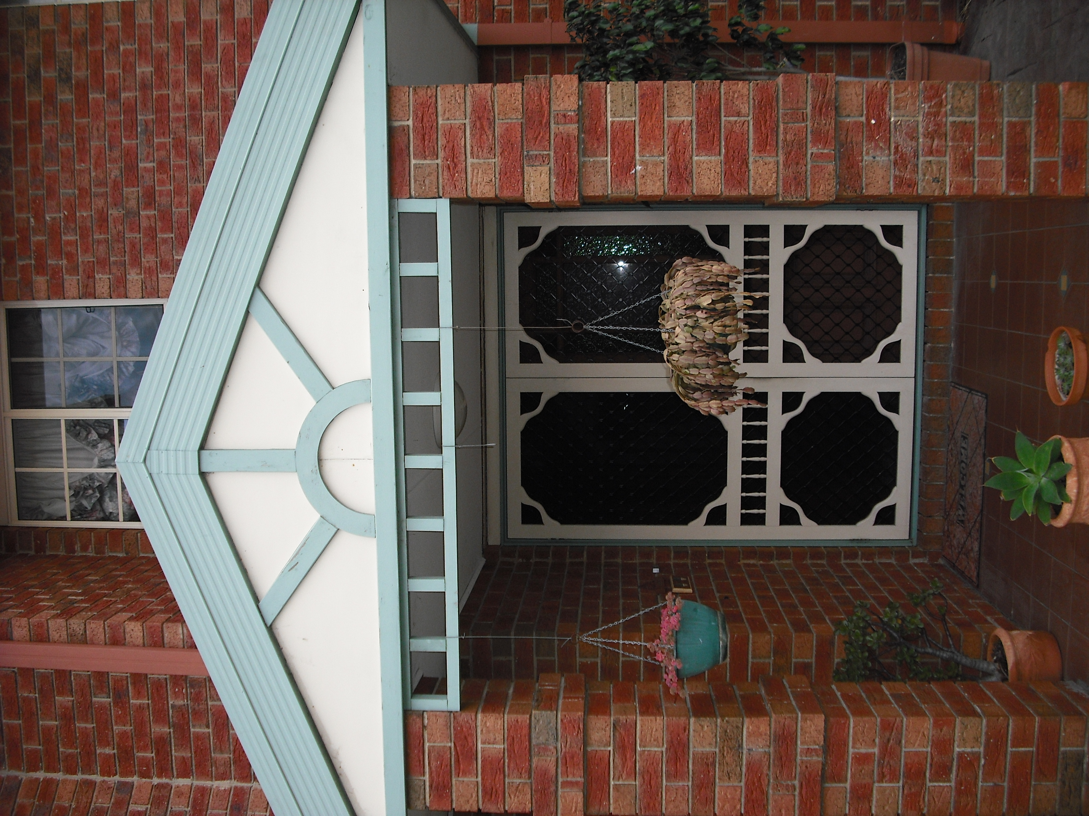

*The house is now warmer and easier to heat.*

*Greater heat retention in the bedrooms and upstairs area.*

* 1. The original set-up

The house is a 235 m2 two storey, brick-veneer with a concrete slab-on-ground floor and a tiled roof, constructed in the 1990s. Prior to the retrofits, it had R3.5 insulation batts installed on the ceiling, although there was not full insulation coverage around the perimeter of the building[[161]](#footnote-162). The external walls were insulated with R1.5 batts. It had a measured natural air leakage rate of 0.87 air changes per hour, which means that in winter the warm air inside the house was replaced by cold outside air, which had to be re-heated, a bit over once every hour. The main air leakage sites were external doors and windows without weather stripping, a ducted evaporative cooler without an effective damper, a large hole above the refrigerator recess, four ceiling exhaust fans, and architraves not sealed to plaster walls.

The house is occupied by a family of four. Prior to the retrofits, the annual gas consumption of the household was around 63,591 MJ per year, with an estimated 46,538 MJ per year (73%) of this used for home heating. This is significantly lower than the average of 61,190 MJ per year for central heating found in Sustainability Victoria’s previous study of the existing housing stock [SV2015], due to the ceilings and walls being well insulated, the concrete slab-on-ground floor, and the relatively short daily operating time of the heating. The annual electricity consumption of the household was 3,389 kWh per year, or an average daily electricity consumption of 9.3 kWh per day, which is well below average[[162]](#footnote-163). This was largely due to the house having photovoltaic (or solar) panels installed on the roof to generate electricity – some of this is used in the house, and some is exported to the electricity grid.

The house is heated mainly with a gas ducted heating system, used for around 6.7 hours per day. The heating was controlled manually, and was typically run from around 7:00 am to 9:30 am in the morning, and from 5:00 pm to 10:30 pm in the evening, with some additional usage during the middle of the day and occasionally early in the morning. The heating thermostat was normally set to between 18 to 19oC in the morning, and 19 to 20oC in the afternoon and evening. The house occupants found the house to be quite uncomfortable, with a lot of draughts; the main bedroom and lounge were found to be “extremely uncomfortable”.

The existing gas ducted heater and its associated ductwork were around 20-years old. The gas ducted heater was inefficient, with only a 2.5 Star Gas Energy Rating. The heater’s gas pilot light had a very high measured gas consumption rate (23.7 MJ per day), which means that over a full year the pilot light alone could consume up to 8,651 MJ.

* 1. The energy efficiency retrofits

The comprehensive retrofits undertaken at the house focussed on increasing winter comfort and reducing winter heating energy use, by increasing the energy efficiency of the house’s building shell through insulation and draught sealing, and increasing the energy efficiency of the ducted heating system by upgrading both the gas furnace and the ductwork. In addition to this, an old refrigerator was replaced with a high efficiency new one, and an existing gas storage water heater was replaced with a new one. The retrofits which were undertaken are shown in Figure 31. The draught sealing reduced the natural air leakage rate to 0.29 air changes per hour, and included weather stripping external doors and some windows, sealing architraves, and installing dampers on three ceiling exhaust fans. The total cost of all retrofit work was $10,061.

Figure 31: Energy efficiency retrofits undertaken

|  |  |  |
| --- | --- | --- |
| Air leakage rate of 0.87 Air Changes per Hour |  | Draught sealing to reduce air leakage rate to 0.29 Air Changes per Hour |

|  |  |  |
| --- | --- | --- |
| R3.5 ceiling insulation, but with gaps around the perimeter of the ceiling. |  | Additional R3.5 batts installed to give better insulation coverage. |

|  |  |  |
| --- | --- | --- |
| Approx. 20-year old, 2.5 Star gas ducted heater, with high pilot light consumption |  | New 6 Star gas ducted heater |

|  |  |  |
| --- | --- | --- |
| Approx. 20-year old gas heating ductwork |  | New R1.4 heating ductwork |

|  |  |  |
| --- | --- | --- |
| 20-year old, 412-litre, 2-door refrigerator |  | New 4 Star, 416-litre, 2-door refrigerator |

|  |  |  |
| --- | --- | --- |
| 17-year old 170-litre, 4 Star, gas storage water heater |  | New 390-litre, 5 Star gas storage water heater |

* 1. Impact of the retrofits

The house was monitored before and after the retrofits were undertaken to help assess the impact of the retrofits on energy consumption and occupant comfort, and surveys were also conducted with the occupants to obtain their feedback on the impact of the retrofits. The gas and electricity consumption of the gas ducted heating, and the inside and outside temperatures were monitored over the period 28 May to 14 September 2013. The retrofit work commenced on 27 June with the draught sealing, and was completed on 23 July with the installation of the new gas ducted heater.

* + 1. Building shell and heating retrofits

Figure 32 shows the daily gas consumption of the gas ducted heater plotted against the average daily outside temperature[[163]](#footnote-164) (red line) over the entire monitoring period. The blue columns show the gas consumption of the heater prior to the start of the retrofits, and the green and orange columns show the gas consumption after the retrofits – the green columns cover the period prior to the upgrade of the gas ducted heating system[[164]](#footnote-165) and the orange columns cover the period after this[[165]](#footnote-166), when all retrofit work had been completed. It is evident from this graph that that the daily gas consumption of the heating is highly dependent on the average daily outside temperature; gas consumption tends to be lower on the warmer days and higher on the colder days. It is also evident that after all retrofit work had been completed, the daily gas consumption was lower than before.

Figure 32: Gas consumption of ducted heating vs average daily outside temperature

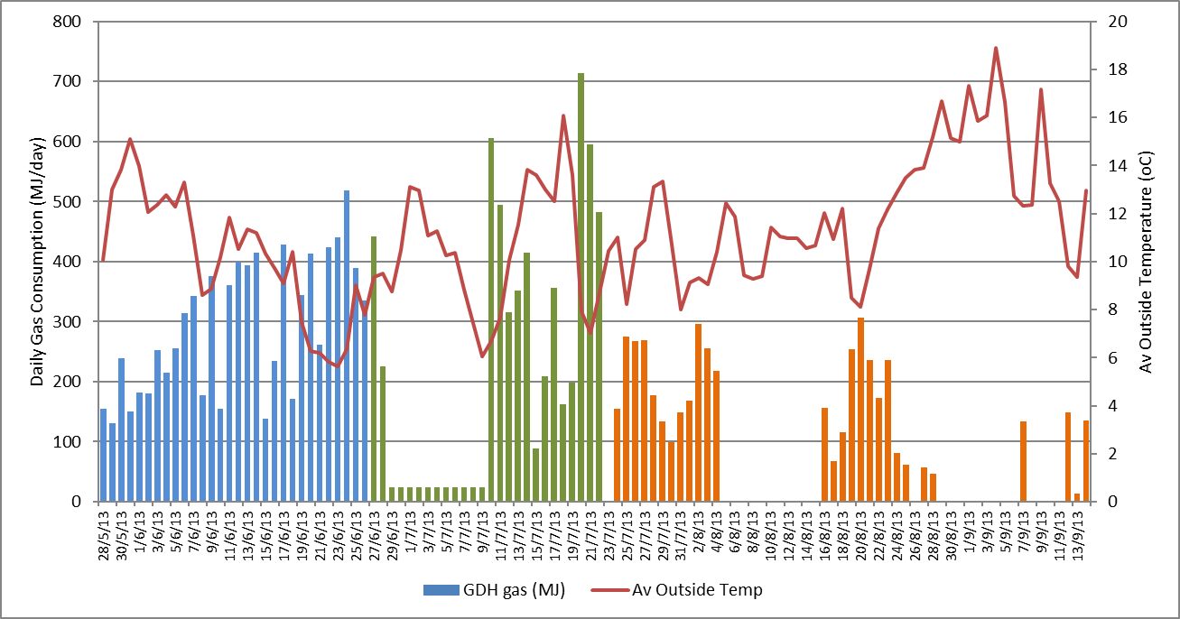

Further evidence of the reduction in heating energy consumption is provided in Figure 33. This shows the average daily gas consumption profile of the gas ducted heater on days on which the heating was used prior to the retrofits and in the period after all building shell and heating retrofits had been completed (after 23 July). The average daily gas consumption dropped from 301 MJ per day prior to the retrofits to an average of 162 MJ per day after the retrofits, or a reduction of around 46.2%.

Figure 33: Average daily gas consumption profile of the heating

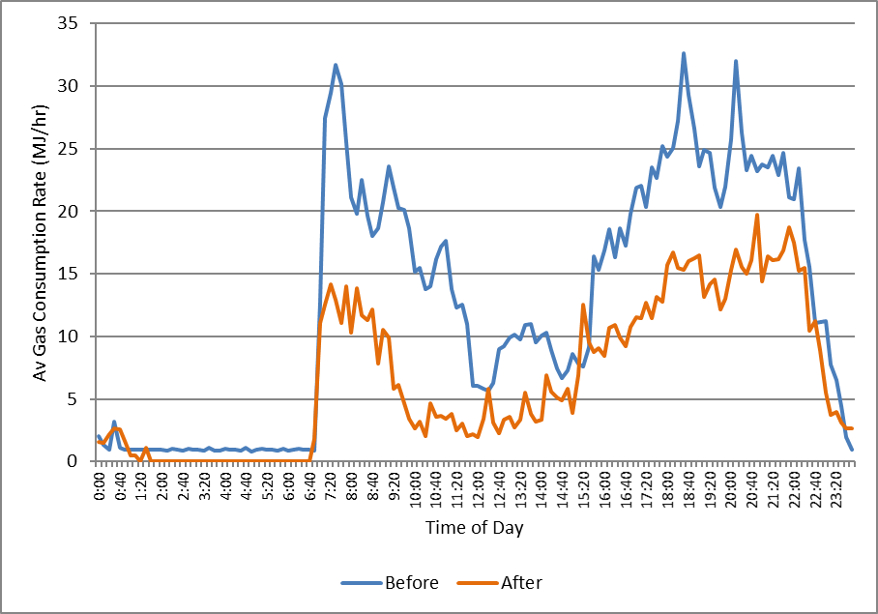

In practice, the energy savings achieved by the building shell and ducted heating system retrofits are likely to have been a bit different to this ‘raw estimate’ of 46.2%, and the further information provided in Figure 34 helps to understand why. The graphs show the average daily outside and inside temperature profiles of the house[[166]](#footnote-167) before and after the retrofits were undertaken. From Figure 34 (a) it is evident that, in general, the outside temperatures after the retrofits had been completed were higher than before. The average daily outside temperature was 10.2oC prior to the retrofits and 11.2oC afterwards.

Figure 34 (b) shows that after the retrofits, inside temperatures were generally higher than before, especially during the night-time hours (10:00 pm to 7:00 am). Over the whole day, the average inside temperature was 17.8oC before the retrofits, and 18.1oC afterwards. These higher inside temperatures partly reflect the higher outside temperatures after the retrofits, meaning that the house did not cool down as much overnight when the heating was not operating. The heating temperatures during the late afternoon and evening also seem to have been a bit higher after the retrofits.

Figure 34: Average daily outside and inside temperature profiles

|  |  |
| --- | --- |
| (a) Average daily outside temperature profile | (b) Average daily inside temperature profile |

|  |  |
| --- | --- |
|  | (c) Average daily temperature difference profile |

Figure 34 (c) shows that the average temperature difference between inside and outside the house was lower after the retrofits, especially from 7:00 am to 3:30 pm, and from 7:00 pm to 11:00 pm. The average daily temperature difference was 7.5oC before the retrofits, and 7.0oC[[167]](#footnote-168) afterwards. Again, this largely reflects that higher outside temperatures after the retrofits compared to before. This temperature difference is proportional to the rate of heat loss from the house, and therefore the “heating load” faced by the heater. The lower average temperature difference after the retrofits means that the heater did not have to work as hard to maintain comfort conditions inside the house - part of the 46.2% “raw” energy saving is due to this, meaning that in practice the actual energy saving was not as large.

To obtain an alternative estimate of the heating energy savings achieved by the building shell and heating system retrofits, we used the data on the average daily gas consumption of the heater and average daily outside temperatures to characterise the energy performance of the heating system before and after the retrofits, and to estimate the annual heating energy consumption in a typical year[[168]](#footnote-169). The results of this analysis are provided in Figure 35. We estimate that the annual energy saving achieved was 20,636 MJ per year, or a 44.3% saving.

Figure 35: Energy performance characteristics of the main heating system

**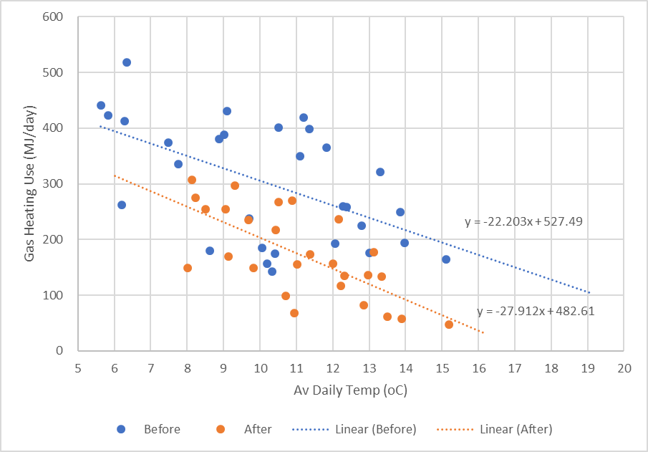**

In addition to the gas saving, we estimate that there was an increase in electricity use associated with the gas ducted heater after the new heater was installed. Gas ducted heaters use electricity to power the main air circulation and combustion fans as well as the electronic controls. The average power consumption of the gas ducted heater when operating was 642 Watts for the new heater, and only 382 Watts for the original heater. The average electricity consumption before the heater upgrade was 1.66 kWh per day compared to 2.21 kWh per day afterwards, or an increase of saving of 0.55 kWh per day. Over a full year, we estimate that the electricity consumption would have increased by 90 kWh[[169]](#footnote-170).

* + 1. Water heating retrofits

As part of the retrofit package, an existing 17-year old, 4-Star gas storage water heater was replaced with a new 5-Star gas storage unit. The project budget did not allow the water heater to be separately metered to measure the gas and hot water consumption, and the cold and hot water temperatures. Based on the number of occupants in the house, and the energy performance of the existing and new water heaters, we estimate an initial gas consumption of 19,628 MJ per year, reducing to 17,492 MJ per year following the installation of the 5-Star gas water heater. This gives an annual gas saving of 2,136 MJ per year, or 10.9%.

* + 1. Refrigerator retrofits

The house initially had a 412-litre two-door refrigerator/freezer that was around 20-years old. This was replaced with a new 416-litre, 4.0 Star two-door refrigerator. This resulted in a significant electricity saving. The daily electricity consumption of the refrigerator, before and after the replacement are shown in Figure 36. The blue columns are for the existing two-door refrigerator and the orange columns[[170]](#footnote-171) are for the new high efficiency refrigerator. The average energy saving during the monitoring period was 1.14 kWh per day. The annual electricity saving was estimated to be 442 kWh per year (or 76.1%).

Figure 36: Daily electricity consumption of the refrigerator/freezer

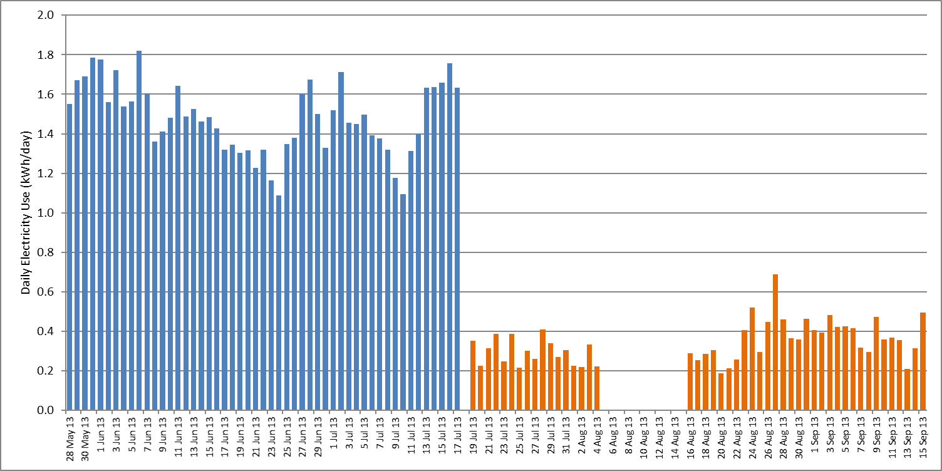

* 1. Householder experience of the retrofits

Overall, the occupants were happy with the retrofits. Their rating of winter comfort[[171]](#footnote-172) increased from 2 on a scale of 1 to 5 prior to the retrofits, to 4 afterwards. Initially, the house was felt to be “quite uncomfortable” with “lots of draughts”. The main bedroom and lounge were found to be “extremely uncomfortable”. Afterwards, the house was “warmer, easier to heat”, and the main bedroom and loungeroom were warmer. The house was found to be “much more comfortable” with “greater heat retention” in the bedrooms and upstairs areas.

Prior to the retrofits, the occupants gave the house a rating of 3 to 4 for the difficulty of heating[[172]](#footnote-173), and this reduced to a rating of 1 afterwards. Initially, the main bedroom and the larger rooms were considered to have a “slow response”. Afterwards, the occupants noticed “much better performance” and that the lounge heated up more quickly.

Satisfaction with the original gas ducted heater was rated as 3 on a five-point scale[[173]](#footnote-174). It was now fairly old and starting to break down. Satisfaction with the new gas ducted heater was rated as 5. Initially there was an issue with the condensation drain on the heater not working properly, but this was quickly fixed.

The household’s second refrigerator was the one replaced, with their satisfaction rating for the refrigerator increasing from 1 to 2 before the replacement, to a rating of 5 afterwards. The new fridge was found to be quieter than the old one.

The original gas water heater was now also fairly old, and had needed repairs on a number of occasions. The satisfaction rating for the water heater increased from 2 to 5. The new water heater resulted in a “much better shower”, and was felt to provide “more consistent, better water quality”. It was also found to heat the water more quickly.

There were a number of issues with the building shell and heating system retrofits. Some of the doors that had weather stripping installed could not be closed. Also, some of the new ductwork was not installed correctly, and needed to be replaced.

* 1. Economics of the retrofits

The cost of the different energy efficiency retrofits (parts and labour), and the estimated annual energy, energy bill and greenhouse gas savings which resulted from them are shown in Table 20. The costs presented in the table do not include any government incentives, and the energy savings are based on typical current energy tariffs[[174]](#footnote-175). Due to the bunched way in which the building shell and heating retrofits were undertaken it was not possible to identify the impact of each individual retrofit, so we have grouped these measures together.

We estimate that the house used an average of 46,538 MJ per year of gas for heating prior to the retrofits. Our analysis of the heating data collected during the retrofit trial suggests that a heating energy saving of 20,636 MJ per year (44.3%) was achieved for the gas consumption, although this was off-set to some extent by an increase in the heater’s electricity consumption of 90 kWh per year. The total cost of the building shell and heating upgrades was $7,246, and the estimated annual energy bill saving was $425 per year, giving a payback period of 17.0 years on the investment.

Table 20: Summary of cost and annual savings for the energy efficiency retrofits

|  |  |  |  |  |  |  |
| --- | --- | --- | --- | --- | --- | --- |
| Retrofit | Cost  ($) | Annual savings | | | | Payback period  (Yrs) |
| Gas  (MJ/yr) | Electricity  (kWh/yr) | Greenhouse gas  (kg/yr) | Energy Bill  ($/yr) |
| Draught sealing | $1,290 |  |  |  |  |  |
| Ceiling insulation top-up | $1,386 |  |  |  |  |  |
| 6 Star gas ducted heater | $2,285 |  |  |  |  |  |
| R1.4 gas heating ductwork | $2,285 |  |  |  |  |  |
| ***Subtotal - building shell and heating*** | ***$7,246*** | ***20,636*** | ***-90*** | ***1,036*** | ***$425*** | ***17.0*** |
| Water heating retrofit | $1,420 | 2,136 | - | 118 | $51 | 28.1 |
| Refrigerator replacement | $1,395 | - | 442 | 522 | $141 | 9.9 |
| Total | $10,061 | 22,772 | 352 | 1,675 | $617 | 16.3 |

The cost of the overall retrofit package was $10,061. We estimate that it reduced the total annual gas consumption of the household by around 22,772 MJ per year (35.8%) and total annual electricity consumption by around 352 kWh per year (10.4%), resulting in annual energy bill savings of around $617 per year for a payback of around 16.3 years. Annual greenhouse gas savings are estimated to be 1.68 tonnes per year.

The longest payback was for the water heating upgrade, due to the relatively low gas saving that was expected to have been achieved. It should be noted however, that the water heater would normally be replaced once it had reached its end of life, meaning that the cost of upgrading to a high efficiency model would be just the difference between a standard water heater and the 5 Star one (around $160). This would give a much lower upgrade cost, and therefore a much lower payback.

The refrigerator replacement had the lowest payback, due to the large electricity saving achieved. As with the water heater upgrade, this replacement would normally be undertaken when the refrigerator had reached its end of life, and the upgrade cost would be just the difference between the high efficiency model and the standard new refrigerator. This is estimated to be only $394 [SV2017a].

Some of the upgrades could also be eligible for a financial incentive through the Victorian Government’s *Victorian Energy Upgrades* scheme, and this would further reduce the investment required from the householder. Draught sealing, gas ducted heating and ductwork replacement, and refrigerator upgrades all currently attract some level of incentive. The incentives available through the *Victorian Energy Upgrades* scheme would reduce this ‘differential cost’ even further. If these factors are taken into account, the overall cost of the appliance upgrades would be effectively lower, and therefore the payback somewhat shorter.

Over the next decade or so we expect that energy prices will continue to rise, especially for gas, increasing the size of the annual energy bill saving and increasing the rate of return on the initial investment.

1. Appendix 4 – House CR4

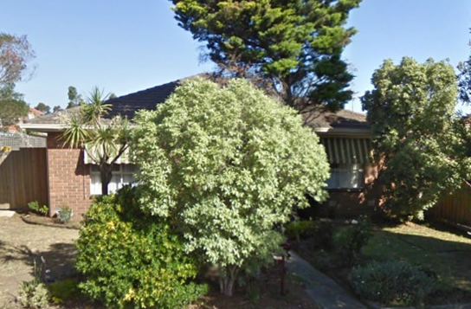

*Heats very quickly, heater doesn’t come on as often.*

*I don’t seem to use the heater as often. The house seems to retain the heat better.*

* 1. The original set-up

The house is a 98 m2 1970s brick-veneer, with a suspended timber floor and a tiled roof. Prior to the retrofits, the walls and floors were uninsulated, and there was loose-fill cellulose fibre insulation installed on the ceiling with an R-value of around R2.0. The house was reasonably airtight for an existing house. It had a measured natural air leakage rate of 0.86 air changes per hour, meaning that in winter the warm air inside the house was replaced by cold outside air, which had to be re-heated, a bit over once every hour. The main air leakage sites were an external door without adequate weather stripping, windows without weather stripping, and a perforated attic hatch.

The house is occupied by a family of two. Before the retrofits, the annual gas consumption was around 69,781 MJ per year, with an estimated 40,916 MJ (59%) of this used for home heating. This is lower than the average heating gas use of 61,190 MJ per year for a centrally heated house found in Sustainability Victoria’s study of the existing (pre-2005) housing stock [SV2015], due mainly to the relatively small size of the house and the relatively low level of air leakage. Historically, the household’s annual mains electricity consumption was around 3,686 kWh per year, or an average daily electricity consumption of only 10.1 kWh per day. This is slightly below average for a 2-person household[[175]](#footnote-176).

The house is heated mainly with a gas ducted heating system, used for around 9 hours per day during the winter months. During the week, the heater was generally run for around one hour in the morning (7:00 am to 8:00 am) and for about five hours in the evening (6:00 pm to 11:00 pm), with some additional heater usage during the middle of the day. On the weekends, the heating was run for longer hours, typically from around 9:00 am to around 10:30 pm. The house was heated to around 19oC to 20oC. The occupants found the house to be reasonably comfortable in the winter months, but noted that it was “really bad” in summer, due to the difficulty ventilating the house.

The existing gas ducted heater was at least 10 years old and, with a 2.1 Star Gas Energy Rating, was inefficient. The heating ductwork was also at least 10 years old, was located under the floor, and was in poor condition.

* 1. The energy efficiency retrofits

The comprehensive retrofits undertaken at the house focussed on increasing winter comfort and reducing winter heating energy use, by increasing the energy efficiency of the house’s building shell through insulation and draught sealing, and increasing the energy efficiency of the ducted heating system by upgrading the gas furnace and its associated ductwork. In addition to this, an old gas storage water heater was replaced with a new high efficiency model. The retrofits which were undertaken are shown in Figure 37. The total cost of all retrofit work was $10,602.

Figure 37: Energy efficiency retrofits undertaken

|  |  |  |
| --- | --- | --- |
| Air leakage rate of 0.86 Air Changes per Hour |  | Draught sealing to reduce air leakage rate to 0.85 Air Changes per Hour |

|  |  |  |
| --- | --- | --- |
| Uninsulated brick-veneer walls |  | Hydrophobic granulated rockwool insulation pumped into the external wall cavity |

|  |  |  |
| --- | --- | --- |
| Uninsulated suspended timber floors |  | R2.0 under-floor insulation installed |

|  |  |  |
| --- | --- | --- |
| 10-year old, 2.1 Star gas ducted heater |  | New 6-Star gas ducted heater |

|  |  |  |
| --- | --- | --- |
| 10-year old gas heating ductwork, in poor condition |  | New R1.4 heating ductwork |

|  |  |  |
| --- | --- | --- |
| >10-year old gas storage water heater |  | New 5 Star gas storage water heater |

The draught sealing measures reduced the natural air leakage rate of the house from 0.86 to 0.85 air changes per hour. They included weather stripping an external door, weather stripping windows, and sealing the perforated attic hatch.

* 1. Impact of the retrofits

The house was monitored before and after the retrofits were undertaken to help assess the impact of the retrofits on energy consumption and occupant comfort, and occupant surveys were conducted to obtain feedback on their experience of the retrofits. The electricity consumption of the gas ducted heating system, the electricity consumption of all switchboard circuits, and the internal and external temperatures were monitored over the period 28 May to 11 September 2013[[176]](#footnote-177). The building shell and heating system retrofit work commenced on 27 June with the draught sealing, and was completed on 26 July with the installation of the under-floor insulation. The gas ducted heating system upgrade was undertaken on 16 July, and the cavity wall insulation installed on 19 July. The gas water heating system was replaced on 25 July.

* + 1. Building shell and heating retrofits

Figure 38 shows the daily gas consumption of the ducted heater (columns) plotted against the average daily outside temperature[[177]](#footnote-178) (red line) over the entire monitoring period. The light blue columns show the daily gas consumption of the heater prior to the retrofits, and the green, aqua and orange columns show the daily gas consumption after the retrofits – the green columns cover the period after the draught sealing was undertaken, the aqua columns the period during which the heating system upgrade was undertaken and the wall and floor insulation was installed, and the orange columns cover the period after all retrofit work was completed. The gap in the gas consumption data from 8 to 22 August corresponds to the period when the metering equipment was removed for data download. It is evident from this chart that the daily gas consumption of the heating is highly dependent on the average daily external temperature; gas consumption tends to be lower on the warmer days and higher on the colder days. It is also evident that daily gas use after the retrofits was lower than before, especially after all retrofits had been undertaken.

Figure 38: Gas consumption of ducted heating vs average daily outside temperature

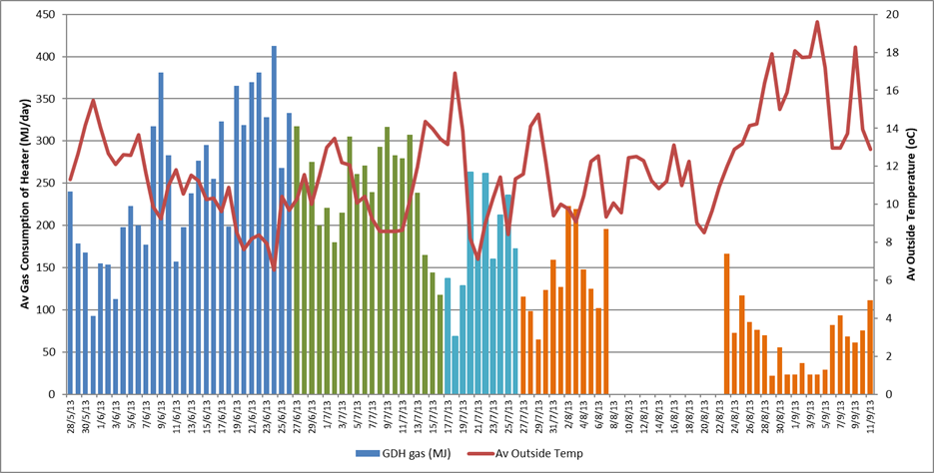

Further evidence of the reduction in heating energy consumption is provided in Figure 39, which shows the average daily gas consumption profile of the ducted gas heater on the days on which the heating was used prior to the retrofits, and in the period after all building shell and heating retrofits had been completed (after 26 July) to 27 August[[178]](#footnote-179). The gas consumption dropped from an average of 253.3 MJ per day prior to the retrofits to an average of 130.6 MJ per day after the retrofits, or a reduction of 48.4%.

Figure 39: Average daily gas consumption profile of the heating

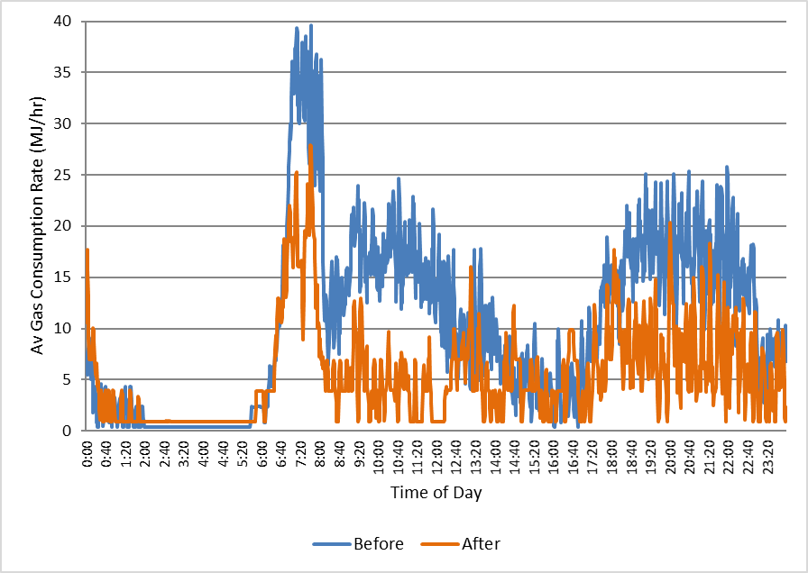

In practice, the gas energy savings achieved by the building shell and ducted heating system retrofits are likely to have been different to the 48.4% saving suggested by a simple comparison of daily gas consumption before and after the retrofits, and the further information provided in Figure 40 helps to understand why. These graphs show the average daily outside and inside temperature profiles of the house[[179]](#footnote-180) before and after the retrofits were undertaken, as well as the average temperature difference profile[[180]](#footnote-181) on the days that the heating was used. From Figure 40 (a) it is evident that, in general, the outside air temperatures were higher after the retrofits than before. The average daily outside temperature was 10.9oC prior to the retrofits and 11.9oC after the retrofits.

Figure 40 (b) shows that the average inside temperatures from midnight to the time when the heating was first switched on in the morning (7am to 8 am), were higher after the retrofits than before. This partly reflects the higher night-time temperatures after the retrofits, but is also likely to be due to the now well-insulated house holding the heat better. The inside temperatures during the middle part of the day (10:00 am to 2:00 pm) were lower after the retrofits, although this also corresponds with much lower heating use during this time. From 2:00 pm to 8:00 pm the inside temperatures after the retrofits were higher than before, and from 8:00 pm to 11:00 pm they were about the same. Over the whole day, the average inside temperature in the heated areas increased from 18.2oC before the retrofits to 18.5oC afterwards.

Figure 40 (c) shows that the average temperature difference between inside and outside the house was similar after the retrofits to before. It was slightly higher from midnight to 7:00 am, slightly lower during the middle part of the day, slightly higher from 2:00 pm to 8:00 pm, and then almost identical for the rest of the day. The average temperature difference during the time that the heating was operating was operating was 8.30oC[[181]](#footnote-182) before the retrofits and 7.85oC afterwards. This temperature difference is proportional to the rate of heat loss from the house, and therefore the “heating load” faced by the heater. The lower average temperature difference after the retrofits meant that the heat output from the heater could be lower after the retrofits than before to achieve the same thermostat settings.

Figure 40: Average daily outside and inside temperature profiles

|  |  |
| --- | --- |
| (a) Average daily outside temperature profile | (b) Average daily inside temperature profile |
|  | (c) Average daily temperature difference profile |

To obtain an alternative estimate of the heating energy savings achieved by the building shell and heating system retrofits, we used the data on the average daily gas consumption of the heater and average daily outside temperatures to characterise the energy performance of the heating system before and after the retrofits, and to estimate the annual heating energy consumption in a typical year[[182]](#footnote-183). The results of this analysis are provided in Figure 41. We estimate that the annual energy saving achieved was 17,602 MJ per year, or a 43.0% saving.

In addition to the reduction in gas consumption after the building shell and heating system upgrades, there was also a reduction in the electricity consumption of the gas ducted heater, which is due mainly to the air circulation fan. While the power consumption of the new gas ducted heater was slightly higher than the old gas ducted heater (around 406 Watts before the retrofit and 487 Watts afterwards), the increased efficiency of the building shell and the heating system meant that the fan operated for less time, saving electricity. Based on the measured electricity and gas consumption data for both the original and new heaters[[183]](#footnote-184) we estimate a net reduction in electricity consumption of around 68 kWh per year.

Figure 41: Energy performance characteristics of the main heating system

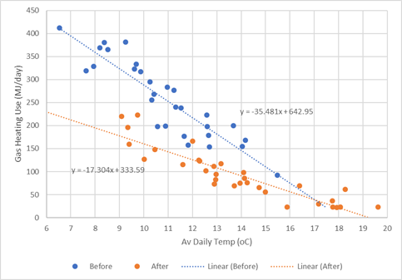

* + 1. Water heating retrofits

As part of the retrofit package, an existing gas storage water heater was replaced with a new 5-Star gas storage water heater. The age and full nameplate details of the existing water heater were not recorded[[184]](#footnote-185), but it is likely that it had a Gas Energy Rating of no more than 3 Stars. The project budget did not allow the water heater to be separately metered to measure the gas and hot water consumption, and the cold and hot water temperatures. Based on the number of occupants in the house, and the energy performance of the existing (taken to be 3 Stars) and new water heaters, we estimate an initial gas consumption of 18,626 MJ per year, reducing to 14,639 MJ per year following the installation of the 5-Star gas water heater. This gives an annual gas saving of 3,987 MJ per year, or 21.4%.

* 1. Householder experience of the retrofits

The house occupants were generally happy with the retrofit outcomes. Prior to the retrofits, they rated the overall thermal comfort level of the house in winter as 3 on a scale of 1 to 5[[185]](#footnote-186). It was felt to be reasonably comfortable when the heating was operating, but cooled down quickly once the heating was switched off. The main issue noted was that a draught could be felt in the lounge room. After the retrofits, the overall winter comfort rating increased to 5, with improvements particularly noted in the lounge and bedrooms. The dining room was still felt to be cool, due to the lack of window coverings in this room.

Even though the occupants felt that there was little difficulty heating the house before the retrofits – it rated 1 to 2 on a scale of 1 to 5[[186]](#footnote-187) before, and rated 1 afterwards – they felt that there were some improvements here after the retrofits. The house now heated quickly and retained the heat better, and it was not necessary to use the heating as often.

In the householder survey, the occupants noted that the house was “really hot” in summer, mainly due to the difficulty of providing any ventilation. Due to the timing of the trial, the occupants were not able to provide feedback on any improvements in summer comfort resulting from the retrofits. It is likely that the insulation would have also lead to improvements in occupant comfort during the summer months. As the house used a split-system air conditioner to provide summer cooling in the main living area, this should have resulted in further energy bill savings.

The occupants rated their satisfaction with their existing gas storage water heaters as a 3 on a scale of 1 to 5[[187]](#footnote-188), although noted that the pilot light occasionally went out, and that they “don’t love it because it heats up a lot of water”. Their satisfaction rating increased to a 5 after the new high efficiency gas storage water heater was installed.

* 1. Economics of the retrofits

The cost of the different energy efficiency retrofits (parts and labour), and the estimated annual energy, energy bill and greenhouse gas savings which resulted from them are shown in Table 21. The costs presented in the table are the full costs and do not include any government incentives, and the energy savings are based on typical current energy tariffs[[188]](#footnote-189). For the building shell and heating system upgrades, the energy bills savings are only for the heating season. This house uses a split system air conditioner for summer cooling in the main living area, and the building shell upgrades are likely to have also reduced electricity bills during the summer months.

Table 21: Summary of cost and annual savings for the energy efficiency retrofits

|  |  |  |  |  |  |  |
| --- | --- | --- | --- | --- | --- | --- |
| Retrofit | Cost  ($) | Annual savings | | | | Payback period  (Yrs) |
| Gas  (MJ/yr) | Electricity  (kWh/yr) | Greenhouse gas  (kg/yr) | Energy Bill  ($/yr) |
| Draught sealing | $674 |  |  |  |  |  |
| 6 Star gas ducted heater | $2,070 |  |  |  |  |  |
| R1.4 gas heating ductwork | $1,565 |  |  |  |  |  |
| Wall insulation | $3,183 |  |  |  |  |  |
| Underfloor insulation | $1,711 |  |  |  |  |  |
| ***Subtotal - building shell and heating*** | ***$9,203*** | ***17,602*** | ***68*** | ***1,054*** | ***$414*** | ***22.2*** |
| Water heating retrofit | $1,399 | 3,987 | - | 221 | $95 | 14.7 |
| Total | $10,602 | 21,589 | 68 | 1,274 | $509 | 20.8 |

We estimate that the house used an average of 40,916 MJ per year of gas for heating prior to the retrofits. Our analysis of the heating data collected during the retrofit trial suggests that a heating energy saving of 17,602 MJ per year (43.0%) was achieved for the gas consumption, and a small additional electricity saving of 68 kWh per year associated with the gas ducted heater’s fan. The total cost of the building shell and heating upgrades was $9,203, and the estimated annual energy bill saving was $414 per year, giving a payback period of 22.2 years on the investment.

The total upgrade package cost $10,602. We estimate that it has reduced total annual gas consumption by around 21,589 MJ per year (30.9%) and total annual electricity consumption by around 68 kWh per year (1.8%), resulting in annual energy bill savings of around $509 per year for an overall payback of 20.8 years. Annual greenhouse savings are estimated to be 1.27 tonnes per year.

The water heating upgrade was the most cost effective upgrade, due to the much lower cost.

Some of the upgrades undertaken are eligible for a financial incentive through the *Victorian Energy Upgrades* scheme, and this would further reduce the investment required from the householder. The gas ducted heater, gas ductwork upgrade, and the draught sealing all currently attract some level of incentive[[189]](#footnote-190). It is also likely that, in the majority of cases, the gas ducted heater and water heater upgrades would only be undertaken when the existing appliances fail or are close to the end of their life. This means that the additional cost of installing the high efficiency appliances is only the differential cost between a standard appliance and a high efficiency model. For gas ducted heaters this is around $900, and for a gas storage water heater around $160. The incentives available through the *Victorian Energy Upgrades* scheme would reduce this ‘differential cost’ even further. If these factors are taken into account, the overall cost of the appliance upgrades would be effectively lower, and therefore the payback somewhat shorter.

Over the next decade or so we expect that energy prices will continue to rise in real terms, especially for natural gas, increasing the size of the annual energy bill saving and increasing the rate of return on the initial investment.

1. Appendix 5 – House CR5

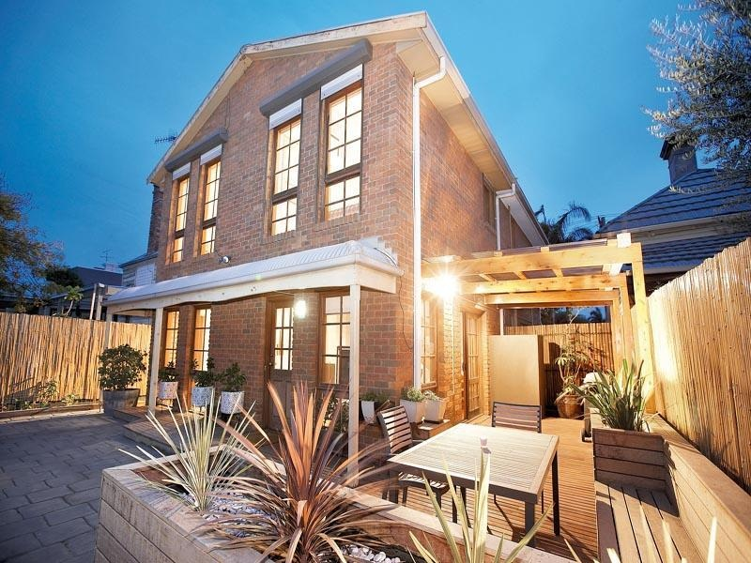

*If we go out for a couple of hours, we notice that the house has retained the heat much better.*

*Really can feel the heat from downstairs heating the upstairs bedroom.*

* 1. The original set-up

The house is an 80 m2 double storey house, with cavity-brick walls, a concrete slab-on-ground floor and a metal roof, constructed in the 1980s. Prior to the retrofits, the ceiling and walls were uninsulated. The house had a measured natural air leakage rate of 1.57 air changes per hour, meaning that in winter the warm air inside the house was replaced by cold outside air, which had to be re-heated, a bit over one and a half times every hour. The main air leakage sites were three external doors without weather stripping, three ceiling exhaust fans without dampers, architraves not sealed to plaster walls, and windows without weather stripping.

The house is occupied by two people. Before the retrofits, the annual gas consumption was around 13,375 MJ per year, with gas only being used for water heating and possibly also cooking. Historically, the household’s annual mains electricity consumption was around 5,756 kWh per year, or an average daily electricity consumption of 15.8 kWh per day. This is above the average for a 2-person household, mainly due to the use of a reverse-cycle air conditioner as the main form of heating[[190]](#footnote-191).

The house is heated mainly with a split-system reverse-cycle air conditioner located in the downstairs living area. The heating was used for around 9.4 hours per day during the winter months. The heater was generally run from around 8:00 am to 10:00 am in the morning, from around 1:30 pm to 4:00 pm in the afternoon, and from around 5:30 pm to midnight in the evening, with some usage in the early morning hours. Heater usage was higher on the weekend than on the weekdays. The house was heated to around 19oC to 20oC. The occupants found the house to be a bit uncomfortable, especially the upstairs area, which was not heated directly with the air conditioner.

* 1. The energy efficiency retrofits

The comprehensive retrofits undertaken at the house focussed on increasing winter comfort and reducing winter heating energy use, by increasing the energy efficiency of the house’s building shell through insulation and draught sealing. In addition to this, an existing gas storage water heater was replaced with a gas-boosted solar water heater, and an existing refrigerator was replaced with a new high efficiency one. The retrofits which were undertaken are shown in Figure 42. The total cost of all retrofit work was $14,059.

Figure 42: Energy efficiency retrofits undertaken

|  |  |  |
| --- | --- | --- |
| Air leakage rate of 1.57 Air Changes per Hour |  | Draught sealing to reduce air leakage rate to 1.08 Air Changes per Hour |

|  |  |  |
| --- | --- | --- |
| Uninsulated ceilings to metal roof |  | Cellulose fibre loose-fill insulation installed on the ceiling to achieve around R2.5 |

|  |  |  |
| --- | --- | --- |
| Uninsulated cavity-brick walls |  | Hydrophobic granulated rockwool insulation pumped into the external wall cavity |

|  |  |  |
| --- | --- | --- |
| Gas storage water heater (age unknown) |  | New gas-boosted solar water heater |

|  |  |  |
| --- | --- | --- |
| 10-year old, 447-litre, 2.4 Star, 2-door refrigerator / freezer |  | New 505-litre, 3.5 Star, 2-door refrigerator / freezer |

The draught sealing measures reduced the natural air leakage rate of the house from 1.57 to 1.08 air changes per hour. They included weather stripping external doors and windows, installing dampers for ceiling exhaust fans, and sealing architraves.

* 1. Impact of the retrofits

The house was monitored before and after the retrofits were undertaken to help assess the impact of the retrofits on energy consumption and occupant comfort, and occupant surveys were conducted to obtain feedback on their experience of the retrofits. The electricity consumption of the room reverse-cycle air conditioner, the electricity consumption of all switchboard circuits, and the internal and external temperatures were monitored over the period 25 May to 30 September, 2013. The building shell and heating system retrofit work commenced on 3 July with the draught sealing, and was completed on 17 July with the installation of the ceiling and wall insulation.

* + 1. Building shell and heating retrofits

Figure 43 shows the daily electricity consumption of the reverse-cycle air conditioner (columns) plotted against the average daily outside temperature[[191]](#footnote-192) (red line) over the entire monitoring period. The light blue columns show the daily electricity consumption of the heater prior to the retrofits, and the green and orange columns show the daily electricity consumption after the retrofits – the green columns cover the period during which the retrofits were undertaken, and the orange columns cover the period after all retrofit work was completed. It is evident from this chart that the daily electricity consumption of the heating is highly dependent on the average daily external temperature; consumption tends to be lower on the warmer days and higher on the colder days. It is difficult to identify a clear reduction in electricity consumption after the retrofit work had been completed.

Figure 43: Electricity consumption of reverse-cycle air conditioner vs average daily outside temperature

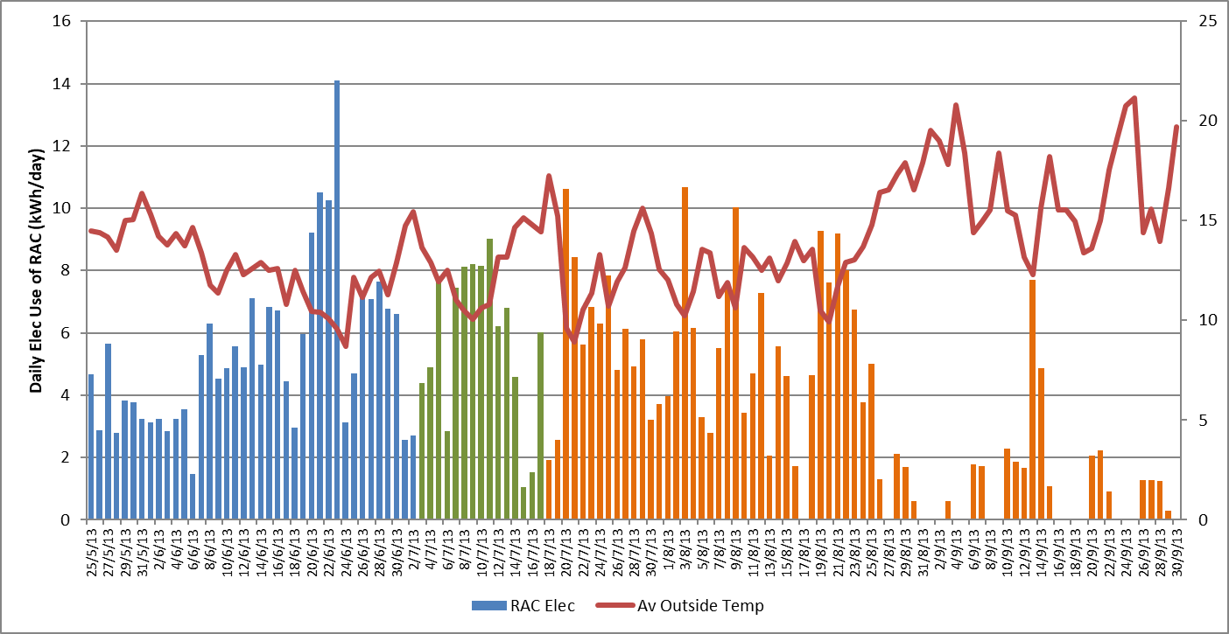

Figure 44: Average daily electricity consumption profile of the heating

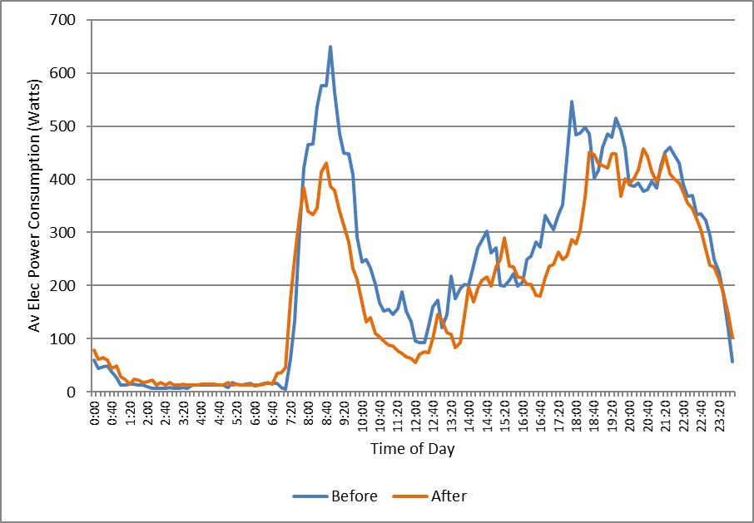

Further evidence of the reduction in heating energy consumption is provided in Figure 44. This shows the average daily electricity consumption profile of the reverse-cycle air conditioner on days on which the heating was used prior to the retrofits and in the period after all building shell and heating retrofits had been completed (after 17 July). The electricity consumption has dropped from an average of 5.35 kWh per day prior to the retrofits to an average of 4.47 kWh per day after the retrofits, or a reduction of 16.4%.

In practice, the electricity savings achieved by the building shell retrofits are likely to have been different to the 16.4% saving suggested by a simple comparison of daily electricity consumption before and after the retrofits, and the further information provided in Figure 45 helps to understand why. These graphs show the average daily outside and inside temperature profiles of the house[[192]](#footnote-193) before and after the retrofits were undertaken, as well as the average temperature difference profile[[193]](#footnote-194) on the days that the heating was used. From Figure 45 (a) it is evident that, in general, the outside air temperatures were higher after the retrofits than before, especially during the daytime. The average daily temperature was 12.8oC prior to the retrofits and 13.6oC after the retrofits.

Figure 45: Average daily outside and inside temperature profiles

|  |  |
| --- | --- |
| (a) Average daily outside temperature profile | (b) Average daily inside temperature profile |
|  | (c) Average daily temperature difference profile |

From Figure 45 (b) it is evident that the inside temperatures were considerably higher after the retrofits than before, especially during the early morning hours. The average daily inside temperature increased from 18.2oC prior to the retrofits to 19.0oC afterwards. This is partly due to the higher outside temperatures, and partly due to the better insulated house holding its heat better once the heating is turned off, but also suggests that the thermostat settings were higher.

Figure 45 (c) shows that the temperature difference[[194]](#footnote-195) between inside the house and outside was higher after the retrofits in the early morning hours (midnight to 8:00 am), corresponding to those times when the heating was generally not operating. This suggests that the insulation was working to retain the heat inside the house during these times. The temperature differences during the daylight hours (8:00 am to 5:00 pm) were slightly lower after the retrofits, and the temperature differences during the evening were about the same. The temperature difference is proportional to the rate of heat loss from the house, and therefore the “heating load” faced by the heater. The lower temperature difference during the daylight hours, means that the heating did not have to work as hard during these times to maintain the required comfort conditions.

To obtain an alternative estimate of the heating energy savings achieved by the building shell and heating system retrofits we used the data on the average daily electricity consumption of the heater and average daily outside temperatures to characterise the energy performance of the heating system before and after the retrofits, and to estimate the annual heating energy consumption in a typical year[[195]](#footnote-196). The results of this analysis are provided in Figure 46. We estimate that the annual energy saving achieved was 396 MJ per year (109.9 kWh per year), or a 9.0% saving.

Figure 46: Energy performance characteristics of the main heating system

**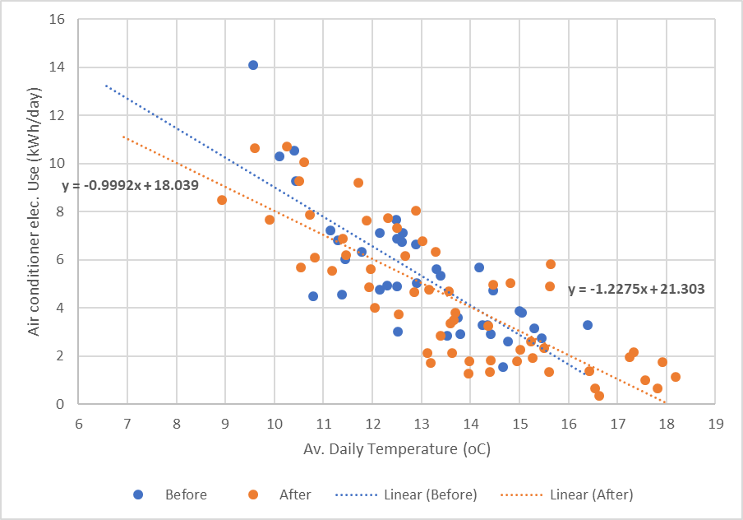**

* + 1. Water heating retrofits

As part of the retrofit package, an existing gas storage water heater (around 3.5 Star) was replaced with a gas-boosted solar water heater that used an instantaneous gas water heater to provide the bosting. The project budget did not allow the water heater to be separately metered to measure the gas and hot water consumption, and the cold and hot water temperatures. Based on the number of occupants in the house, and the energy performance of the existing and new water heaters, we estimate an initial gas consumption of 11,775 MJ per year, reducing to 1,225 MJ per year following the installation of the gas-boosted solar water heater. This gives an annual gas saving of 10,550 MJ per year, or 89.6%. The gas saving was off-set to some extent by an estimated annual electricity consumption of around 48 kWh per year, associated with the instantaneous gas booster.

* + 1. Refrigerator retrofits

The house initially had a 447-litre two-door refrigerator/freezer that was around 10-years old. This was replaced with a new 505-litre, 3.5 Star 2-door refrigerator. This resulted in a significant electricity saving. The daily electricity consumption of the refrigerator, before and after the replacement is shown in Figure 47. The blue columns are for the existing 2-door refrigerator and the orange columns[[196]](#footnote-197) are for the new high efficiency refrigerator. The average energy saving during the monitoring period was 0.72 kWh per day. The annual electricity saving was estimated to be 282 kWh per year (or 49.0%).

Figure 47: Daily electricity consumption of the refrigerator/freezer

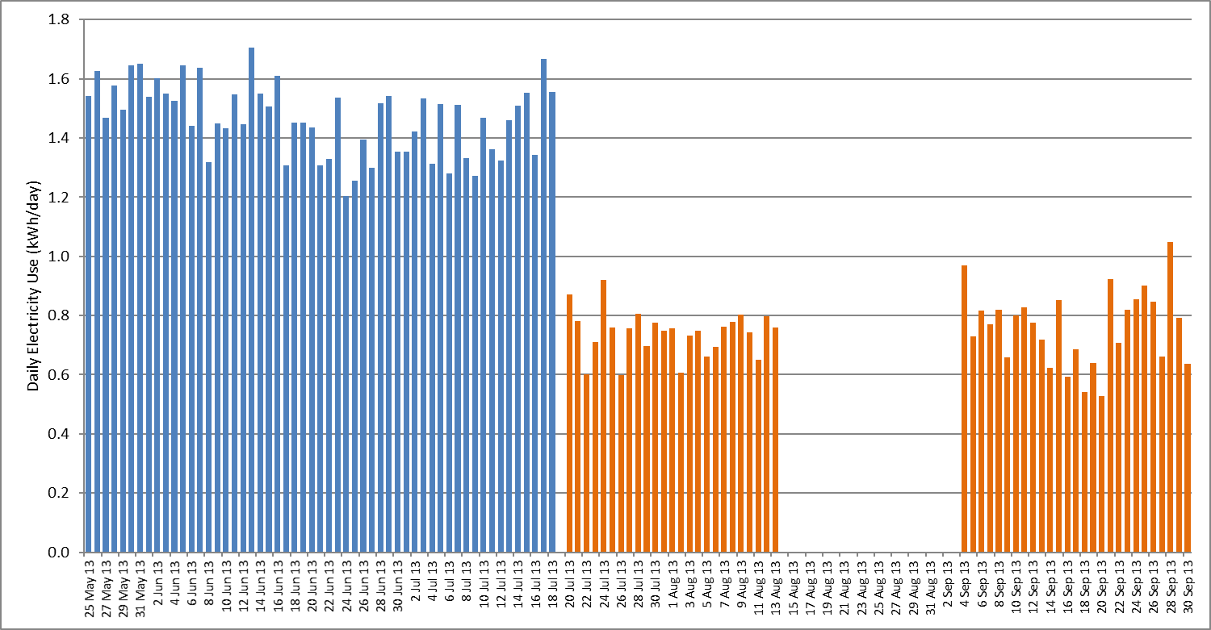

* 1. Householder experience of the retrofits

Overall, the occupants were happy with the retrofits. Their rating of the house’s winter comfort increased from 2 to 3 on a scale of 1 to 5[[197]](#footnote-198) before the retrofits, to a rating of 4 afterwards. Before the retrofits, the upstairs area was felt to be particularly uncomfortable (a rating of 1 to 2). Afterwards, “On very cold days the house still felt a bit cold, but it was noticeable the house was keeping warmer”. The comfort rating for the upstairs bedroom increased to 5. The occupants felt that they could “Really … feel heat from downstairs heating the bedroom”. In the evening, the lounge was found to be less draughty, and there was greater heat retention.

Prior to the retrofits, the house was considered to be reasonably easy to heat – the occupants gave it a rating of 2 on a scale of 1 to 5[[198]](#footnote-199). Afterwards, they noted that “If we go out for a couple of hours, we notice that the house has retained the heat much better”.

The occupants rating of their satisfaction with the original refrigerator was 3 on a scale of 1 to 5[[199]](#footnote-200): “It’s old, but it works well”, although it was found to be noisy. After it was replaced, the satisfaction rating increased to 5. The occupants liked the temperature monitors provided on both the inside and the outside of the refrigerator. They did notice the occasional “strange noise” from the new refrigerator, which seemed to be associated with the refrigerator’s defrost cycle.

Prior to the retrofits, the occupants rated their satisfaction with their water heating system as 4 on a scale of 1 to 5. This increased to 5 after it was replaced with the gas-boosted water heater.

The occupants did experience several issues with the retrofits. In the bathroom, some of the cellulose fibre insulation installed in the ceiling was coming through the exhaust duct when it was windy. One of the bricks was not replaced after the wall insulation had been installed, and some of the doors that used to close quietly were now noisy, due to the brush used on the bottom of the draught arrestors.

* 1. Economics of the retrofits

The cost of the different energy efficiency retrofits (parts and labour), and the estimated annual energy, energy bill and greenhouse gas savings which resulted from them are shown in Table 22. The costs presented in the table are the full costs and do not include any government incentives, and the energy savings are based on typical current energy tariffs[[200]](#footnote-201). For the building shell upgrades, the energy bills savings are only for the heating season. This house uses a split system air conditioner for summer cooling in the main living area, and the building shell upgrades are likely to have also reduced electricity bills during the summer months.

Table 22: Summary of cost and annual savings for the energy efficiency retrofits

|  |  |  |  |  |  |  |
| --- | --- | --- | --- | --- | --- | --- |
| Retrofit | Cost  ($) | Annual savings | | | | Payback period  (Yrs) |
| Gas  (MJ/yr) | Electricity  (kWh/yr) | Greenhouse gas  (kg/yr) | Energy Bill  ($/yr) |
| Draught sealing | $896 |  |  |  |  |  |
| Ceiling insulation | $1,786 |  |  |  |  |  |
| Wall insulation | $3,420 |  |  |  |  |  |
| ***Subtotal - building shell*** | ***$6,102*** | ***-*** | ***110*** | ***130*** | ***$35*** | ***174.1*** |
| Water heating retrofit | $5,980 | 10,550 | -48 | 527 | $285 | 21.0 |
| Refrigerator replacement | $1,977 | - | 282 | 333 | $90 | 22.0 |
| Total | $14,059 | 10,550 | 344 | 990 | $410 | 34.3 |

We estimate that the house used an average of 4,391 MJ per year (1,220 kWh per year) of electricity for heating prior to the retrofits. Our analysis of the heating data collected during the retrofit trial suggests that a heating energy saving of 396 MJ per year (110 kWh per year), or 9.0%, was achieved for the reverse-cycle air conditioner. The total cost of the building shell and heating upgrades was $6,102, and the estimated annual energy bill saving was $35 per year, giving a payback period of 174.1 years on the investment.

The total upgrade package cost $14,059. We estimate that it has reduced total annual gas consumption by around 10,550 MJ per year (78.9%) and total annual electricity consumption by around 344 kWh per year (6.0%), resulting in annual energy bill savings of around $410 per year for an overall payback of 34.3 years. Annual greenhouse savings are estimated to be 0.99 tonnes per year.

The water heating and refrigerator retrofits were much more cost-effective than the building shell upgrades, due to the larger energy and energy bill savings achieved. In practice, these appliances would normally be replaced when they had reached their end of life, or were close to it. In this case, the cost of upgrading to a high efficiency model is only the cost difference between the high efficiency and the standard model[[201]](#footnote-202), meaning that in practice the paybacks are likely to be lower than shown in the table.

Some of the upgrades undertaken are eligible for a financial incentive through the *Victorian Energy Upgrades* scheme. The draught sealing, and the refrigerator and water heater upgrade all currently attract some level of incentive[[202]](#footnote-203). The solar water heater would also benefit from an incentive available through the small-scale technology certificate (STC) scheme. The incentives available through the *Victorian Energy Upgrades* and theSTC scheme would reduce the upgrade cost to the household even further.

Over the next decade or so we expect that energy prices will continue to rise in real terms, especially for natural gas, increasing the size of the annual energy bill saving and increasing the rate of return on the initial investment.

1. Appendix 6 – House CR6

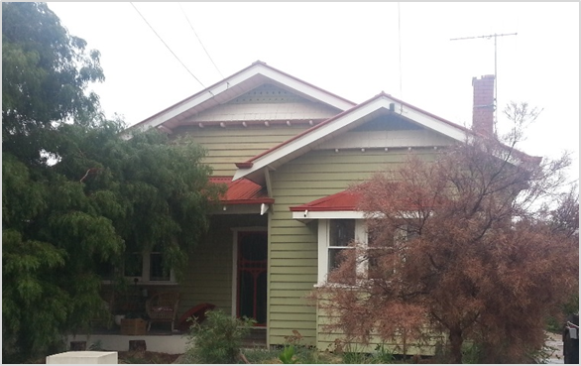

*Much more comfortable now. More stable. Less contrast in temperatures.*

*Quicker to bring up to temperature. Temperature holds better in the house. Use the heating system less.*

* 1. The original set-up

The house is a 122 m2 1920s era weatherboard, with a suspended timber floor and corrugated iron roof. Prior to the retrofits, it had only 25 mm (around R1.0) expanded polystyrene foam insulation boards installed on the ceiling, although many of these boards were broken and/or had become dislodged, resulting in an overall insulation level and coverage that was quite poor. Both the walls and the floor were uninsulated, and the sub-floor space was open to the elements. The house had a measured natural air leakage rate of 1.88 air changes per hour, meaning that in winter the warm air inside the house was replaced by cold outside air, which had to be re-heated, nearly twice every hour. This fairly high level of air leakage was due partly to the timber construction of the house, and also due to the presence of wall vents, an open fireplace with an unsealed chimney, and the use of double-hung timber-framed windows.

The house is occupied by a family of four. Prior to the retrofits its annual gas consumption was around 111,384 MJ per year, with an estimated 78,259 MJ (70%) of this used for home heating. This is significantly higher than the average of 61,190 MJ per year for central heating found in Sustainability Victoria’s previous study of the existing (pre-2005) housing stock [SV2015], and is particularly high given the size of the house. The high heating energy consumption is due mainly to the low level of insulation and the high level of air leakage. Historically, the annual electricity consumption of the household was around 3,107 kWh per year, or an average daily electricity consumption of only 8.5 kWh per day, which is below average for a 4-person household[[203]](#footnote-204).

The house is heated mainly with a gas ducted heating system, which was used for around 10.5 hours per day during the winter months. The heating was manually controlled, and was typically run from around 7:00 am to 11:00 pm on Monday and Tuesday and on the weekend, and from 6:00 am to 8:00 am and 5:00 pm to 11:00 pm from Wednesday to Friday. The heating thermostat was normally set to around 20 to 21oC. Prior to the retrofits, the occupants found the house reasonably comfortable, although noted that the main bedroom, dining room and lounge-living areas were colder than the rest of the house. The main bedroom and living room were also felt to be quite breezy.

The existing gas ducted heater and its associated ductwork were around 23 years old and, with only a 2.0 Star Gas Energy Rating, the gas furnace was inefficient. The gas heating ductwork had a fairly low level of insulation (around R0.6), although was still in reasonable condition. The gas furnace was located outside, with the ductwork run under the floor. The gas ducted heating was supplemented by a small portable electric heater - with a power consumption of around 500 Watts – in one of the children’s bedrooms, which was run overnight.

* 1. The energy efficiency retrofits

The comprehensive retrofits undertaken at the house focussed on increasing winter comfort and reducing winter heating energy use by increasing the energy efficiency of the house’s building shell through insulation and draught sealing, and increasing the energy efficiency of the ducted heating system by upgrading the gas furnace. The retrofits which were undertaken are shown in Figure 48. The total cost of all retrofit work was $13,070.

Figure 48: Energy efficiency retrofits undertaken

|  |  |  |
| --- | --- | --- |
| Air leakage rate of 1.88 Air Changes per Hour |  | Draught sealing to reduce air leakage rate to 0.92 Air Changes per Hour |

|  |  |  |
| --- | --- | --- |
| R1.0 ceiling insulation, broken and dislodged in some places giving poor coverage |  | Existing insulation and ceiling debris removed and R3.5 insulation batts installed |

|  |  |  |
| --- | --- | --- |
| Uninsulated weatherboard walls |  | Hydrophobic granulated rockwool pumped into wall cavity through holes in the weatherboards. |

|  |  |  |
| --- | --- | --- |
| 23-year old, 2.0 Star gas ducted heater |  | New 5.8 Star gas ducted heater |

The draught sealing measures reduced the natural air leakage rate of the house from 1.88 to 0.92 air changes per hour, and included weather stripping two external doors, sealing 10 wall vents and broken window panes with clear silicon gap filler, and sealing around window frames, architraves and external doors. A selection of the draught sealing upgrades which were undertaken are shown in Figure 49.

Figure 49: Selection of the draught sealing measures used

|  |  |  |
| --- | --- | --- |
| Wall vent sealed with clear silicone | Broken window pane sealed with clear silicone gap filler | Weather stripping applied front door |

Further efficiency and comfort improvements could have been achieved by installing underfloor insulation and by replacing the existing gas heating ductwork with high efficiency new ductwork. This was not undertaken as part of this trial, partly to keep the overall retrofit costs within the allocated budget and partly because, as shown in Figure 50, there was insufficient clearance (only around 300 mm) to allow underfloor insulation to be easily installed or to accommodate the larger diameter (around 500 mm) of the more energy efficient heating ductwork which is now available.

Figure 50: Limited clearance under suspended timber floor

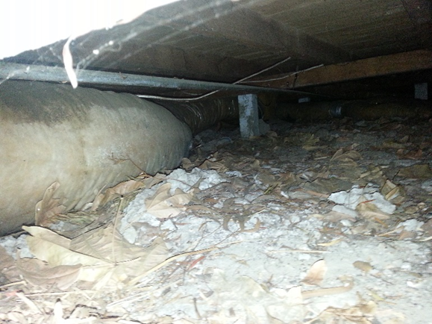

* 1. Impact of the retrofits

The house was monitored before and after the retrofits were undertaken to help assess the impact of the retrofits on energy consumption and occupant comfort, and surveys were also conducted with the occupants to obtain their feedback on their experience of the retrofits. The gas and electricity consumption of the gas ducted heating system, and the inside and outside temperatures were monitored over the period 21 May to 21 September 2014. The building shell and heating retrofits started on 26 June and were completed on 8 July. The ceiling and wall insulation work was undertaken on 25 and 26 June, the gas ducted heater furnace replaced on 2 July, and the draught sealing work undertaken on 8 July.

* + 1. Building shell and heating retrofits

Figure 51 shows the daily gas consumption of the gas ducted heater plotted against the average daily outside temperature[[204]](#footnote-205) (red line) over the entire monitoring period. The blue columns show the daily gas consumption of the heater prior to the retrofits, and the green and orange columns show the daily gas consumption after the retrofits – the green columns cover the period when the retrofits were being undertaken and the orange columns cover the period after all upgrade work had been completed. It is evident from this graph that that the daily gas consumption of the heating is highly dependent on the average daily outside temperature; gas consumption tends to be lower on the warmer days and higher on the colder days. It is also evident that daily gas use of the heating after the retrofits was substantially lower than before.

Figure 51: Gas consumption of ducted heating vs average daily outside temperature

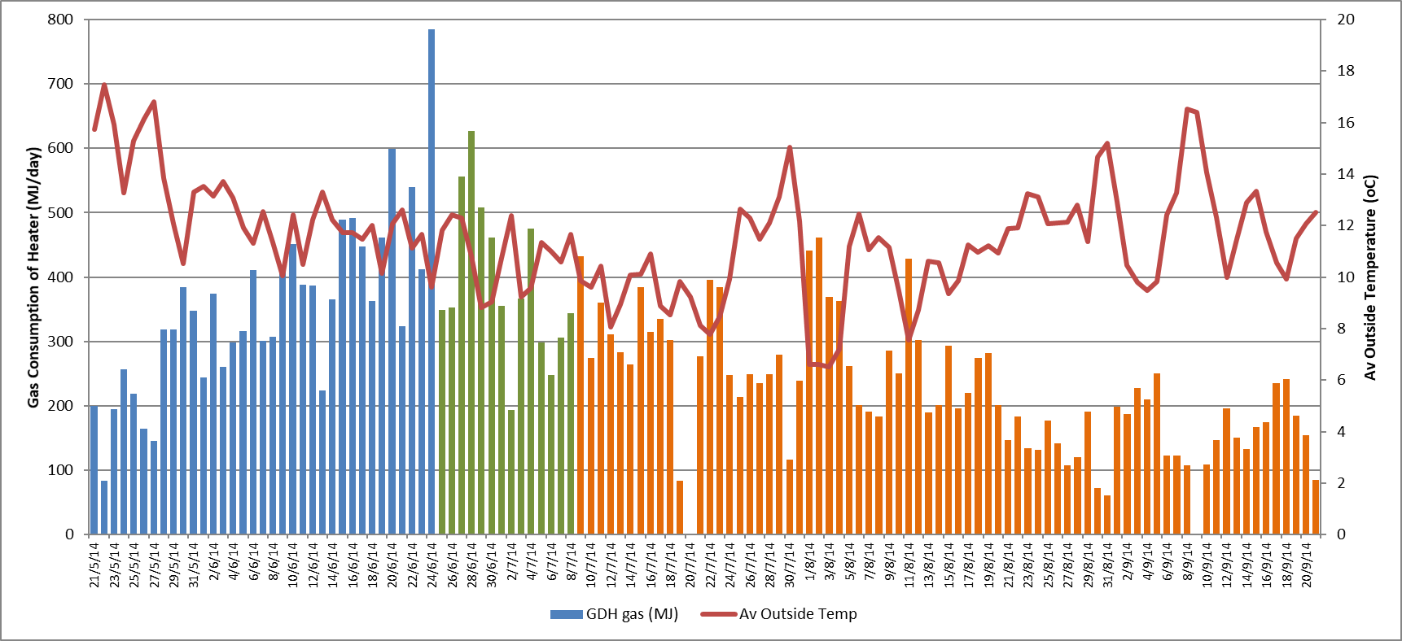

Further evidence of the reduction in heating energy consumption is provided in Figure 52. This shows the average daily gas consumption profile of the gas ducted heater on days on which the heating was used prior to the retrofits and in the period after all building shell and heating retrofits had been completed (after 8 July). The gas consumption has dropped from an average of 351.2 MJ per day prior to the retrofits to an average of 228.7 MJ per day after the retrofits, or a reduction of 34.9%.

It is also evident from Figure 52 that the gas ducted heating system is being used less after the retrofits than before. The average hours of operation on the days that the heating was used decreased from 10.5 hours per day prior to the retrofits to 8.5 hours per day after the retrofits. Prior to the retrofits there was some usage of the heating from late evening (around 11:00 pm) to early morning (around 6:00 am), although after the retrofits the heating was almost never used during these night time hours.

Figure 52: Average daily gas consumption profile of the heating

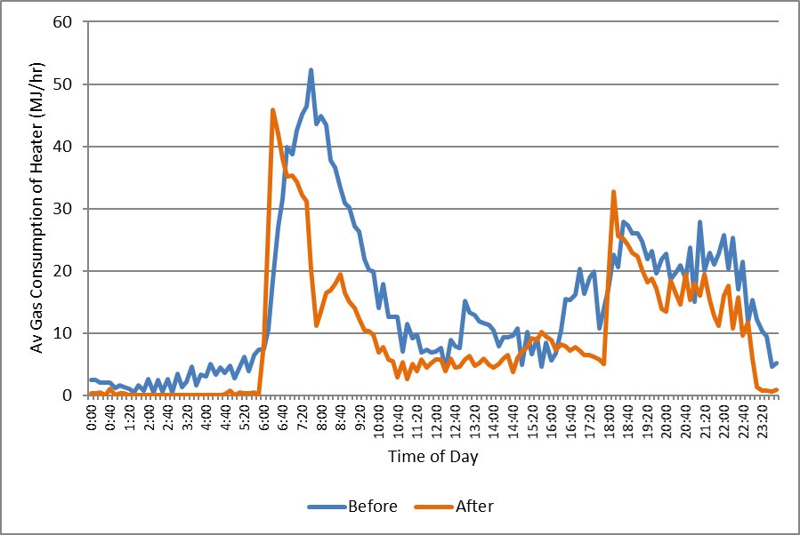

The occupants also noted that they stopped using the small portable electric heater in the children’s bedroom after the retrofits, as this was no longer necessary to keep the room warm overnight. This would have resulted in an additional electricity saving, although as the electricity consumption of this heater was not metered we have not been able to measure this saving exactly[[205]](#footnote-206).

In practice, the gas energy savings achieved by the building shell and ducted heating system retrofits are likely to have been a bit different to the 34.9% saving suggested by a simple comparison of daily gas consumption before and after the retrofits, and the further information provided in Figure 53 helps to understand why. These graphs show the average daily outside and inside temperature profiles of the house[[206]](#footnote-207) before and after the retrofits were undertaken, as well as the average temperature difference profile[[207]](#footnote-208). From Figure 53 (a) it is evident that, in general, the outside air temperatures were lower during the post-retrofit period than during the pre-retrofit period, especially during the night time. The average daily temperature was 12.7oC prior to the retrofits, and 11.0oC after the retrofits.

Figure 53 (b) shows that the inside temperatures were generally lower throughout the day after the retrofits had been undertaken, although similar temperatures were achieved in the early morning from around 6:30 am to 8:00 am when the heater was first switched on. The lower temperatures after the retrofit from late evening (11:00 am) to early morning (6:00 am) are consistent with the fact that the gas ducted heating, and portable electric heater, were largely not used after the retrofits during this period. However, even though the internal temperatures were lower after the retrofits, the occupants reported a significant increase in thermal comfort (see below). This may have been because the addition of the wall insulation and the better insulated ceiling resulted in the ceiling and internal wall surfaces having a higher temperature after the retrofits, and because the draught sealing reduced the incidence of draughts inside the house. In both cases this would have enabled the occupants to feel comfortable at a lower air temperature[[208]](#footnote-209).

Figure 53: Average daily outside and inside temperature profiles

|  |  |
| --- | --- |
| (a) Average daily outside temperature profile | (b) Average daily inside temperature profile |
|  | (c) Average daily temperature difference profile |

Figure 53 (c) shows that the average temperature difference between inside and outside the house was larger after the retrofits from around 6:00 pm to 8:00 am, including the main periods in the morning and evenings when the heating was operated. The average temperature difference when the heating was operating was 7.3oC[[209]](#footnote-210) before the retrofits and 8.2oC after the retrofits. This temperature difference is proportional to the rate of heat loss from the house and therefore the “heating load” faced by the heater. The higher average temperature difference after the retrofits meant that the heat output from the heater had to be larger after the retrofits than before to achieve the required thermostat setting.

To obtain an alternative estimate of the heating energy savings achieved by the building shell and heating system retrofits, we used the data on the average daily gas consumption of the heater and average daily outside temperatures to characterise the energy performance of the heating system before and after the retrofits, and to estimate the annual heating energy consumption in a typical year[[210]](#footnote-211). The results of this analysis are provided in Figure 54. We estimate that the annual energy saving achieved was 37,624 MJ per year, or a 48.1% saving.

Figure 54: Energy performance characteristics of the main heating system

**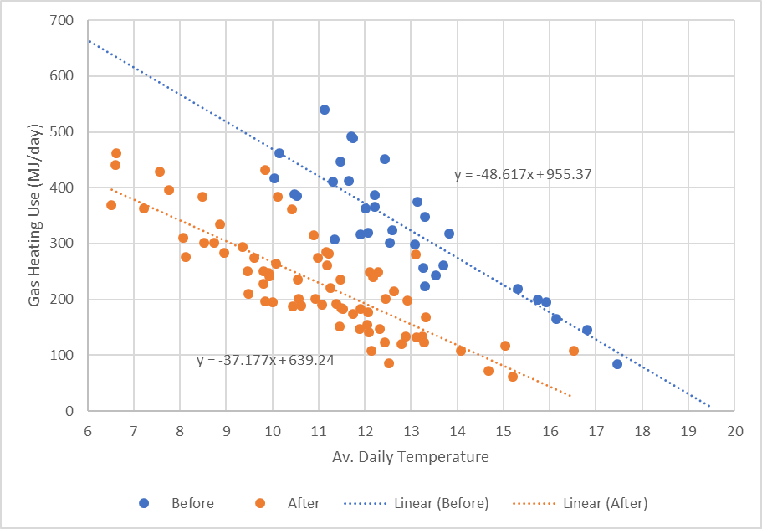**

In addition to the gas saving, we estimate that there was a small reduction in electricity use associated with the gas ducted heater replacement. Gas ducted heaters use electricity to power the main air circulation and combustion fans as well as the electronic controls. The average electricity consumption before the heater upgrade was 2.05 kWh per day compared to 2.33 kWh per day afterwards, or an increase of 0.28 kWh per day. Over a full year, we estimate that the electricity consumption of the gas ducted heater will decrease by 26 kWh[[211]](#footnote-212). As noted above, there was also an electricity saving (around 433 kWh per year) associated with the electric heater used in one of the bedrooms overnight.

* 1. Householder experience of the retrofits

Overall the house occupants were very happy with the retrofits. The building shell and heating upgrades were perceived to have increased the winter comfort of the home - from a rating of 3 to a rating of 5 on a scale of 1 to 5[[212]](#footnote-213). Similarly, the occupants felt that the upgrades significantly reduced the difficulty of heating their home, with the rating[[213]](#footnote-214) decreasing from 4 prior to the retrofits to 1 afterwards.

The occupants stated that prior to the retrofits the “heat output differs from room-to-room and so it is hard to establish a consistent temperature in all rooms. Generally, [this] means some rooms are slightly cooler than desired.” In particular, the main bedroom and the dining room and lounge/living area were felt to be cooler than other areas of the house, with the main bedroom and living room also felt to be “quite breezy”. After the retrofits, the occupants noted that the house was “Much more comfortable now. More stable. Less contrast in temperatures.” These improvements in comfort were experienced across the whole house. They also noted that the house was “Quicker to bring up to temperature. Temperature holds better in the house. Use the heating less.” The impact of the draught sealing measures was also noted: “Less breeze through the house – really notice it in the living room and the hallway” and kitchen.

The fact that the house was now more comfortable had some additional benefits. The occupants stated that they were now “More likely to stay home and work, rather than go out somewhere warm”, and that they now get up earlier in winter.

Satisfaction with the heating system also increased after the retrofits, from an initial rating[[214]](#footnote-215) of 2 to a rating of 5. In addition to the difficulties of achieving an even temperature throughout the house the occupants noted that the original heater was “noisy on ignition which can wake the kids”. The new gas ducted heating system was quieter and warmed the house up more quickly. The fact that the new heater’s controller allowed automated control of the operating times of the heating was also seen as an advantage.

Due to the timing of the retrofit trials the occupants were not able to provide feedback on any improvements in summer comfort resulting from the retrofits. It is likely that the insulation and air sealing would have also lead to improvements in occupant comfort during the summer months. However, as the house did not have an air conditioner at the time of the retrofit trials the upgrades would not have resulted in any additional energy savings during the summer months.

* 1. Economics of the retrofits

The cost of the different energy efficiency retrofits (parts and labour), and the estimated annual energy, energy bill and greenhouse gas savings which resulted from them are shown in Table 23. The cost of the ceiling insulation top-up includes the cost of removing and disposing of the existing foam-board insulation and other debris found in the ceiling before installing new R3.5 insulation batts, and so is higher than if a simple insulation top-up was undertaken. In the case of the wall insulation, the initial electrical inspection required for this measure identified the need to upgrade the house’s electrical switchboard[[215]](#footnote-216), and this is included in the cost of this measure. The costs presented in the table do not include any government incentives, and the energy savings are based on typical current energy tariffs[[216]](#footnote-217). Due to the bunched way in which the building shell and heating retrofits were undertaken it was not possible to identify the impact of each individual retrofit, so we have grouped these measures together.

We estimate that the house used an average of 78,259 MJ per year of gas for heating prior to the retrofits. Our analysis of the heating data collected during the retrofit trial suggests that a heating energy saving of 37,624 MJ per year (48.1%) was achieved for the gas consumption, and a small additional electricity saving of 26 kWh per year associated with the gas ducted heater’s fan. There was also an estimated 433 kWh per year electricity saving, as it was no longer necessary to operate the plug-in electrical heating in one of the bedrooms after the retrofit. The total cost of the building shell and heating upgrades was $13,070, and the estimated annual energy bill saving was $899 per year, giving a payback period of 14.5 years on the investment.

In this house, only building shell and heating system upgrades were undertaken. We estimate that the upgrades reduced the total annual gas consumption of the household by 33.8%, and total annual electricity consumption by around 14.8%. Annual greenhouse gas savings are estimated to be 2.62 tonnes per year.

Table 23: Summary of cost and annual savings for the energy efficiency retrofits

|  |  |  |  |  |  |  |
| --- | --- | --- | --- | --- | --- | --- |
| Retrofit | Cost  ($) | Annual savings | | | | Payback period  (Yrs) |
| Gas  (MJ/yr) | Electricity  (kWh/yr) | Greenhouse gas  (kg/yr) | Energy Bill  ($/yr) |
| Draught sealing | $660 |  |  |  |  |  |
| Ceiling insulation top-up | $2,461 |  |  |  |  |  |
| Wall insulation | $6,604 |  |  |  |  |  |
| Gas ducted heater | $3,345 |  |  |  |  |  |
| ***Sub-total for gas ducted heating*** | ***$13,070*** | ***37,624*** | ***26*** | ***2,112*** | ***$761*** | ***17.2*** |
| Electric heating in bedroom | - | - | 433 | 511 | $138 | - |
| Total | $13,070 | 37,624 | 459 | 2,623 | $899 | 14.5 |

Some of the upgrades could also be eligible for a financial incentive through the Victorian Government’s *Victorian Energy Upgrades* scheme[[217]](#footnote-218), and this would further reduce the investment required from the householder. Draught sealing and, gas ducted heating upgrades all currently attract some level of incentive.

It is also likely that in most cases the gas ducted heater upgrade would only be undertaken when the existing heater failed or was close to its end of life. This means that the additional cost of installing the high efficiency heating system is only the differential cost between a standard appliance and a high efficiency model, or around $900. The incentives available through the *Victorian Energy Upgrades* scheme would reduce this ‘differential cost’ even further. If this is taken into account, the overall cost of the heating system upgrade would be effectively lower, and therefore the payback somewhat shorter.

Over the next decade or so we expect that energy prices will continue to rise, especially for gas, increasing the size of the annual energy bill saving and increasing the rate of return on the initial investment.

1. Appendix 7 – House CR7

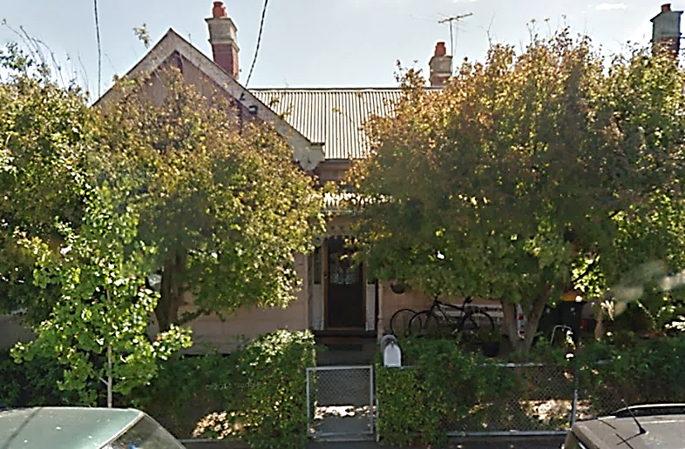

*Generally, feel that the house is more comfortable, with both the wall and sub-floor insulation being installed.”*

*The exposed timber floors are not as cold due to the installation of the underfloor insulation.*

* 1. The original set-up

The house is a 100-year old, 126 m2 weatherboard cottage with a suspended timber floor and an iron roof. Prior to the retrofits, the ceiling was insulated with R3.2 batts, but the walls and floor were largely uninsulated[[218]](#footnote-219). The house was reasonably airtight for such an old weatherboard house. It had a measured natural air leakage rate of 1.20 air changes per hour, meaning that in winter the warm air inside the house was replaced by cold outside air, which had to be re-heated, a bit over once every hour. The main air leakage sites were external doors without adequate weather stripping, ceiling exhaust fans without dampers, open fireplaces, and architraves not sealed to plaster walls.

The house is occupied by a family of three adults. Before the retrofits, the annual gas consumption was around 62,201 MJ per year, with an estimated 42,494 MJ (68%) of this used for home heating. This is lower than the average heating gas use of 61,190 MJ per year for a centrally heated house found in Sustainability Victoria’s study of the existing (pre-2005) housing stock [SV2015], due to the ceilings of the house being well insulated and the relatively low air leakage rate. Historically, the household’s annual mains electricity consumption had been around 5,180 kWh per year, but has now dropped to around 3,390 kWh per year (9.3 kWh per day) following the installation of rooftop PV panels in 2012. This is below average for a 3-person household[[219]](#footnote-220), largely due to the rooftop PV panels used to generate electricity. These partly offset the mains electricity used in the house, with the excess generation being exported to the grid.

The house is heated mainly with a gas ducted heating system, used for around 9.6 hours per day during the winter months, although an open wood fire is used occasionally in the living-dining area. The heater was often switched on at around 6:00 am in the morning and left on until around 11:00 pm at night, on both weekdays and the weekend, although the actual usage times varied from day-to-day. Heater usage was heaviest in the early morning (6:00 am to 8:30 am) and in the late afternoon (4:00 pm to 6:00 pm). The house was generally heated to around 18 to 19oC, although sometimes in the late afternoon and evenings this was increased to around 20 to 21oC. The occupants of the house found it to be reasonably comfortable during the winter months, although the front study was found to be colder than the rest of the house.

The existing gas ducted heater was around 20 years old. It was not possible to determine the Gas Energy Rating of the heater, but the occupants noted that it was classed as “high efficiency” when it was purchased. The heater had an electronic ignition, and no pilot light, suggesting that it had a rating of around 3.5 Stars. The heating ductwork was also around 20 years old. It was located under the floor, and was in fairly poor condition, with tears in the outer plastic sleeve evident in some places.

* 1. The energy efficiency retrofits

The comprehensive retrofits undertaken at the house focussed mainly on increasing winter comfort and reducing winter heating energy use by increasing the energy efficiency of the house’s building shell through insulation and draught sealing, and increasing the energy efficiency of the ducted heating system by upgrading its associated ductwork; the occupants did not want their existing gas furnace upgraded to a higher efficiency model. In addition to this, an old refrigerator was replaced with a new high efficiency model, and halogen downlights located in the living areas, bathroom and laundry were replaced with LED downlights. The retrofits which were undertaken are shown in Figure 55. The total cost of all retrofit work was $12,926.

Figure 55: Energy efficiency retrofits undertaken

|  |  |  |
| --- | --- | --- |
| Air leakage rate of 1.20 Air Changes per Hour |  | Draught sealing to reduce air leakage rate to 0.85 Air Changes per Hour |

|  |  |  |
| --- | --- | --- |
| Uninsulated weatherboard walls (front section of house) |  | Hydrophobic granulated rockwool insulation pumped into the external wall cavity |

|  |  |  |
| --- | --- | --- |
| C:\Users\ianm\AppData\Local\Microsoft\Windows\INetCache\Content.Word\20140411_085441.jpg  Uninsulated suspended timber floors, 20-year old heating ductwork |  | http://intranet/Docs/Projects/1072_TechResearch/Delivery/House%20C7%20–%20Photos/20140916_080727.jpg  Floors insulated with R2.0 batts, new R1.65 heating ductwork installed |

|  |  |  |
| --- | --- | --- |
| C:\Users\ianm\AppData\Local\Microsoft\Windows\INetCache\Content.Word\20140411_090300.jpg  20-year old, 532-litre, refrigerator |  | C:\Users\ianm\AppData\Local\Microsoft\Windows\INetCache\Content.Word\20140916_080035.jpg  New 3.5 Star, 431-litre, refrigerator |

1. Appendix 8 – House CR8

**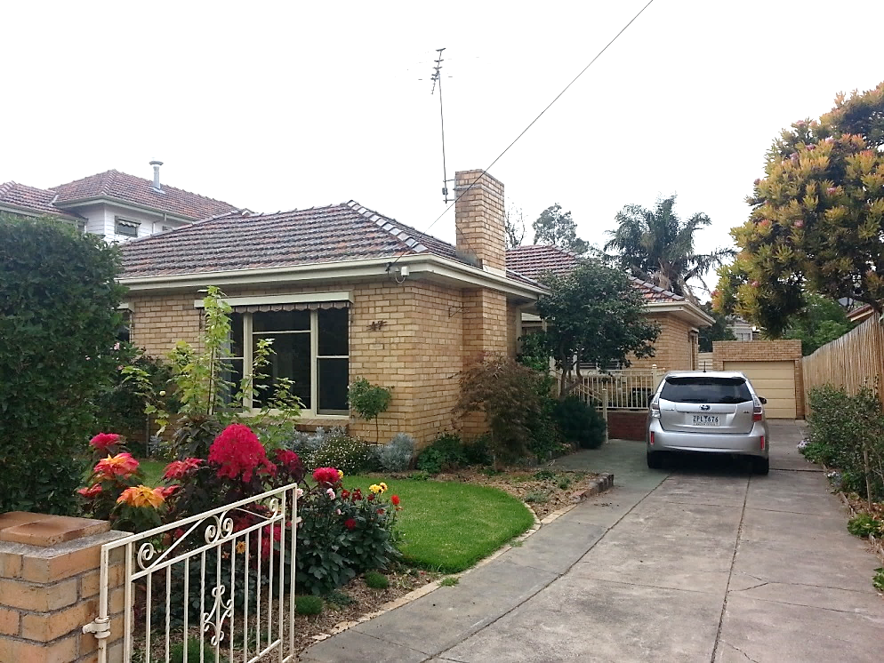**

1. The *OGA* study data was collected from a reasonably representative sample of 60 existing (pre-2005) stand-alone and semi-detached houses. It was used to assess the energy efficiency status of the houses, and to identify the building shell, lighting and appliance upgrades that could be practically applied to the houses. [↑](#footnote-ref-2)
2. The energy savings for the draught sealing and clothes dryer retrofits have been reduced to reflect the results of the draught sealing [SV2016b] and clothes dryer [SV2016g] retrofit trials. Lighting costs have been reduced to reflect a 60% reduction in the cost of LED lamps since the *OGA* study. The findings from the gas heating ductwork [SV2016d] and swimming pool pump [SV2016e] retrofit trials have been added to the table. Energy bill savings are based on typical 2018 residential energy tariffs: peak electricity (33.13 c/kWh); off-peak electricity (18.55 c/kWh); natural gas (2.29 c/MJ). Bill savings for low flow shower rose, clothes washer and dishwasher upgrades include the water savings. A greenhouse gas coefficient of 1.17 kg/kWh has been used for electricity and 0.05523 kg/MJ for natural gas. The cost used for the appliance upgrades is the full cost, adjusted (discounted) to account for the age of the appliances found in the houses. All other costs are the full upgrade cost. [↑](#footnote-ref-3)
3. Household averages were obtained by combining the Victorian residential energy consumption data for 2016-17 from *Australian Energy Statistics*, *Table F – Australian energy consumption, by state, by industry, & fuel type, energy units*, Dept. of the Environment and Industry, August 2018, and estimates of the number of occupied private dwellings from the *ABS Census of Population and Housing 2016* accessed from .idcommunity (<https://profile.id.com.au>). Greenhouse gas coefficients were obtained from *National Greenhouse Accounts Factors*, Dept. of the Environment and Energy, July 2018. [↑](#footnote-ref-4)
4. In Victoria, the *Victorian Energy Upgrades* program (also called the Victorian Energy Efficiency Target (VEET)), a mandatory obligation on energy retailers to assist consumers to save energy through specific energy efficiency upgrades or fuel substitution measures, has seen large-scale replacement of inefficient incandescent and halogen lighting with low energy CFL or LED lighting. Installation of low flow shower roses, replacement of electric water heaters, replacement of inefficient electric and gas heating, and low level draught sealing has also been undertaken. Minimum energy performance standards (MEPS), implemented through the national Equipment Energy Efficiency (E3) Program, has also driven improvements to the efficiency of new incandescent light globes, refrigerative air conditioners, refrigerators and freezers, televisions, and gas water heaters which replace existing units when they are replaced. [↑](#footnote-ref-5)
5. Estimates are based on data in the spreadsheet *OutputTables - Final V1.0 – AU* published in conjunction with the report *Residential Baseline Study for Australia 2000 – 2030*, EnergyConsult for Dept. of Industry & Science (on behalf of the E3 Program), August 2015. [↑](#footnote-ref-6)
6. A good summary of the evidence for these benefits is provided in the report *Targeted review of evidence of direct and co-benefits of energy efficiency upgrades in low income dwellings in Australia*, prepared for the CRC for Low Carbon Living [CRCLCL2018]. Detailed studies of the costs of poor housing – including houses being too cold and/or too hot due to inefficient building shells – have recently been undertaken in the UK [BRE2015] and the European Union [BRE2018]. [↑](#footnote-ref-7)
7. These multiple benefits were also recognised in a recent report from the UK Climate Change Committee [CCC2019]. This report noted that: “UK homes have a critical role to play in meeting the twin climate goals of reducing emissions and adapting to the current and future climate. … Retrofitting measures offers substantial opportunities for addressing climate risks and improving people’s health and well-being.” (page 47) It noted further that: “Our homes, and the way we use them, can also help by shifting consumption away from peak, and towards periods when renewable energy is available”. (page 75) [↑](#footnote-ref-8)
8. The main retrofits considered were: comprehensive draught sealing; insulation of uninsulated ceiling or top-up of poorly insulated ceiling; under-floor insulation; pump-in cavity wall insulation; heating system upgrade (furnace and ductwork if gas ducted heating system); replacement of old water heater; and replacement of old refrigerator. [↑](#footnote-ref-9)
9. For the last batch of houses, Energy Efficient Strategies was engaged by Sustainability Victoria to undertake the meter installation and removal work. [↑](#footnote-ref-10)
10. The projects were funded on an annual basis, and more funding would have been required to monitor this number of houses over a two-year period, with one year of monitoring prior to the retrofits and one year after. [↑](#footnote-ref-11)
11. A recent report for the Clean Energy Regulator found that the average size of a residential PV system being installed was now 4.8 kW, and Victoria was around the same as the national average. (*Small scale technology certificates – Projections 2018 to 2020*, ACIL Allen Consulting, 12 January, 2018.) [↑](#footnote-ref-12)
12. IT = information technology (computers, computer monitors, printers, modems, routers, etc); HE = home entertainment (TVs, video players, DVD players/recorders, PVR, audio equipment, game consoles, etc). [↑](#footnote-ref-13)
13. The calculator uses the area of the different building shell elements – ceilings, walls, floor and windows – as well as their thermal properties, based on their composite R-value. The natural air leakage rate (ACH) is also used. The external temperature data used was taken from recent SV retrofit trials, and averaged over the key heating period (June to August). Average heat losses (MJ/hr) when the heating is operating are calculated by dividing the difference between the internal and external temperatures by the composite R-value of each shell element, multiplying by the area of the building elements, and then aggregating to estimate the average heat loss rate over the June to August period. This simplistic analysis does not account for the thermal mass of the house. [↑](#footnote-ref-14)
14. It is assumed that the brick-veneer house has an enclosed sub-floor space, and that the weatherboard house has an unenclosed subfloor space. It is assumed that the floor is carpeted. Ceiling height is assumed to be 2.7 metres. [↑](#footnote-ref-15)
15. This corresponds to an air leakage rate of 40 ACH at a 50 Pascal pressure difference. This is simply divided by 20 to estimate the natural air leakage rate. The *OGA* study found an average measured natural air leakage rate of 2.02 ACH for houses constructed prior to 1990. Houses that are more airtight will have a lower natural air leakage rate, and therefore lower winter heat losses due to air leakage. [↑](#footnote-ref-16)
16. The following profile was used to approximate the average heating operating profile observed in the retrofit trial houses: weekdays – heating 9 hours per day, from 6:30 to 9:00 am and from 4:30 to 11:00 pm; weekends – heating 11.5 hours per day, from 7:00 am to noon, and from 5:00 pm to 11:30 pm. [↑](#footnote-ref-17)
17. Note that the addition of a thick, close-fitting, drape housed in a box pelmet provides thermal insulation for a window when the curtain is shut. Secondary glazing or double-glazing can be used, but is much more expensive. [↑](#footnote-ref-18)
18. Easy installation occurs where there is an A-frame roof and easy access to the roof-space to install the insulation. Difficult installation occurs where there is a flat or raked ceiling, and roofing iron or tiles need to be removed to install the insulation. It can also mean that only a fairly low level of insulation (up to R2.5) can be installed, due to space restrictions. [↑](#footnote-ref-19)
19. The NZ government agency EECA provides excellent information resources on insulating homes, including information on how to check existing ceiling insulation. See: <https://www.energywise.govt.nz/at-home/insulation/ceiling-insulation/checking-ceiling-insulation/> and <https://www.energywise.govt.nz/at-home/insulation/> . Sustainability Victoria’s *Energy Smart Housing Manual* is also an excellent source of information on insulation, and improving the thermal performance of a house’s building shell in general – see <https://www.sustainability.vic.gov.au/You-and-your-home/Building-and-renovating/Energy-Smart-Housing-Manual> [↑](#footnote-ref-20)
20. A detailed discussion of these is provided in [SV2016b], pages 10 to 14. [↑](#footnote-ref-21)
21. This includes smoke, odours from cooking and toilet areas, products of combustion from heating and cooking (e.g. carbon dioxide, sulphur dioxide and nitrogen dioxide), and fumes from paints and chemicals (e.g. volatile organic compounds) and formaldehyde emissions from furniture, carpet, finishes and building materials. [↑](#footnote-ref-22)
22. These heaters do not have a flue, and expel the products of combustion – mainly water vapour, carbon dioxide and nitrous oxides – into the room air. Carbon monoxide can also be emitted by these heaters, especially if they are faulty or poorly maintained. In Victoria, these heaters cannot be operated on natural gas. [↑](#footnote-ref-23)
23. <https://www.esv.vic.gov.au/safety-education/gas-safety-at-home/heating-your-home-with-gas/> [↑](#footnote-ref-24)
24. <https://www.esv.vic.gov.au/safety-education/gas-safety-at-home/heating-your-home-with-gas/> . [↑](#footnote-ref-25)
25. The sub-floor space might be totally unenclosed, or might be partially enclosed by boards. [↑](#footnote-ref-26)
26. This is based on analysing the detailed underfloor insulation data from [SV2015] using the same energy tariffs as for Table 1. The paybacks are quite similar, as the centrally heated homes were generally somewhat bigger than the houses with room heating, meaning that the cost of installing the underfloor insulation was higher. [↑](#footnote-ref-27)
27. In our heat load modelling tool, the heat loss rate was 4.9 MJ/hr for the unenclosed floor and 2.3 MJ/hr for the enclosed floor. The addition of R1.5 under-floor insulation reduced the heat loss rate to 1.9 MJ/hr (3 MJ/hr saving) for the unenclosed floor and 1.2 MJ/hr for the enclosed floor (1.1 MJ/hr saving). [↑](#footnote-ref-28)
28. One advantage of this type of insulation is that as well as providing insulation it can seal cracks and gaps between old floorboards, helping to reduce the air leakage rate. [↑](#footnote-ref-29)
29. Weatherboard houses with uninsulated walls will cool down quickly in winter, and heat up quickly on hot summer days. Brick-veneer walls have better thermal performance than weatherboard walls, due to the “thermal mass” (or heat storage capacity) of the outer leave of brickwork. This is especially the case in summer, meaning that brick-veneer houses do not heat up as quickly. However, in a prolonged hot spell, the brickwork can become saturated with heat, meaning that the houses take longer to cool down at night or after a cool change. [↑](#footnote-ref-30)
30. The R-value that is achieved with granulated rockwool depends on the density that is achieved when the insulation is installed. [↑](#footnote-ref-31)
31. This report provides a more detailed discussion of products that can be used for pump-in cavity wall insulation, and on the installation of granulated rockwool cavity wall insulation, including issues related to the condition of the existing walls and rain ingress. [↑](#footnote-ref-32)
32. Where houses have air conditioning to provide cooling during the summer months, the energy savings will be larger and the payback period shorter. This study was conducted over winter months, so only the heating energy savings were measured. [↑](#footnote-ref-33)
33. The *Cavity Wall Insulation Retrofit Trial* involved only houses with gas ducted heating. The modelling undertaken for the *OGA* study [SV2015], updated for current energy tariffs, suggests an average payback period of 21.8 years in houses with gas ducted heating, and 46.3 years in houses with gas room heating. [↑](#footnote-ref-34)
34. The way in which the majority of brick-veneer walls are constructed means that the top plate of the timber frame is somewhat higher than the top of the external brickwork. This means that once the cavity between the brick and the timber frame has been filled with insulation, the section of timber above the top of the brickwork still needs to be insulated. This can be done by cutting an insulation batt to size and fitting between the wall studs. See page 16 of [SV2016c]. [↑](#footnote-ref-35)
35. A minimum temperature difference of 10o Celsius is required between the inside and outside temperatures for a period of 4 hours prior to conducting the imaging survey. For more details on the thermal imaging of external walls, and the best conditions for undertaking thermal imaging surveys see pages 21 to 22 of [SV2016c]. [↑](#footnote-ref-36)
36. The Victorian Department of Health and Human Services (DHHS) has used this approach to improve the thermal performance of external walls when upgrading some of its old high rise towers. See: <https://www.kingspan.com/au/en-au/products-brands/insulation/case-studies/residential/department-of-health-and-human-services-dhhs-hig> [↑](#footnote-ref-37)
37. When electrical wiring carries a current it will tend to heat up. Covering the wiring with insulation will reduce its ability to dissipate this heat, and in some instances this may cause the wiring to overheat and create a fire risk. [↑](#footnote-ref-38)
38. The heat load model used as the basis of the data in Figure 4 and Table 1 assumed that initially the houses had single-glazed windows with only Holland blinds. [↑](#footnote-ref-39)
39. Heat losses through windows, and approaches to reducing these heat losses, are described in much more detail in SV’s *Window Film Secondary Glazing Retrofit Trial* report [SV2017b], and in the *Energy Smart Housing Manual* (<https://www.sustainability.vic.gov.au/You-and-your-home/Building-and-renovating/Energy-Smart-Housing-Manual>) [↑](#footnote-ref-40)
40. The gap between the existing pane of glass and the film is dictated by the window frame, and may not be within the optimal range. Also, the window frame needs to be suitable and the film applied correctly to get a good bond, and ensure that the gap is air tight. It may not be possible to apply the film to all window types – for example, the upper section of double-hung sash windows. see [SV2017b], pages 41 to 45, for further information. [↑](#footnote-ref-41)
41. In addition to the full cost of the new double-glazed windows, there are the labour costs to remove the existing windows, install the new double-glazed windows, and make good. SV’s OGA study found an average cost of $12,145 per house for this measure (see Table 1). [↑](#footnote-ref-42)
42. In SV’s 2013 window film trial, the costs were found to be around $10 per square metre for the basic materials, and $60 per square metre for commercial installation. [↑](#footnote-ref-43)
43. Data from the *ABS4602 Environmental Issues* series of reports or data releases for 1994, 1999, 2002, 2005, 2008, 2011 and 2014 was projected out to 2020, based on historical trends. Any “don’t know” responses were removed, and re-allocated to the different heater types based on a pro-rata allocation. [↑](#footnote-ref-44)
44. This could be plug-in or fixed electrical convection heaters, electric panel heaters, electric “night store” heaters, or electric radiant heaters. [↑](#footnote-ref-45)
45. For gas ducted, gas room and room reverse-cycle air conditioners, it was assumed that the heating was replaced by a high efficiency model of the same type. It was assumed that the electric resistance heating (panel heaters) were replaced with a high efficiency reverse-cycle air conditioner. [↑](#footnote-ref-46)
46. One reason for the fairly long payback for the room reverse-cycle air conditioners is that the systems found in people’s homes were relatively new, and therefore already reasonably efficient. This reduced the energy savings which could be achieved when upgrading to a new efficient system. [↑](#footnote-ref-47)
47. For further information see: <https://www.victorianenergysaver.vic.gov.au/save-energy-and-money/discount-energy-saving-products> [↑](#footnote-ref-48)
48. See SV heating running cost and greenhouse gas emission comparisons for further information: <https://www.sustainability.vic.gov.au/You-and-your-home/Save-energy/Heating/Heating-running-costs> [↑](#footnote-ref-49)
49. Data from the *ABS4602 Environmental Issues* series of reports or data releases for 1994, 1999, 2002, 2005, 2008, 2011 and 2014 was projected out to 2020, based on historical trends. Any “don’t know” responses were removed, and re-allocated to the different heater types based on a pro-rata allocation. [↑](#footnote-ref-50)
50. See pages 16 to 24 of [SV2016f] for a discussion of energy use by gas water heaters, including the differences between gas storage and gas instantaneous systems. Gas water heaters carry an Energy Rating label which indicates the relative energy efficiency of gas water heaters on a scale of 1 to 6 stars, based on the tested hot water load. Currently, this test uses a hot water load equivalent to 200 litres of hot water per day, raised by 45oC above cold water temperature, with the test being conducted in an ambient air temperature of 20oC. Average hot water use is estimated to be only 100 to 125 litres per day, meaning that the tested load is well above typical hot water usage – the efficiency of storage water heaters is lower at this lower load, due to the impact of the fixed standing losses. In addition to this, the annual average ambient air temperature in much of Victoria is around 14 to 15oC, meaning that in practice the standing losses from storage water heaters are larger than measured by the current test. The standing losses may also be increased by wind and rain when the storage water heaters are located outside. In contrast, gas instantaneous water heaters tend to maintain a fairly constant efficiency as the hot water load decreases, until it drops to quite low levels. The ambient conditions have less impact on their performance when located outside, as they only burn gas when they are heating water. [↑](#footnote-ref-51)
51. For a comparison of the annual running costs and greenhouse gas emissions of different water heater types, for different levels of hot water use, see: <https://www.sustainability.vic.gov.au/You-and-your-home/Save-energy/Hot-water/Hot-water-running-costs> [↑](#footnote-ref-52)
52. Solar water heaters use solar energy (sunlight) to heat water on sunny days – the better systems will derive 60 to 80% of their energy annual from the solar contribution, with the remaining energy coming from either an electric or gas boost. Heat pump water heaters use a refrigeration cycle to extract heat from the ambient air, with this heat ultimately coming from the sun. They use electricity to drive the refrigeration compressor. [↑](#footnote-ref-53)
53. For further information see: <http://www.cleanenergyregulator.gov.au/RET/Scheme-participants-and-industry/Agents-and-installers/Small-scale-technology-certificates> [↑](#footnote-ref-54)
54. For further information see: <https://www.victorianenergysaver.vic.gov.au/save-energy-and-money/discount-energy-saving-products> [↑](#footnote-ref-55)
55. The theoretical overall energy saving would be (1 – (0.6 x 0.8)) x 100% [↑](#footnote-ref-56)
56. See Section A5: Effect of Application Order on Energy Savings (pages 153 to 160). [↑](#footnote-ref-57)
57. The average annual gas consumption was estimated from gas bills provided by the participating households. Generally, 3 to 4 years of billing data was available for each house. The estimate of the annual gas use for heating was based on an analysis of the daily gas consumption of the heaters prior to the retrofits. This was correlated with average daily outside temperature data to characterise the temperature-dependent performance of the house & heating system, and this function was applied to average daily temperature data for the last 6 years and averaged. The methodology is explained in more detail in Section 3.3. The remainder of the gas (19,484 MJ per year) was used for water heating and cooking. [↑](#footnote-ref-58)
58. The *Victorian Utility Consumption Household Survey* 2015 found that in 2014 the average annual gas consumption for a 4-person household was 59,031 MJ per year, and the average annual electricity consumption was 5,810 kWh per year. Six of the 14 houses had rooftop PV systems, which is above the current Victorian average. [↑](#footnote-ref-59)
59. For this house, the total annual gas consumption was based on only a few years of energy bills, while the estimate of the gas use for heating is based on six years of weather data. This is likely to explain the discrepancy between the estimate of the total gas use and the gas use for heating. [↑](#footnote-ref-60)
60. This figure is based on comparable retrofit costs for the *OGA* study, e.g. gas storage, gas instantaneous or gas boosted solar water heaters, where relevant. These average costs have been weighted to be consistent with the retrofits actually undertaken at the houses. [↑](#footnote-ref-61)
61. For both the *Comprehensive Retrofit Trial* houses and the *OGA* study houses, the costs are based on the full upgrade costs, including the water heater and fridge heater upgrades, and exclude any government rebates or incentives that are available. For the *OGA* study houses, the water heater upgrade costs are weighted based on the type of water heater used for the upgrades in the retrofit trial: gas storage water heaters (57.1%); gas instantaneous (28.6%); and gas-boosted solar (14.3%). [↑](#footnote-ref-62)
62. For houses with gas ducted heating, data on both the gas and electricity consumption of the heaters was collected by directly metering the heaters. The electricity consumption of gas ducted heaters is due mainly to their air circulation and combustion air fans, and can be quite high during the winter heating season. For the houses in this study, the average daily electricity consumption of the gas ducted heaters ranged from 1.23 to 3.54 kWh per day in the pre-retrofit period, with the average across the houses being 2.12 kWh per day. For a 5-month heating period this suggests an electricity consumption of around 185 to 531 kWh per year. At the high end, this is comparable to the annual electricity consumption of a family-sized refrigerator. [↑](#footnote-ref-63)
63. This shows how the temperature varied over the day, based on metered data collected at 10-minute intervals. Data for the days on which the heating was operated was used to derive the average daily profiles. [↑](#footnote-ref-64)
64. Temperature differences are normally given in degrees Kelvin (K). For simplicity, in Figure 7 we use degrees Celsius (oC). [↑](#footnote-ref-65)
65. During these periods, the heating is cycling on and off in a fairly uniform manner, and both the inside temperature and temperature difference remain reasonably constant. To be useful, the packets of data need to cover a period of at least 2 hours. [↑](#footnote-ref-66)
66. During a period of steady state operation, the heat output of the heating system should equal the heat loss rate from the building. There will also be energy losses in the heating system, as well as in the ductwork where a ducted heating system is used. Therefore, the energy consumption rate of the heating system is the same as the energy loss rate due to the building shell (heat losses) and heating system (conversion energy losses). The higher the temperature difference across the building shell, the higher this rate of heat loss rate will be. [↑](#footnote-ref-67)
67. The slope of the lines measures the average energy loss rate for each degree Celsius of temperature difference. If there has been an improvement in efficiency, the energy loss rate is lower, and therefore the slope of the line is lower. [↑](#footnote-ref-68)
68. This can only be done for houses that use gas as the main heating fuel. Gas is mainly used for heating, water heating and cooking, and winter gas consumption is dominated by heating. The summer gas consumption – when the only gas use is likely to be for cooking and water heating – is used to estimate the annual energy use for these end-uses (by multiplying the lowest daily use (MJ/day) by 365 and by 1.2), and this is subtracted from the total annual gas consumption to estimate heating gas use. Where possible, historical gas billing data for at least three years prior to the retrofits is used, and a heating degree day index is used to adjust the annual estimates to account for years that are warmer and cooler than average. [↑](#footnote-ref-69)
69. See article on OpenEE Meter, “How it works”, <https://www.openee.io/open-source/how-it-works> [↑](#footnote-ref-70)
70. Ideally, this would use the weather data files from the NatHERS rating tools such as AccuRate to produce data on average daily temperatures for a typical weather year. However, these weather files are based on older weather data that is typical of the 1990s. Climate change has resulted in a warming trend, meaning that this data is no longer accurate. For this study, daily maximum and minimum temperature data from the Melbourne Airport weather station obtained from <http://www.bom.gov.au/climate/data/> was used to estimate the average daily temperatures for the six years from 2012 to 2017. The functions derived from Method 2 were applied to the annual weather data for each year, and averaged to estimate the average annual energy use and energy saving. Updated NatHERS weather data files are expected to be available soon, and this updated data could be used for the analysis. [↑](#footnote-ref-71)
71. In this study the gas pilot rate was measured using the gas meter connected to the gas ducted heaters. [↑](#footnote-ref-72)
72. The existing gas ducted heaters with a pilot light had a gas pilot rate between 11.6 to 23.7 MJ per day, with the average being 18.3 MJ per day. This corresponds to an annual gas consumption between 4,234 to 8,651 MJ per year, if the pilot light is not switched off during the summer months. [↑](#footnote-ref-73)
73. Where there has been a major upgrade of a house’s building shell efficiency, due to insulation and draught sealing, it’s not uncommon for the occupants to reduce the thermostat setting on the heating, as they can now feel comfortable at a lower air temperature. If this is the case, there are additional energy savings, as the temperature difference across the building shell is reduced, further reducing the heat losses through the building shell. [↑](#footnote-ref-74)
74. If only building shell and ductwork upgrades are undertaken, there will be a reduction in the electricity consumption of the gas ducted heater, and the “on” time of the gas ducted heater will be lower after the retrofits. If the gas ducted heater is upgraded, the situation is more complicated, as many new gas ducted heaters have a higher electricity consumption than older heaters – this seems to be mainly due to more powerful air circulation fans. This can sometimes lead to an overall increase in the electricity consumption of the gas ducted heaters. [↑](#footnote-ref-75)
75. In general, the electricity consumption is a higher percentage of gas consumption for the new high efficiency heaters compared to the old ones. This is partly because they use gas much more efficiently, but also seems to be due to the newer heaters often having a more power air circulation fan. [↑](#footnote-ref-76)
76. In this house three halogen spotlights in the kitchen were replaced with LED spotlights. [↑](#footnote-ref-77)
77. A detailed explanation of the methodology used for lighting energy savings if provided in [SV2016a]. In a simple sense, a seasonal adjustment factor was calculated for both the pre- and post-retrofit data, and applied to the average daily electricity use to estimate annual electricity consumption. This assumes that: lighting usage follows a sinusoidal pattern throughout the year, with maximum use at the winter solstice and minimum use at the summer solstice; and (2) that summer lighting energy use is around 30% of peak winter use. [↑](#footnote-ref-78)
78. The average daily electricity consumption of the original refrigerator was 2.36 kWh per day and this was reduced to an average daily electricity consumption of 0.60 kWh per day when the new high efficiency refrigerator was installed (a reduction of 74.6%). [↑](#footnote-ref-79)
79. For a detailed description of this methodology refer to [SV 2017a], Section A2: Analysis methodology, pages 59 to 77. The methodology was developed as part of Harrington’s research for the PhD thesis: *Prediction of the Energy Consumption of Refrigerators During Use,* Lloyd Wesley Harrington, PhD thesis, 25 May, 2018, Dept. of Infrastructure Engineering, Melbourne School of Engineering, University of Melbourne. [↑](#footnote-ref-80)
80. For heating, this includes the amount of time each day they operate the heating system, and the thermostat settings used. It also includes time of year occupants start to use heating leading into winter and the time of year they stop using the heating after winter. Similarly, how the occupants use hot water in the house, and lighting, will impact on the amount of energy used for these “energy services”. [↑](#footnote-ref-81)
81. To obtain a reasonable estimate of the impact of an individual retrofit measure requires a minimum of about 30 days of monitoring data, ideally during the main winter heating season. Several years of monitoring would have been required to collect this data. Some of these individual retrofit measures have been investigated in Sustainability Victoria’s various retrofit trials. [↑](#footnote-ref-82)
82. Only one of the houses (CR5) had an electrically powered main heating system, and this was a room reverse-cycle air conditioner. While gas ducted heaters use a considerable amount of electricity, and the building shell upgrades tended to reduce both the gas and electricity consumption of the heaters, where a new high efficiency gas ducted heating system was installed this often had a higher power air circulation fan, and this offset the electricity savings to some extent. Some of the houses with gas ducted heating had electric secondary heating, and there were also savings associated with these. However, the electricity consumption of the secondary heating was not metered in all houses. [↑](#footnote-ref-83)
83. We would expect that the gas furnace upgrades would be more cost effective than the various building shell and ductwork upgrades. However, unlike the other upgrades, the building shell upgrades improve thermal comfort in both winter and summer, and so the benefits are larger than just the energy bill and greenhouse gas savings. [↑](#footnote-ref-84)
84. A 2016 report comparing the results of intrusive lighting surveys undertaken in Australian houses in 2016 and 2010 noted: “This data suggests that programs such as VEET, which have reached more than 30% of Victorian households, are having a significant impact on the overall lighting efficacy in the residential sector” (page 29); and “This data suggests that there has been a significant improvement in lighting efficacy for task and directional lighting due to the halogen to LED transition. LEDs are being installed in new homes/renovations but also under voluntary state schemes like VEET. LED share is significantly higher in Melbourne than other regions” (page 83). *2016 Residential Lighting Report*, Energy Efficient Strategies for Dept. of Industry, Innovation and Science, July 2016. [↑](#footnote-ref-85)
85. Of the retrofits implemented in this trial, the *Victorian Energy Upgrades* program currently provides discounts for draught sealing, gas heating ductwork replacement, and heater, water heater, refrigerator and lighting replacements. Commonwealth Small Scale Technology Certificates (STCs) provide a discount for solar and heat pump water heaters. Both are market schemes, and the incentive provided depends on the type of upgrade undertaken and the market price of the certificates. [↑](#footnote-ref-86)
86. For all houses except CR5, this was natural gas; note that the gas ducted heaters also consume electricity. [↑](#footnote-ref-87)
87. The house had a cathedral style ceiling and cellulose fibre insulation was installed, due to space restrictions and the difficulty of installing insulation. The actual R-value achieved with this installation is unknown. While the walls are recorded as having no insulation, they may have had RFL, reducing the amount of granulated rockwool insulation that could be installed. [↑](#footnote-ref-88)
88. The key considerations here are the flow rate of the shower rose, the type of washing machined and, where they use a top-loading washing machine, the percentage of washes undertaken on the cold wash cycle. [↑](#footnote-ref-89)
89. At house CR5 the electricity consumption increased slightly. This was due to the electricity consumption of the instantaneous gas water heater that was used to boost the solar water heater at this house. [↑](#footnote-ref-90)
90. The official rating scale for the Gas Energy Rating labels used for gas water heaters only goes to 6 Stars. The manufacturer of this unit claims that its performance is equivalent to a 7 Star water heater, based on the labelling test and the labelling algorithms used. [↑](#footnote-ref-91)
91. Gravity fed electric storage water heaters tend are lower pressure than mains pressure water heaters, resulting in lower flow rates when showering. The post-retrofit householder survey for this house indicated a higher pressure and flow rate, and that they were using more hot water after the new gas instantaneous unit was installed. [↑](#footnote-ref-92)
92. At CR2, 6 halogen lamps in a rumpus room were replaced. At CR12, 6 x 40 Watt “candle” lamps on a chandelier fitting and 4 x 60 Watt light globes were replaced. At house CR13, 2 halogen downlight lamps in a bedroom were replaced, and bedrooms are a fairly low usage area for lighting. [↑](#footnote-ref-93)
93. In 2017, total Victorian deaths from all causes was 39,791, with 280 of these resulting from transport accidents. *ABS3303.0 Causes of Deaths, Victoria, 2017*, Australian Bureau of Statistics, 26 September, 2018. [↑](#footnote-ref-94)
94. This includes respiratory and cardiovascular conditions, rheumatism, arthritis, allergies, and mental health (chronic stress and depression) conditions. [↑](#footnote-ref-95)
95. The total annual cost burden to the NHS cited in the report were [BRE2015]: physical inactivity – 0.9 to 1.0 billion British Pounds; Smoking – 2.3 to 3.3 billion British Pounds; alcohol intake – 3.2 billion British pounds. [↑](#footnote-ref-96)
96. <https://www.sustainability.vic.gov.au/Grants-and-funding/Victorian-Healthy-Homes-Program> [↑](#footnote-ref-97)
97. Some of this would be due to reduced medical costs for the households, and some would be due to reduced government expenditure on health. [↑](#footnote-ref-98)
98. Note that our quoted results for [MEF2011] are different to those reported in [CECLEL2018] – we used the version of the report revised in June 2012, which may explain the difference. [↑](#footnote-ref-99)
99. This program covered both the installation of insulation (expected to be 178,259 houses) and the installation of clean heating (expected to be 60,635 houses). [↑](#footnote-ref-100)
100. The very large health benefit found in this study is partly due to the inclusion of an economic value for reductions in mortality. Based on the data in Table 20 of the report, this seems to account for around 73% of the total health benefit, or NZ$924 million – the health benefit would be reduced to NZ$342 million if this was not included. The inclusion of a benefit relating to a reduction in sick days off work or school would have also increased the estimated health benefits. [↑](#footnote-ref-101)
101. All peak days occurred during the summer months, with residential air conditioning being a key contributor. The modelling of the residential cooling loads was based on hourly intervals, meaning that that the air conditioners “cycled” on an hourly basis, giving a “saw tooth” demand profile. The report notes that in practice it would be much smoother, and the electricity demand reduction would be larger than estimated. [↑](#footnote-ref-102)
102. Householders were asked to provide a rating on a scale of 1 to 5 for the different attributes being assessed, and were also invited to comment on the reason for providing a rating and on any changes or issues noticed following the retrofits. [↑](#footnote-ref-103)
103. Winter comfort: 1 = Extremely uncomfortable, 5 = Extremely comfortable. Difficulty of heating: 1 = No difficulty, 5 = Extremely difficult. Heater performance: 1 = No issues, 5 = Many issues. Water heater, fridge and lighting performance: 1 = Extremely dissatisfied, 5 = Extremely satisfied. Except for “Difficulty of heating”, an increase in the rating after the retrofits indicates an improvement. For “Difficulty of heating” a decrease in the rating indicates improved performance. [↑](#footnote-ref-104)
104. For further discussion of these benefits, and the evidence for them, see: CRCLCL2018, WHO2018. [↑](#footnote-ref-105)
105. A number of overseas studies have sought to quantify the costs of poor quality (including inefficient) housing, and/or the benefits that could be achieved from improving them – see BRE2015, BRE2016, TAPP2016. The Victorian Government’s *Healthy Homes* project is seeking to measure the health benefits from energy efficiency upgrades to houses occupied by low income households with chronic health issues. See: <https://www.sustainability.vic.gov.au/About-us/Grants-and-funding/Victorian-Healthy-Homes-Program> [↑](#footnote-ref-106)
106. A feeling of “thermal comfort” is about balancing the heat losses from the body with the heat produced by the body. In winter, a person’s body will radiate some heat to cold surfaces, and increasing the temperature of these surfaces by installing insulation reduces this radiant heat loss. This means that the temperature of the room air does not need to be as high to feel thermally comfortable. The air movement created by draughts increases the rate of heat loss from the body, so reducing draughts also reduces the heat losses from the body. [↑](#footnote-ref-107)
107. Graving feed hot water systems have the lowest water pressure, and this can lead to low hot water flow rates. This means that baths and sinks fill slowly, and it can also make it difficult to balance the hot and cold water flows in the shower to achieve an acceptable shower temperature, especially when other hot water outlets are switched on. Mains pressure hot water systems have the highest pressure, and are less impacted by the use of other hot water outlets. Continuous flow, or instantaneous, water heaters tend to have a lower water pressure than mains pressure systems. [↑](#footnote-ref-108)
108. This shows the average percentage of time that the heating was operating during the day, on the days that the heating was operating, based on 10-minute time intervals, during either the pre-retrofit or post-retrofit monitoring period. Average profiles were prepared for each house, and then the average profile was prepared for all 14 houses. [↑](#footnote-ref-109)
109. This profile was derived in the same way as for the average heater operating profile. It shows how the average internal temperature in the heated areas of the houses varied across the day, on the days the heating was operating, based on 10-minute time intervals. [↑](#footnote-ref-110)
110. This is the radiant heat entry from the sun shining through windows during the day. In winter this occurs mainly through the north facing windows. [↑](#footnote-ref-111)
111. Temperatures after the retrofits are slightly higher in the early morning period, around 6:00 am to 9:00 am. This is likely to be due to the better heat retention that has resulted from the insulation and draught sealing upgrades, and the better insulated dwelling meaning that the temperatures increase more quickly when the heating is first switched on in the morning. [↑](#footnote-ref-112)
112. This was the case for houses CR1, CR2, CR6, CR8, CR9, CR10, and CR11. [↑](#footnote-ref-113)
113. This was the case for houses CR5, CR12 and CR13. The largest temperature increase was evident at CR5. [↑](#footnote-ref-114)
114. This equipment was installed for SV’s *Gas Water Heater Retrofit Tria*l [SV2016f], and is quite expensive. The analysis of the data collected is quite complex. [↑](#footnote-ref-115)
115. This is the amount of energy that the water heater must impart to the water that is heated, usually measured as an average daily task (MJ per day) or an annual task (MJ per year). [↑](#footnote-ref-116)
116. Wall insulation – SV2016c; Draught sealing – SV2016b; Gas heating ductwork – SV2016d; Gas water heaters – SV2016f; Halogen downlights – SV2016a. [↑](#footnote-ref-117)
117. Common incandescent or halogen lamps are “omnidirectional” and generate a fairly uniform light output in all directions. The shape of the lighting beam produced by LED light globes can be quite variable, and may not be omnidirectional. When replacing lamps, it is important to have ones with a comparable light output, and a comparable beam shape. [↑](#footnote-ref-118)
118. CSIRO researchers used data from 129 houses with reverse-cycle air conditioners located in Adelaide, Brisbane and Melbourne to investigate the range of internal temperatures at which the occupants were most likely to air condition their houses in summer and winter months. However, air conditioners are currently used as the main form of heating in only small proportion of Victorian houses. Of the 21 houses located in Melbourne in the CSIRO study, 15 used gas heating, suggesting only 6 of the houses used the air conditioner for heating. See: Dong Cheng, Zhengen Ren, Melissa James, “What the Indoor Air Temperatures in Houses in Three Australian Cities Tell Us”, Proceedings of the 10th Windsor Conference: *Rethinking Comfort*, Windsor, UK, 12-15 April 2018. [↑](#footnote-ref-119)
119. This is the amount of heat produced by the heating system and input to the home. The actual energy consumption of the heaters depends on their conversion efficiency (ratio of heat out to energy input), heat losses in ductwork or piping (for central heating systems), electrical power consumption for air distribution and combustion air fans (gas heaters), or controls, and fixed energy consumption due to gas pilot lights or standby power consumption. [↑](#footnote-ref-120)
120. These assume that the living areas are heated to 20oC from 7:00 am to midnight, and are unheated from midnight to 7:00 am. They assume that bedroom areas are heated to 18oC from 7:00 am to 9:00 am, and from 4:00 pm to midnight, and heated to 15oC from midnight to 7:00 am. [↑](#footnote-ref-121)
121. For example, a heating tool developed for Sustainability Victoria, which uses heating load data from *AccuRate*, makes the following assumptions. All day heating profile: *Zoned* – living rooms heated to 20oC from 6 am to 10 pm; bedrooms heated to 18oC from 6 am to 9 am and from 5 pm to 10 pm; *Unzoned* – living rooms heated to 20oC from 6 am to 10 pm; bedrooms heated to 18oC from 6 am to 10 pm. Work day heating profile: *Zoned* – living rooms heated to 20oC from 6 am to 8 am and from 5 pm to 11 pm; bedrooms heated to 18oC from 6 am to 8 am and from 5 pm to 11 pm; *Unzoned* – living rooms heated to 20oC from 6 am to 8 am and from 5 pm to 11 pm; bedrooms heated to 18oC from 6 am to 8 am and from 5 pm to 11 pm. [↑](#footnote-ref-122)
122. This included days on which the heating was not operated, usually because the occupants were absent from the house. [↑](#footnote-ref-123)
123. The graphs show the average percentage of the time that the heating was operating during each 10-minute period during the day. This includes those days when the heating was not operating due to the houses being unoccupied. [↑](#footnote-ref-124)
124. The tools assume that the heating *could* be operating during the specified hours. However, the heater is only assumed to operate when the internal temperatures in the unheated house fall below a specified level. [↑](#footnote-ref-125)
125. This assumes 2 days per week “all day” profile (28%) and 5 days per week “work day” profile (72%), with the assumed operating profiles weighted accordingly. Heating use on week-day public holidays is also likely to display an “all day” profile, suggesting a weighting of 32%:68% would be more appropriate. In practice, annual work and school holidays, and sick days suggest an even higher percentage of days would conform to an “all day” profile, even for households where most occupants were at work or school on weekdays. [↑](#footnote-ref-126)
126. In the Trial, the households that did run their heating overnight often used a “night setback” of around 14oC to 15oC. This usually meant that the heating stopped operating for several hours after it was first put onto the night setback, and resumed heating between 2:00 am to 4:00 am. [↑](#footnote-ref-127)
127. Most households will display an “all day” heating profile on the weekends, while on weekdays this will mainly only apply to households where there is fairly continuous occupancy, e.g. households with retired or unemployed occupants, or households with young children where one of the parents stays at home. Households where the occupants are either working or attending school, or both, will show low levels of occupancy during the day; the exception here is weekdays that are public holidays, sick days, or when the occupants are on annual or school holidays. [↑](#footnote-ref-128)
128. We used Bureau of Meteorology data from Melbourne Airport to estimate heating degree days for 2010 to 2018, based on an 18oC reference. Maximum and minimum temperature data was used to estimate the daily average temperature. Over the April to November period there was, on average, 1,325 HDD, while over the June to August period there was, on average, 731 HDD. [↑](#footnote-ref-129)
129. This average assumes a constant ratio between HDD and daily operating time. In practice the annual average may be less than this, as the data collected by SV suggests that this ratio is lower in the warmer months either side of winter. Not that the heating is unlikely to be in “on” mode for all of this time – it would normally be cycling on and off to maintain the required thermostat setting. [↑](#footnote-ref-130)
130. The data was based on 10-minute logging intervals. The averages are for the internal temperature during these period, when the heating was operating. [↑](#footnote-ref-131)
131. House CR5 had a room reverse-cycle air conditioner as the main form of heating. The gas ducted heater at house CR7 was not replaced. [↑](#footnote-ref-132)
132. This is from the Gas Energy Rating labels which are used with gas ducted heaters. The rating ranges from 1 Star (least efficient) to 6 Stars (most efficient). The replacement gas ducted heaters had a rating of either 5.8 Stars or 6.0 Stars. The most efficient gas ducted heaters on the market have an energy performance that is claimed to be equivalent to 7.0 Stars, although the official rating scale does not extend this far. Where the Gas Energy Rating labels were no longer on the appliances, or were unreadable, the brand and model number were used to obtain the Star Rating from old versions of the Australian Gas Association’s Certified Product Directory. [↑](#footnote-ref-133)
133. Most of the original gas ducted heaters had a gas pilot light. The gas pilot light is used to ignite the main gas burner when the heating is switched on. It can be manually switched off at the end of the heating season, although we did not collect information on whether the households did this or not. The original heaters at houses CR7, CR9, CR11 and CR14 had an electronic ignition and did not use a gas pilot light. All the high efficiency gas ducted heaters used as a replacement had an electronic ignition. [↑](#footnote-ref-134)
134. The average daily electricity consumption of the heaters is the average measured during the pre- and post-retrofit monitoring period, on those days that the heating was operating. The estimated annual gas consumption of the heaters was combined with the data on their electricity consumption as a percentage of their gas consumption to estimate the annual electricity consumption. [↑](#footnote-ref-135)
135. This was obtained from scatter plots of the daily electricity and gas consumption of the heaters. In most cases, the relationship between the electricity and gas consumption is very linear. [↑](#footnote-ref-136)
136. This is the ratio between the heat output and the gas consumption of the heaters. The Gas Energy Ratings are based partly on this, but also take into account any pilot light gas consumption and the electricity consumption of the heaters, as well as the zoning ability of the heaters, so a particular Star Rating can correspond to a range of conversion efficiencies. Typical conversion efficiencies for different Star Ratings are: 2 Stars (65%); 3 Stars (74%); 5 Stars (87%); 6 Stars (91%) and 7 Star equivalent (95.5%). [↑](#footnote-ref-137)
137. In February 2019, Energy Rating website ([www.energyrating.gov.au](http://www.energyrating.gov.au)) data shows Comparative Energy Consumption for 2-door fridge freezers in the size range of 300 to 400 litres of 202 to 487 kWh per year. [↑](#footnote-ref-138)
138. On the Gas Energy Rating labels this is given in MJ per m3 per year. [↑](#footnote-ref-139)
139. In Victorian houses with gas ducted heating and without electrical water heating, the gas ducted heater could be one of the highest single areas of electricity consumption during the heating period. [↑](#footnote-ref-140)
140. The *Victorian Utility Consumption Household Survey* 2015 found that in 2014 the average annual gas consumption for a 4-person household was 59,031 MJ per year, and the average annual electricity consumption was 5,810 kWh per year. Six (43%) of the 14 houses had rooftop PV systems, which is above the current Victorian average. [↑](#footnote-ref-141)
141. In Victoria, the *Victorian Energy Upgrades* scheme makes financial incentives available for a wide range of energy efficiency upgrades, and a rebate for solar and heat pump water heaters is also available through the new *Solar Homes Package*. There are also financial incentives available for solar and heat pump water heaters through the Commonwealth Government’s Small-scale Technology Certificate scheme. [↑](#footnote-ref-142)
142. The *Victorian Utility Household Consumption Survey 2015*, found an average electricity consumption for a household of 4 or more people in 2014 of 5,810 kWh per year (15.9 kWh per day). No specific data was available for 7 person households. [↑](#footnote-ref-143)
143. Supplementary electric heating seems to have been used in other rooms, but no details were recorded for this, and it was not metered. [↑](#footnote-ref-144)
144. Temperatures were monitored with a 10-minute sampling interval. The average daily temperature is the average of all the temperature readings over a full day. [↑](#footnote-ref-145)
145. The average daily temperature profiles cover only those days on which the heating was used. They show the average temperature at a particular time of day both before and after the retrofits. The inside temperature profiles are an average of temperatures recorded in four different heated areas in the home. [↑](#footnote-ref-146)
146. Strictly speaking temperature differences should be given in degrees Kelvin (K). For simplicity, we have used degrees Celsius (oC). [↑](#footnote-ref-147)
147. This used analysis Method 2, which is described in more detail in Appendix 15. [↑](#footnote-ref-148)
148. Total Heating Degree Days (referenced to an 18oC base) were calculated for the pre- and post-retrofit periods in 2013. The annual consumption of the electric heater, before and after retrofit, was estimated by multiplying the measured electricity consumption in the relevant period by the total HDD for 2013 from April to November. These were then adjusted based on the average HDD for the period 2010 to 2014, to estimate the electricity consumption of the electric heater in an average year. [↑](#footnote-ref-149)
149. The electricity consumption of the original heater was 1.58% of the gas consumption, while the electricity consumption of the new heater was 3.51% of the gas consumption. The relationship between electricity and gas consumption was quite linear in both cases. The annual electricity consumption of the gas ducted heater is estimated to have increased by 68 kWh per year. [↑](#footnote-ref-150)
150. 1 = extremely uncomfortable; 3 = comfortable; 5 = extremely comfortable. [↑](#footnote-ref-151)
151. Tariffs are based on typical Melbourne electricity and gas tariffs in February 2018 – electricity (31.9 c/kWh), gas heating (1.98 c/MJ). The gas tariff is based on a declining block structure, and takes into account the profile of the household’s gas use throughout the year. Any early payment discount that the house is eligible for has not been taken into account. [↑](#footnote-ref-152)
152. If undertaken correctly, eligible upgrades generate Victorian Energy Efficiency Certificates (VEECs), and these can be sold in a certificate market. Generally, the installer will offer the householder a financial incentive when the upgrades are undertaken, with the size of the incentive based on the number of VEECs generated and the current market price for certificates. [↑](#footnote-ref-153)
153. The *Victorian Utility Household Consumption Survey 2015,* found an average electricity consumption for a household of 4 or more people in 2014 of 5,810 kWh per year (15.9 kWh per day). [↑](#footnote-ref-154)
154. Temperatures were monitored with a 10-minute sampling interval. The average daily temperature is the average of all the temperature readings over a full day. [↑](#footnote-ref-155)
155. The average daily temperature profiles cover only those days on which the heating was used. They show the average temperature at a particular time of day, both before and after the retrofits. The internal temperature profiles are an average of temperatures recorded in three different heated areas in the home. [↑](#footnote-ref-156)
156. Strictly speaking temperature differences should be given in degrees Kelvin (K). For simplicity, we have used degrees Celsius (oC). [↑](#footnote-ref-157)
157. This used analysis Method 2, which is described in more detail in Appendix 15. [↑](#footnote-ref-158)
158. The electricity consumption of the original heater was 2.87% of the gas consumption, while the electricity consumption of the new heater was 3.74% of the gas consumption. The relationship between electricity and gas consumption was quite linear in both cases. [↑](#footnote-ref-159)
159. Further information on how this annual saving was calculated are provided in the report *Refrigerator Retrofit Trial* [SV2017a]. [↑](#footnote-ref-160)
160. Tariffs are based on typical Melbourne electricity and gas tariffs in February 2018 – electricity (31.9 c/kWh), gas heating (2.14 c/MJ). The gas tariff is based on a declining block structure, and takes into account the profile of the household’s gas use throughout the year. Any early payment discount that the house is eligible for has not been taken into account. [↑](#footnote-ref-161)
161. MEFL estimated that around 5% of the ceiling area was not insulated. [↑](#footnote-ref-162)
162. The *Victorian Utility Household Consumption Survey 2015,* found an average electricity consumption for a household of 4 or more people in 2014 of 5,810 kWh per year (15.9 kWh per day). [↑](#footnote-ref-163)
163. Temperatures were monitored with a 10-minute sampling interval. The average daily temperature is the average of all the temperature readings over a full day. [↑](#footnote-ref-164)
164. Note that the house was unoccupied from 29 June to 9 July. The gas consumption evident during this period is due to the existing gas ducted heater’s pilot light. [↑](#footnote-ref-165)
165. Note that the meters were removed for data download on 6 August, but were not replaced until 15 August, leaving a gap in data collection. The house was unoccupied from 29 August to 6 September, and from 8 to 11 September. [↑](#footnote-ref-166)
166. The average daily temperature profiles cover only those days on which the heating was used. They show the average temperature at a particular time of day, both before and after the retrofits. The internal temperature profiles are an average of temperatures recorded in three different heated areas in the home. [↑](#footnote-ref-167)
167. Strictly speaking temperature differences should be given in degrees Kelvin (K). For simplicity, we have used degrees Celsius (oC) [↑](#footnote-ref-168)
168. This used analysis Method 2, which is described in more detail in Appendix 15. [↑](#footnote-ref-169)
169. The electricity consumption of the original heater was 1.77% of the gas consumption, while the electricity consumption of the new heater was 4.43% of the gas consumption. The relationship between electricity and gas consumption was quite linear in both cases. [↑](#footnote-ref-170)
170. The gap in the data from 5 to 15 August is due to the meter being removed for data download. [↑](#footnote-ref-171)
171. 1 = extremely uncomfortable; 3 = comfortable; 5 = extremely comfortable. [↑](#footnote-ref-172)
172. 1= no difficulty; 5 = extremely difficult. [↑](#footnote-ref-173)
173. 1 = very dissatisfied; 5 = very satisfied. [↑](#footnote-ref-174)
174. Tariffs are based on typical Melbourne electricity and gas tariffs in February 2018 – electricity (31.9 c/kWh), gas for heating (2.2 c/MJ), gas for water heating (2.37 c/MJ). The gas tariff is based on a declining block structure, and takes into account the profile of the household’s gas use throughout the year. Any early payment discount that the house is eligible for has not been taken into account. [↑](#footnote-ref-175)
175. The *Victorian Utility Consumption Household Survey 2015*, found an average consumption for a 2-person household in 2014 of 4,416 kWh per year, or 12.1 kWh per day. [↑](#footnote-ref-176)
176. A gas meter with a pulsed output and pulse counter was installed on the gas ducted heater. Unfortunately, the pulse counter was not installed correctly, and no data was collected. The gas consumption was estimated from the electricity consumption of the heater, using data on the relationship between electricity and gas use for the same model of heater. The electricity meter had to be removed on 8 August as the memory was nearly full, but was not replaced until 23 August, loosing several weeks of data. [↑](#footnote-ref-177)
177. Temperatures were monitored using a 10-minute sampling interval. The average daily temperature is the average of all the temperature readings over a full day. [↑](#footnote-ref-178)
178. After this date the external temperatures increased substantially, lowering the daily gas consumption of the heater. The period 27 July to 27 August provides a fairer comparison with the pre-retrofit data. [↑](#footnote-ref-179)
179. The average daily temperature profiles cover only those days on which the heating was used. They show the average temperature at a particular time of day, both before and after the retrofits. The internal temperature profiles are an average of temperatures recorded in three different heated areas in the home. [↑](#footnote-ref-180)
180. This is the difference between the outside temperature and the inside temperature. The larger this temperature difference the harder the heating must work to maintain a given thermostat setting. [↑](#footnote-ref-181)
181. Strictly speaking temperature differences should be given in degrees Kelvin (K). For simplicity, we have used degrees Celsius (oC). [↑](#footnote-ref-182)
182. This used analysis Method 2, which is described in more detail in Appendix 15. [↑](#footnote-ref-183)
183. There is a linear relationship between the electricity and gas consumption of gas ducted heaters. Electricity consumption was 2.48% of the gas consumption for the existing gas ducted heater, and 3.31% for the new heater. [↑](#footnote-ref-184)
184. The existing water heater was a Vulcan Hotshot which was at least 10 years old. [↑](#footnote-ref-185)
185. 1 = extremely uncomfortable, 3 = comfortable, and 5 = extremely comfortable. [↑](#footnote-ref-186)
186. 1 = no difficulty, 5 = extremely difficult. [↑](#footnote-ref-187)
187. 1 = very dissatisfied, 5 = very satisfied. [↑](#footnote-ref-188)
188. Tariffs are based on typical Melbourne electricity and gas tariffs in February 2018 – electricity (31.9 c/kWh), gas heating (2.23 /MJ), and gas water heating (2.39 c/MJ). The gas tariffs are based on a declining block structure, and take into account the profile of the household’s gas use throughout the year. [↑](#footnote-ref-189)
189. If undertaken correctly, eligible upgrades generate Victorian Energy Efficiency Certificates (VEECs), and these can be sold in a certificate market. Generally, the installer will offer the householder a financial incentive when the upgrades are undertaken, with the size of the incentive based on the number of VEECs generated and the current market price for certificates. [↑](#footnote-ref-190)
190. The *Victorian Utility Consumption Household Survey 2015*, found an average consumption for a 2-person household in 2014 of 4,416 kWh per year, or 12.1 kWh per day. [↑](#footnote-ref-191)
191. Temperatures were monitored using a 10-minute sampling interval. The average daily temperature is the average of all the temperature readings over a full day. [↑](#footnote-ref-192)
192. The average daily temperature profiles cover only those days on which the heating was used. They show the average temperature at a particular time of day, both before and after the retrofits. The internal temperature profiles are an average of temperatures recorded in three different heated areas in the home. [↑](#footnote-ref-193)
193. This is the difference between the outside temperature and the inside temperature. The larger this temperature difference the harder the heating must work to maintain a given thermostat setting. [↑](#footnote-ref-194)
194. Strictly speaking temperature differences should be given in degrees Kelvin (K). For simplicity, we have used degrees Celsius (oC) [↑](#footnote-ref-195)
195. This used analysis Method 2, which is described in more detail in Appendix 15. [↑](#footnote-ref-196)
196. The gap in the data from 14 August to 3 September are due to the meter being removed for data download. [↑](#footnote-ref-197)
197. 1 = extremely uncomfortable; 3 = comfortable; 5 = extremely comfortable [↑](#footnote-ref-198)
198. 1 = no difficulty; 5 = extreme difficulty [↑](#footnote-ref-199)
199. 1 = very dissatisfied; 5 = very satisfied [↑](#footnote-ref-200)
200. Tariffs are based on typical Melbourne electricity and gas tariffs in February 2018 – electricity (31.9 c/kWh), gas water heating (2.85 c/MJ). The gas tariffs are based on a declining block structure, and take into account the profile of the household’s gas use throughout the year. [↑](#footnote-ref-201)
201. For the refrigerator, we estimate that this is $213 [SV2017a], and for the water heater we estimate that this is around $4,890. [↑](#footnote-ref-202)
202. If undertaken correctly, eligible upgrades generate Victorian Energy Efficiency Certificates (VEECs), and these can be sold in a certificate market. Generally, the installer will offer the householder a financial incentive when the upgrades are undertaken, with the size of the incentive based on the number of VEECs generated and the current market price for certificates. [↑](#footnote-ref-203)
203. The *Victorian Utility Household Consumption Survey 2015,* found an average electricity consumption for a household of 4 or more people in 2014 of 5,810 kWh per year (15.9 kWh per day). [↑](#footnote-ref-204)
204. Temperatures were monitored with a 10-minute sampling interval. The average daily temperature is the average of all the temperature readings over a full day. [↑](#footnote-ref-205)
205. The electricity consumption for the different switchboard circuits was monitored using a 10-minute sampling interval. However, the protection switch on this meter failed on 20 June, so data was only collected during the pre-retrofit period. We have been able to use the daily load profile data of one of these circuits to estimate the electricity consumption of the electric heater. The power consumption of the heater is around 500 Watts, and we estimate the annual average electricity consumption of the heater is around 433 kWh. [↑](#footnote-ref-206)
206. The average daily temperature profiles cover only those days on which the heating was used. They show the average temperature at a particular time of day both before and after the retrofits. The internal temperature profiles are an average of temperatures recorded in four different heated areas in the home. [↑](#footnote-ref-207)
207. This is the difference between the outside temperature and the inside temperature. The larger this temperature difference the harder the heating must work to maintain a given thermostat setting. [↑](#footnote-ref-208)
208. In winter a person with feel “thermally comfortable” when the heat lost by their body is in balance with the heat produced by their body. The heat losses can occur via conduction to the surrounding air, via direct contact with cold surfaces, and via radiation from their body to colder surfaces. Even if lower internal air temperatures result in increased heat losses via conduction, a person can still feel comfortable if their radiant losses to cold surfaces are reduced. [↑](#footnote-ref-209)
209. Strictly speaking temperature differences should be given in degrees Kelvin (K). For simplicity, we have used degrees Celsius (oC). [↑](#footnote-ref-210)
210. This used analysis Method 2, which is described in more detail in Appendix 15. [↑](#footnote-ref-211)
211. The electricity consumption of the original heater was 2.04% of the gas consumption, while the electricity consumption of the new heater was 3.40% of the gas consumption. The relationship between electricity and gas consumption was quite linear in both cases. [↑](#footnote-ref-212)
212. 1 = extremely uncomfortable; 5 = extremely comfortable. [↑](#footnote-ref-213)
213. 1= no difficulty; 5 = extreme difficulty. [↑](#footnote-ref-214)
214. 1= very dissatisfied; 5 = very satisfied. [↑](#footnote-ref-215)
215. When the wall insulation is pumped into the wall cavity it will cover any electrical wiring which is present, reducing the ability of the wiring to dissipate heat when carrying a current. In some cases, this will require circuit breakers located on the switchboard to be changed so that they reduce the maximum current which can be carried by the wiring. [↑](#footnote-ref-216)
216. Tariffs are based on typical Melbourne electricity and gas tariffs in February 2018 – electricity (31.9 c/kWh), gas heating (2.00 c/MJ). The gas tariff is based on a declining block structure, and takes into account the profile of the household’s gas use throughout the year. Any early payment discount that the house is eligible for has not been taken into account. [↑](#footnote-ref-217)
217. If undertaken correctly, eligible upgrades generate Victorian Energy Efficiency Certificates (VEECs), and these can be sold in a certificate market. Generally, the installer will offer the householder a financial incentive when the upgrades are undertaken, with the size of the incentive based on the number of VEECs generated and the current market price for certificates. [↑](#footnote-ref-218)
218. Wall insulation was installed at the rear of the house when a renovation was undertaken in the late 1990s. Photos taken during the retrofits also show that some sections of the floor had been insulated with concertina reflective foil ‘batts’. [↑](#footnote-ref-219)
219. The *Victorian Utility Consumption Household Survey 2015*, found an average electricity consumption for a 3-person household in 2014 of 4,550 kWh per year (12.5 kWh/day). [↑](#footnote-ref-220)